**2700-0150**

**Appendix 9: Online Survey Introductory Pages Screenshots**

Screenshot of Survey Entry Page Requiring Awardee/Center Unique PIN

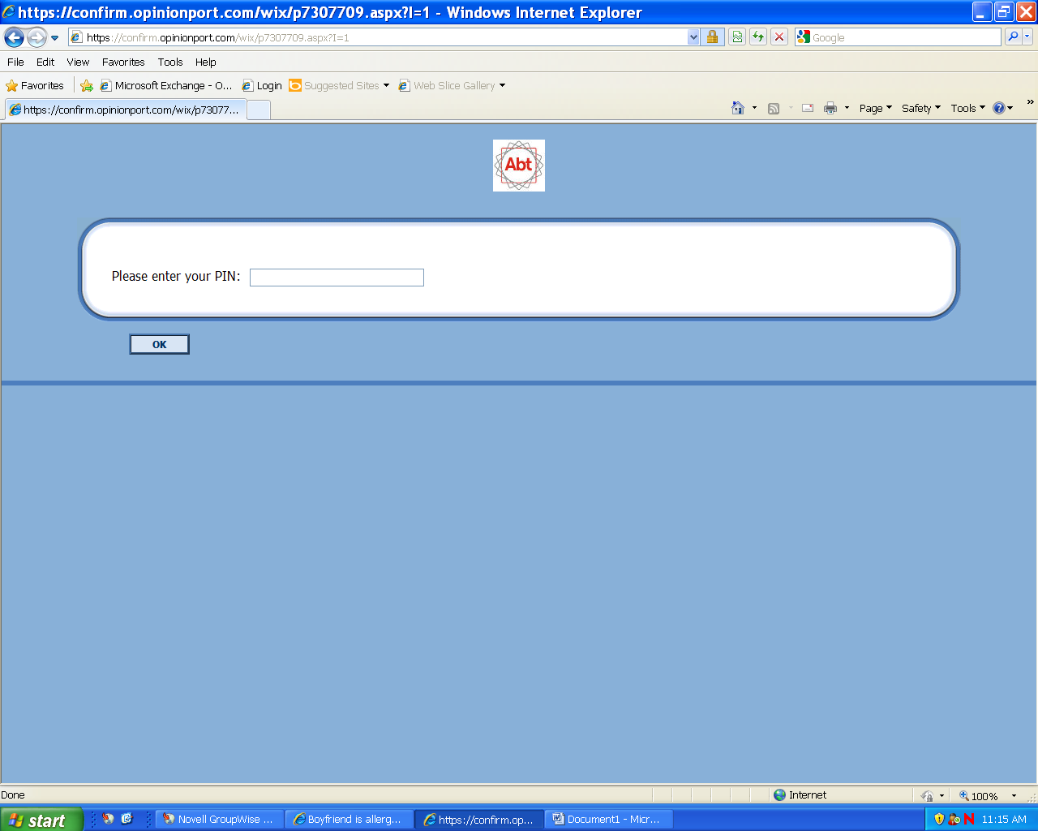

Screenshot of Participation Agreement Template

