Usability Testing on Data.gov (Req-14)
October 2014

OMB Control No: 3090-0297
Expires: 06/30/2016

Public reporting burden of this collection of information is estimated to average 30 minutes per response, including the time for reviewing instructions, searching existing data sources, gathering and maintaining the data needed, and completing and reviewing the collection of information. Send comments regarding the burden estimate or any other aspect of this collection of information, including suggestions for reducing this burden, to the Data.gov Program, Office of Citizen Services and Innovative Technologies, General Services Administration, 1800 F Street, NW, Washington, DC 20405.

Questions (note headings are for planning purposes only for use by the Data.gov team--not visible to testers)

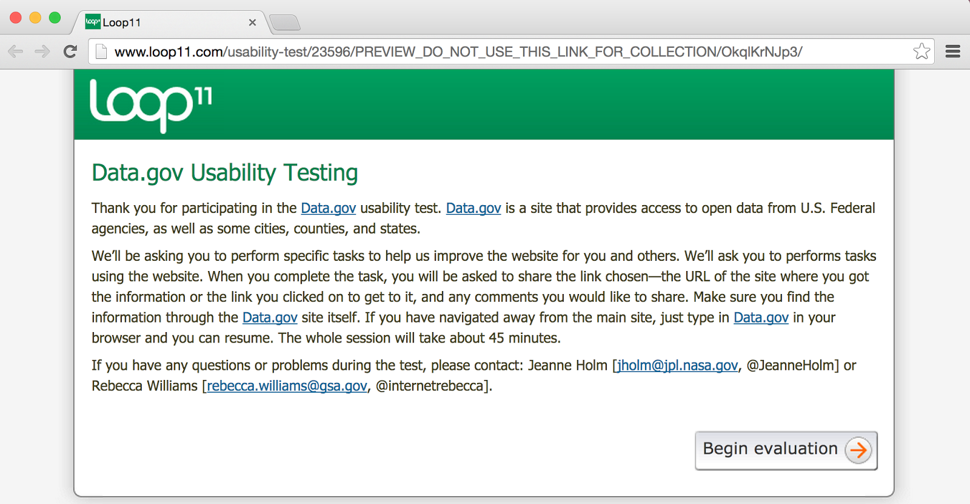

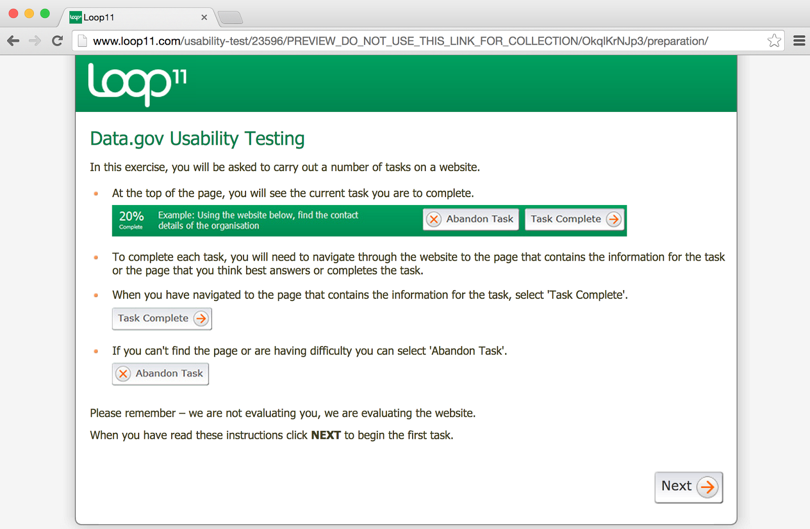

Your gear:

- What platform and device are you using for testing?
  - Computer
  - Mobile phone
  - Tablet

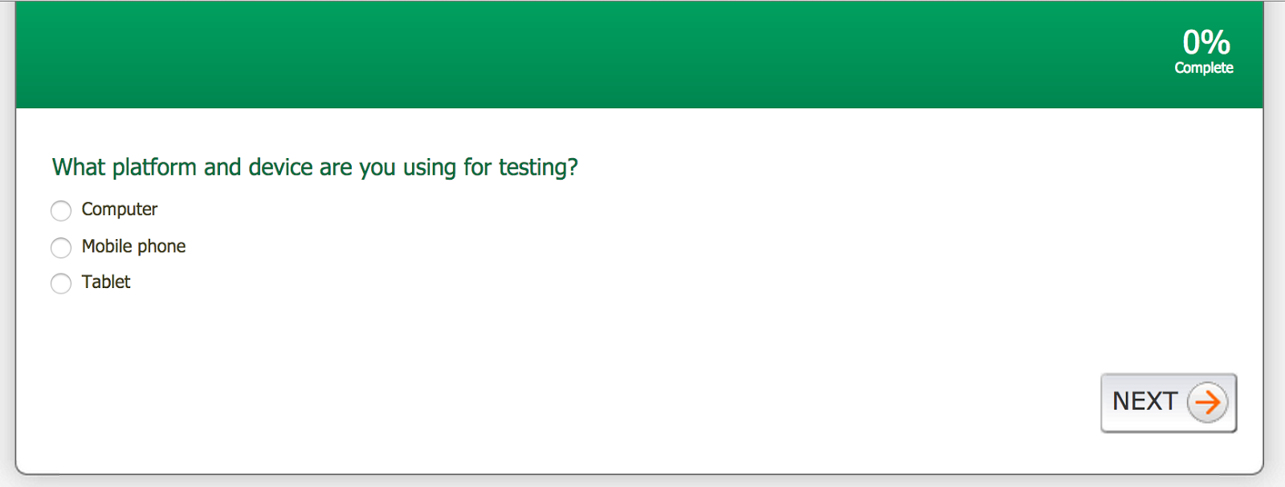
- What operating system and hardware?
  - What app (if applicable)?
  - What browser (if applicable)?
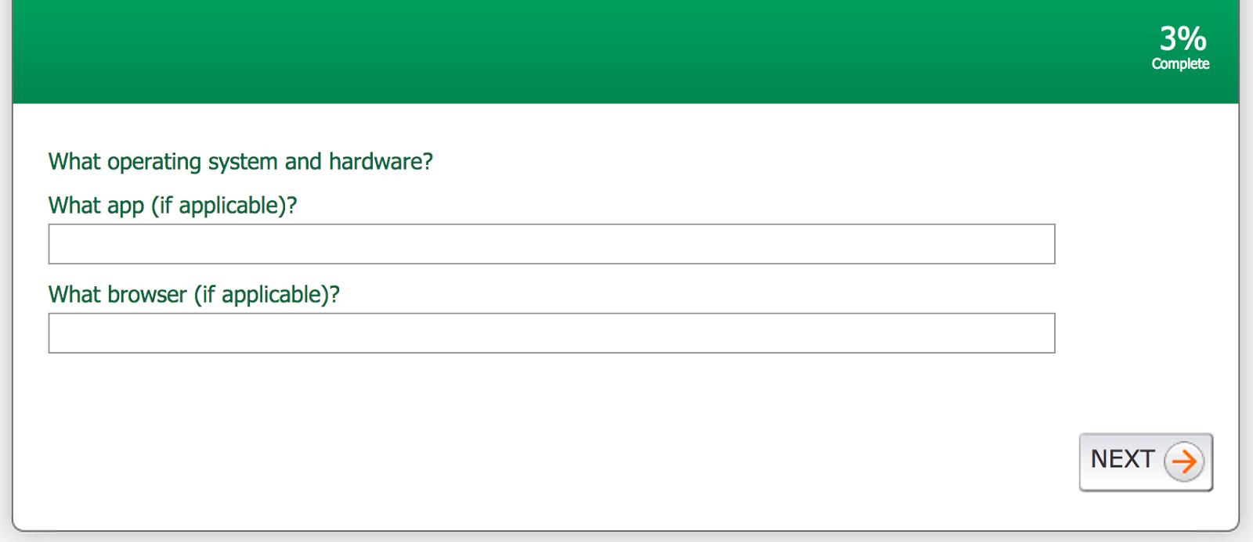
Let’s get started!

- First Impressions: Spend a few minutes exploring Data.gov
  - What do you notice first? __________
  - What is the purpose of this site? __________

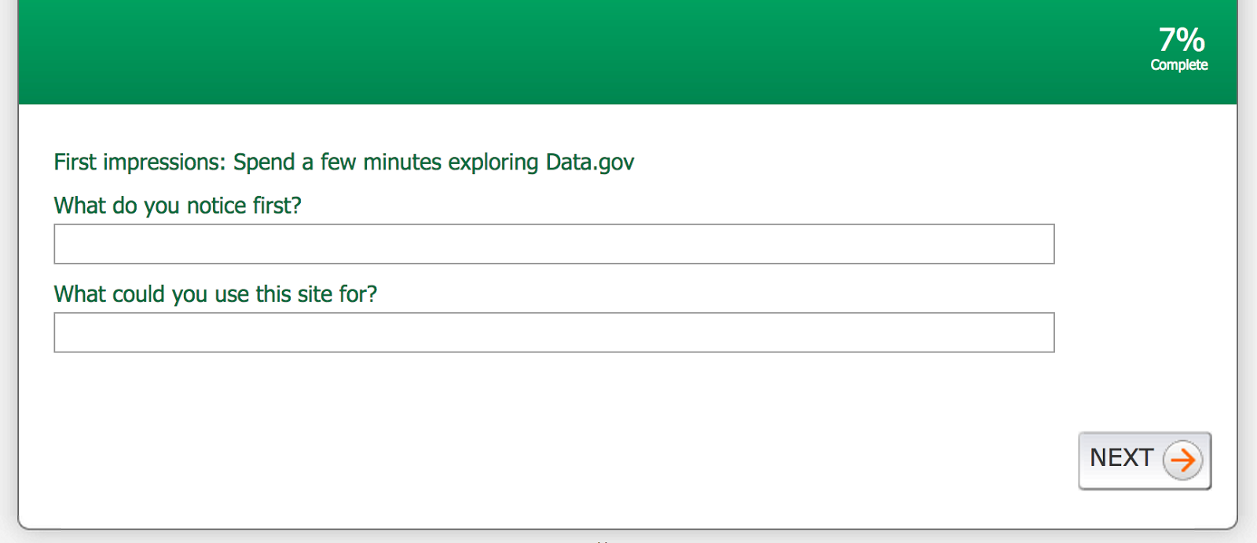

- Rate your overall satisfaction with the appearance of Data.gov
  - 1 Not at all satisfied
  - 2
  - 3
  - 4
  - 5 Extremely satisfied
  - 0 (Don't know/Does not apply)
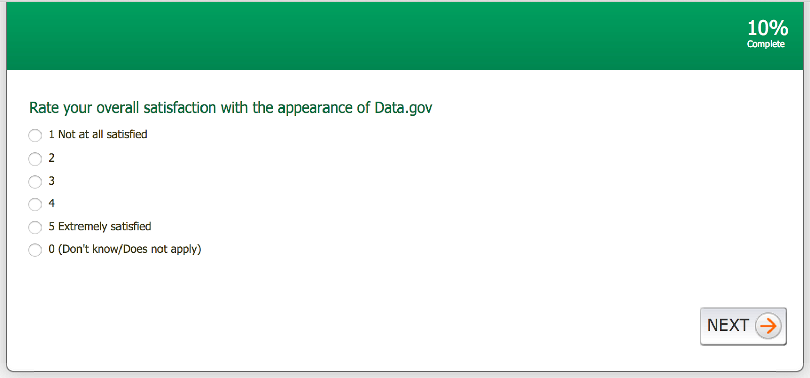
- Why did you give the rating you gave for #4? __________
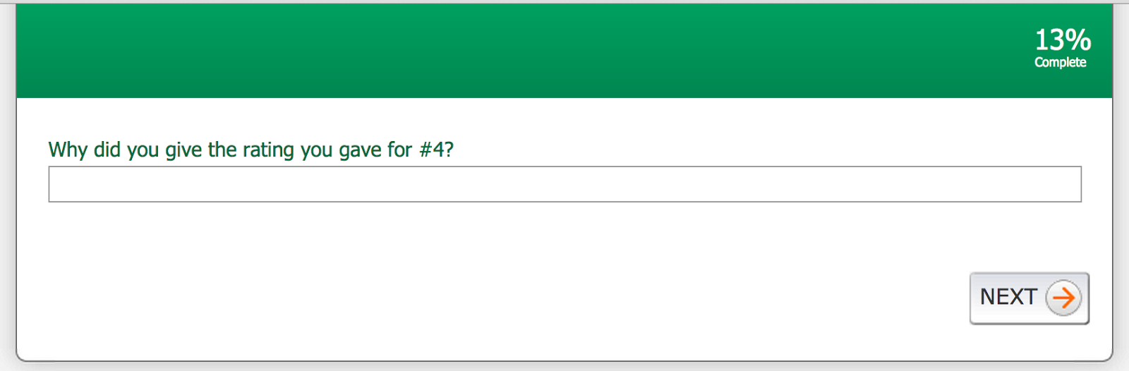

- Rate your overall satisfaction with the menu navigation of Data.gov
  - 1 Not at all satisfied
  - 2
  - 3
  - 4
  - 5 Extremely satisfied
  - 0 (Don't know/Does not apply)

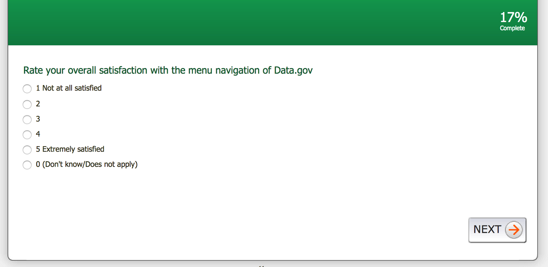
- Why did you give the rating you gave in #6? __________
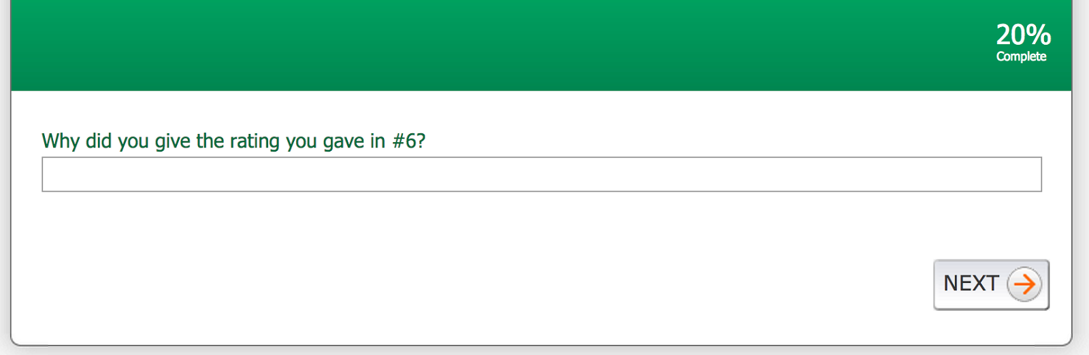

Searching for Open Data:

Search for a dataset that is relevant to your interests, until you find one. If the dataset you find does not apply to the questions below, feel free to search again.

- Rate your overall satisfaction with the search experience.
  - 1 Not at all satisfied
  - 2
  - 3
  - 4
  - 5 Extremely satisfied
  - 0 (Don't know/Does not apply)

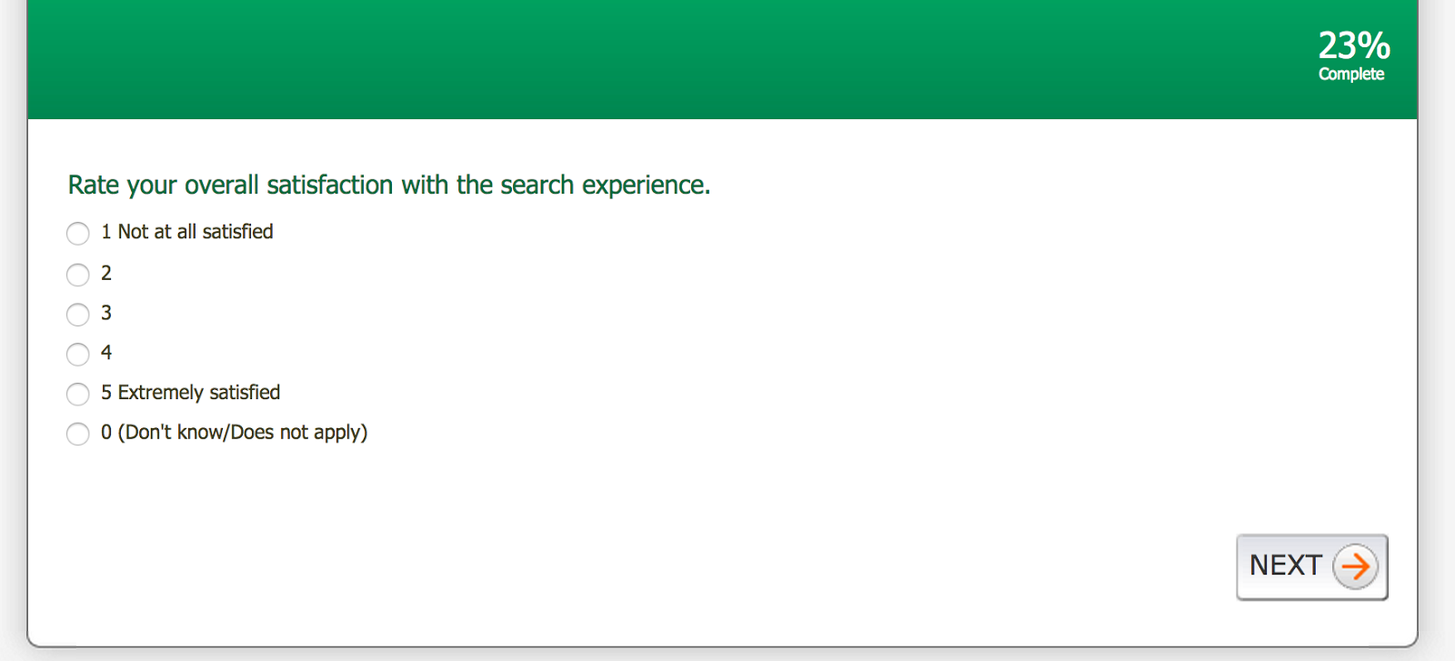
- Why did you give the rating you gave in #8? __________

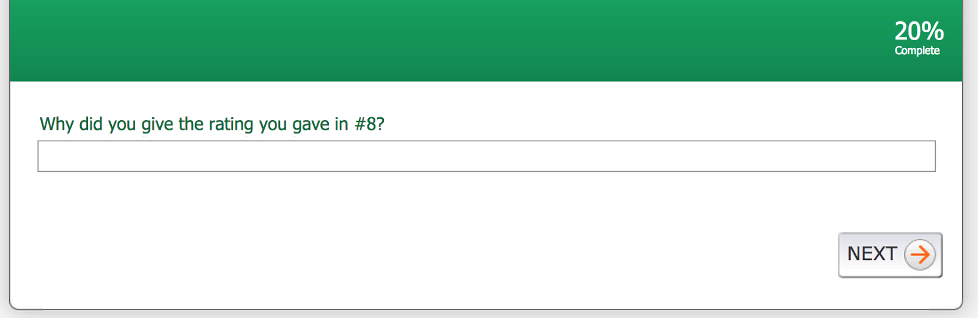

Click on this dataset.

- Are the dataset’s different format types presented clearly?
  - 1 Not at all straightforward
  - 2
  - 3
  - 4
  - 5 Extremely straightforward
  - 0 (Don't know/Does not apply)

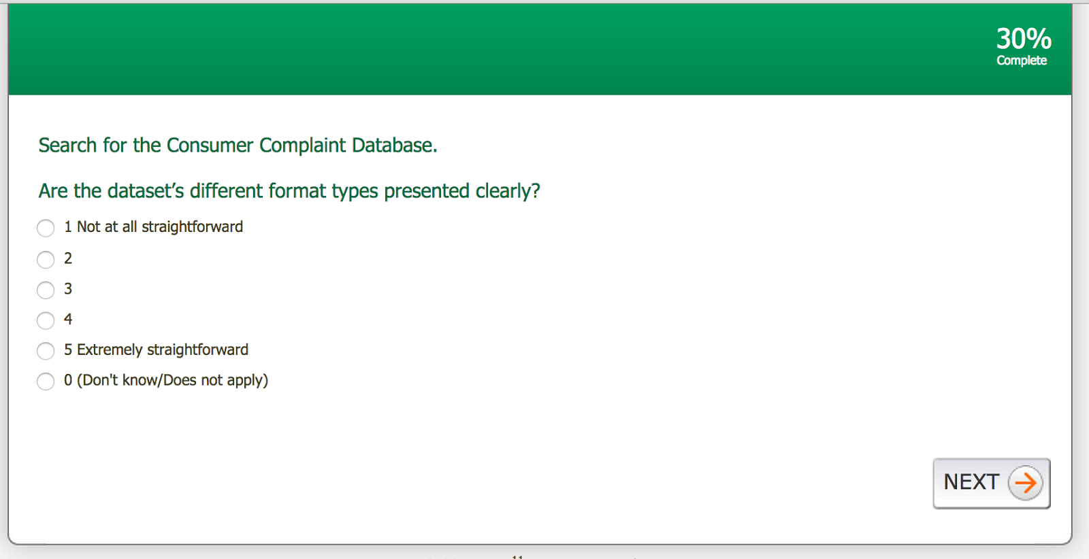
- Why did you give the rating you gave in #10? __________
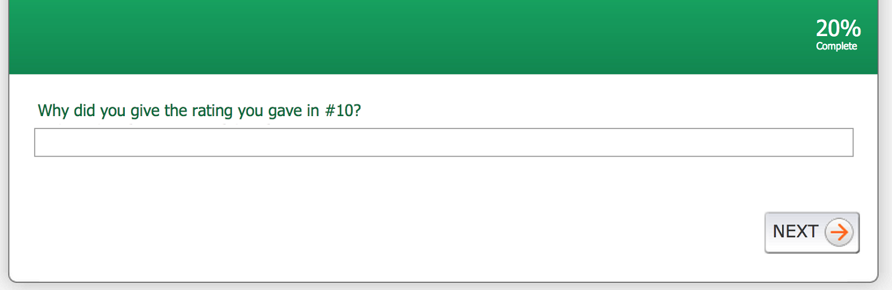

- If applicable: if you came across a broken link or file format not to your preference, was it clear who to contact?
  - Y
  - N
  - Why? __________
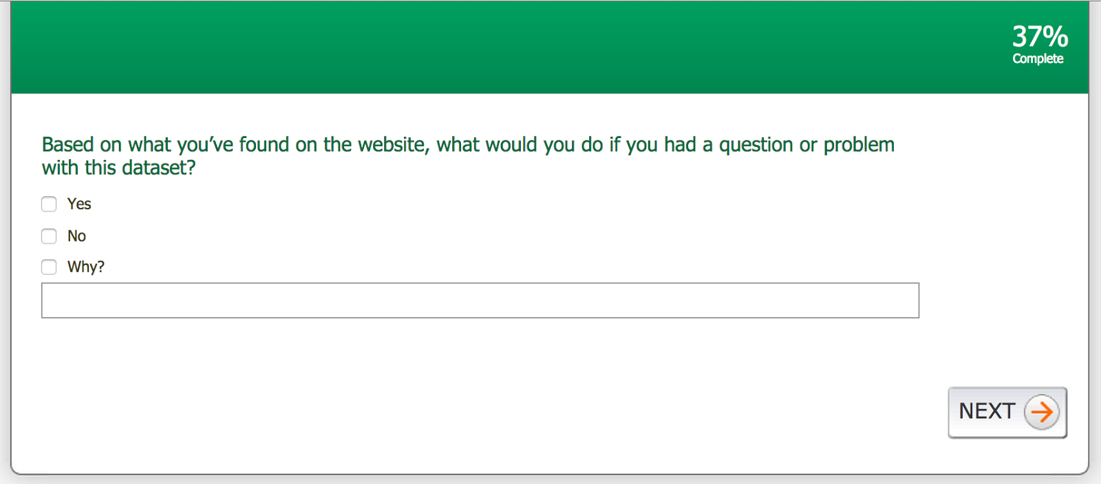

Navigate to the Topics page of Data.gov and choose a Topic to explore.

- For reference, which Topic did you choose? __________
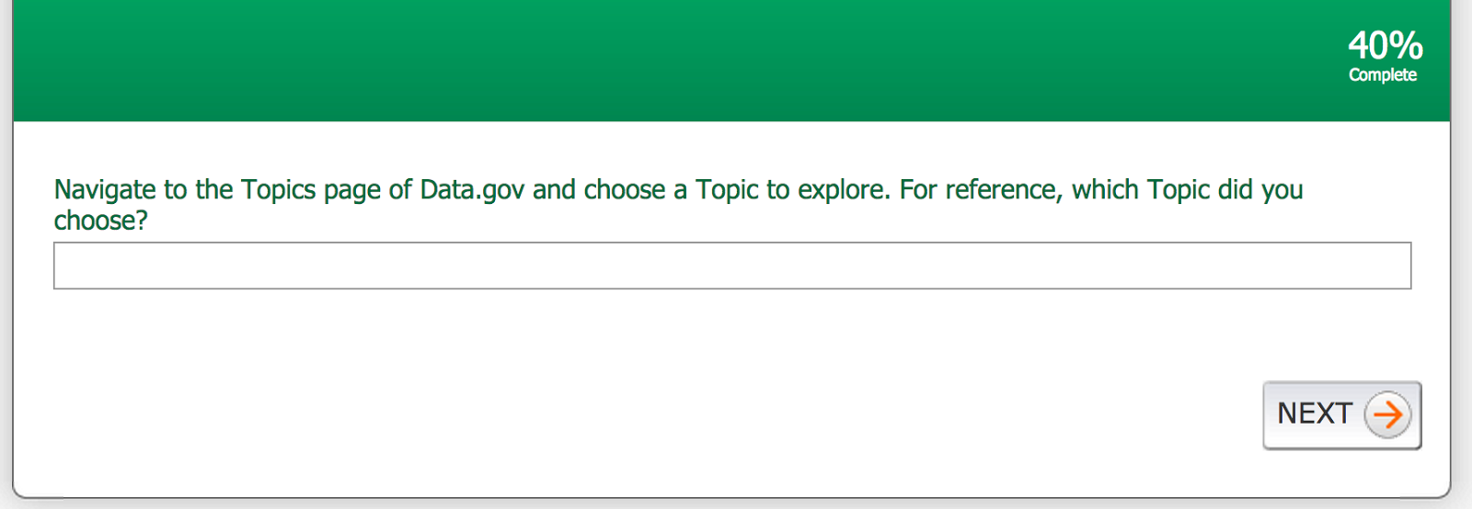
- Rate your overall satisfaction with your chosen Topic in terms of navigation, layout, content, and data
  - 1 Not at all satisfied
  - 2
  - 3
  - 4
  - 5 Extremely satisfied
  - 0 (Don't know/Does not apply)
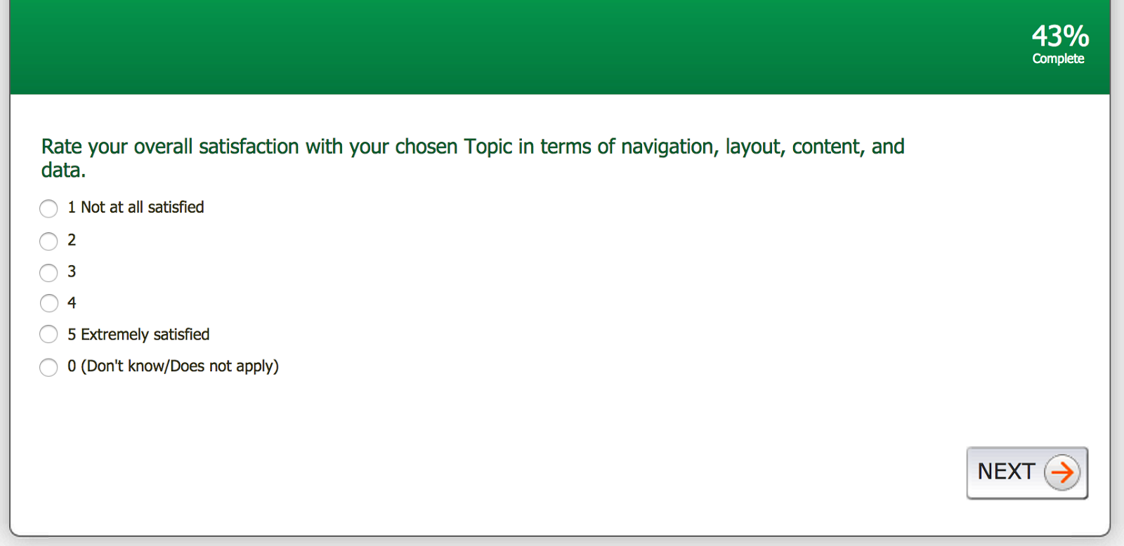

- Why did you give the rating you gave in #14? __________

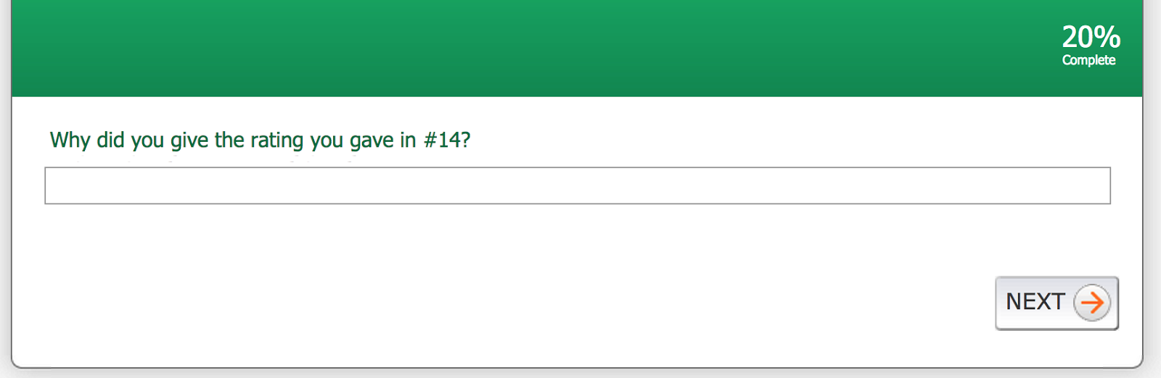
- Test Scenarios (pick one):

You want to find the effects of climate change in your community. Find information about the climate.  Rate how straightforward it is to find the top insights and topics related to climate data?  1 Not at all straightforward  2  3  4  5 Extremely straightforward  0 (Don't know/Does not apply)  Rate how straightforward it is to find the most important datasets related to climate?  1 Not at all straightforward  2  3  4  5 Extremely straightforward  0 (Don't know/Does not apply) | You are investigating alternative fuel development. Find a dataset related to biofuel companies.  Rate how straightforward it is to find the data owner of that dataset.  1 Not at all straightforward  2  3  4  5 Extremely straightforward  0 (Don't know/Does not apply)  Rate how straightforward it is to preview the dataset and see if there is a company in New York.  1 Not at all straightforward  2  3  4  5 Extremely straightforward  0 (Don't know/Does not apply)  Rate how straightforward it is to download the dataset.  1 Not at all straightforward  2  3  4  5 Extremely straightforward  0 (Don't know/Does not apply)
You are looking at crime in your city. Locate information about topics and data related to crime or safety.  Rate how straightforward it is to find related datasets in XML format.  1 Not at all straightforward  2  3  4  5 Extremely straightforward  0 (Don't know/Does not apply)  Rate how straightforward it is to find data from Illinois.  1 Not at all straightforward  2  3  4  5 Extremely straightforward  0 (Don't know/Does not apply) | You are researching education issues and want to compare U.S. data to data from other countries.  Rate how straightforward it is to find a listing of open data sites from other countries.  1 Not at all straightforward  2  3  4  5 Extremely straightforward  0 (Don't know/Does not apply)

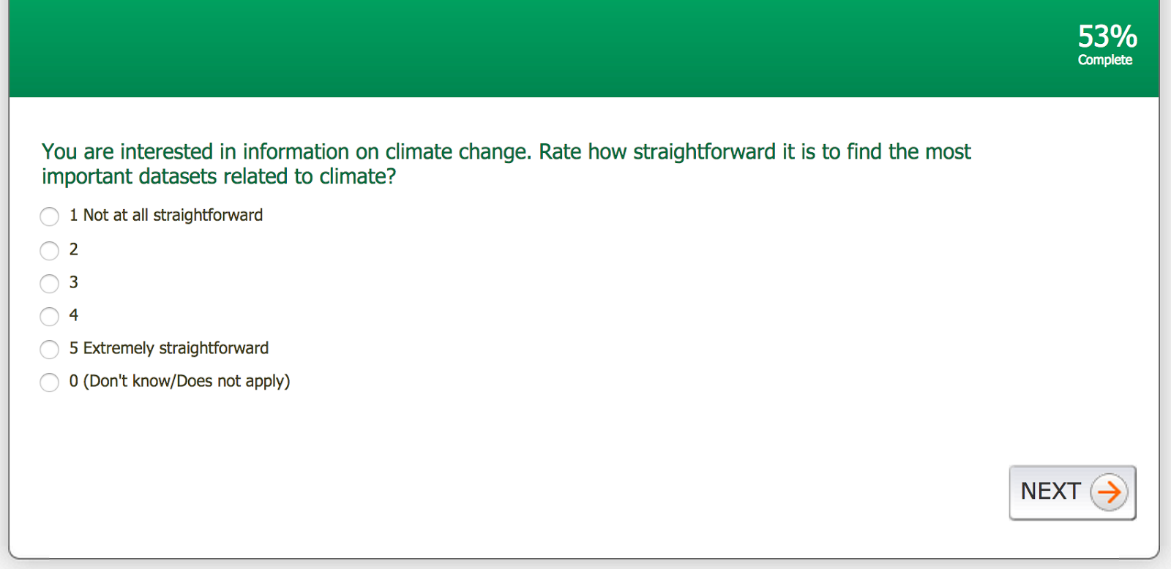

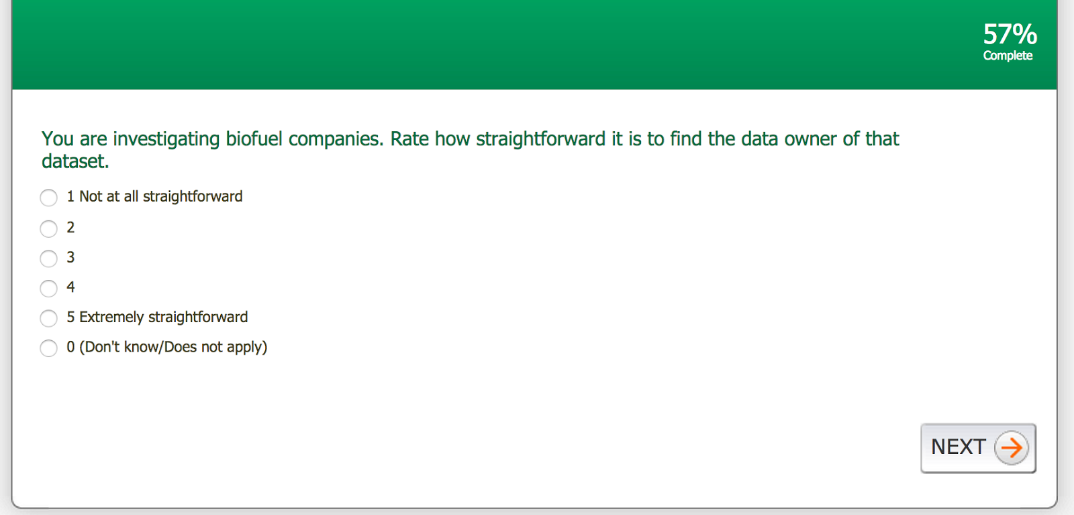

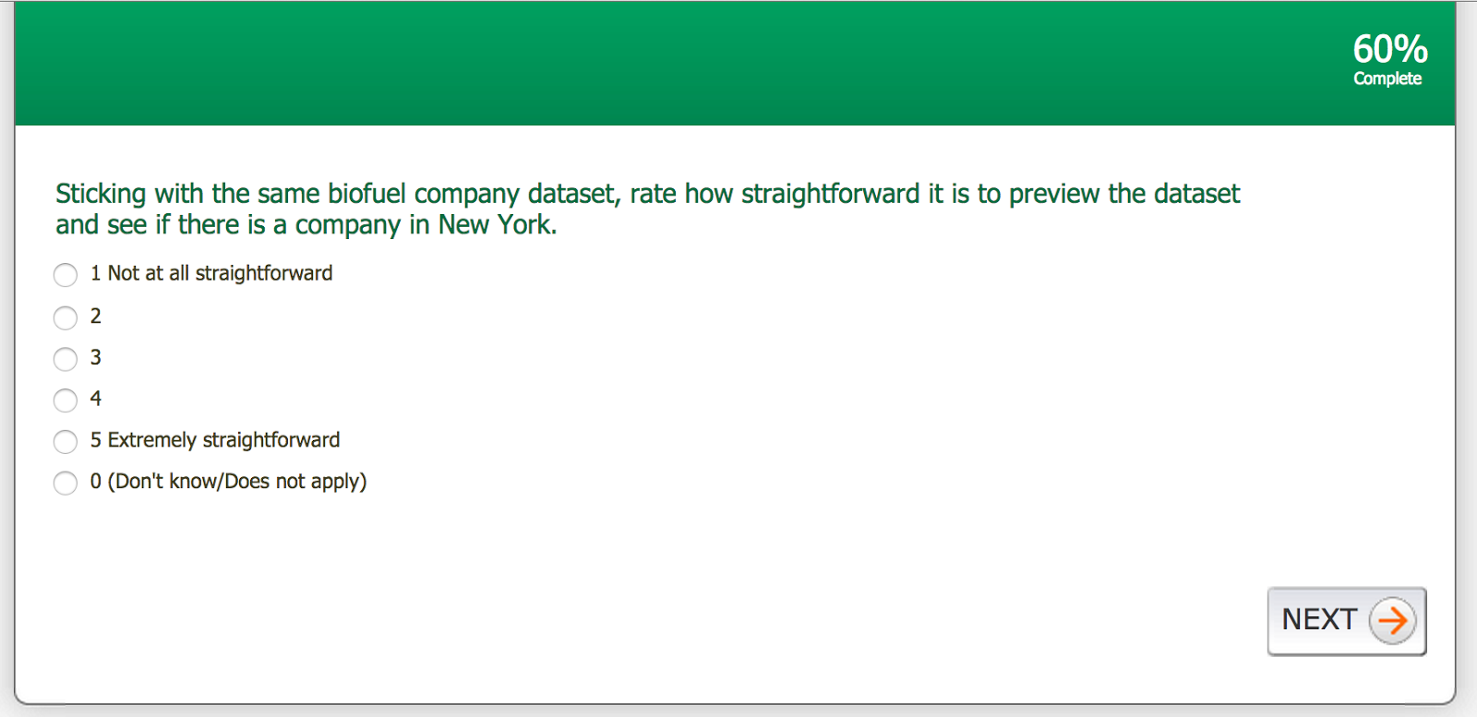
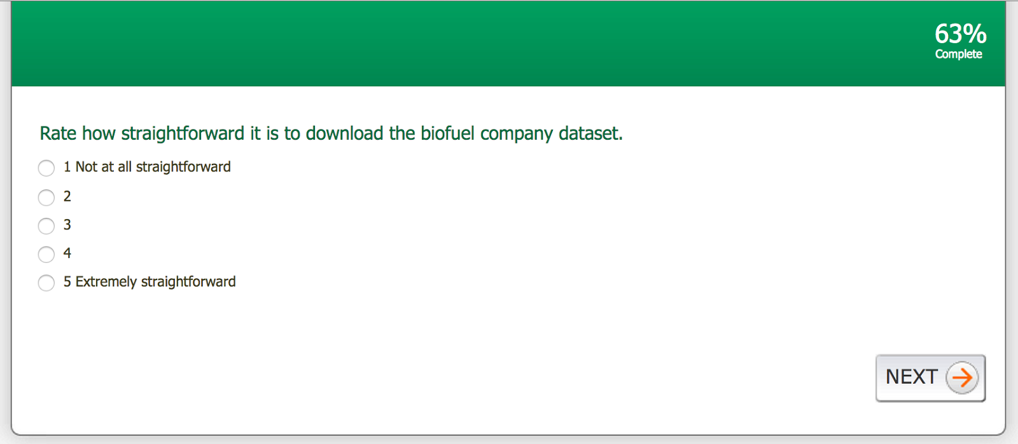
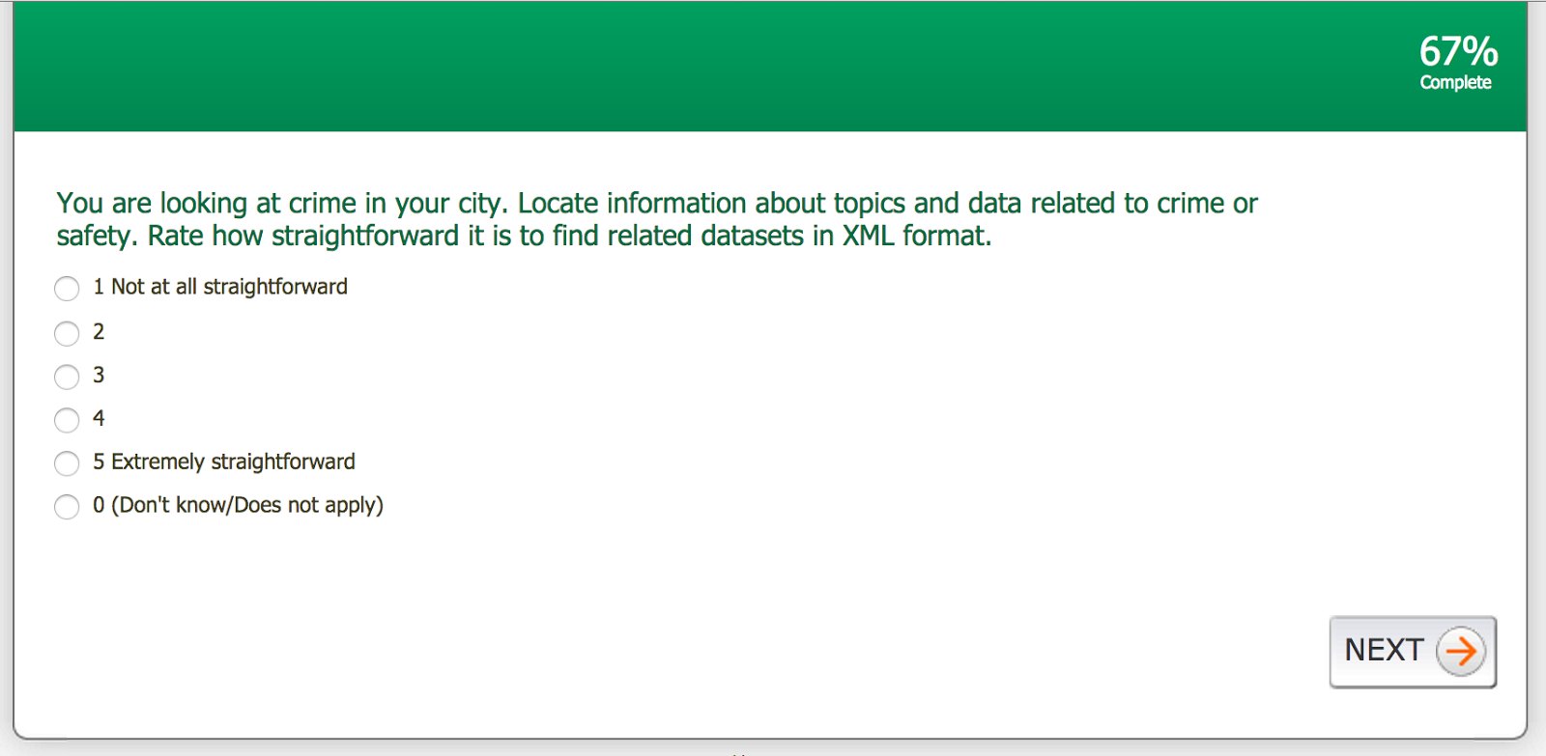
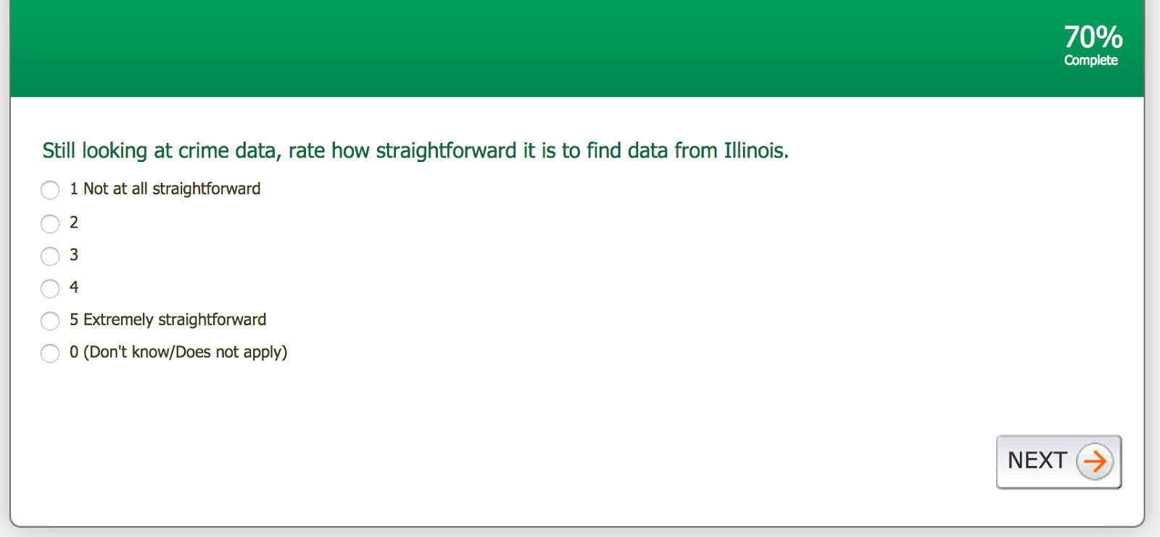
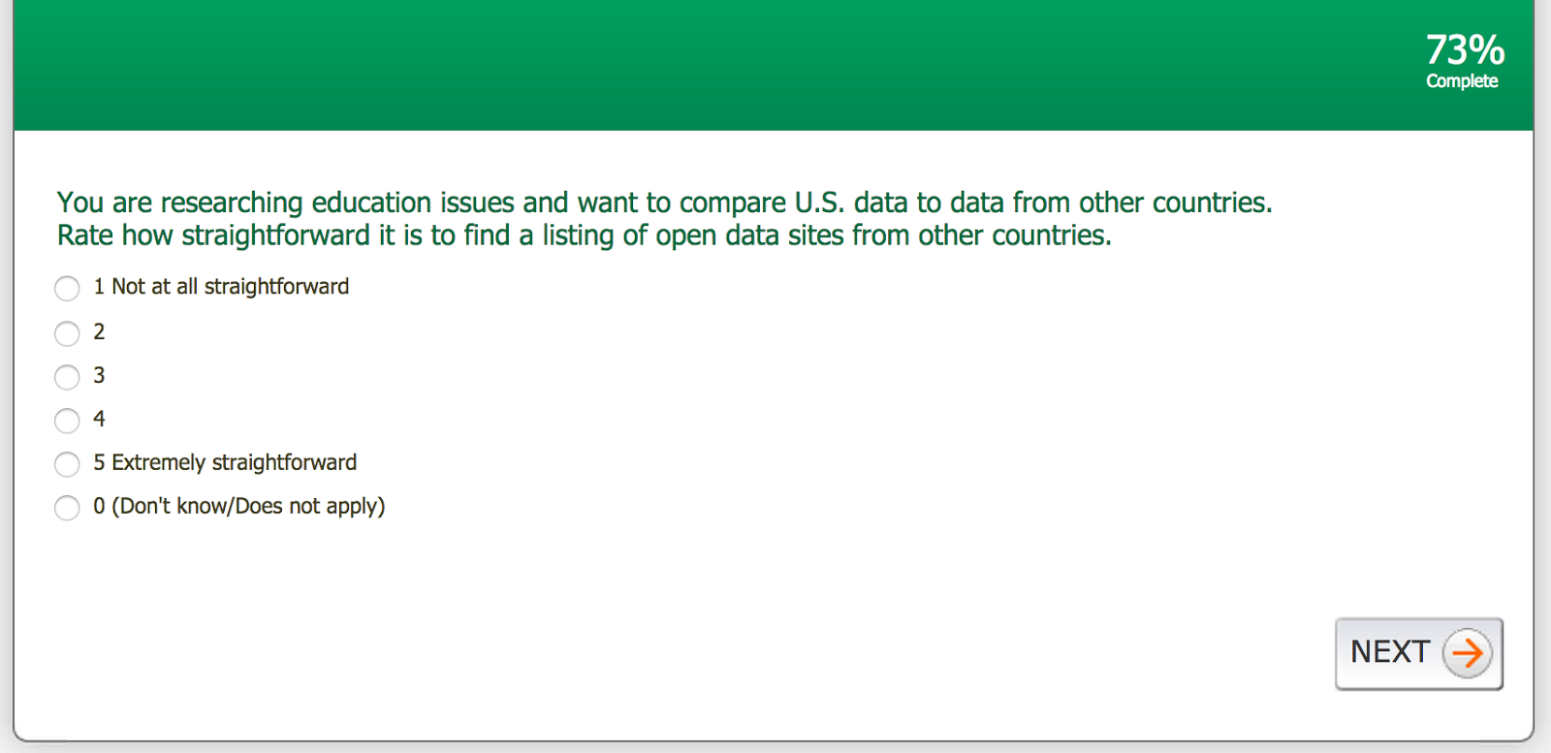
Navigate to Developers on Data.gov.

- You are creating a new website. Rate how straightforward it is to find web services or APIs that you could use.
  - 1 Not at all straightforward
  - 2
  - 3
  - 4
  - 5 Extremely straightforward
  - 0 (Don't know/Does not apply)

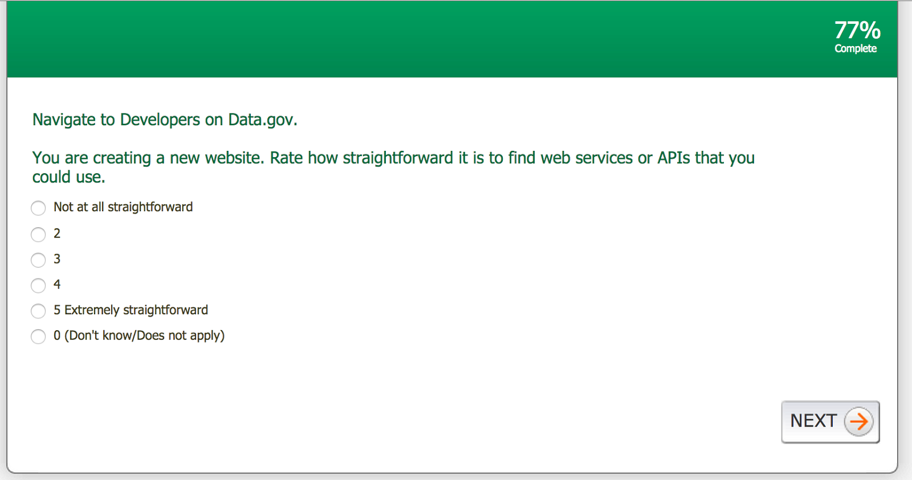

- Why did you give the rating you gave in #17? __________

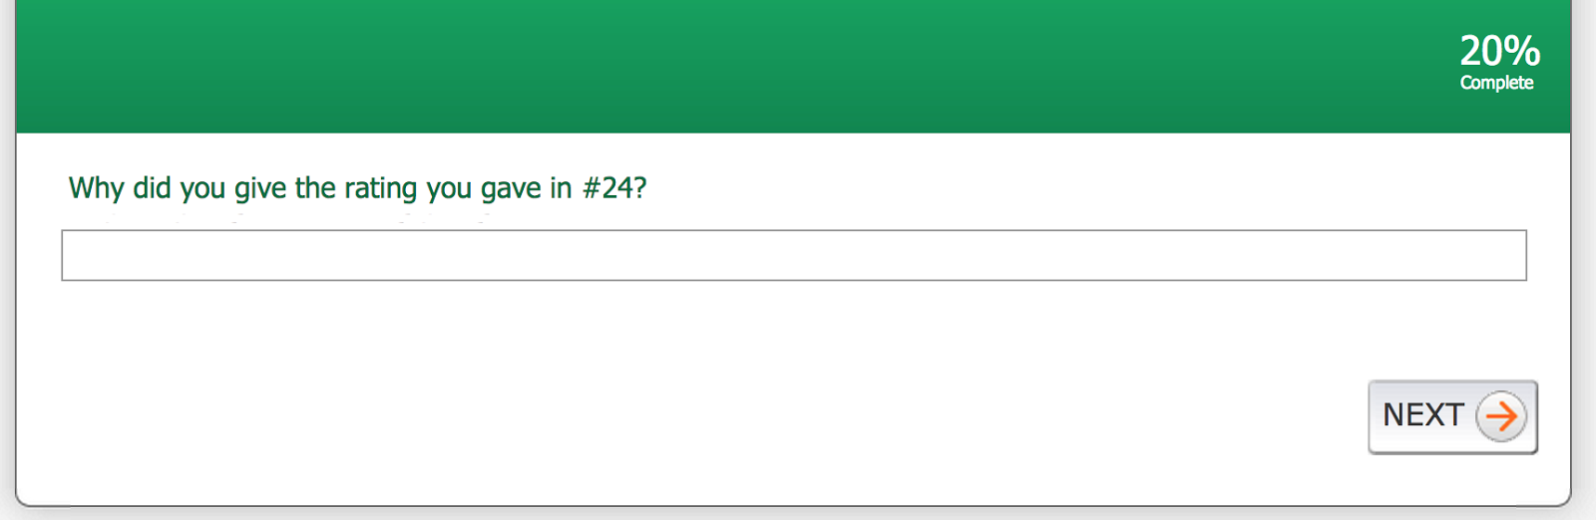
Finishing Up!

- Lasting Impressions: Rate the following Data.gov features by how important they are to you as a user:

Data Catalog  - 1 Not at all important  - 2  - 3  - 4  - 5 Extremely important  - 0 (Don't know/Does not apply) | Contact Information  - 1 Not at all important  - 2  - 3  - 4  - 5 Extremely important  - 0 (Don't know/Does not apply)
Curated Data Collections or Topics  - 1 Not at all important  - 2  - 3  - 4  - 5 Extremely important  - 0 (Don't know/Does not apply) | Information About Data.gov  - 1 Not at all important  - 2  - 3  - 4  - 5 Extremely important  - 0 (Don't know/Does not apply)
Data Stories or Impacts  - 1 Not at all important  - 2  - 3  - 4  - 5 Extremely important  - 0 (Don't know/Does not apply) | Federal Agency Participation / Policy Compliance  - 1 Not at all important  - 2  - 3  - 4  - 5 Extremely important  - 0 (Don't know/Does not apply)
Data.gov Metrics (Analytics, API calls, Data Request Frequency)  - 1 Not at all important  - 2  - 3  - 4  - 5 Extremely important  - 0 (Don't know/Does not apply) | Bulk Downloads of Data.gov’s Metadata  - 1 Not at all important  - 2  - 3  - 4  - 5 Extremely important  - 0 (Don't know/Does not apply)

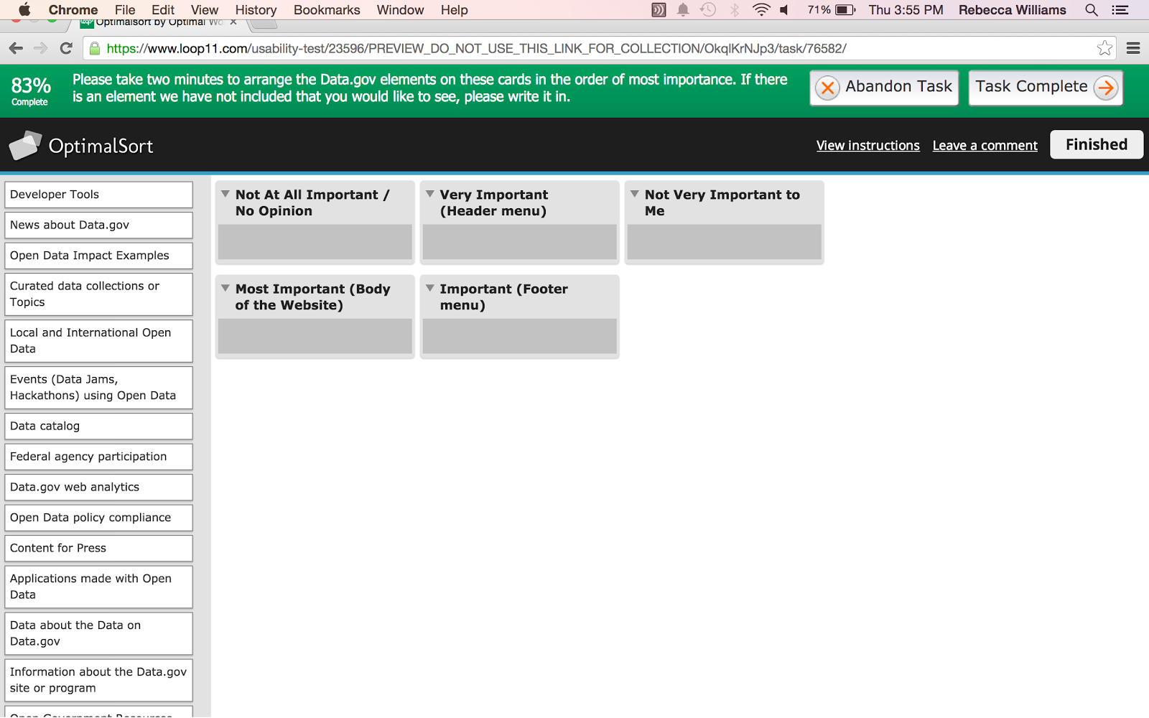

- What type of content or feature that would you like to see added? __________
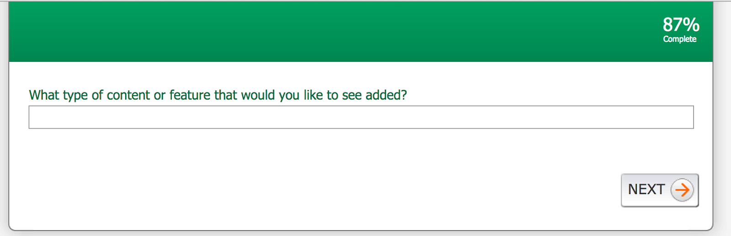
- If you could change two things about Data.gov, what would you change? __________
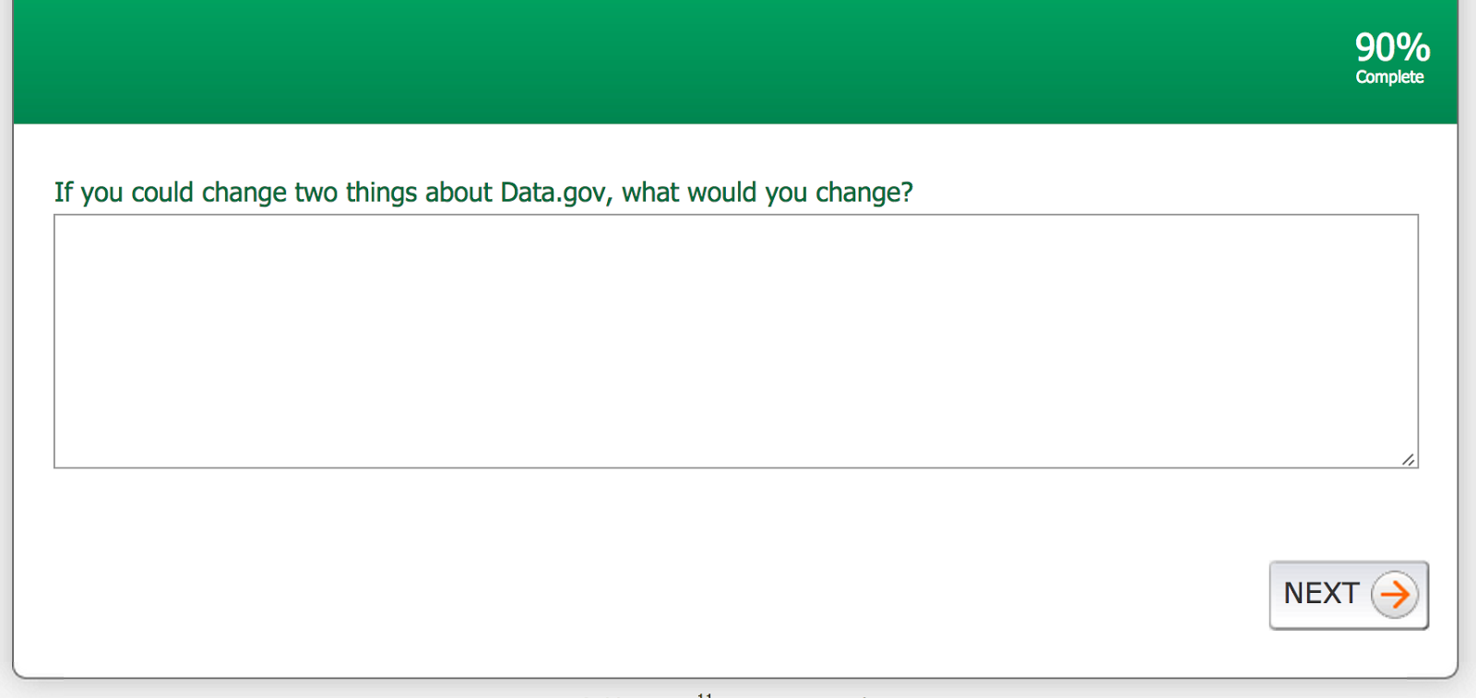

- Rate your overall satisfaction with the feedback mechanisms on Data.gov
  - 1 Not at all satisfied
  - 2
  - 3
  - 4
  - 5 Extremely satisfied
  - 0 (Don't know/Does not apply)

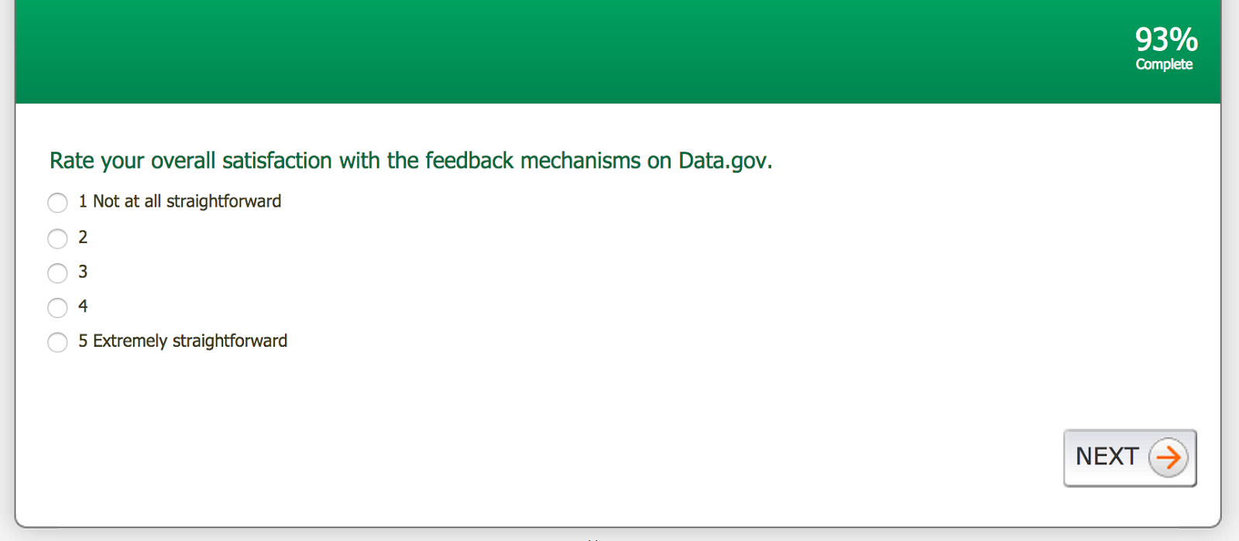
- Why did you give the rating you gave in #22? __________

