2016 Government Customer Experience Index (GCXi)
Data.gov Survey Questions
(Req-30)

Invitation Email

Subject: We need your feedback!

Dear Data.gov Customer,

Today, we're launching our annual customer satisfaction survey and we’d appreciate your input. Please tell us what’s working, what’s not, and how we can make Data.gov more useful for you. This survey is anonymous, and should take you less than 6 minutes to complete. Click the button below to start. Thank you!

By the way, did you know that GSA offers several free and low-cost products and services to agencies? After you complete the survey, please check out everything we have to offer to agencies and let me know if you’d like additional information.

Thank you for your time.
Sincerely,

Hyon Kim
Program Manager
Office of Citizen Services and Innovative Technologies/18F
U.S. General Services Administration

PRA Information
OMB Control Number: 3090-0297; Expires 06/30/2016
Paperwork Reduction Act Statement - This information collection meets the requirements of 44 U.S.C. § 3507, as amended by section 2 of the Paperwork Reduction Act of 1995. You do not need to answer these questions unless we display a valid Office of Management and Budget (OMB) control number. The OMB control number for this collection is 3090-0297. We estimate that it will take 6 minutes to read the instructions, gather the facts, and answer the questions. Send only comments relating to our time estimate, including suggestions for reducing this burden, or any other aspects of this collection of information to: General Services Administration, Regulatory Secretariat Division (MVCB), ATTN: Ms. Flowers/IC 3090-0297, 1800 F Street, NW, Washington, DC 20405.

Page 1
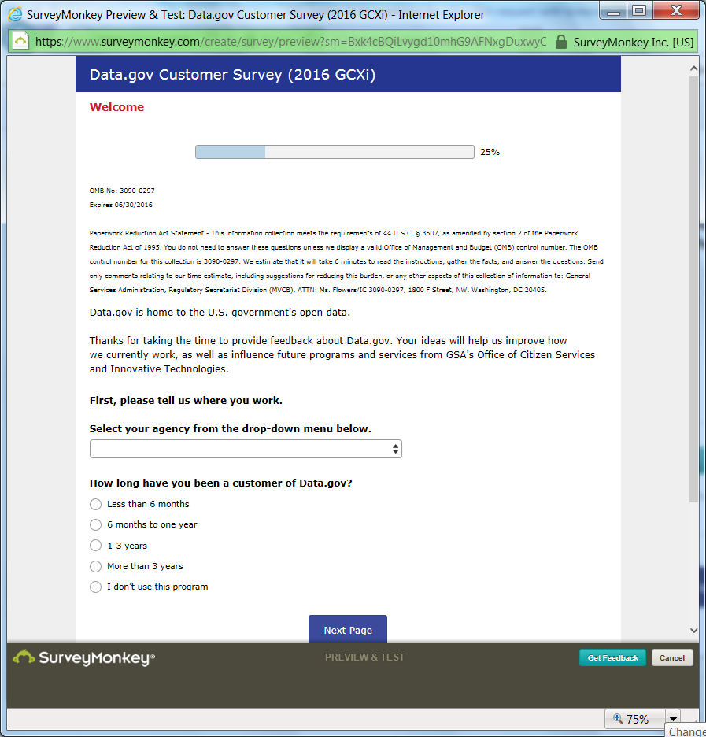

[Note: If the “I’m not a member/I don’t use this program” answer is selected, the user will be shown the “final thoughts” screen (Page 5). This response is intended to help us determine how our branding resonates with the audience.]

PAGE 1 w/agency list dropdown

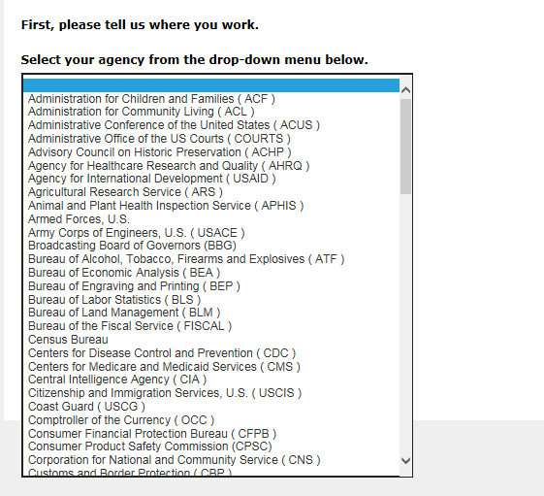

[Note: One of OCSIT’s strategic goals is to reach as many agencies as possible with our services; we currently support almost 700 federal employees at over 100 different federal agencies.]
[Note: The agency drop-down list is comprised of the following agencies:
Administration for Children and Families ( ACF )  Administration for Community Living ( ACL )  Administrative Conference of the United States ( ACUS )  Administrative Office of the US Courts ( COURTS )  Advisory Council on Historic Preservation ( ACHP )  Agency for Healthcare Research and Quality ( AHRQ )  Agency for International Development ( USAID )  Agricultural Research Service ( ARS )  Animal and Plant Health Inspection Service ( APHIS )  Armed Forces, U.S.  Army Corps of Engineers, U.S. ( USACE )  Broadcasting Board of Governors (BBG)  Bureau of Alcohol, Tobacco, Firearms and Explosives (ATF)  Bureau of Economic Analysis ( BEA )  Bureau of Engraving and Printing ( BEP )  Bureau of Labor Statistics ( BLS )  Bureau of Land Management ( BLM )  Bureau of the Fiscal Service ( FISCAL )  Census Bureau  Centers for Disease Control and Prevention ( CDC )  Centers for Medicare and Medicaid Services ( CMS )  Central Intelligence Agency ( CIA )  Citizenship and Immigration Services, U.S. ( USCIS )  Coast Guard ( USCG )  Comptroller of the Currency ( OCC )  Consumer Financial Protection Bureau ( CFPB )  Consumer Product Safety Commission (CPSC)  Corporation for National and Community Service ( CNS )  Customs and Border Protection ( CBP )  Defense Commissary Agency (DeCA)  Defense Intelligence Agency ( DIA )  Defense Media Activity ( DMA )  Department of Agriculture ( USDA )  Department of Commerce ( DOC )  Department of Defense ( DOD )  Department of Education ( ED )  Department of Energy ( DOE )  Department of Health and Human Services ( HHS )  Department of Homeland Security ( DHS )  Department of Housing and Urban Development ( HUD )  Department of Justice ( DOJ )  Department of Labor ( DOL )  Department of State ( DOS )  Department of the Interior ( DOI )  Department of the Treasury ( TREAS )  Department of Transportation ( DOT )  Department of Veterans Affairs ( VA )  Director of National Intelligence ( DNI )  Economic Research Service ( ERS )  Employee Benefits Security Administration ( EBSA )  Energy Efficiency and Renewable Energy ( EERE )  Energy Information Administration ( EIA )  Environmental Protection Agency ( EPA )  Equal Employment Opportunity Commission (EEOC)  Export-Import Bank of the United States ( EXIM ) | Farm Service Agency ( FSA )  Federal Aviation Administration ( FAA )  Federal Communications Commission ( FCC )  Federal Deposit Insurance Corporation ( FDIC )  Federal Emergency Management Agency ( FEMA )  Federal Railroad Administration ( FRA )  Federal Reserve System ( FRB )  Federal Trade Commission ( FTC )  Fish and Wildlife Service ( FWS )  Food and Drug Administration ( FDA )  Food Safety and Inspection Service ( FSIS )  Forest Service, U.S. ( FS )  General Services Administration ( GSA )  Geological Survey, U.S. ( USGS )  Institute of Museum and Library Services ( IMLS )  Internal Revenue Service ( IRS )  Library of Congress ( LOC )  Local Government Agency  Mint, U.S.  National Aeronautics and Space Administration ( NASA )  National Agricultural Library ( NAL )  National Agricultural Statistics Service ( NASS )  National Archives and Records Administration (NARA)  National Cancer Institute ( NCI )  National Endowment for the Arts ( NEA )  National Geospatial-Intelligence Agency ( NGIA )  National Highway Traffic Safety Administration ( NHTSA )  National Institute of Standards and Technology ( NIST )  National Institutes of Health ( NIH )  National Library of Medicine ( NLM )  National Oceanic and Atmospheric Administration (NOAA)  National Park Service ( NPS )  National Science Foundation ( NSF )  National Transportation Safety Board ( NTSB )  Nuclear Regulatory Commission ( NRC )  Occupational Safety and Health Administration ( OSHA )  Office of Government Ethics ( OGE )  Office of Personnel Management ( OPM )  Patent and Trademark Office ( USPTO )  Peace Corps  Postal Service, U.S. ( USPS )  Rural Development ( RD )  Securities and Exchange Commission ( SEC )  Small Business Administration ( SBA )  Smithsonian Institution ( SI )  Social Security Administration ( SSA )  State Government Agency  Substance Abuse & Mental Health Services Administration ( SAMHSA )  Transportation Security Administration ( TSA )  Veterans Benefits Administration ( VBA )  Veterans Health Administration ( VHA )  White House (Incl. EOP, OMB, OSTP)

PAGE 2
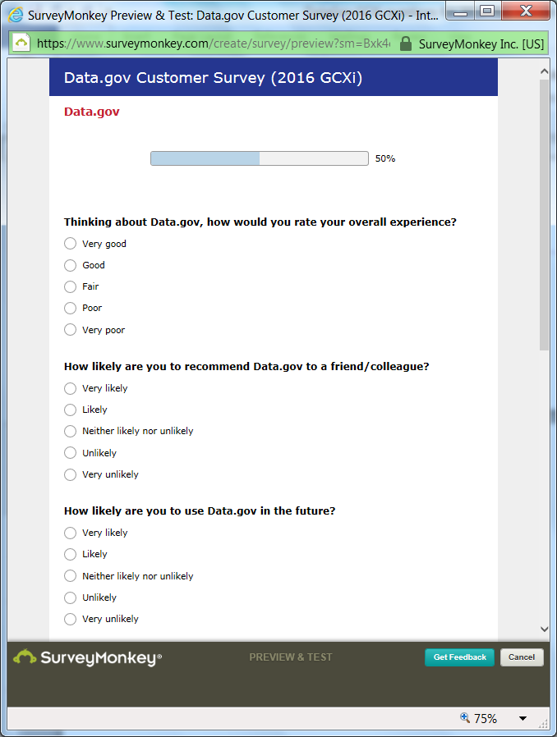

PAGE 2, cont.
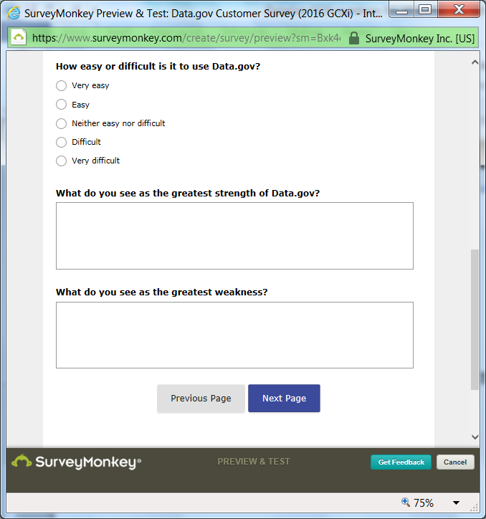

PAGE 3
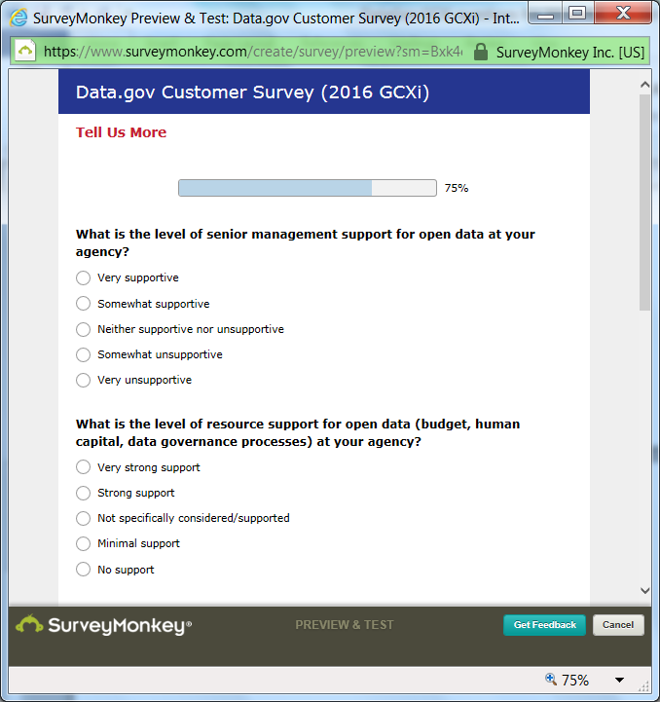

PAGE 3, cont.
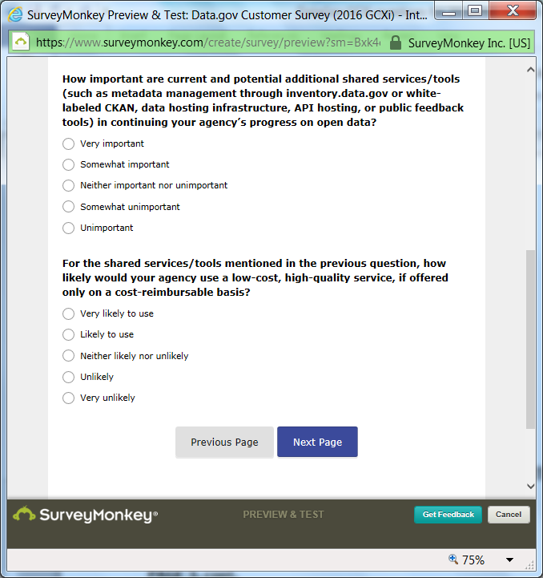

PAGE 4
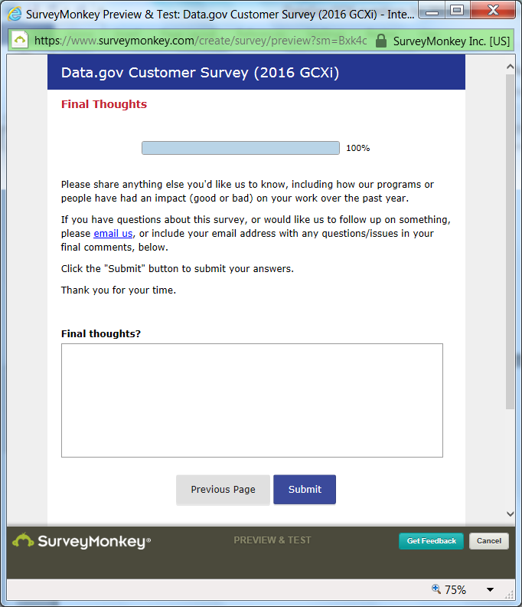

Survey End

[Note: After participants click the “submit” button, they will be taken to the DigitalGov.gov homepage.]
