2016 Government Customer Experience Index (GCXi)
CX-COP Survey Questions
Req-26

Invitation Email

Subject: We need your feedback!

Dear CX-COP member,

Today, we're launching our annual customer satisfaction survey and we’d appreciate your input. Please tell us what’s working, what’s not, and how we can make the CX-COP more useful for you. This survey is anonymous, and should take you less than 6 minutes to complete. Click the button below to start. Thank you!



By the way, did you know that GSA offers several free and low-cost products and services to agencies? We also host several other Communities of Practice, in addition to the CX-COP. After you complete the survey, please check out everything we have to offer to agencies and let me know if you’d like additional information.

Thank you for your time.
Sincerely,

Rachel Flagg
Program Manager
Office of Citizen Services and Innovative Technologies/18F
U.S. General Services Administration

PRA Information
OMB Control Number: 3090-0297; Expires 06/30/2016
Paperwork Reduction Act Statement - This information collection meets the requirements of 44 U.S.C. § 3507, as amended by section 2 of the Paperwork Reduction Act of 1995. You do not need to answer these questions unless we display a valid Office of Management and Budget (OMB) control number. The OMB control number for this collection is 3090-0297. We estimate that it will take 6 minutes to read the instructions, gather the facts, and answer the questions. Send only comments relating to our time estimate, including suggestions for reducing this burden, or any other aspects of this collection of information to: General Services Administration, Regulatory Secretariat Division (MVCB), ATTN: Ms. Flowers/IC 3090-0297, 1800 F Street, NW, Washington, DC 20405.

Survey Page 1

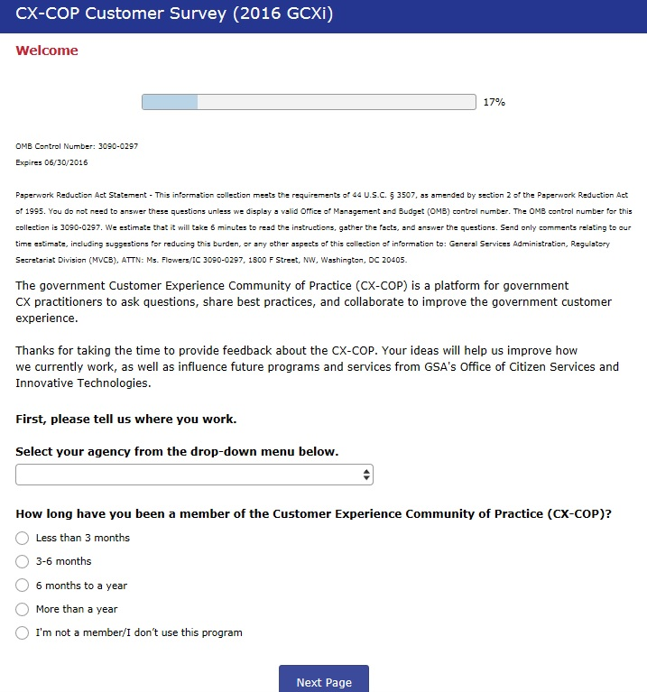

[Note: If the “I’m not a member/I don’t use this program” answer is selected, the user will be shown the “final thoughts” screen (Page 5). This response is intended to help us determine how our branding resonates with the audience.]

PAGE 1, cont.

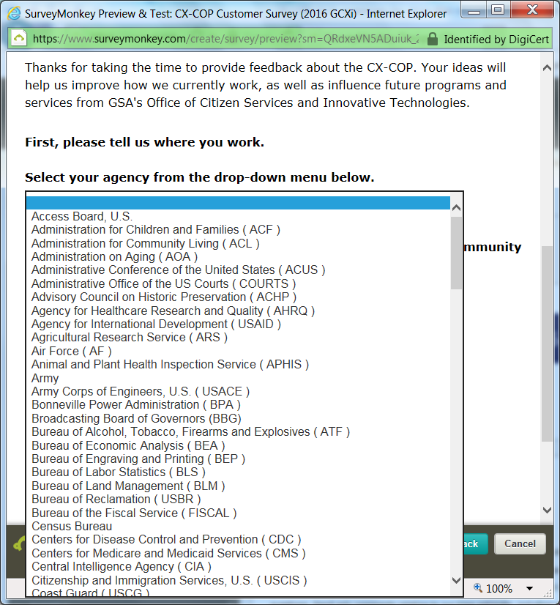

[NOTE: This request is only for state and local government customers. However, the same request will be sent out to all customers; therefore, all possible agencies are listed below:]
Access Board, U.S.  Administration for Children and Families ( ACF )  Administration for Community Living ( ACL )  Administration on Aging ( AOA )  Administrative Conference of the United States ( ACUS )  Administrative Office of the US Courts ( USCOURTS )  Advisory Council on Historic Preservation ( ACHP )  Agency for Healthcare Research and Quality ( AHRQ )  Agency for International Development ( USAID )  Agricultural Research Service ( ARS )  Air Force ( AF )  Animal and Plant Health Inspection Service ( APHIS )  Army  Army Corps of Engineers, U.S. ( USACE )  Bonneville Power Administration ( BPA )  Broadcasting Board of Governors ( BBG )  Bureau of Alcohol, Tobacco, Firearms and Explosives (ATF)  Bureau of Economic Analysis ( BEA )  Bureau of Engraving and Printing ( BEP )  Bureau of Labor Statistics ( BLS )  Bureau of Land Management ( BLM )  Bureau of Reclamation ( USBR )  Bureau of the Fiscal Service ( FISCAL )  Census Bureau  Centers for Disease Control and Prevention ( CDC )  Centers for Medicare and Medicaid Services ( CMS )  Central Intelligence Agency ( CIA )  Citizenship and Immigration Services, U.S. ( USCIS )  Coast Guard ( USCG )  Comptroller of the Currency ( OCC )  Consumer Financial Protection Bureau ( CFPB )  Consumer Product Safety Commission ( CPSC )  Corporation for National & Community Service ( CNS )  Customs and Border Protection ( CBP )  Defense Acquisition University ( DAU )  Defense Commissary Agency ( DeCA )  Defense Contract Management Agency ( DCMA )  Defense Finance & Accounting Service (DFAS)  Defense Health Agency ( DHA )  Defense Information Systems Agency ( DISA )  Defense Intelligence Agency ( DIA )  Defense Logistics Agency ( DLA )  Defense Media Activity ( DMA )  Defense Security Service ( DSS )  Defense Technical Information Center ( DTIC )  Defense Threat Reduction Agency ( DTRA )  Department of Agriculture ( USDA )  Department of Commerce ( DOC )  Department of Defense ( DOD )  Department of Education ( ED )  Department of Energy ( DOE )  Department of Health and Human Services ( HHS )  Department of Homeland Security ( DHS )  Department of Housing and Urban Development ( HUD )  Department of Justice ( DOJ )  Department of Labor ( DOL )  Department of State ( DOS )  Department of the Interior ( DOI )  Department of the Treasury ( TREAS )  Department of Transportation ( DOT )  Department of Veterans Affairs ( VA )  Director of National Intelligence ( DNI )  Drug Enforcement Administration ( DEA )  Economic Development Administration ( EDA )  Economic Research Service ( ERS )  Employee Benefits Security Administration ( EBSA )  Energy Efficiency and Renewable Energy ( EERE )  Energy Information Administration ( EIA )  Environmental Protection Agency ( EPA )  Equal Employment Opportunity Commission ( EEOC )  Export-Import Bank of the United States ( EXIM )  Farm Service Agency ( FSA )  Federal Aviation Administration ( FAA )  Federal Communications Commission ( FCC )  Federal Deposit Insurance Corporation ( FDIC )  Federal Emergency Management Agency ( FEMA )  Federal Reserve System ( FRB )  Federal Student Aid ( FAFSA )  Federal Trade Commission ( FTC ) | Fish and Wildlife Service ( FWS )  Food and Drug Administration ( FDA )  Food Safety and Inspection Service ( FSIS )  Forest Service, U.S. ( FS )  General Services Administration ( GSA )  Geological Survey, U.S. ( USGS )  Government Accountability Office ( GAO )  Government Publishing Office, U.S. ( GPO )  Health Resources and Services Administration ( HRSA )  Immigration and Customs Enforcement ( ICE )  Institute of Museum and Library Services ( IMLS )  Internal Revenue Service ( IRS )  Library of Congress ( LOC )  Local Government Agency  Marine Corps ( USMC )  Merit Systems Protection Board ( MSPB )  Mint, U.S.  National Aeronautics and Space Administration ( NASA )  National Agricultural Library ( NAL )  National Agricultural Statistics Service ( NASS )  National Archives and Records Administration ( NARA )  National Cancer Institute ( NCI )  National Endowment for the Arts ( NEA )  National Endowment for the Humanities ( NEH )  National Geospatial-Intelligence Agency ( NGIA )  National Highway Traffic Safety Administration ( NHTSA )  National Institute of Allergy and Infectious Diseases ( NIAID )  National Institute of Arthritis and Musculoskeletal and Skin Diseases ( NIAMSD )  National Institute of Dental and Craniofacial Research ( NIDCR )  National Institute of Environmental Health Sciences ( NIEHS )  National Institute of General Medical Sciences ( NIGMS )  National Institute of Mental Health ( NIMH )  National Institute of Neurological Disorders and Stroke ( NINDS )  National Institute of Standards and Technology ( NIST )  National Institute on Drug Abuse ( NIDA )  National Institutes of Health ( NIH )  National Library of Medicine ( NLM )  National Oceanic and Atmospheric Administration (NOAA)  National Park Service ( NPS )  National Renewable Energy Laboratory ( NREL )  National Science Foundation ( NSF )  National Security Agency ( NSA )  National Transportation Safety Board ( NTSB )  Navy  Nuclear Regulatory Commission ( NRC )  Occupational Safety and Health Administration ( OSHA )  Office of Government Ethics ( OGE )  Office of Personnel Management ( OPM )  Patent and Trademark Office ( USPTO )  Peace Corps  Pension Benefit Guaranty Corporation ( PBGC )  Postal Service, U.S. ( USPS )  Rural Development ( RD )  Securities and Exchange Commission ( SEC )  Small Business Administration ( SBA )  Smithsonian Institution ( SI )  Social Security Administration ( SSA )  State Government Agency  Substance Abuse & Mental Health Services Administration ( SAMHSA )  Transportation Security Administration ( TSA )  Veterans Benefits Administration ( VBA )  Veterans Health Administration ( VHA )  Western Area Power Administration ( WAPA )  White House (Incl. EOP, OMB, OSTP)  OTHER - Not Listed (Please enter agency name in field provided)

Page 2

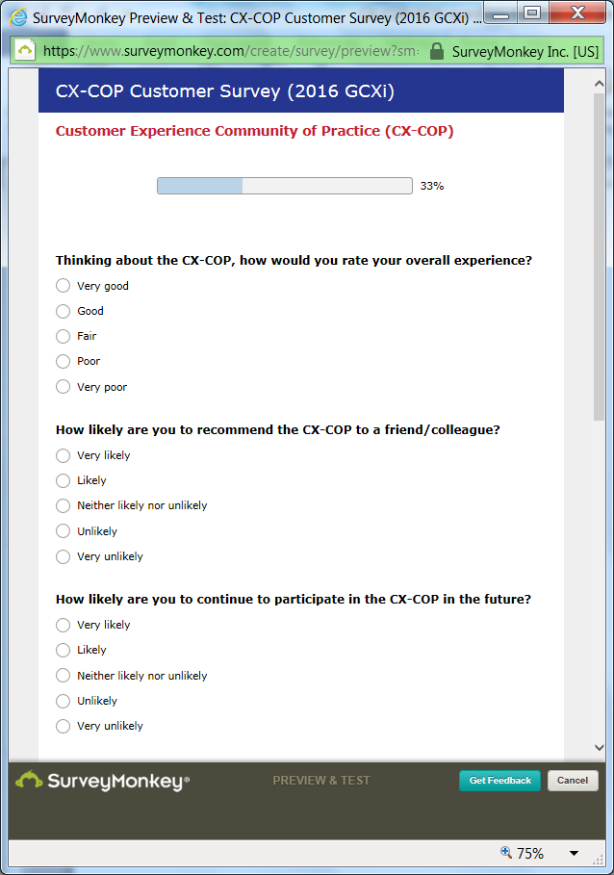

Page 2, cont.

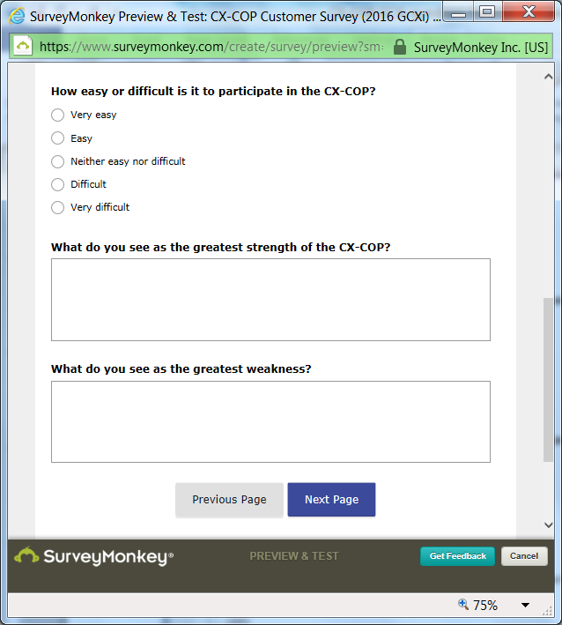

PAGE 3

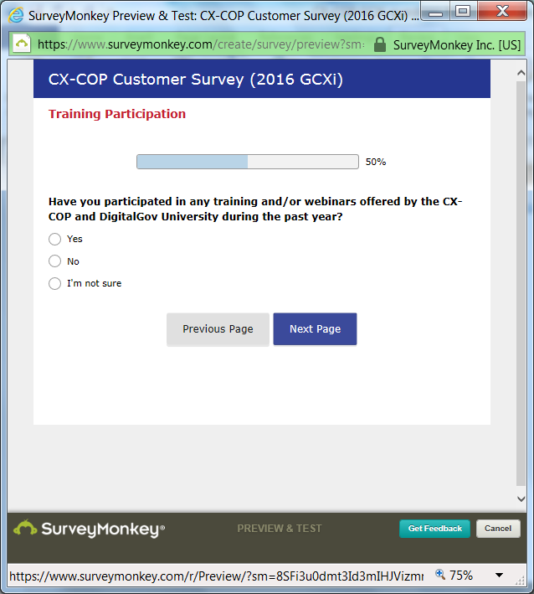

[Note: If the response is “Yes,” the user will be taken to page 3a; if the response is “No” or “Not Sure,” they will be taken to Page 4.]

PAGE 3a

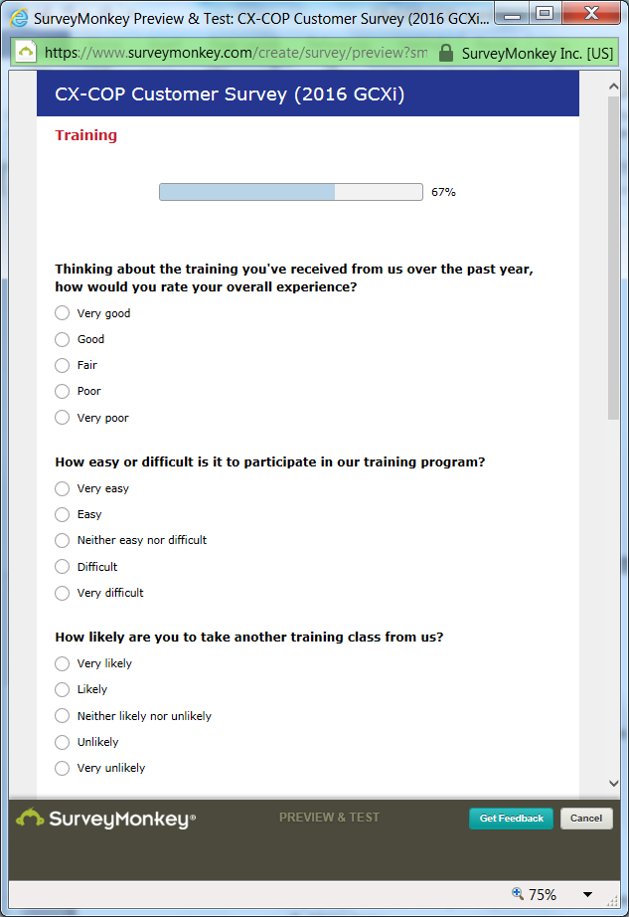

PAGE 3a, cont.

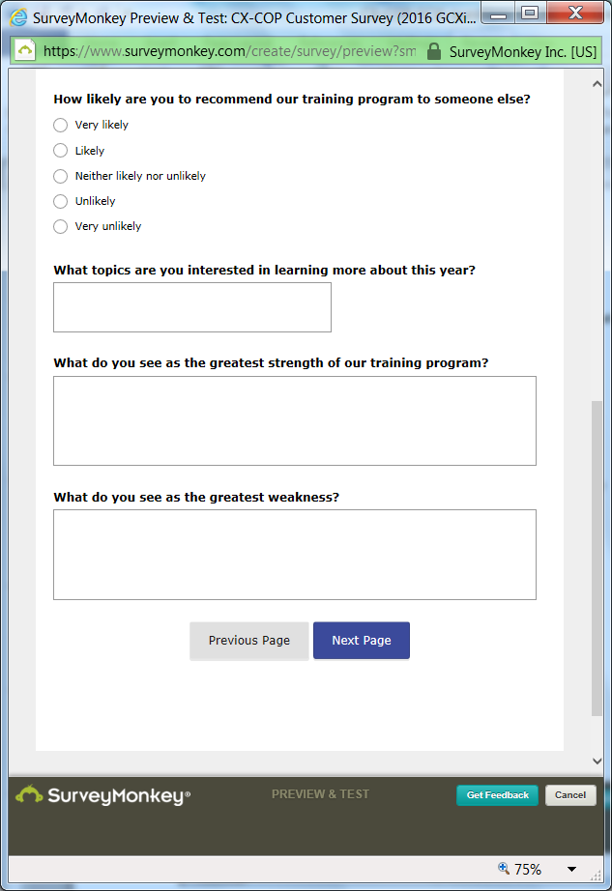

PAGE 4

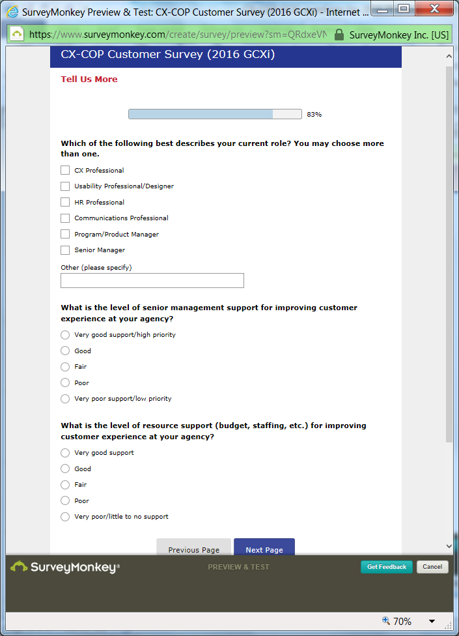

PAGE 5

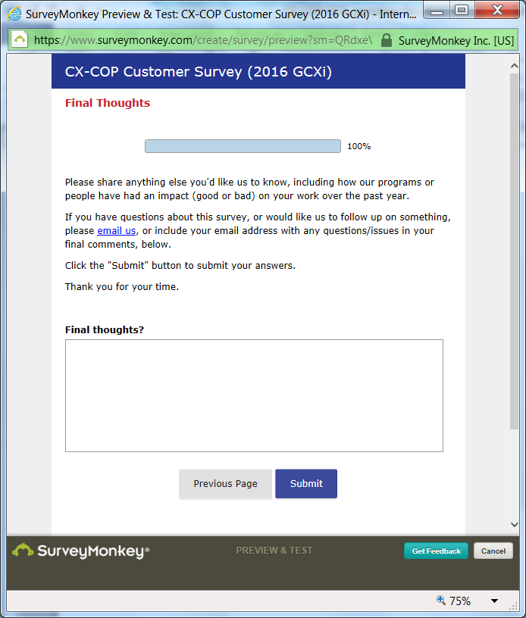

Survey End

[Note: After participants click the “submit” button, they will be taken to the DigitalGov.gov homepage.]
