December XX, 20XX

Dear Sir/Madam,

The U.S. Department of Agriculture’s (USDA) National Agricultural Statistics Service (NASS) is the primary data collection agency of agricultural information for the Federal Government. NASS is a non-regulatory, statistical agency, whose primary mission is to collect and publish summarized data for use by farmers, universities, legislators, agri-businesses, lending institutions, grower’s associations, etc.

NASS is currently conducting a national survey to identify potential agricultural activities in the United States and to gather basic agricultural information. Known as the National Agricultural Classification Survey, this form provides a basis for identifying agricultural activities.

Participation in the National Agricultural Classification Survey is voluntary and will help ensure that data on agricultural production and practices in your community and across the nation are as complete and accurate as possible. It will also allow NASS to increase coverage of under-represented populations.

We ask that you complete and return the survey form even if you are not actively farming, ranching, or conducting any other type of agricultural activity. For your convenience, you can also fill out the questionnaire online using the instructions on the back. Your response helps ensure that U.S. agriculture is represented accurately.

NASS safeguards the privacy of all respondents and ensures that no individual respondent or operation can be identified from the data we publish. Your responses will be kept confidential as required by federal law under Title 7 and CIPSEA.

We value your input and look forward to your participation in making the National Agricultural Classification Survey a success. To learn more about NASS and surveys we conduct, please visit http://www.nass.usda.gov/.

Sincerely,
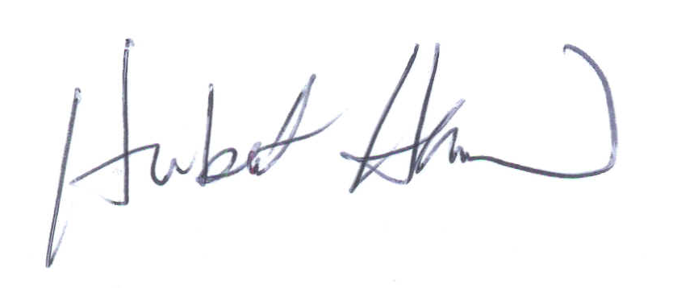
Hubert Hamer
Chair, Agricultural Statistics Board

Enclosure (1)

