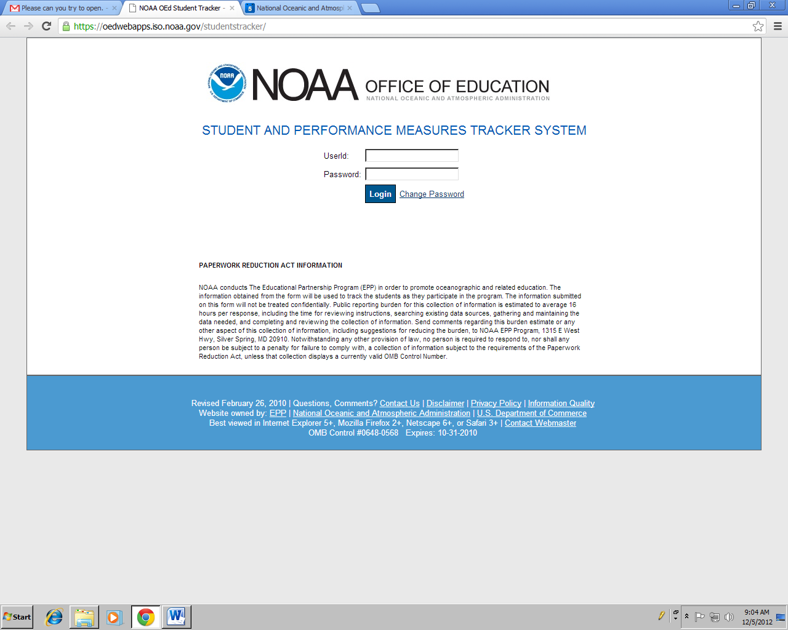

**Login Page**

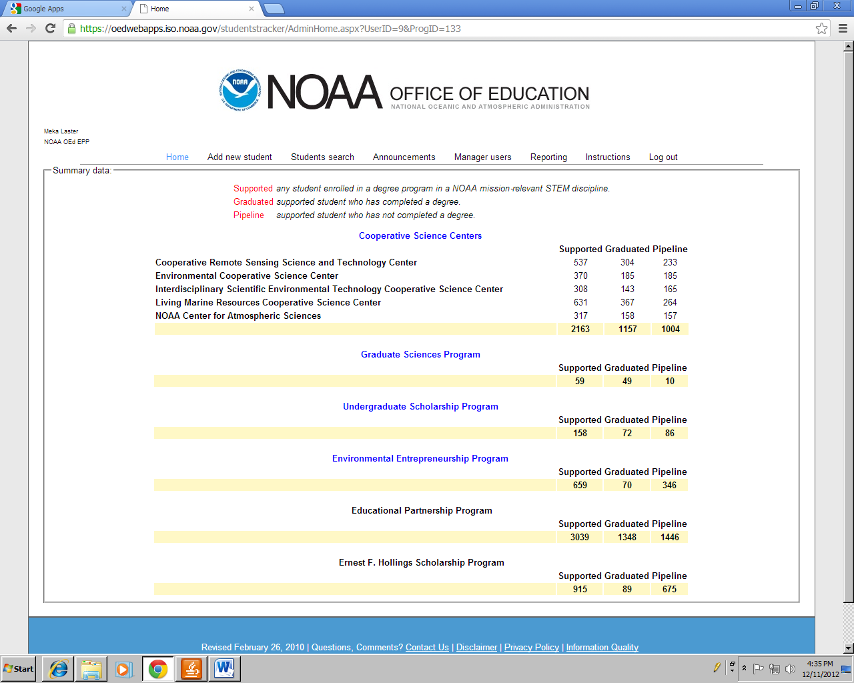

**Summary Data**

**(First Page)**

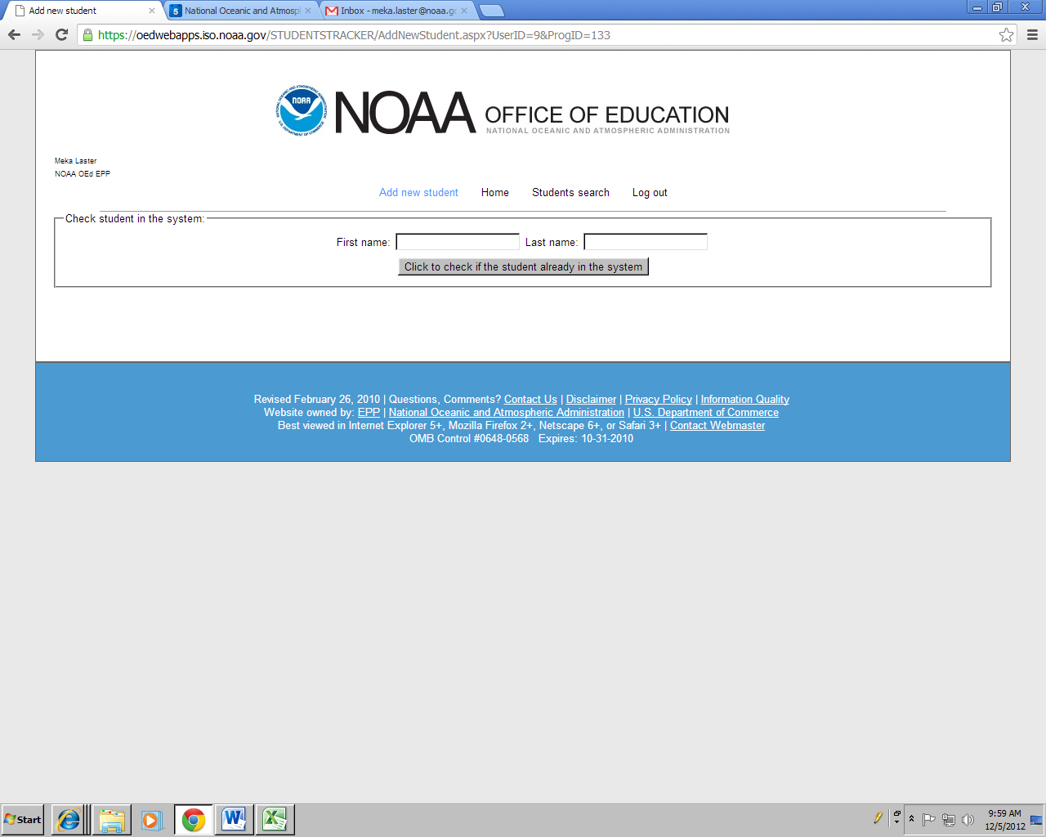

**Add new student**

**(First page – top of page)**

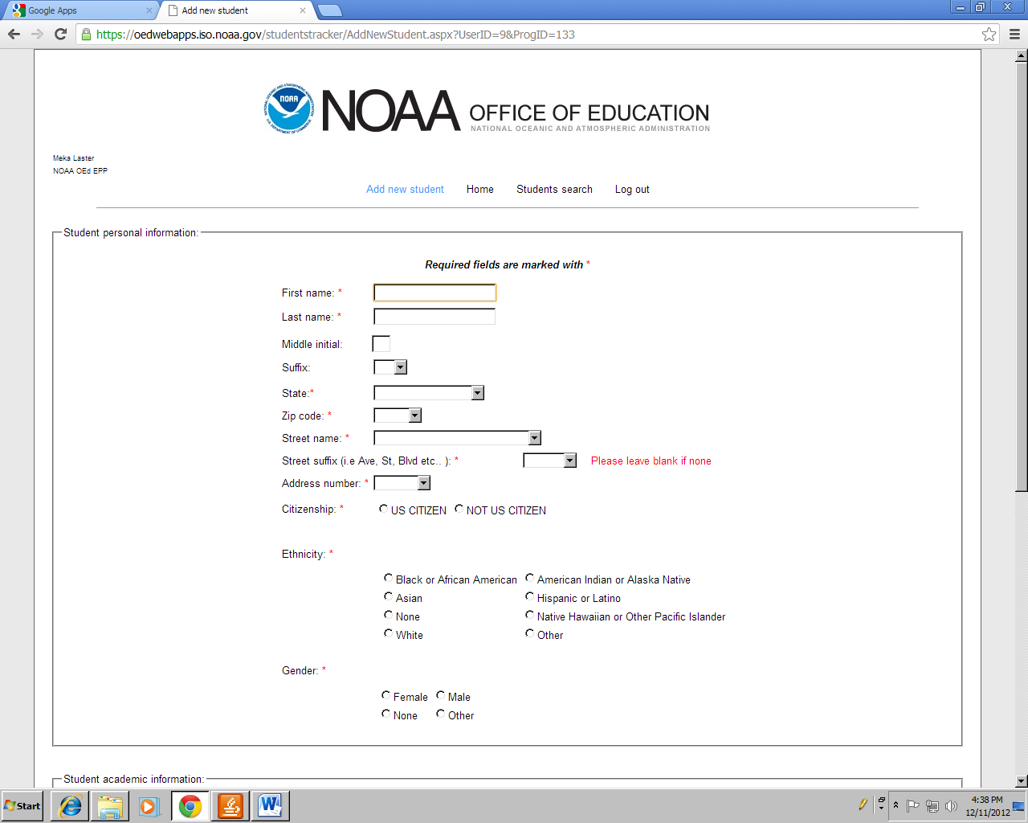

**Add new student**

**(Second page – top of page)**

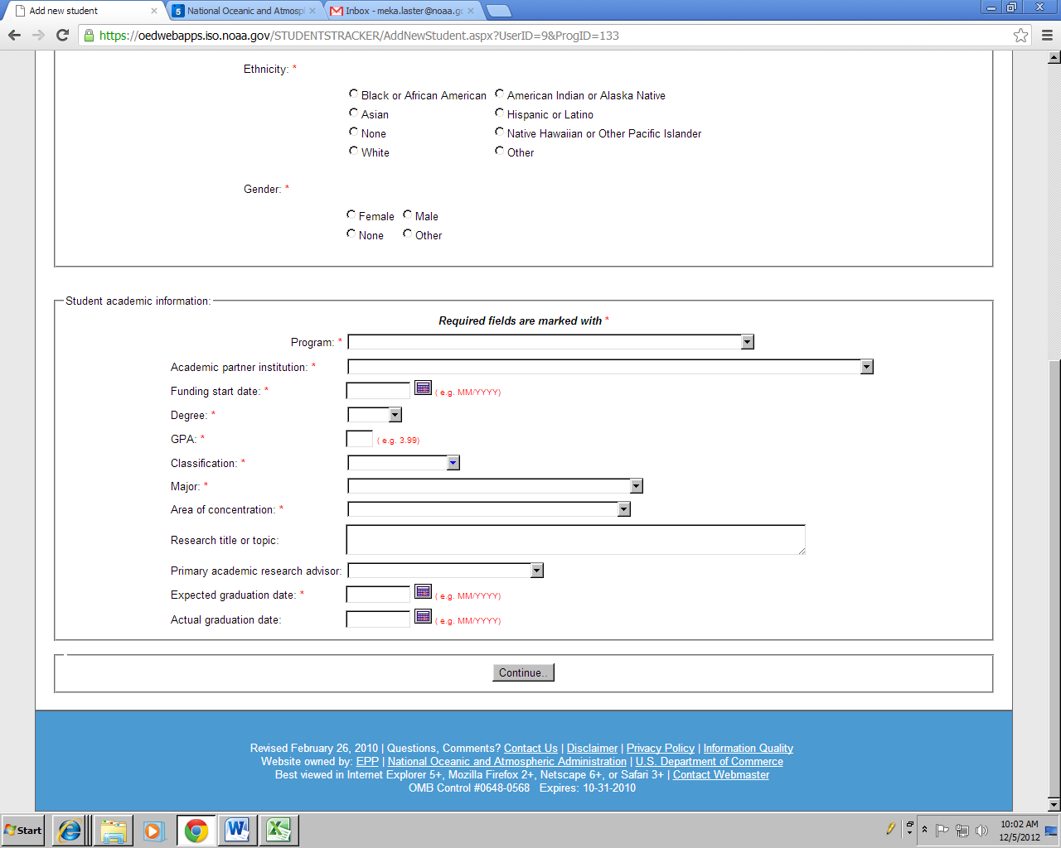

**Add new student**

**(Second page – bottom of page)**

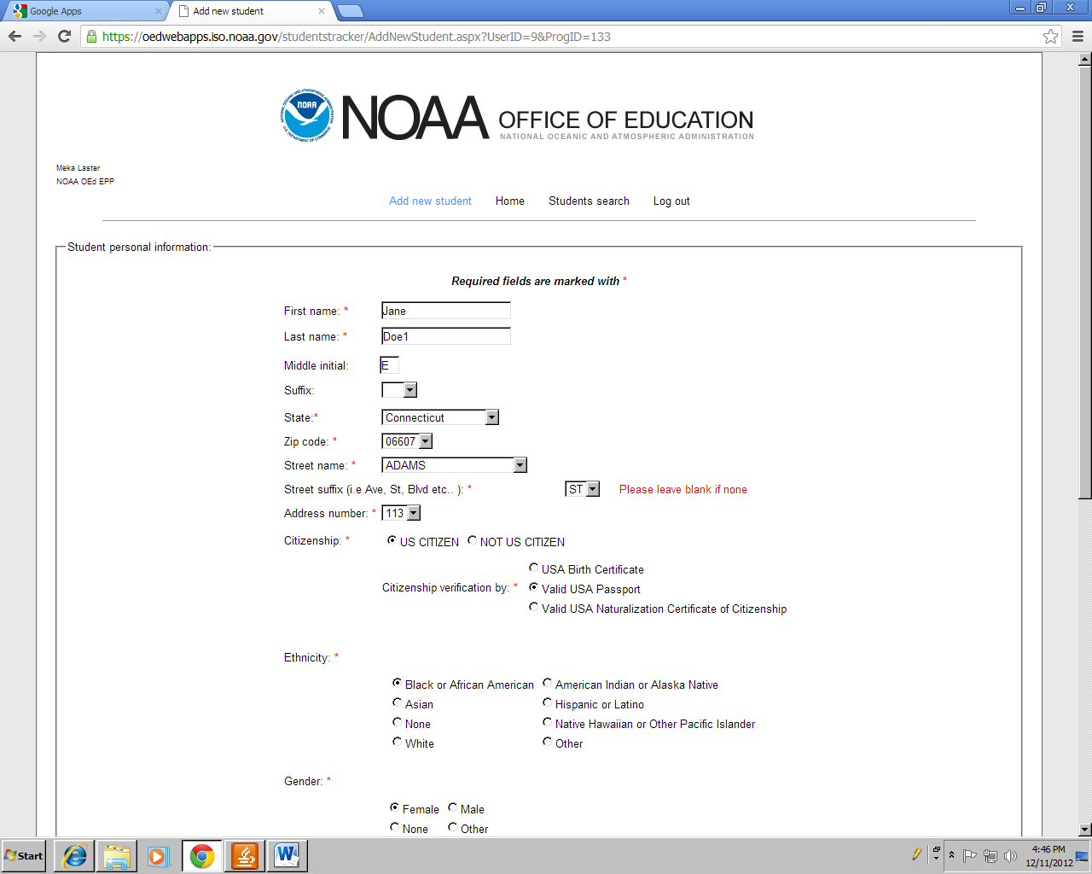

**Add new student**

**(Second page – bottom of page)**

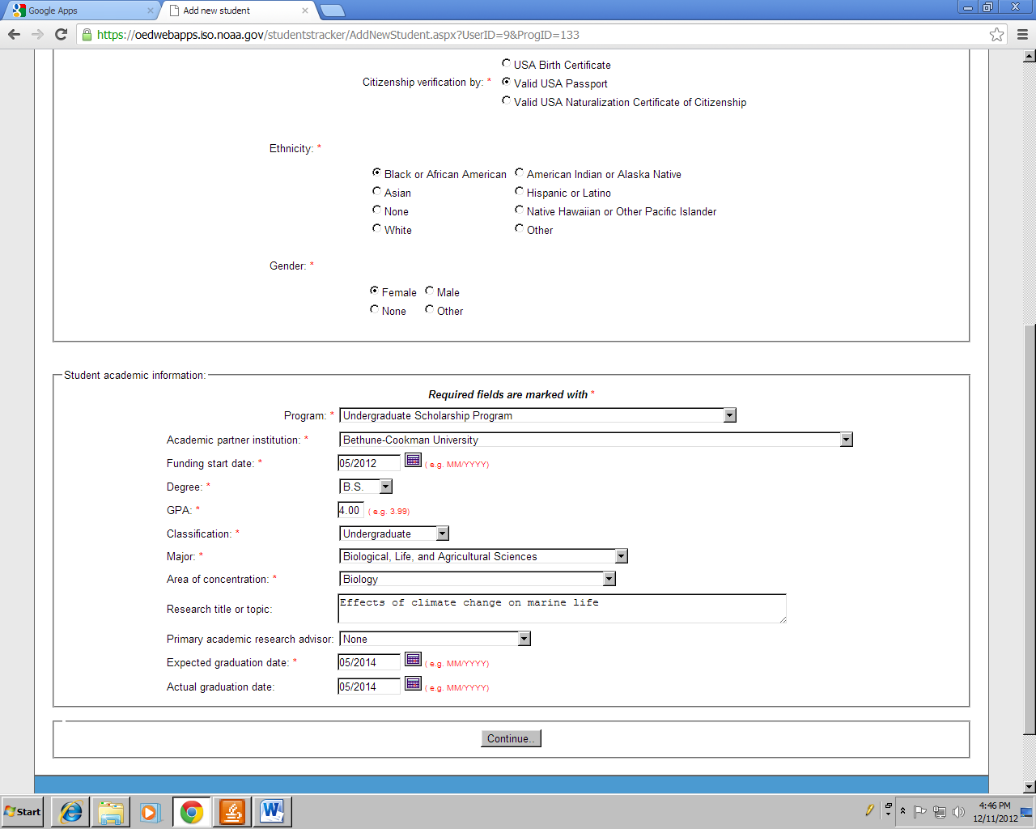

**Add new student**

**(Second page – bottom of page)**

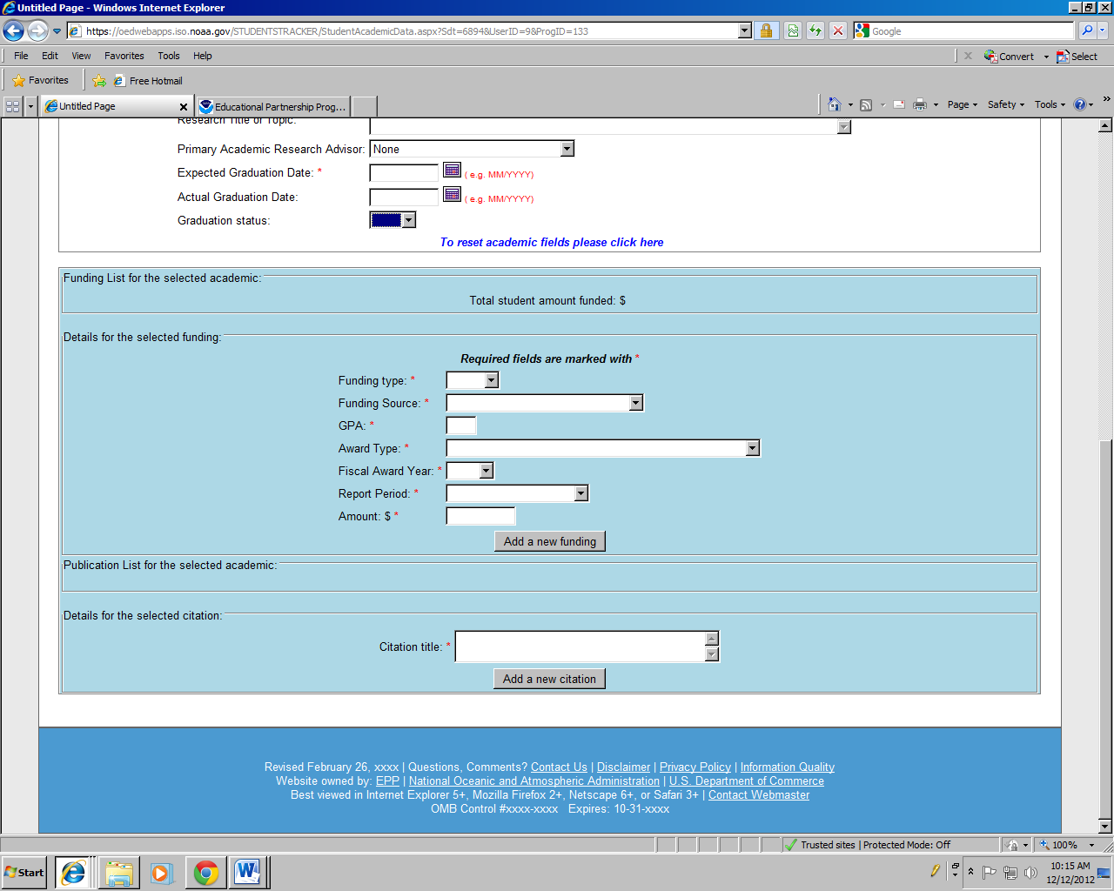

**Add new student**

**(Funding list for each academic)**

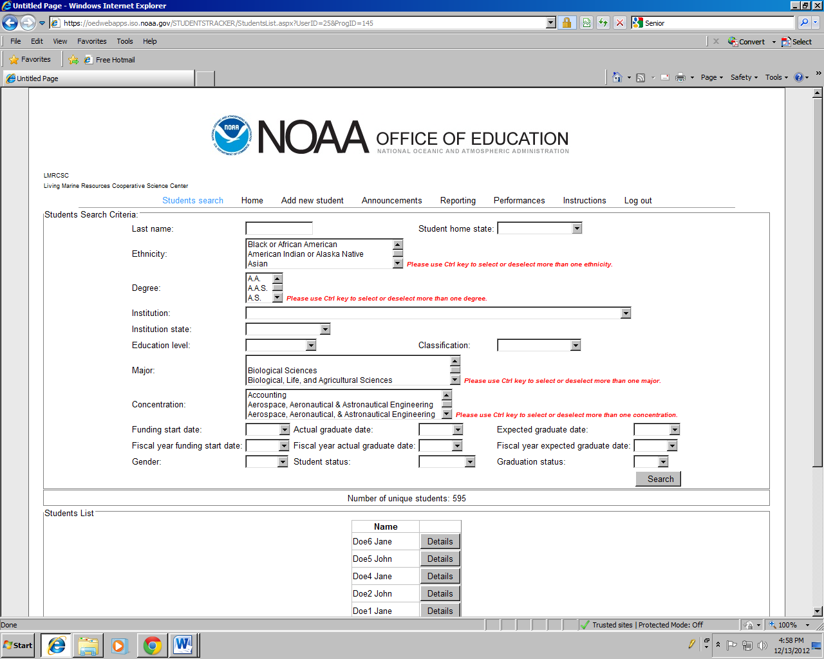

**Student Search**

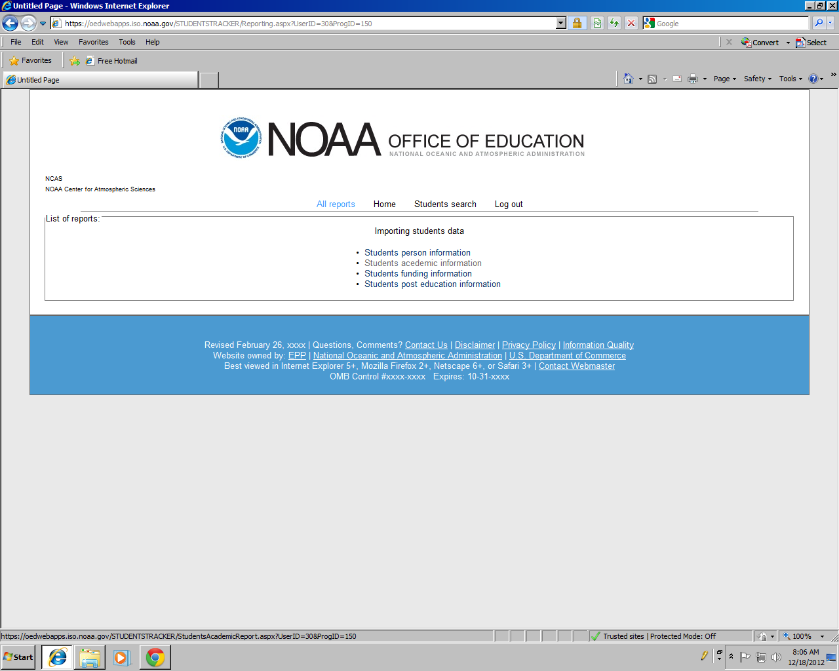

**Reporting**

**(Program Coordinator Role)**

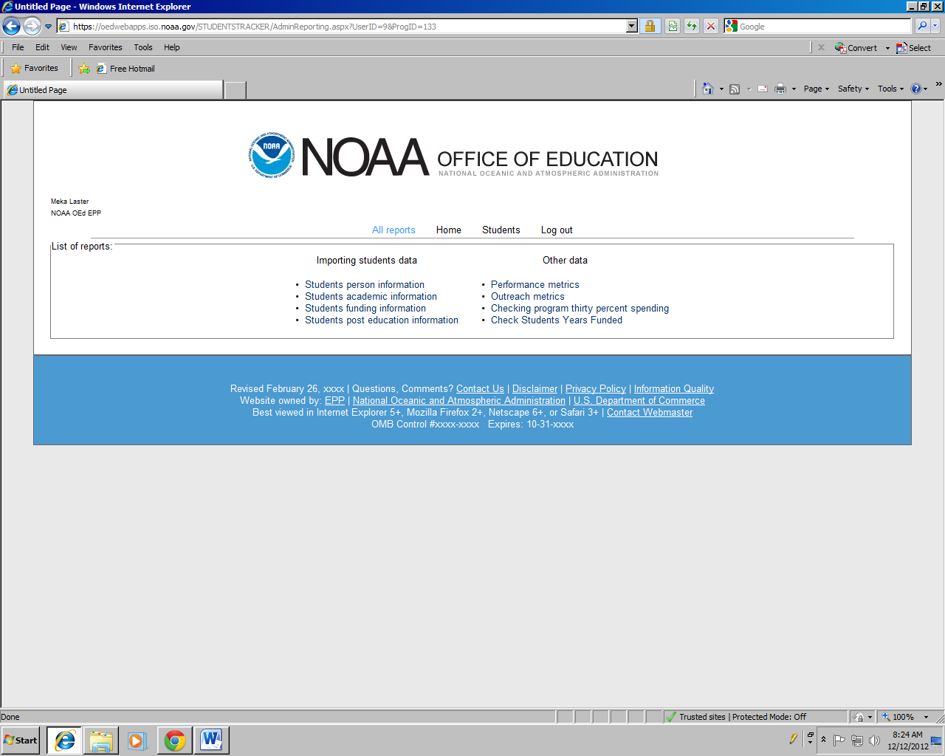

**Reporting**

**(Administrator Role)**

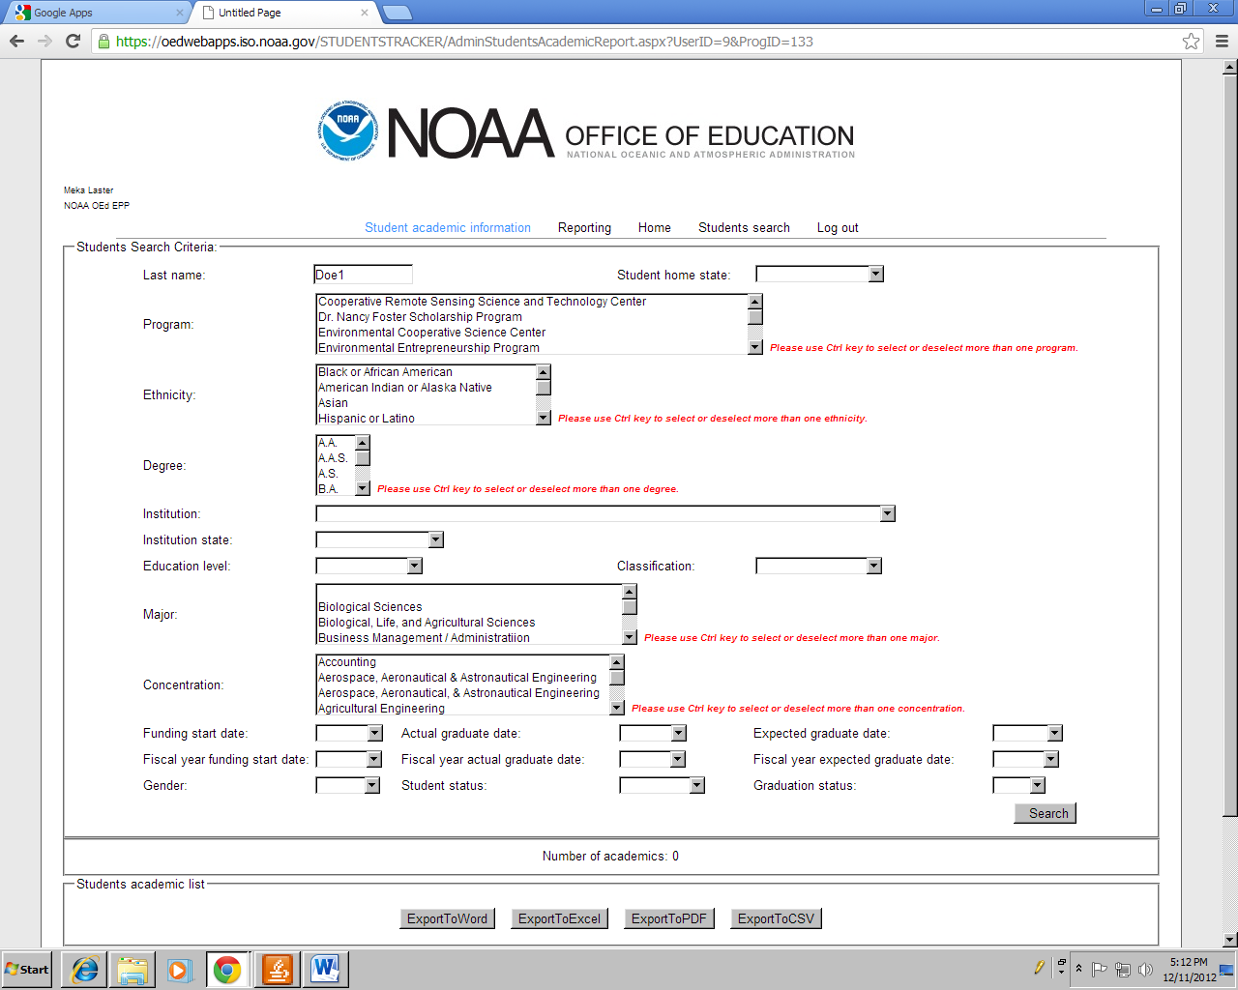

**Reporting**

**Student academic information**

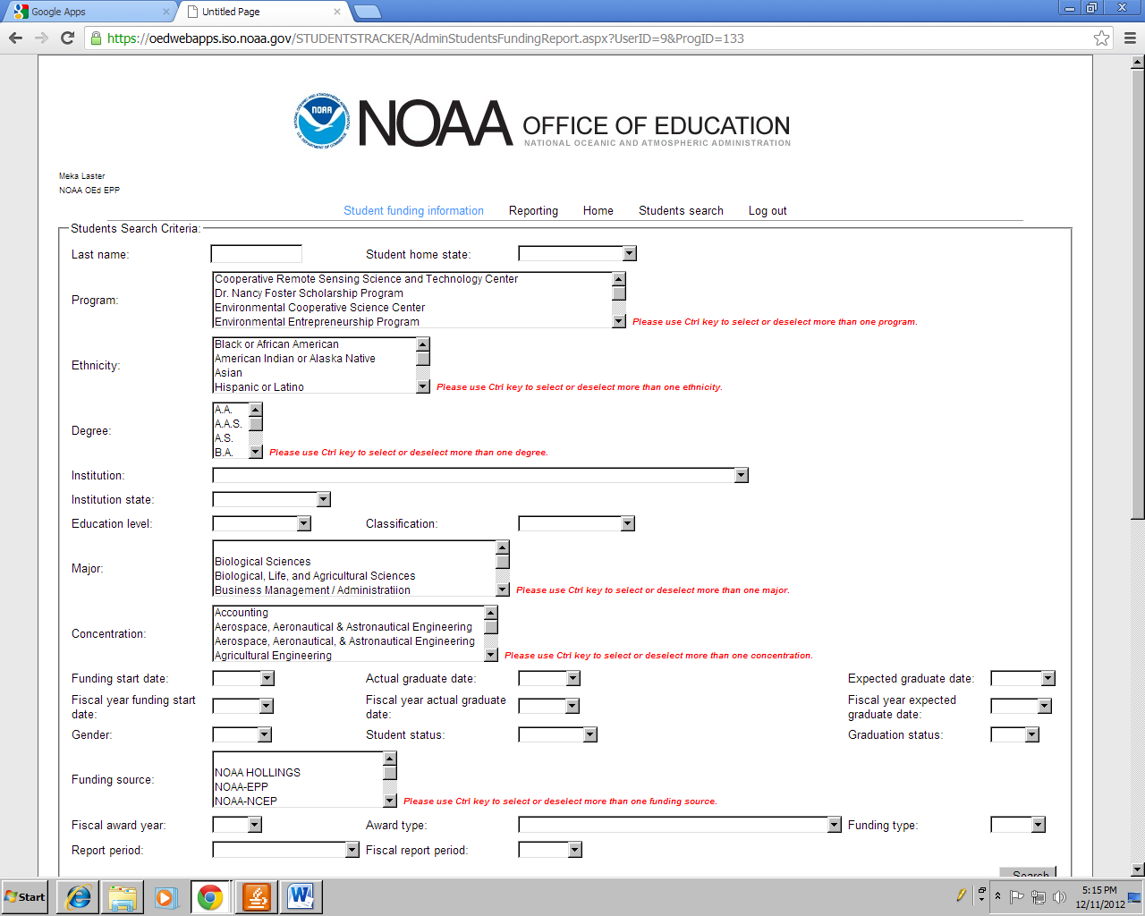

**Reporting**

**Student funding information**

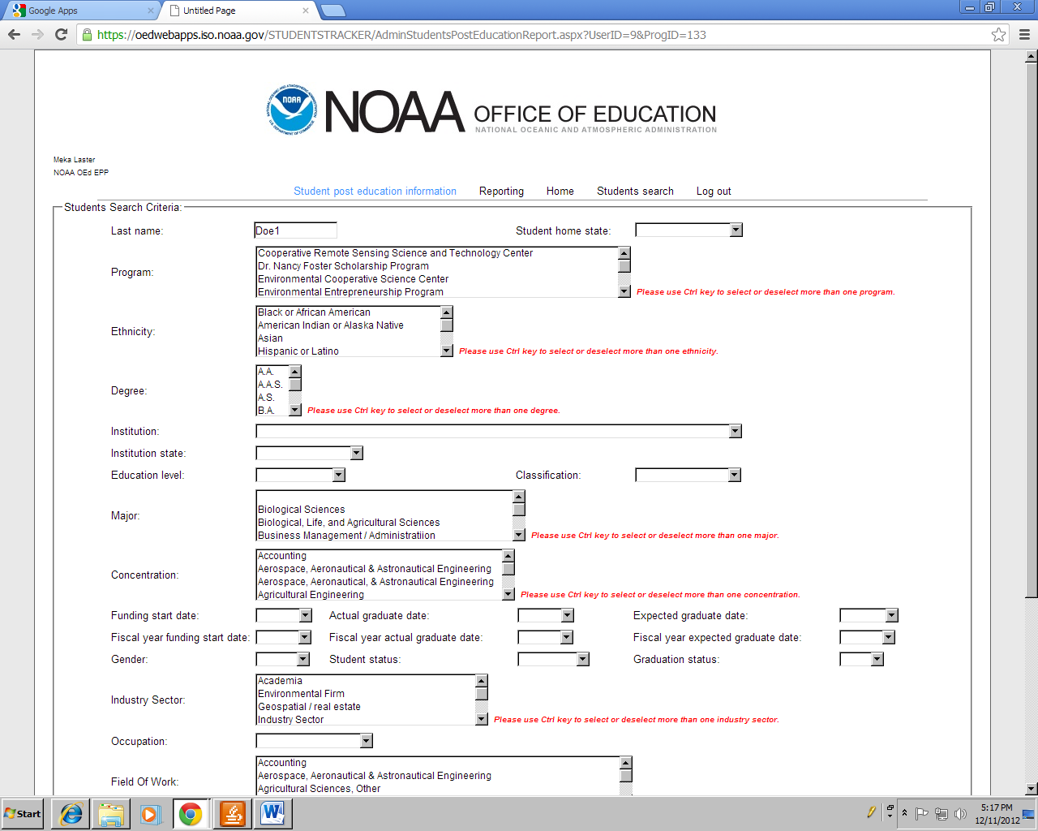

**Reporting**

**Student funding information**

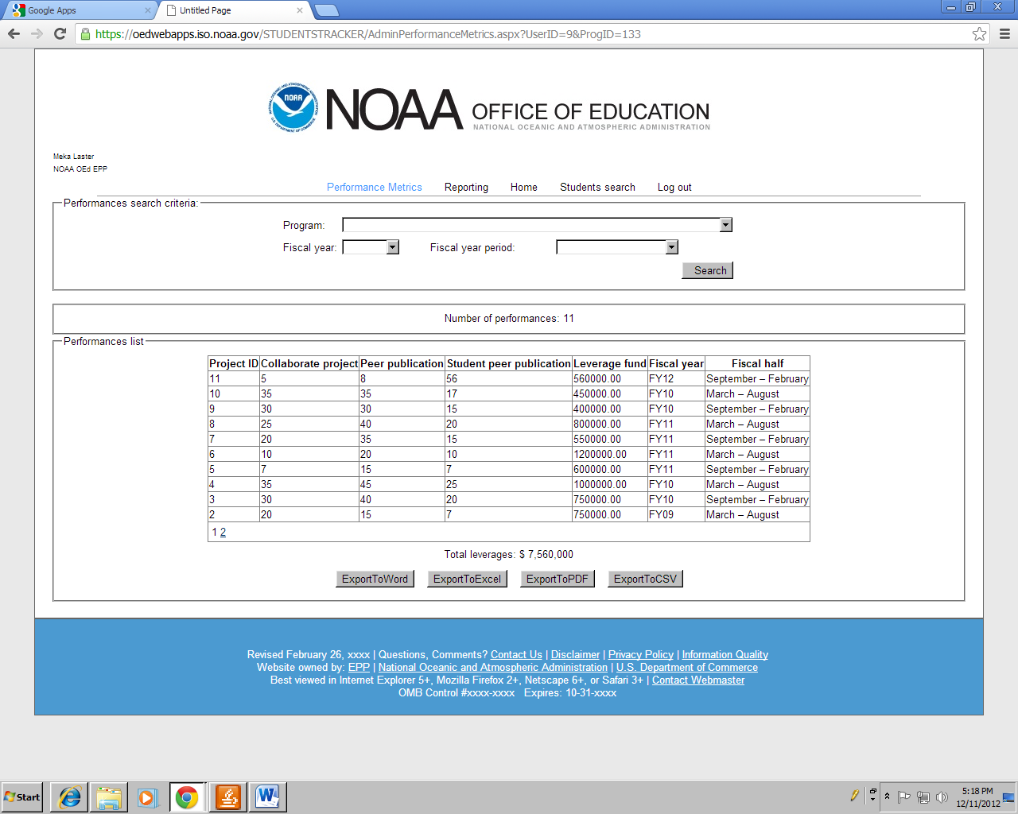

**Reporting**

**Performance Metrics**

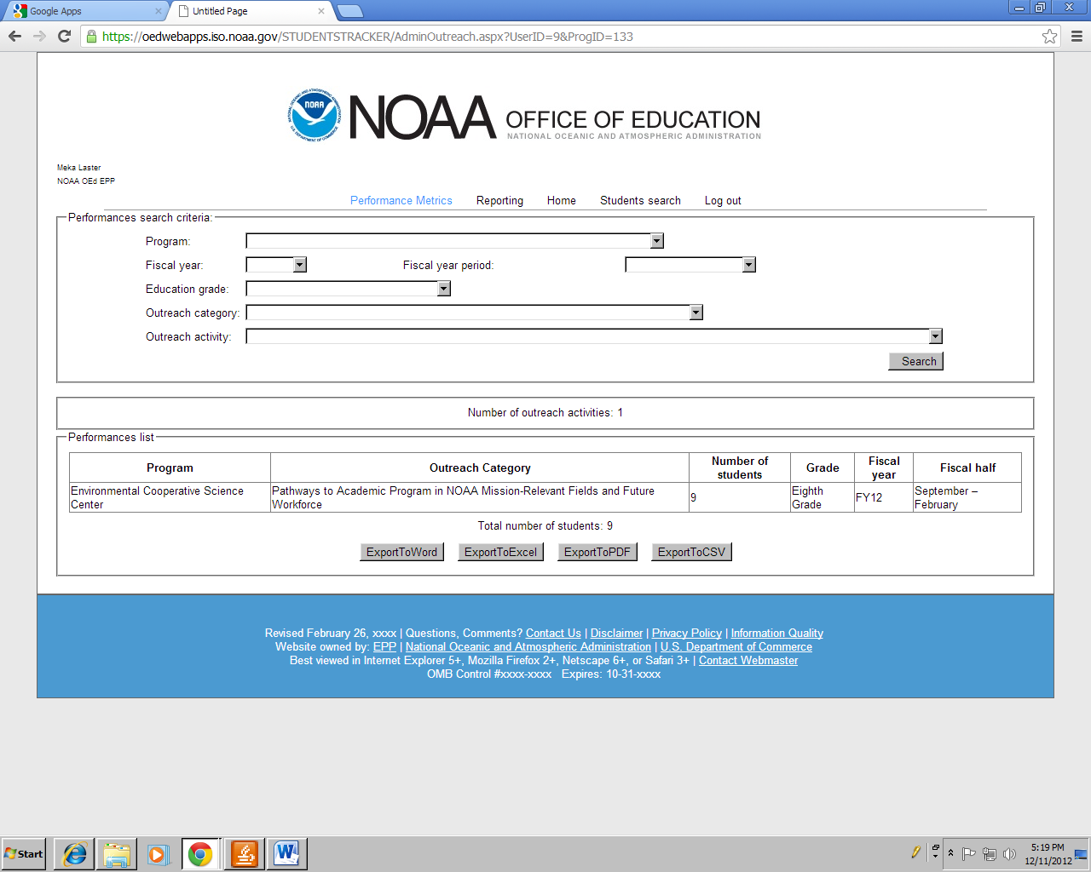

**Reporting**

**Outreach Metrics**

**(Administrator Role)**

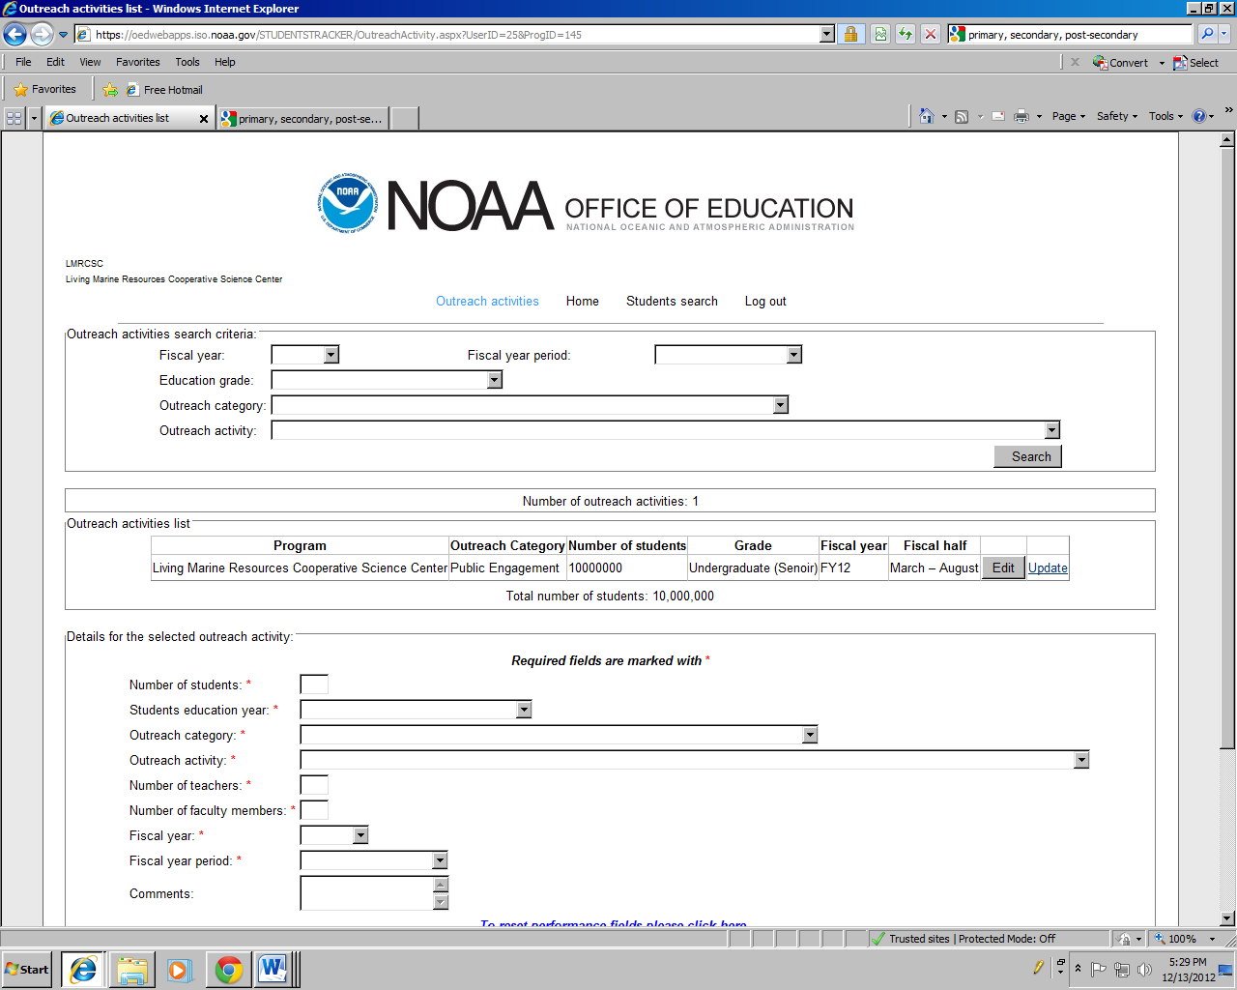

**Reporting**

**Outreach Metrics**

**(Program Coordinator Role)**

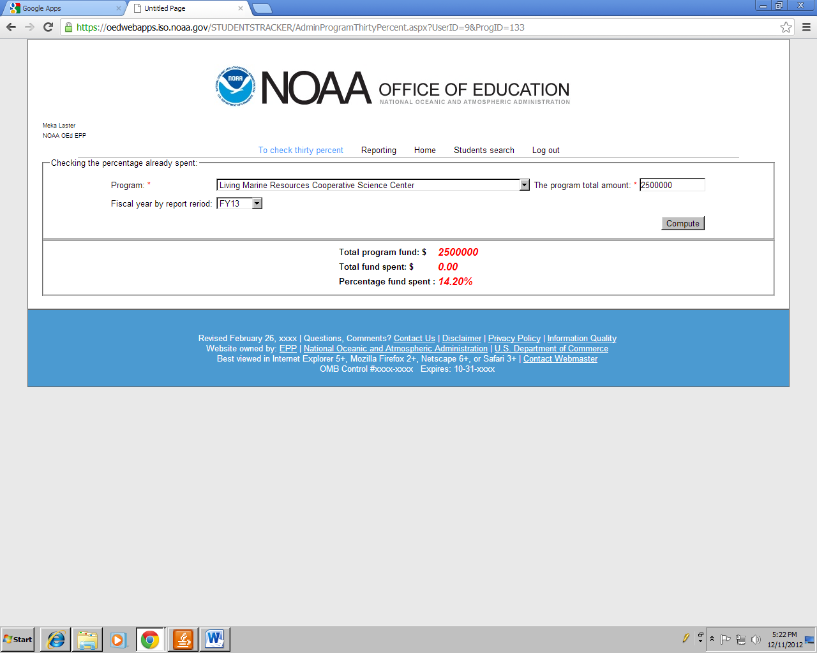

**Reporting**

**Check thirty percent program spending**