Date: Day, Month, Year
Point of Contact, Title
Company Name, Phone
Street Address, State, Zip Code

Attention Point of Contact,

Dear Point of Contact:

The Bureau of Industry and Security (BIS), Office of Technology Evaluation is conducting a specialized survey in support of a Diminishing Manufacturing Sources and Material Shortages (DMSMS) Cost Resolution Values assessment. An earlier Cost Resolution Values survey was conducted in 2008. The Defense community and industry have recently developed renewed solution categories. This survey will be used to: 1) validate the solution categories being used, and 2) determine the cost of each solution category used. The final results of this survey, once reviewed and analyzed, will be aggregated and distributed as a resource document to the entire DMSMS community.

Your company/organization has been identified by the sponsoring DMSMS Working Group as maintaining a DMSMS program for a defense system and/or platform. Please download the Excel formatted survey and corresponding instructions at:

http://www.bis.doc.gov/DMSMS_Study

A response to this survey is required by law (50 U.S.C. app. Sec. 2155). Failure to respond can result in a maximum fine of $10,000, imprisonment of up to one year, or both. Information furnished herewith is deemed confidential and will not be published or disclosed except in accordance with Section 705 of the Defense Production Act of 1950, as amended (50 U.S.C App. Sec. 2155). Such information also is protected from disclosure from Freedom of Information Act requests.

Please remember that your organization, whether it be part of a for-profit company, Federally Funded Research and Development Corporation (FRDC), non-profit, academic institution or U.S. Government military or civilian entity, is required by Federal Law (50 U.S.C. App Sec 2155) to complete and submit this survey by Day, Month, Year (30 calendar days from the mailing date above).

If you have any questions regarding the survey, please e-mail DMSMS_Study@bis.doc.gov, or contact Matt Sigmund at 202-482-0634 or Intern Name at 202-482-XXXX. Please contact me at 202-482-4060 if you have any questions regarding the overall DMSMS Cost Resolution Values project.

Thank you for your participation.

Sincerely,

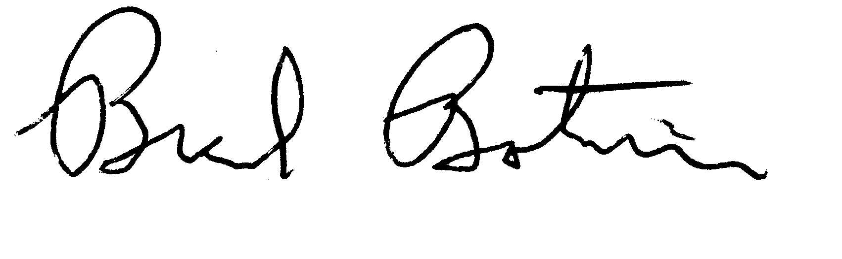
Brad Botwin
Director, Industrial Studies
Office of Technology Evaluation

