Attachment 10

Form Name: Phase II Section Foreman Form
Form Approved
OMB No. 0920-0843
Exp. Date xx/xx/20xx

Mine Name: ___________
Full Study Section Foreman Subject ID: _______________
Section Number: ____
Phone #: _________________________

ENVIRONMENT
(NOTE: these questions are to be asked to each section foreman on a monthly basis via a conference call; please instruct the section foreman that all of the following questions pertain to conditions over the past month.)

- How many working faces do you currently have at your mine (please enter)?___________

- What is the mining height of your section at the face (please enter)?____________

- How would you describe your mine floor conditions at the face (please circle)?

        - Extremely wet/standing water
        - Extremely dry/no mud whatsoever
        - Thick mud
        - Slightly muddy
        - Alternating between muddy and dry depending on the day/week
        - Mostly dry
        - Completely dry
        - Rocky
        - Smooth
        - Soft
        - Other (please specify) ___________________________________

- How much rock is spalling (i.e. breaking into chips or fragments) off from the roof and/or rib (please circle)?

        - None
        - Very little
        - Some
        - A lot

Public reporting burden of this collection of information is estimated to average 10 minutes per response, including the time for reviewing instructions, searching existing data sources, gathering and maintaining the data needed, and completing the collection of information. An agency may not conduct or sponsor, and a person is not required to respond to a collection of information unless it displays a currently valid OMB control number. Send comments regarding this burden estimate or any other aspect of this collection of information, including suggestions for reducing this burden to CDC/ATSDR Information Collection Review Office, 1600 Clifton Road NE, MS D-74, Atlanta, Georgia 30333; ATTN: PRA (0920-0843).
- Referring to your roof control plan

    - What are the length of the bolts you are using (please write down all bolt lengths)?

____________________________________________________________
____________________________________________________________
____________________________________________________________
____________________________________________________________

    - What types of supplemental supports are you using (place an “x” under the answer for each type of support)?

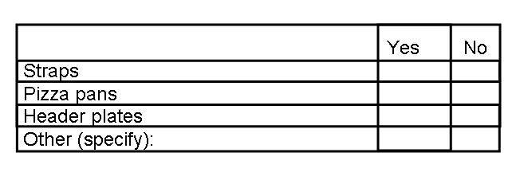

- What types of floor and roof material have you dealt with over the past month (please circle all that apply)?

        - Shale
        - Sandstone
        - Other (please specify) _______________________

- What conditions have changed in your section in the past month (please circle all that apply)?

        - None
        - Type of surrounding rock
        - Roof control plan
        - Quality of roof
        - Amount of wetness
        - Seam height
        - Now have undulating ground conditions
        - Now have non-undulating ground conditions
        - Other (please specify) _______________________

- Is the floor level or does it have a dip or pitch (please circle)?

        - Level
        - Dip or pitch

