Form Approved
OMB# 0920-0338
Expiration Date: 04/31/2011
«Name»
«Company»
«Address_1»
«Address_2»
«City_State_Zip»

Dear «Salutation»:

This letter is to notify you that the Centers for Disease Control and Prevention (CDC) has begun processing the Ingredient Report recently submitted by you on «date», on behalf of «Company». As you know, 15 U.S.C. §4403(a)(A) of the Comprehensive Smokeless Tobacco Health Education Act provides in part that each person who manufactures, packages, or imports smokeless tobacco products shall annually provide the Department of Health and Human Services with a list of the ingredients added to tobacco in the manufacture of smokeless tobacco products as well as a specification of the quantity of nicotine contained in each product.

Based on an initial review of the submissions, CDC has noted several errors, which are summarized in the attached document. Please correct these errors and provide a written update within 60 business days. Upon receipt of your corrected Ingredient Report, CDC will complete its review of your submission and provide a final determination regarding compliance.

If you require additional assistance please contact Ruth L. Hayes, (770) 488-5743.

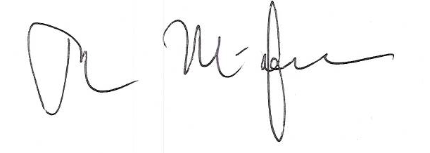
Sincerely yours,

Tim A. McAfee, MD, MPH
Director
Office on Smoking and Health
National Center for Chronic Disease Prevention and Health Promotion

Enclosure: (1)

Public reporting burden of this collection of information is estimated to average 6.5 hours per response, including the time for reviewing instructions, searching existing data sources, gathering and maintaining the data needed, and completing and reviewing the collection of information. An agency may not collect or sponsor, and a person is not required to respond to, a collection of information unless it displays a currently valid OMB control number. Send comments regarding this burden estimate or any other aspect of this collection of information, including suggestions for reducing this burden, to CDC/ATSDR Reports Clearance Officer, 1600 Clifton Road NE, MS E-11, Atlanta, Georgia 30333; ATTN: PRA (0920-0338).

