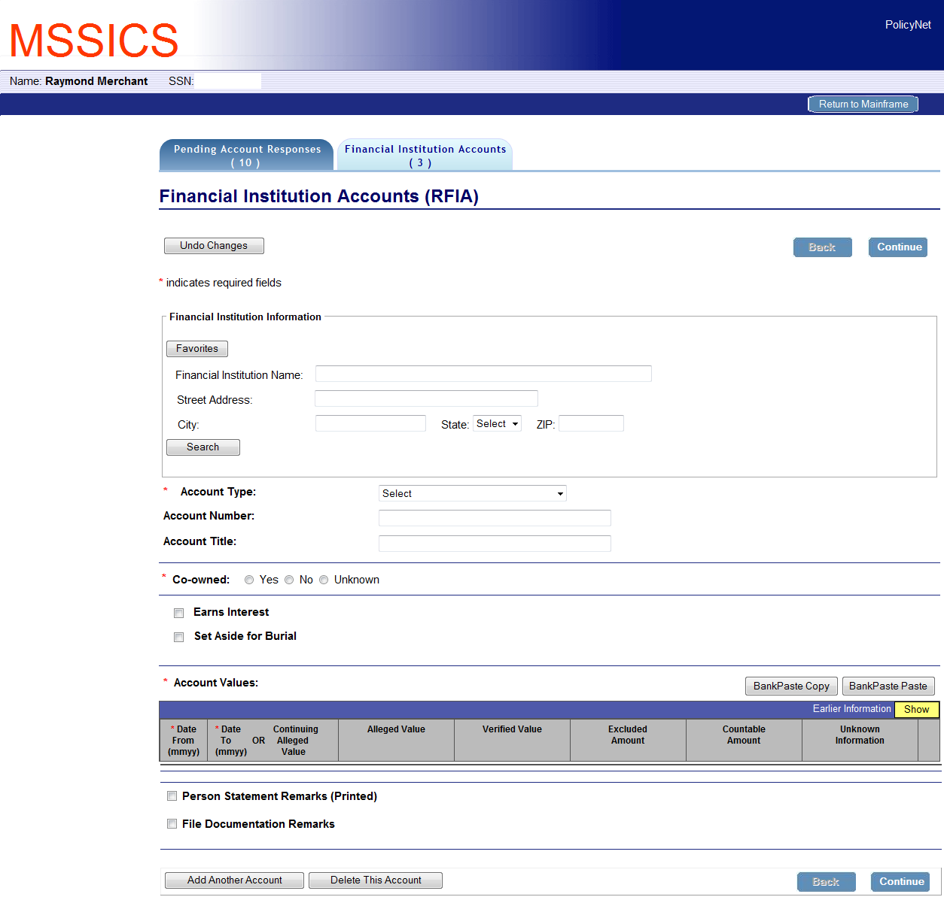
MSSICS – Financial Institution Accounts – (RFIA)

