After completing the MWR, respondent is taken to the Industry Verification description page. Here they are given a brief description of the Industry Verification, as well as a Time of Completion statement. They can select their individual UI account in order to verify the industry.
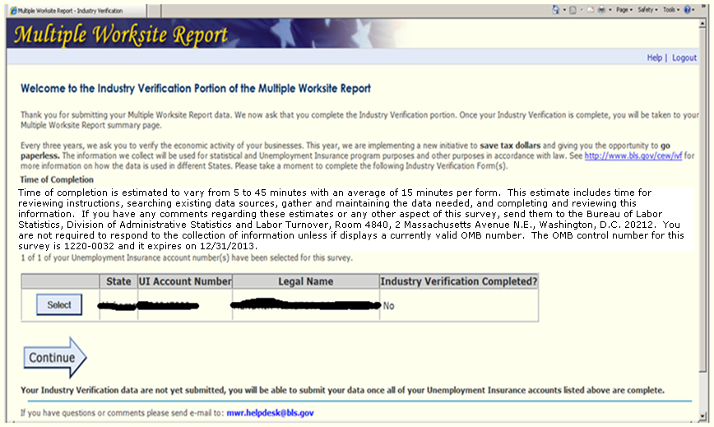

When they select a UI account, they are taken to the page with their state law and OMB number to verify their Industry Description for each worksite. The NVM paper form also asks that they verify their address, but the respondent has already verified their address through MWRWeb so it would be redundant to ask again. On this page, they can also opt out of web reporting and request a paper form.
Mandatory:
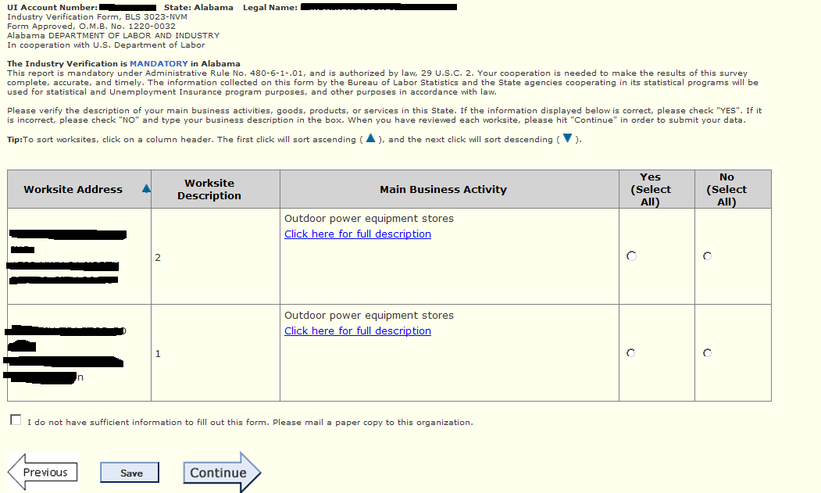
Voluntary:
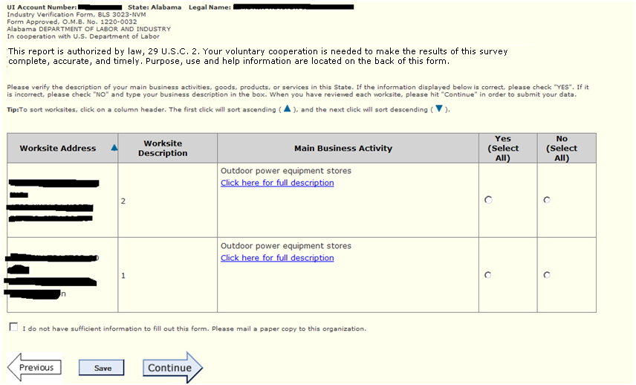

Once they complete all of the UIs, they are taken to a summary page where they can edit, view and print their data prior to submitting it to BLS.
