Appendix A
Linkages to Administrative Data Sources

A.1 Develop Linkages with Administrative Data Sources
We will develop linkages with existing data sources to supplement the Beginning Postsecondary Students Longitudinal Study (BPS:12/14) interview data. NCES recognizes the great value added to the BPS:12/14 data file with the addition of data from specific administrative data sources. Certain data (for example, specific financial aid amounts and associated dates) can only be accurately obtained from sources other than the student or parent. Through the experience of collecting data for many NCES postsecondary studies, including previous BPS studies, Baccalaureate and Beyond (B&B), and National Postsecondary Study Aid Study (NPSAS), a considerable knowledge has been gained in performing file merges with many existing sources of valuable data, including Department of Education’s (ED) Central Processing System (CPS) for Free Application for Federal Student Aid (FAFSA) data, the National Student Loan Data System (NSLDS), and ACT. For this study, we plan to perform file merges with the CPS and NSLDS datasets: CPS, NSLDS.
The Family Educational Rights and Privacy Act (FERPA; 34 CFR Part 99) allows the disclosure of information without prior consent for the purposes of BPS:12/14 according to the following excerpts: 99.31 asks “Under what conditions is prior consent not required to disclose information?” and explains in 99.31 (a) “an educational agency or institution may disclose personally identifiable information from an education record of a student without the consent required by 99.30 if the disclosure meets one or more specific conditions. BPS:12/14 collection falls under:
Sec. 99.31 (a)( 3). The disclosure is, subject to the requirements of Sec. 99.35, to authorized representatives of--
(i) The Comptroller General of the United States;
(ii) The Attorney General of the United States;
(iii) The Secretary; or
(iv) State and local educational authorities.

BPS:12/14 is collecting data under the Secretary’s authority. The personally identifiable information is collected from student record systems with adherence to the security protocol detailed in 99.35: “What conditions apply to disclosure of information for Federal or State program purposes?”

(a)(1) Authorized representatives of the officials or agencies headed by officials listed in Sec. 99.31(a)(3) may have access to education records in connection with an audit or evaluation of Federal or State supported education programs, or for the enforcement of or
compliance with Federal legal requirements that relate to those programs.
(2) Authority for an agency or official listed in Sec. 99.31(a)(3) to conduct an audit, evaluation, or compliance or enforcement activity is not conferred by the Act or this part and must be established under other Federal, State, or local authority.
(b) Information that is collected under paragraph (a) of this section must:
(1) Be protected in a manner that does not permit personal identification of individuals by anyone other than the officials or agencies headed by officials referred to in paragraph (a) of this section, except that those officials and agencies may make further disclosures of personally identifiable information from education records on behalf of the educational agency or institution in accordance with the requirements of Sec. 99.33(b); and
(2) Be destroyed when no longer needed for the purposes listed in paragraph (a) of this section.
(c) Paragraph (b) of this section does not apply if:
(1) The parent or eligible student has given written consent for the
disclosure under Sec. 99.30; or
(2) The collection of personally identifiable information is
specifically authorized by Federal law.

A.2 File Merge with ED Central Processing System (CPS)
We propose to perform file merges with the CPS data containing federal student aid application information. The merge with CPS can occur at any time for any number of cases, provided that the case has an apparently valid SSN associated with it. BPS contractor, RTI, will send a file to CPS and receive in return a large data file containing all students who applied for federal aid. The programs and procedures are already in place to prepare and submit files according to rigorous CPS standards. Similarly, programs and procedures to receive and process data obtained from CPS have also been developed.
RTI will electronically upload a file on the FAFSA secure web-site for matching. The file contains SSN and the first 2 letters of the sample member’s last name, but no other information. Access to the site for the upload is restricted to authorized users who are registered and provide identification/authentication information to the FAFSA data site. The file is retrieved by the Central Processing System or CPS (the FAFSA contractor data system) for linkage. The linked file, containing student aid applications for matched records, is then made available to RTI only through a secure connection (EdConnect) which requires username and password. All CPS files will be processed, edited, and documented for inclusion on the analytic data files. The CPS data will cover academic years beginning with 2012–2013. All CPS files will be processed, edited, and documented for inclusion in the Electronic Codebook (ECB).

A.3 File Merge with National Student Loan Data System Disbursement
RTI will also conduct a file merge with the NSLDS to collect federal loan and Pell grant data for the 2012-13 award year. The resulting file will contain cumulative amounts for each student’s entire postsecondary education enrollment. Files are transmitted using a secure connection (EdConnect) which requires username and password. Programs to create the files for the merge and also programs to read the received data already exist. All matching processes are initiated by RTI staff providing a file with one record per sample member to be merged.

Appendix B
Data Security Language for Vendor Contracts

Data Security Requirements

  - Contractor shall use data supplied to them by Company for the specific purpose included in the corresponding Statements of Work only.
  - Contractor will protect all data supplied to them by Company as specifically stated in Exhibit C, attached.
  - Unless otherwise agreed to, Contractor will promptly and properly destroy data supplied to them by Company upon the Statement of Work completion date.

EXHIBIT C
COMPANY INFORMATION SECURITY REQUIREMENTS
- Definitions.
“Business Contact Information” is defined as name, job title, department name, company name, business telephone, business fax number, and business email address.
“COMPANY Confidential Information” as defined in the Agreement.
“Information Processing System(s)” is defined as the individual and collective electronic, mechanical, or software components of CONTRACTOR operations that store and/or process COMPANY Confidential Information.
“Information Security Event” is defined as any situation where COMPANY Confidential Information is lost; is subject to unauthorized or inappropriate access, use, or misuse; the security, confidentiality, or integrity of the information is compromised; or the availability of CONTRACTOR Information Processing Systems is compromised by external attack.
“Security Breach” is defined as an unauthorized access to CONTRACTOR’s facilities, Information Processing Systems or networks used to service, store, or access COMPANY Confidential Information, provided such unauthorized access exposes COMPANY Confidential Information or provided CONTRACTOR is required to report such unauthorized access to appropriate legal or regulatory agencies or affected COMPANY members.
“Industry best practice” is defined by the information security guidelines prepared by the PCI Security Standards Council and documented in the PCI DSS requirements as well as standards and guidelines prepared by the Federal Financial Institutions Examination Council (FFIEC)
- Security and Confidentiality.
Before receiving, or continuing to receive, COMPANY Confidential Information, CONTRACTOR will implement and maintain an information security program that ensures: 1) COMPANY’s Confidential Information and CONTRACTOR’s Information Processing Systems are protected from internal and external security threats; and 2) that COMPANY Confidential Information is protected from unauthorized disclosure.
- Security Policy.
  - Formal Security Policy. Consistent with the requirement of this Attachment, CONTRACTOR will create an information security policy that is approved by CONTRACTOR’s management, published and communicated to all CONTRACTOR’s employees. Such information security policy may be reviewed by COMPANY at CONTRACTOR’s place of business pursuant to confidentiality obligations.
  - Security Policy Review. CONTRACTOR will review the information security policy at planned intervals or if significant changes occur to ensure its continuing suitability, adequacy, and effectiveness.
- Asset Management.
  - Asset Inventory. CONTRACTOR shall have the ability to identify the location of all CONTRACTOR Information Processing Systems and media containing COMPANY Confidential Information.
  - Acceptable Use. CONTRACTOR will implement rules for the acceptable use of information and assets which is no less restrictive than industry best practice and consistent with the requirements of this Attachment.
  - Equipment Use While on COMPANY Premises. While on COMPANY’s premises, CONTRACTOR will not connect hardware (physically or via a wireless connection) to COMPANY systems unless necessary for CONTRACTOR to perform Services under this Agreement. This hardware must be inspected / scanned by COMPANY before use.
  - Portable Devices. COMPANY Confidential Information, with the exception of Business Contact Information, may not be stored on portable devices including, but not limited to, laptops, external hard drives, Personal Digital Assistants, MP3 devices, and USB devices.
  - Personally-owned Equipment. COMPANY Confidential Information, with the exception of Business Contact Information, may not be stored on personally-owned equipment.
- Human Resources Security.
  - Security Awareness Training. Prior to CONTRACTOR employees receiving access to COMPANY Confidential Information, they will receive security awareness training appropriate to their job function. CONTRACTOR will also ensure that recurring security awareness training is performed.
  - Removal of access Rights. The access rights of all CONTRACTOR employees to CONTRACTOR Information Processing Systems or media containing COMPANY Confidential Information will be removed immediately upon termination of their employment, contract or agreement, or adjusted upon change.
- Physical and Environmental Security.
  - Secure Areas. CONTRACTOR will secure all areas, including loading docks, holding areas, telecommunications areas, cabling areas and off-site areas that contain Information Processing Systems or media containing COMPANY Confidential Information by the use of appropriate security controls in order to ensure that only authorized personnel are allowed access and to prevent damage and interference. The following controls will be implemented:
    - Access will be controlled and restricted by use of a defined security perimeter, appropriate security barriers, entry controls and authentication controls. A record of all accesses will be securely maintained.
    - All personnel will be required to wear some form of visible identification to identify them as employees, contractors, visitors, et cetera.
    - Visitors to secure areas will be supervised, or cleared for non-escorted accessed via an appropriate background check. Their date and time of entry and departure will be recorded.
  - Environmental Security. CONTRACTOR will protect equipment from power failures and other disruptions caused by failures in supporting utilities.
- Communications and Operations Management.
  - Protections Against Malicious Code. CONTRACTOR will implement detection, prevention, and recovery controls to protect against malicious software, which is no less than current industry best practice and perform appropriate employee training on the prevention and detection of malicious software.
  - Back-ups. CONTRACTOR will perform appropriate back-ups of CONTRACTOR Information Processing Systems and media containing COMPANY Confidential Information as required in order to ensure services and service levels described in this Statement of Work.
  - Media and Information Handling. CONTRACTOR will protect against unauthorized access or misuse of COMPANY Confidential Information contained on media by use of a media control management program and provide a copy of the program to COMPANY.
    - COMPANY input and result code data can be stored as Audit Data in a SQLServer table. All Audit Data on this SQLServer table can only be accessed for up to 180 days. After 180 days the Audit Data in the SQLServer table is automatically destroyed.
  - Media and Information Disposal. CONTRACTOR will securely and safely dispose of COMPANY Confidential Information that resides on media (including but not limited to hard copies, disks, CDs, DVDs, optical disks, USB devices, hard drives) upon the Statement of Work completion date using establishment of procedures to include, but not be limited to:
    - Disposing of COMPANY Confidential Information on media so that it is rendered unreadable or undecipherable, such as by burning, shredding, pulverizing or overwriting in compliance with DoD Standard 5220.22-M.
    - Maintaining a secured disposal log that provides an audit trail of disposal activities.
    - Purging COMPANY Confidential Information from all CONTRACTOR’s physical storage mediums (filing cabinets, drawers, et cetera.) and from all Information Processing Systems, including back-up systems, within thirty (30) days of the latest occurrence of following: upon termination of this agreement; or as soon as the COMPANY Confidential Information is no longer required to perform services under this Statement of Work.
    - Providing a Certificate of Destruction to COMPANY certifying that all COMPANY Confidential Information was purged. The certificate will be provided to COMPANY within ten (10) business days after the information was purged.
  - Exchange of Information. To protect confidentiality and integrity of COMPANY Confidential Information in transit, CONTRACTOR will:
    - Perform an inventory, analysis and risk assessment of all data exchange channels (including but not limited to FTP, HTTP, HTTPS, SMTP, modem, and fax) to identify and mitigate risks to COMPANY Confidential Information from these channels.
    - Monitor and inspect all data exchange channels to detect unauthorized information releases.
    - Ensure that appropriate security controls using approved data exchange channels are employed when exchanging COMPANY Confidential Information.
    - If COMPANY Confidential Information can only be sent to CONTRACTOR electronically, then CONTRACTOR must employ industry standard encryption security measures (minimum standard of NIST’s FIPS 140-2) to encrypt COMPANY Confidential Information prior to transmitting via the Internet. Otherwise, COMPANY Confidential Information can only be sent to CONTRACTOR using an encrypted (minimum standard NIST’s FIPS 140-2) CD-ROM sent via courier service with a tracking number.
    - Ensure that information (including persistent cookies) about COMPANY customers, members or employees is not harvested by CONTRACTOR web pages except for purposes of this Agreement.
  - Monitoring. To protect against unauthorized access or misuse of COMPANY Confidential Information residing on CONTRACTOR Information Processing Systems, CONTRACTOR will:
    - Employ current industry best practice security controls and tools to monitor Information Processing Systems and log user activities, exceptions, unauthorized information processing activities, suspicious activities and information security events. Logging facilities and log information will be protected against tampering and unauthorized access. Logs will be kept for at least 90 days.
    - Perform frequent reviews of logs and take necessary actions to protect against unauthorized access or misuse of COMPANY Confidential Information.
    - At COMPANY’s request, make logs available to COMPANY to assist in investigations of security breaches.
    - Comply with all relevant legal requirements applicable to monitoring and logging activities.
    - Ensure that the clocks of all relevant information processing systems are synchronized using a national or international time source.
- Access Control.
  - User access Management. To protect against unauthorized access or misuse of COMPANY Confidential Information residing on CONTRACTOR Information Processing Systems, CONTRACTOR will:
    - Employ a formal user registration and de-registration procedure for granting and revoking access and access rights to all CONTRACTOR Information Processing Systems.
    - Employ a formal password management process.
    - Perform recurring reviews of users’ access and access rights to ensure that they are appropriate for the users’ role.
  - User Responsibilities. To protect against unauthorized access or misuse of COMPANY Confidential Information residing on CONTRACTOR Information Processing Systems, CONTRACTOR will:
    - Ensure that CONTRACTOR Information Processing Systems users follow current security practices in the selection and use of strong passwords.
    - Ensure that unattended equipment has appropriate protection to prohibit access and use by unauthorized individuals.
    - Ensure that COMPANY Confidential Information contained at workstations, including but not limited to paper and on display screens is protected from unauthorized access.
  - Network access Control. access to internal, external, and public network services that allow access to CONTRACTOR Information Processing Systems shall be controlled. CONTRACTOR will:
    - Ensure that current industry best practice standard authentication mechanisms for network users and equipment are in place and updated as necessary.
    - Ensure electronic perimeter controls are in place to protect CONTRACTOR Information Processing Systems from unauthorized access.
    - Ensure authentication methods are used to control access by remote users.
    - Ensure physical and logical access to diagnostic and configuration ports is controlled.
  - Operating System access Control. To protect against unauthorized access or misuse of COMPANY Confidential Information residing on CONTRACTOR Information Processing Systems, CONTRACTOR will:
    - Ensure that access to operating systems is controlled by a secure log-on procedure.
    - Ensure that CONTRACTOR Information Processing System users have a unique identifier (user ID).
    - Ensure that the use of utility programs that are capable of overriding system and application controls are highly restricted and tightly controlled.
    - Ensure that inactive sessions are shut down when technically possible after a defined period of inactivity.
    - Employ restrictions on connection times when technically possible to provide additional security for high risk applications.
  - Mobile Computing and Remote Working. To protect COMPANY Confidential Information residing on CONTRACTOR Information Processing Systems from the risks inherent in mobile computing and remote working, CONTRACTOR will:
    - Perform a risk assessment to identify and mitigate risks to COMPANY Confidential Information from residing on mobile computing and remote access systems.
    - Develop a policy, operational plans and procedures for managing mobile computing and remote access systems to ensure that COMPANY Confidential Information does not reside on or are used on these systems.
- Information Systems Acquisition, Development and Maintenance.
  - Security of System Files. To protect CONTRACTOR Information Processing Systems and system files containing COMPANY Confidential Information, CONTRACTOR will ensure that access to source code is restricted to authorized users who have a direct need to know.
  - Security in Development and Support Processes. To protect CONTRACTOR Information Processing Systems and system files containing COMPANY Confidential Information, CONTRACTOR will:
    - Ensure that the implementation of changes is controlled by the use of formal change control procedures.
    - Employ industry best practice security controls to minimize information leakage.
    - Employ oversight quality controls and security management of outsourced software development.
- Information Security Incident Management.

Reporting Information Security Events and Weaknesses. To protect CONTRACTOR Information Processing Systems and system files containing COMPANY Confidential Information, CONTRACTOR will, in the event that Contractor becomes aware of (or reasonably suspects) that any information and data obtained pursuant to the Services has been compromised in any manner, immediately notify Company via email or telephone call and follow-up on the incident in writing and provide all requested information about the event. For purposes of this obligation, “compromise” includes suspected or known incidents without limitation: (i) any unauthorized access to information and data obtained pursuant to the Services, (ii) any inadvertent disclosure of information and data obtained pursuant to the Services to any third party, (iii) any known or suspected misuse of information and data obtained pursuant to the Services by any person (even if such person was authorized to access such information or data), (iv) any suspected use of information and data obtained pursuant to the Services by any person outside of the scope of that person’s authority, and (v) any known or suspected alteration of information and data obtained pursuant to the Services other than as required or permitted by this Agreement.
  - Information Security Events and Security Breaches: Contractor shall
    - Implement a process to ensure that Information Security Events and Security Breaches are reported through appropriate management channels as quickly as possible.
    - Train all employees of information systems and services how to report any observed or suspected Information Security Events and Security Breaches.
    - Notify COMPANY by email (JDavismailto:@RTI.org or by phone (800-334-8571) immediately of all suspected Information Security Events and Security Breaches. Following any such event or breach, CONTRACTOR will promptly notify COMPANY as to the COMPANY Confidential Information affected and the details of the event or breach.
- Business Continuity Management.
  - Business Continuity Management Program. In order to ensure services and service levels described in this agreement, CONTRACTOR will:
    - Develop and maintain a process for business continuity throughout the organization that addresses the information security requirements needed for the CONTRACTOR’s business continuity so that the provision of products and/or services provided under the Agreement to COMPANY is uninterrupted.
    - Identify events that can cause interruptions to business processes, along with the probability and impact of such interruptions and their consequences for information security.
    - Develop and implement plans to maintain or restore operations and ensure availability of information at the required level and in the required time scales following interruption to, or failure of, critical business processes and provide COMPANY a copy of the same.
    - Test and update Business Continuity Plans regularly to ensure that they are up-to-date and effective.
- Security Assessments.
  - Initial and Recurring Security Assessments. CONTRACTOR will permit COMPANY representatives to perform an on-site physical and logical Security Assessment of CONTRACTOR’s data processing and business facilities prior to the release of COMPANY Confidential Information and each year thereafter. Security Assessments will be performed during regular business hours, at a date and time agreed to by both parties, and will not require online access to CONTRACTOR’s Information Processing Systems.
  - Security Assessments Following Information Security Events and Security Breaches. Following the occurrence of an Information Security Event or Security Breach, CONTRACTOR will permit COMPANY representatives to perform an on-site physical and logical Security Assessment of CONTRACTOR’s data processing and business facilities to assess the impact of the event or breach even if a Security Assessment has been completed within the year.
  - Security Assessment Findings. Upon completion of a Security Assessment, COMPANY will provide CONTRACTOR with a Security Assessment completion letter that summarizes COMPANY’s Security Assessment findings. These findings may identify critical security deficiencies identified as “Mandatory” that require immediate correction before COMPANY can release, or continue to release, COMPANY Confidential Information to CONTRACTOR. CONTRACTOR will implement and continue to maintain all mutually agreed upon “Mandatory” security findings. If mutual agreement to “Mandatory” security findings cannot be reached, then these issues may be escalated using the dispute resolution provisions within this Agreement

Appendix C
Full-scale Sampling Specifications
      - Introduction
For the NPSAS:12 sample design and selection, the following 5-step cost/variance optimization process was used:
- Establish precision requirements for key estimates.
- Develop institution and student sampling strata to support the key estimates.
- Develop a cost model.
- Develop a relative variance model.
- Determine the optimum sample allocation.

- Precision Requirements
The precision goal for NPSAS:12 was to achieve relative standard errors (RSEs) of 10 percent or less and comparable to or less than NPSAS:08 for key national estimates for the full population, undergraduate students, and graduate students. The key estimates are based on acquired knowledge of the NPSAS data, how the data will be used for analysis, and what data are most important. An additional precision goal for NPSAS:12 was to achieve RSEs of 10 percent or less and comparable to or less than NPSAS:04 for key national estimates for first-time beginners (FTBs). The appropriate outcomes and domains, for which precision constraints will be developed for FTBs, were determined from field test results testing new FTB items.

3. Institution Frame and Sample Selection
To be eligible for NPSAS:12 an institution was required during the 2011-12 academic year to:
- offer an educational program designed for persons who had completed secondary education;
- offer at least one academic, occupational, or vocational program of study lasting at least 3 months or 300 clock hours;
- offer courses that are open to more than the employees or members of the company or group (e.g., union) that administered the institution;
- be located in the 50 states or the District of Columbia;
- be other than a U.S. Service Academy; and
- have a signed Title IV participation agreement with the U.S. Department of Education.
Institutions providing only avocational, recreational, or remedial courses or only in-house courses for their own employees were excluded. U.S. Service Academies were also excluded because of their unique funding/tuition base.
The NPSAS:12 full-scale institution sampling frame was constructed during the field test from the IPEDS:2008–09 header, Institutional Characteristics (IC), 12-Month and Fall Enrollment, and Completions files. In order to guarantee complete data for the frame, data were imputed using the latest IPEDS imputation procedures for the small number of institutions with missing enrollment information.
As discussed earlier in the supporting materials for the forms clearance package, the NPSAS:12 field test institution sample was selected statistically, rather than purposively as had been done in past NPSAS cycles. A statistical sample would provide more control to ensure that the field test and the full-scale institution samples have similar characteristics, and would allow inferences to be made to the target population, supporting the analytic needs of the field test experiments. In order to accomplish this, NPSAS:12 also changed the process by which the institution sample was selected. Previous cycles selected the full-scale sample prior to selecting the field test sample from the complement. NPSAS:12 selected both institution samples simultaneously. First, a sample of 1,971 institutions, comprising the institutions needed for both the field test and full-scale studies, was selected from the stratified frame. Then, 300 of the 1,971 institutions were selected for the field test using simple random sampling within institutional strata. The remaining 1,671 institutions comprised the full-scale sample. Figure 1 displays the flow of institution sampling activities.
Figure 1. NPSAS:12 institution sample flow

Institutions for the initial sample were selected using sequential probability minimum replacement (PMR) sampling (Chromy 1979), which resembles stratified systematic sampling with probabilities proportional to a composite measure of size (Folsom, Potter, and Williams 1987). This is the same methodology that has been used since NPSAS:96. PMR allows institutions to be selected multiple times but, instead of allowing that to happen, all institutions with a probability of being selected more than once were instead included in the sample one time with certainty, i.e., were a certainty institution. Institution measures of size were determined using annual enrollment data from the most recent IPEDS 12-Month and Fall Enrollment Components. Using composite measure of size sampling ensured that target sample sizes would be achieved within institution and student sampling strata while also achieving approximately equal student weights across institutions.
The institution sample was freshened in order to add newly eligible institutions to the sample and produce a sample that is representative of institutions eligible in the 2011-2012 academic year. To do this, the IPEDS:2009−10 header, Institutional Characteristics (IC), 12-Month and Fall Enrollment, and Completions files were used to create an updated sampling frame of currently NPSAS-eligible institutions. This frame was then compared with the original frame, and 387 new or newly eligible institutions were identified. These 387 institutions make up the freshening sampling frame. The freshening sample size was then determined such that the freshened institutions would have similar probabilities of selection to the originally selected institutions within sector (stratum) in order to minimize unequal weights and subsequently variances; 21 freshened institutions were selected.
The 10 institutional strata used for NPSAS:12 were based on institutional level, control, and highest level of offering:
1. public less-than-2-year
2. public 2-year
3. public 4-year non-doctorate-granting
4. public 4-year doctorate-granting
5. private nonprofit less-than-4-year
6. private nonprofit 4-year non-doctorate-granting
7. private nonprofit 4-year doctorate-granting
8. private for-profit less-than-2-year
9. private for-profit 2-year
10. private for-profit 4-year.
Although prior NPSAS administrations aggregated private for-profit 2-year and 4-year institutions into one sampling strata, for NPSAS:12 the two were split into separate strata to reflect the recent growth in enrollment in for-profit 4-year institutions.
When data collection is complete, an overall 99 percent eligibility rate among sampled institutions should be reached. The institutional response rate is expected to be about 85 percent. The eligibility and response rates will likely vary by institutional strata. Based on these expected rates, the institution sample sizes and estimated sample yield by the ten institutional strata are presented in table 1.
Within each institutional stratum, additional implicit stratification for the full-scale was accomplished by sorting the sampling frame within stratum by the following classifications: (1) historically Black colleges and universities (HBCU) indicator; (2) Hispanic-serving institutions (HSI) indicator (3) Carnegie classifications of postsecondary institutions; (4) the Office of Business Economics (OBE) Region from the IPEDS header file (Bureau of Economic Analysis of the U.S. Department of Commerce Region); (5) state and system for states with large systems, e.g., the SUNY and CUNY systems in New York, the state and technical colleges in Georgia, and the California State University and University of California systems in California; and (6) the institution measure of size. The objective of this implicit stratification was to approximate proportional representation of institutions on these measures.
Table 1. NPSAS:12 full-scale institution sample sizes and estimated yield
Institutional sector | Frame count¹ | Number sampled | Number eligible | List respondents
Total | 7,052 | 1,692 | 1,672 | 1,416
Public
Less-than 2-year | 271 | 22 | 19 | 14
2-year | 1,108 | 381 | 381 | 335
4-year non-doctorate-granting | 356 | 130 | 130 | 117
4-year doctorate-granting | 309 | 230 | 230 | 200
Private
Nonprofit less-than-4-year | 263 | 20 | 20 | 17
Nonprofit 4-year non-doctorate-granting | 1,031 | 260 | 260 | 218
Nonprofit 4-year doctorate-granting | 555 | 221 | 221 | 183
For-profit less-than-2-year | 1,513 | 55 | 52 | 41
For-profit 2-year | 1,028 | 115 | 111 | 90
For-profit 4-year | 618 | 258 | 248 | 201
¹ Institution counts based on IPEDS:2008-09 and IPEDS:2009-10 header files.

Table 2. NPSAS:12 preliminary student sample sizes and yield
Institutional sector | Sample students |  |  |  | Eligible students |  |  |  | Interview Respondents |  |  |  | Responding students per responding institution
Institutional sector | Total | FTBs | Other undergraduate Students | Graduate students | Total | FTBs | Other undergraduate students | Graduate students | Total | FTBs | Other undergraduate students | Graduate students | Responding students per responding institution
Total | 124,644 | 45,413 | 63,497 | 15,735 | 118,748 | 43,068 | 60,396 | 15,283 | 83,124 | 31,045 | 41,746 | 10,333 | 59
Public
Less-than 2-year | 1,279 | 717 | 563 | 0 | 1,036 | 580 | 456 | 0 | 623 | 366 | 257 | 0 | 45
2-year | 41,304 | 14,822 | 26,483 | 0 | 38,693 | 13,885 | 24,808 | 0 | 26,235 | 10,013 | 16,223 | 0 | 78
4-year non-doctorate-granting | 8,288 | 1,954 | 4,962 | 1,372 | 8,115 | 1,913 | 4,858 | 1,344 | 6,095 | 1,553 | 3,809 | 733 | 52
4-year doctorate-granting | 20,057 | 3,864 | 11,182 | 5,012 | 19,728 | 3,800 | 10,998 | 4,930 | 15,226 | 3,155 | 8,585 | 3,486 | 76
Private nonprofit
Less-than-4-year | 1,646 | 937 | 709 | 0 | 1,484 | 844 | 639 | 0 | 811 | 486 | 325 | 0 | 48
4-year non-doctorate-granting | 8,311 | 2,250 | 3,458 | 2,604 | 8,116 | 2,195 | 3,378 | 2,543 | 6,334 | 1,906 | 2,732 | 1,696 | 29
4-year doctorate-granting | 8,770 | 2,100 | 1,733 | 4,937 | 8,509 | 2,080 | 1,692 | 4,736 | 6,451 | 1,703 | 1,410 | 3,338 | 35
Private for-profit
Less-than-2-year | 5,472 | 3,074 | 2,398 | 0 | 4,720 | 2,651 | 2,068 | 0 | 2,407 | 1,430 | 977 | 0 | 59
2 year | 10,849 | 5,971 | 4,878 | 0 | 10,408 | 5,728 | 4,680 | 0 | 7,004 | 4,028 | 2,976 | 0 | 78
4 year | 18,668 | 9,726 | 7,131 | 1,810 | 17,938 | 9,391 | 6,817 | 1,730 | 11,938 | 6,406 | 4,452 | 1,080 | 59
NOTE: FTB = first time beginner. Detail may not sum to totals due to rounding.

4. Student Sample Design and Selection
The students eligible for inclusion in the sample were those who are enrolled in a NPSAS-eligible institution in any term or course of instruction between July 1, 2011, and April 30, 2012, and who were:
- enrolled in either (a) an academic program; (b) at least one course for credit that could be applied toward fulfilling the requirements for an academic degree; (c) exclusively non-credit remedial coursework but who the institution has determined are eligible for Title IV aid; or (d) an occupational or vocational program that required at least 3 months or 300 clock hours of instruction to receive a degree, certificate, or other formal award;
- not currently enrolled in high school; and
- not enrolled solely in a GED or other high school completion program.
The following section describes the student sample design, including plans for sampling students from enrollment lists.
Based on past experience, a minimum of a 95 percent student eligibility rate and an overall 70 percent student interview response rate are expected. The preliminary sample sizes and sample yield are presented in table 2. As indicated in the table, the sample was designed to include about 117,000 students. The distribution of the sample by institution and student strata will be finalized after completion of the sample optimization process.
Several student subgroups were intentionally sampled at rates different than their natural occurrence within the population due to specific analytic objectives. Two groups were oversampled to better understand their unique experiences within postsecondary education. Specifically:
- Undergraduates, both FTB and non-FTB, at all award levels enrolled in for-profit institutions, who receive about 25 percent of disbursed federal aid despite constituting only about 11 percent of the student population; and
- FTB undergraduates enrolled in sub-baccalaureate programs at all types of institutions, which have important early labor market experiences that can only be explored via BPS if a sufficient starting sample is identified.
Similarly, two students groups were undersampled: graduate students in business and graduate students in education. Because of their sheer number, these sample members make it difficult to draw inference about the experiences of graduate students in other disciplines, particularly those related to science, engineering, technology, and mathematics (STEM), which were oversampled.
Potential FTBs will be identified for longitudinal follow up, and the remaining undergraduate students will be classified as other undergraduates. The NPSAS sampling rates for students identified as potential FTBs and other undergraduate students were adjusted based on field test interview and pre-sampling matching results (see below), as well as on results from both NPSAS:04 and BPS:04/06, to yield appropriate sample sizes after accounting for expected false positive and false negative rates by sector
The eleven student sampling strata are:
- first-time beginning undergraduate students enrolled in sub-baccalaureate programs
- other first-time beginning undergraduate students
- other undergraduate students
- master’s degree students in STEM programs
- master’s degree students in education and business programs
- master’s degree students in other programs
- doctoral-research/scholarship/other students in STEM programs
- doctoral-research/scholarship/other students in education and business programs
- doctoral-research/scholarship/other students in other programs
- doctoral-professional practice students
- other graduate students
As part of the cost/variance optimization process, it was determined that there is sufficient sample for the graduate student strata. The sample size for graduate students was increased to help offset the increased design effect and variance for analyses of all graduate students.
As was done in past rounds of NPSAS, the eleven student strata were sampled at different rates to control the sample allocation. Differential sampling rates facilitate obtaining the target sample sizes necessary to meet analytic objectives for defined domain estimates.
A variable-based (rather than source-based) definition of a study member will be used, like that used in NPSAS:04 and NPSAS:08, updated by changes to the interview. Specifically, a NPSAS:12 study member will be defined as any sample member who is determined to be eligible for the study and, minimally, has valid data from any source for the following:
- student type (undergraduate or graduate);
- date of birth or age;
- gender; and
- at least 8 of the following 15 variables:
  - dependency status;
  - marital status;
  - any dependents;
  - income;
  - expected family contribution (EFC);
  - degree program;
  - class level;
  - first-time beginner (FTB) status;
  - months enrolled;
  - tuition;
  - received federal aid;
  - received non-federal aid;
  - student budget;
  - race; and
  - parent education.
The rate of study membership is expected to be about 90 percent.
Creating student sampling frames. Sample institutions were asked to provide an electronic student enrollment list. The following data items were requested for NPSAS-eligible students enrolled at each sample institution. Most of these items are the same as what was collected in past NPSAS studies:
- Name
- Social Security Number (SSN)
- Student ID number (if different from SSN)
- Student level (undergraduate, masters, doctoral-research/scholarship/other, doctoral-professional practice, other graduate)
- First-time beginner (FTB) indicator
- Class level of undergraduates (first year, second year, etc.)
- Date of birth (DOB)
- CIP or major
- Degree program
- High school graduation date (month and year)
- Contact information (local and permanent street address and phone number and school and home e-mail address)

As with NPSAS:04 and NPSAS:08, locating data were requested from institutions concurrent with the collection of student lists used for sample selection. This allowed web-based student record collection and interviewing to begin almost immediately after sample selection and thus help meet the tight schedule for data collection, data processing, and file development. For institutions unwilling to provide locating data for all students on enrollment lists, locating data were requested for sampled students only immediately after the sample was selected.
The FTB indicator, student level, class level, and date of birth were used to identify and oversample potential FTBs, as described below.
High school graduation date has not been requested on lists in the past for NPSAS, so the feasibility of this request was tested in the field test. About 80 percent of institutions were able to provide this field, and no institution complained about being asked to do so. The information proved useful in identifying current high school students who were not FTBs and were ineligible for the study.
CIP code and major have been collected in the past for NPSAS in order to help identify baccalaureate recipients who are business majors, so that they could be undersampled in NPSAS years that spin off the Baccalaureate and Beyond Longitudinal Study. In NPSAS:08, CIP code and major were also used to oversample STEM majors who were not SMART grant recipients. For NPSAS:12, in order to appropriately undersample business and education graduate students and oversample graduate students in STEM fields, CIP code and major were collected on lists. Schools were also asked to provide degree program for use in identifying FTBs in sub-baccalaureate programs, as described above.
The field test included an indicator of whether the institution received an ISIR (electronic record summarizing the results of the student’s FAFSA processing) from CPS. This was considered potentially useful in FTB analyses; however it has not proved useful for that purpose and, therefore, was not requested in the full-scale study.
Obtaining student enrollment lists. To ensure the secure transmission of sensitive information on the enrollment lists, the following options were provided to institutions: (1) upload encrypted student enrollment list files to the project’s secure website using a login ID and “strong” password provided by RTI, or (2) provide an appropriately encrypted list file via e-mail (RTI will provide guidelines on encryption and creating “strong” passwords). In the field test, only two institutions e-mailed their lists, and the rest of the institutions uploaded them. Based on NPSAS:08 and field test results, few institutions were expected to ask to provide a paper list. However, in the event that an institution was unable to transmit data via the secure electronic methods of transmission outlined above, faxes sent to a secure electronic fax machine could be accepted.
Identifying FTBs during the base year. Accurately qualifying sample members as FTBs is a continuing challenge. Correctly classifying FTBs is important because unacceptably high rates of misclassification (i.e., false positives) can and have resulted in (1) excessive cohort loss with too few eligible sample members to sustain the longitudinal study, (2) excessive cost to “replenish” the sample with little value added, and (3) inefficient sample design (excessive oversampling of “potential” FTBs) to compensate for anticipated misclassification error.
Several steps were taken early in the NPSAS:12 listing and sampling processes to improve the rate at which FTBs would be correctly classified for sampling. First, in addition to an FTB indicator, enrollment lists provided by institutions and institution systems were to include class level, student level, date of birth, and high school graduation date. Students identified by the institution as FTBs, but also identified as in their third year or higher and/or not an undergraduate student, were not classified as FTBs for sampling. Additionally, students appearing to be dually enrolled at the postsecondary institution and in high school based on the high school graduation date were also not eligible for sampling. If the FTB indicator was not provided for a student on the list, but the student was 18 years old or younger and did not appear to be dually enrolled, the student was classified as an FTB for sampling. Otherwise, if the FTB indicator was not provided for a student on the list and the student was over the age of 18, then the student was sampled as an “other undergraduate,” but will be added to the BPS cohort if identified during the interview as an FTB.
Second, prior to sampling, all students listed as potential FTBs were matched to National Student Loan Data System (NSLDS) records to determine if any have a federal financial aid history pre-dating the NPSAS year (earlier than July 1, 2011). Since NSLDS maintains current records of all Title IV grant and loan funding, any students with data showing disbursements from prior years could be reliably excluded from the sampling frame of FTBs. Given that about 60 percent of FTBs receive some form of Title IV aid in their first year, this matching process will not be able to exclude all listed FTBs with prior enrollment, but will significantly improve the accuracy of the listing prior to sampling, yielding fewer false positives. All potential FTBs were sent to NSLDS because ten percent of students aged 18 and younger, sampled as FTBs, and interviewed in the field test were not FTBs (false positives). In the field test, matching to NSLDS identified about 19 percent of the cases sent for matching as false positives. The field test showed that it is feasible to send all potential FTBs to NSLDS for matching. NSLDS has a free process to match the FTBs, and lists were usually returned to RTI in one day.
Third, simultaneously with NSLDS matching, all potential FTBs were matched to the Central Processing System (CPS) to identify students who on their FAFSA indicated that they had attended college previously. In the field test, this process for identifying potential FTBs from a subset of 94 institutions, mainly public and private nonprofit institutions, was evaluated and an additional 2.4 percent of false positives was found from the initial pool of potential FTBs who were not identified as such by NSLDS and NSC. CPS has an automated, free process for matching that has been used for other purposes in the past for NPSAS sample students. This matching can handle large numbers of cases, and the matching usually takes one day.
Fourth, after NSLDS and CPS matching, a subset of the remaining potential FTBs was matched to the National Student Clearinghouse (NSC) for further narrowing of FTBs based on the presence of evidence of earlier enrollment. In the field test, matching to NSC identified about 14 percent of the remaining potential FTBs, after NSLDS matching, as false positives. NSC worked with RTI to set up a process that can handle a large number of potential FTBs and return FTB lists to RTI within two or three days. There is a “charge per case matched” for NSC matching, so an approach targeting potential FTBs over the age of 18 in the public 2-year and for-profit sectors was used. These sectors tended to have high false-positive rates in the field test and in NPSAS:04, and have large full-scale sample sizes.
Fifth, the FTB selection rates set took into account error rates observed in the NPSAS:12 field test, in NPSAS:04, and in BPS:04/06, and the expected pre-sampling matching results, within each sector, as described above. As shown in table 3, some NPSAS:04 institution sectors were better able to accurately identify their students as FTBs. While the sample selection rates took into account false positive rates, the NSLDS, CPS, and NSC record matches should result in improved accuracy. Table 4 shows the field test false positive identification from NSLDS, NSC, CPS, and overall matching, as well as from the interview, by sector.

Table 3. Weighted false positive rate observed in FTB identification, by sector: NPSAS:04
Sector in NPSAS:04 | False positive rate (weighted)
Public
Less-than 2-year | 64.4
2-year | 72.5
4-year non-doctorate-granting | 26.8
4-year doctorate-granting | 27.0
Private nonprofit
Less-than-4-year | 63.1
4-year non-doctorate-granting | 43.4
4-year doctorate-granting | 15.2
Private for-profit
Less-than-2-year | 63.1
2 years or more | 70.0
FTB = first time beginner.

Table 4. Unweighted false positive rate observed in FTB identification from NSLDS, NSC, CPS, and overall matching and from the interview, by sector: NPSAS:12 field test
Sector in NPSAS:12 | False positive rate (unweighted)
Sector in NPSAS:12 | NSLDS | NSC | CPS | Overall matching | Interview
All institutions | 19.2 | 14.1 | 10.2 | 32.1 | 18.2
Public
Less-than 2-year | 29.8 | 29.1 | 0 | 50.2 | 53.8
2-year | 22.0 | 13.7 | 14.9 | 34.9 | 18.1
4-year non-doctorate-granting | 6.7 | 7.0 | 9.5 | 15.6 | 8.4
4-year doctorate-granting | 4.2 | 13.0 | 6.4 | 18.2 | 6.4
Private nonprofit
Less-than-4-year | 8.7 | 16.3 | 14.0 | 26.3 | 24.1
4-year non-doctorate-granting | 20.1 | 12.3 | 6.0 | 31.2 | 10.4
4-year doctorate-granting | 13.0 | 14.1 | 8.4 | 26.3 | 7.9
Private for-profit
Less-than-2-year | 33.6 | 25.4 | 0 | 50.4 | 18.8
2 year | 25.5 | 20.8 | 0 | 41.0 | 44.4
4-year | 48.4 | 22.7 | 9.1 | 60.2 | 28.6
FTB = first time beginner.
Quality control checks for lists. Several checks on the quality and completeness of student lists were implemented before the sample students were selected. For example, the lists failed quality control checks if student level and/or the FTB indicator were not included on the list. Additionally, the unduplicated total of students at the undergraduate and graduate levels on each institution’s student list was checked against the latest IPEDS unduplicated enrollment data from the 12-Month Enrollment Component. The unduplicated count of FTBs on each institution’s student list was checked against IPEDS enrollment data from the Fall Enrollment Component adjusted to estimate full year enrollment. Contact information was checked carefully for each enrollment list as well as for each student sampled. If an institution did not provide high school graduation date, but included many students who were less than 18, the list failed quality control checks because it could erroneously contain high school students.
Institutions failing quality control checks were re-contacted to resolve the discrepancy and verify that the institution coordinator who prepared the student list(s) clearly understood the request being made and provided a list of the appropriate students. When it was determined that the initial list provided by an institution was not satisfactory, a replacement list was requested. Sample students were selected once it was either confirmed that the list received was correct or a corrected list was received. If the list was incorrect, but the institution would not or could not correct it, a determination was made as to whether or not sample selection could proceed depending on the severity of the problem.
Selection of sample students. Students were sampled on a flow basis, as student lists were received, using a stratified systematic sampling procedure. Sample yield was monitored by institution and student sampling strata, and the sampling rates were adjusted, as necessary, to achieve the desired sample yield.
Quality control checks for sampling. RTI has developed technical operating procedures (TOPs) that describe how to properly implement statistical procedures and QC checks. A checklist is available to all NPSAS:12 statisticians to ensure that appropriate QC checks were performed.
Some specific sampling QC checks will include checking that the:
- students on the sampling frames all have a known, non-zero probability of selection;
- number of students selected match the target sample size; and
- sample weight for each student is the inverse of the probability of selection.

5. Cost/Variance Optimization
A cost/variance optimization procedure developed by Chromy was used to determine the sample size distribution across institution and student strata that minimized data collection costs and the variance of estimates of key outcomes. The first step was to set the precision constraints to be the levels of precision achieved in NPSAS:08 (and NPSAS:04 for BPS estimates) for each domain and outcome that drives the sample design. This produced sample sizes that were comparable to those achieved in past studies. A 10 percent level of precision was imposed for some domains where historical levels of precision were higher than 10 percent. The sample sizes and yield presented in table 2 are based on the preliminary optimal allocation that did not yet include domains and outcomes for FTBs.

Appendix D
Bibliography of Publications Using BPS Data

Bibliography of Publications Using BPS Data
Arranged alphabetically by year
National Center for Education Statistics (NCES) publication numbers are indicated in brackets. Publications with an NCES number may be accessed from http://nces.ed.gov.
2012
Mamiseishvili, K. (2012). Academic and Social Integration and Persistence of International Students at U.S. Two-Year Institutions. Community College Journal of Research and Practice, 36(1), 15-27.
2011
Alon, S. (2011). Who Benefits Most from Financial Aid? The Heterogeneous Effect of Need-Based Grants on Students’ College Persistence. Social Science Quarterly, 92(3), 807-829.
Alon, S. & Gelbgiser, D. (2011). The Female Advantage in College Academic Achievements and Horizontal Sex Segregation. Social Science Research. 40(1). 107-119.
Attewell, P., Heil, S, & Reisel, L. Competing Explanations of Undergraduate Noncompletion. American Educational Research Journal, 48(3), 536-559.
Doyle, W. R. (2011). Effect of Increased Academic Momentum on Transfer Rates: An Application of the Generalized Propensity Score. Economics of Education Review, 30(1), 191-200.
Hinrichs, P. (2011). The Effects of Attending a Diverse College. Economics of Education Review, 30(2), 332-341.
Ho, P. & Chang Wei, C. (2011). Trends in Attainment Among Student Populations at Increased Risk of Noncompletion: Selected Years, 1989–90 to 2008–09. (NCES 2012-254). Washington, DC: National Center for Education Statistics.
Horn, L. & Skomsvold, P. (2011). Community College Student Outcomes: 1994-2009. (NCES 2012-253). Washington, DC: National Center for Education Statistics.
Mamiseishvili, K. (2011, September 13). International student persistence in U.S. postsecondary institutions. Higher Education.
Mamiseishvili, K. & Koch, L.C. (2011). First-to-Second-Year Persistence of Students with Disabilities in Postsecondary Institutions in the United States. Rehabilitation Counseling Bulletin. 54(2): 93-105.
McKean, J.R. (2011). First-time Beginning Student Attainment: Examining the Role of Distance Education. Unpublished Ph.D. dissertation, Ohio University.
Radford, A.W. (2011). Military Service Members and Veterans: A Profile of Those Enrolled in Undergraduate and Graduate Education in 2007–08. (NCES 2011-163). Washington, DC: National Center for Education Statistics.
Settle, J.S. (2011). Variables that Encourage Students to Persist in Community Colleges. Community College Journal of Research and Practice, 35(4), 281-300.
Skomsvold, P., Radford, A.W., & Berkner, L. (2011). Web Tables—Six-Year Attainment, Persistence, Transfer, Retention, and Withdrawal Rates of Students Who Began Postsecondary Education in 2003-04. (NCES 2011-152). Washington, DC: National Center for Education Statistics
Soldner, M.E. (2011). Persistence and Attainment among Pell Grant Recipients: Results from the Beginning Postsecondary Students Longitudinal Study of 2004/09. (NCES 2011-275). Washington, DC: National Center for Education Statistics.
Staklis, S., Bersudskaya, V., & Horn, L. (2011). Students Attending For-Profit Postsecondary Institutions: Demographics, Enrollment Characteristics, and 6-Year Outcomes. (NCES 2012-173). Washington, DC: National Center for Education Statistics.
Wine, J., Janson, N., & Wheeless, S. (2011). 2004/09 Beginning Postsecondary Students Longitudinal Study (BPS:04/09) Methodology Report. (NCES 2012-246). Washington, DC: National Center for Education Statistics.
2010
Camp, A. G., Gilleland, D. S., Pearson, C., & Putten, J. V. (2010). Differentiating between Women in Hard and Soft Science and Engineering Disciplines. Journal of College Student Retention: Research, Theory & Practice, 11(3): 363-384.
Chen, R., & DesJardins, S. L. (2010). Investigating the Impact of Financial Aid on Student Dropout Risks: Racial and Ethnic Differences. Journal of Higher Education, 81(2): 179-208.
Crisp, G., and Nora, A. (2010). Hispanic Student Success: Factors Influencing the Persistence and Transfer Decisions of Latino Community College Students Enrolled in Developmental Education. Research in Higher Education, 51(2): 175-194.
Griffith, J. (2010). Community Service Among a Panel of Beginning College Students: Its Prevalence and Relationship to Having Been Required and to Supporting “Capital.” Nonprofit and Voluntary Sector Quarterly, 39(5): 884-900.
Hornak, A.M, Farrell, P.L., and Jackson, N.L. Making It (or Not) on a Dime in College: Implications for Practice. (2010). Journal of College Student Development, 51(5): 481-495.
Li, D. (2010). They Need Help: Transfer Students from Four-Year to Four-Year Institutions. The Review of Higher Education, 33(2): 207-238.
Mamiseishvili, K. (2010). Effects of Employment on Persistence of Low-income, First-Generation College Students. College Student Affairs Journal, 29(1), 65-74, 93.
Museus, S. D. (2010). Understanding Racial Differences in the Effects of Loans on Degree Attainment: A Path Analysis. Journal of College Student Retention: Research, Theory & Practice, 11(4), 499-527.
Radford, A., Berkner, L., Wheeless, S. C., & Shepherd, B. (2010). Persistence and Attainment of 2003-04 Beginning Postsecondary Students: After 6 Years. First Look (NCES 2011-151). Washington, DC: National Center for Education Statistics.
Settle, J. S. (2011). Variables that Encourage Students to Persist in Community Colleges. Community College Journal of Research and Practice, 35(4), 281-300.
2009
Camp, A., Gilleland, D., Pearson, C., and Putten, J.V. (2009). Women's path into science and engineering majors: a structural equation model. Educational Research & Evaluation, 15(1): 63-77.
Camp, A.G., Gilleland, D.S., Pearson, C., and Putten, J.V. (2009). Differentiating between Women in Hard and Soft Science and Engineering Disciplines. Journal of College Student Retention, 11(3): 363-384.
Chen, X. (2009). Students Who Study Science, Technology, Engineering, and Mathematics (STEM) in Postsecondary Education (2009-161). National Center for Education Statistics, Institute of Education Sciences, U.S. Department of Education. Washington, DC.
Choy, S.P., Berkner, L., Lee, J., and Topper, A. (2009). Academic Competitiveness and SMART Grant Programs: First-Year Lessons Learned. Washington, DC: U.S. Department of Education
Cragg, K.M. (2009). Influencing the Probability for Graduation at Four-Year Institutions: A Multi-Model Analysis. Research in Higher Education, 50(4): 394-413.
Doyle, W. (2009). The effect of community college enrollment on bachelor's degree completion. Economics of Education Review, 28(2): 199-206.
Horn, L. (2009). On Track to Complete? A Taxonomy of Beginning Community College Students and Their Outcomes 3 Years After Enrolling: 2003-04 through 2006 (NCES 2009-152). National Center for Education Statistics, Institute of Education Sciences, U.S. Department of Education. Washington, DC.
Radford, A. (2009, July). Military Service Members and Veterans in Higher Education: What the New GI Bill May Mean for Postsecondary Institutions. Washington, DC: American Council on Education.
Radford, A., and Tasoff, S. (2009, July). Web Tables: Choosing a Postsecondary Institution: Considerations Reported by Students (NCES 2009-186). National Center for Education Statistics, Institute of Education Sciences, U.S. Department of Education. Washington, DC.
Radford, A., and Wun, J. (2009, April). Issue Tables: A Profile of Military Service members and Veterans Enrolled in Postsecondary Education in 2007-08 (NCES 2009-182). National Center for Education Statistics, Institute of Education Sciences, U.S. Department of Education. Washington, DC.
Snyder, T.D., Dillow, S.A., and Hoffman, C.M. (2009, March). Digest of Education Statistics, 2008 (NCES 2009-020). National Center for Education Statistics, Institute of Education Sciences, U.S. Department of Education. Washington, DC.
Wine, J., Cominole, M., and Caves, L. (2009, June). 2004/09 Beginning Postsecondary Students Longitudinal Study (BPS:04/09) Field Test (NCES 2009-01). National Center for Education Statistics, Institute of Education Sciences, U.S. Department of Education. Washington, DC.
Wine, J., Cominole, M., and Caves, L. (2009, June). 2004/09 Beginning Postsecondary Students Longitudinal Study (BPS:04/09) Field Test (NCES 2009-01). National Center for Education Statistics, Institute of Education Sciences, U.S. Department of Education. Washington, DC.
2008
Berkner, L., and Choy, S. (2008). Descriptive Summary of 2003-04 Beginning Postsecondary Students: Three Years Later (NCES 2008-174). National Center for Education Statistics, Institute of Education Sciences, U.S. Department of Education. Washington, DC.’
Provasnik, S., and Planty, M. (2008, August). Community Colleges: Special Supplement to The 2008 Condition of Education (NCES 2008-033). National Center for Education Statistics, Institute of Education Sciences, U.S. Department of Education. Washington, DC.
Stratton, L.S., O’Toole, D.M., and Wetzel, J.N. (2008, June). A Multinomial Logit Model of College Stopout and Dropout Behavior. Economics of Education Review, 27(3): 319-331.
2007
Berkner, L., He, S., Mason, M., and Wheeless, S. (2007). Persistence and Attainment of 2003-04 Beginning Postsecondary Students: After Three Years (NCES 2007-169). National Center for Education Statistics, Institute of Education Sciences, U.S. Department of Education. Washington, DC.
Chen, X. (2007). Part-Time Undergraduates in Postsecondary Education: 2003–04 (NCES 2007-165). National Center for Education Statistics, Institute of Education Sciences, U.S. Department of Education. Washington, DC.
Cominole, M., Wheeless, S., Dudley, K., Franklin, J., and Wine, J. (2007). 2004/06 Beginning Postsecondary Students Longitudinal Study (BPS:04/06) Methodology Report (NCES 2008-184). National Center for Education Statistics, Institute of Education Sciences, U.S. Department of Education. Washington, DC.
Dongbin, K. (2007). The Effect of Loans on Students' Degree Attainment: Differences by Student and Institutional Characteristics. Harvard Educational Review, 77(1): 64-100.
Goan, S.K., and Cunningham, A.F. (2007). Differential Characteristics of 2-Year Postsecondary Institutions (NCES 2007-164rev). National Center for Education Statistics, Institute of Education Sciences, U.S. Department of Education. Washington, DC.
Hudson, L., Kienzl, G., and Diehl, J. (2007). Students Entering and Leaving Postsecondary Occupational Education: 1995-2001. (NCES 2007-041). National Center for Education Statistics, Institute of Education Sciences, U.S. Department of Education. Washington, DC.
Hunt-White, T. (2007). 2004/06 Beginning Postsecondary Students Longitudinal Study Data Analysis System (NCES 2007-185). National Center for Education Statistics, Institute of Education Sciences, U.S. Department of Education. Washington, DC.
2006
Anderson, G. (2006). Effectiveness of Statewide Articulation Agreements on the Probability of Transfer: A Preliminary Policy Analysis. The Review of Higher Education, 29(3): 261-291.
Blecher, L. (2006). Persistence toward Bachelor Degree Completion of Students in Family and Consumer Sciences. College Student Journal, 40(3):469-484.
Dougherty, K.J., and Kienzl, G.S. (2006). It's Not Enough to Get Through the Open Door: Inequalities by Social Background in Transfer from Community Colleges to Four-Year Colleges. Teachers College Record, 108(3): 452-487.
Dowd, A. and Coury, T. (2006). The Effect of Loans on the Persistence and Attainment of Community College Students. Research in Higher Education, 47(1): 33-62.
Flowers, L.A. (2006). Effects of Attending a 2-Year Institution on African American Males’ Academic and Social Integration in the First Year of College. Teachers College Record, 108(2): 267-286. [EJ733278]
Horn, L. (2006). Placing College Graduation Rates in Context: How 4-Year College Graduation Rates Vary With Selectivity and the Size of Low-Income Enrollment (NCES 2007-161). National Center for Education Statistics, Institute of Education Sciences, U.S. Department of Education. Washington, DC.
Murphy, K. (2006). Factors Affecting the Retention, Persistence, and Attainment of Undergraduate Students at Public Urban Four Year Higher Education Institutions. Washington, DC: AIR.
Person, A., and Rosenbaum, J. (2006). Educational Outcomes of Labor-Market Linking and Job Placement for Students at Public and Private 2-Year Colleges. Economics of Education Review, 25(4): 412-429.
Titus, M.A. (2006). No College Student Left Behind: The Influence of Financial Aspects of a State's Higher Education Policy on College Completion. The Review of Higher Education, 29(3): 293-317.
Titus, M.A. (2006). Understanding the Influence of the Financial Context of Institutions on Student Persistence at Four-Year Colleges and Universities. The Journal of Higher Education, 77(2): 353-375.
Wine, J., Cominole, M., Wheeless, S., Bryant, A., Gilligan, T., Dudley, K., and Franklin, J. (2006). 2004/06 Beginning Postsecondary Students Longitudinal Study (BPS:04/06) Field Test Methodology Report (NCES 2006-01). National Center for Education Statistics, Institute of Education Sciences, U.S. Department of Education. Washington.
2005
Adelman, C. (2005). Moving into Town--and Moving On: The Community College in the Lives of Traditional-Age Students. Office of Vocational and Adult Education. Washington, DC.
Alfonso, M., Bailey, T.R., and Scott, M. (2005). The Educational Outcomes of Occupational Sub-Baccalaureate Students: Evidence from the 1990s. Economics of Education Review, 24(2): 197-212.
Bailey, T., Jenkins, D., and Leinbach, T. (2005). What We Know about Community College Low-Income and Minority Student Outcomes: Descriptive Statistics from National Surveys. New York, NY: Community College Research Center.
Glenn, D. (2005, September 2). Sociologists Debate Degrees, Dropouts, and Faculty Beliefs. Chronicle of Higher Education, p. A24–A25.
Horn, L., Cataldi, E., and Sikora, A. (2005). Waiting to Attend College: Undergraduates Who Delay Their Postsecondary Enrollment (NCES 2005-152). National Center for Education Statistics, Institute of Education Sciences, U.S. Department of Education. Washington, DC.
Leppel, K. (2005). College Persistence and Student Attitudes Toward Financial Success. College Student Journal, 39(2): 223–241.
Lohfink, M.M., and Paulsen, M.B. (2005). Comparing the Determinants of Persistence for First-Generation and Continuing-Generation Students. Journal of College Student Development, 46(4): 409–428.
Peter, K., and Cataldi, E. (2005). The Road Less Traveled? Students Who Enroll in Multiple Institutions (NCES 2005-157). National Center for Education Statistics, Institute of Education Sciences, U.S. Department of Education. Washington, DC.
Peter, K., and Horn, L. (2005). Gender Differences in Participation and Completion of Undergraduate Education and How They Have Changed Over Time (NCES 2005-169). National Center for Education Statistics, Institute of Education Sciences, U.S. Department of Education. Washington, DC.
Schuetz, P. (2005). UCLA community college review: campus environment: a missing link in studies of community college attrition. Community College Review, 32(4): 60–80.
2004
Bauer, C.J. (2004). The nexus between community college choice and student persistence. Unpublished Ph.D. dissertation, University of Missouri, Saint Louis
Borden, V.M.H. (2004). Accommodating student swirl: when traditional students are no longer the tradition. Change, 36(2): 10–17. [EJ701873]
Boswell, K. (2004). Bridges or barriers? Public Policy and the community college transfer function. Change, 36(6): 22–29. [EJ708608]
Brothen, T., and Wambach, C.A. (2004). Refocusing Developmental Education. Journal of Developmental Education, 28(2): 16–33.
Duggan, M.B. (2004). E-Mail as Social Capital and Its Impact on First-Year Persistence of 4-Year College Students. Journal of College Student Retention Research Theory and Practice, 6(2): 169–189. [EJ683627]
Ferris, E., Finster, M., McDonald, D. (2004). Academic Fit of Student-Athletes: An Analysis of NCAA Division I-A Graduation Rates. Research in Higher Education, 45(6): 555–575.
Hahs-Vaughn, D. (2004). The Impact of Parents' Education Level on College Students: An Analysis Using the Beginning Postsecondary Students Longitudinal Study 1990-92/94. Journal of College Student Development, 45(5): 483-500.
Horn, L., and Berger, R. (2004). College Persistence on the Rise? Changes in 5-Year Degree Completion and Postsecondary Persistence Rates Between 1994 and 2000 (NCES 2005-156). National Center for Education Statistics, Institute of Education Sciences, U.S. Department of Education. Washington, DC.
Kane, M.A., Beals, C., Valeau, E.J., Johnson, M.J. (2004). Fostering Success Among Traditionally Underrepresented Student Groups: Hartnell College’s Approach to Implementation of the Math, Engineering, and Science Achievement (MESA) Program. Community College Journal of Research and Practice, 28(1): 17–26.
Kim, M.H. (2004). The determinants of institutional financial aid and its effect on degree completion: the difference between students at public and private four-year institutions. Ph.D. dissertation Columbia University.
Long, A.C. (2004). Community college attrition of GED certificate holders and regular high school graduates: A comparative study using national BPS data. Unpublished Ph.D. dissertation, Oregon State University
Pascarella, E.T. (2004). First-Generation College Students: Additional Evidence on College Experiences and Outcomes. The Journal of Higher Education, 75(3): 249-284.
Pascarella, E.T. (2004). The Role of Race in the Development of Plans for a Graduate Degree"
The Review of Higher Education, 27(3): 299-320.
Persell, C.H., and Wenglinsky, H. (2004). For-profit post-secondary education and civic engagement. Higher education, 47(2): 337–360.
Saunders, K.P. (2004). Degree attainment of low-socioeconomic status students: Structural equation modeling test of an elaborated theory of socialization. Unpublished Ph.D. dissertation, Iowa State University
Wassmer, R., Moore, C., and Shulock, N. (2004). Effect of Racial/Ethnic Composition on Transfer Rates in Community Colleges: Implications for Policy and Practice. Research in Higher Education, 45(6): 651–672.
2003
Alfonso, M., Bailey, T.R., and Scott, M. (2003, April). The Educational Outcomes of Occupational Sub-Baccalaureate Students: Evidence from the 1990s. Paper presented at the annual meeting of the American Educational Research Association, Chicago, IL. [ED481031]
Ashby, C. M. College completion: Additional efforts could help education with its completion goals. General Accounting Office (GAO-03-568). Washington, DC.
Below, D.L. “The first-to-second-year persistence of public, four-year college students by ethnicity.” (Ph.D. dissertation, University of Missouri, Saint Louis, 2003).
Berkner, L., He, S., and Cataldi, E. F. Descriptive summary of 1995-96 beginning postsecondary students: Six years later. Education Statistics Quarterly, 5(1): 62–67.
Freeman, T.L.(2003). Theoretical model for studying year-to-year persistence of two-year college students by ethnicity using the Beginning Postsecondary Students Longitudinal Study, 1996—1998. Ph.D. dissertation, University of Missouri, Saint Louis.
Hahs, D. L. (2003). The utilization of sample weights in structural equation modeling: An application using the beginning postsecondary students longitudinal study 1990/92/94. Ph.D. dissertation, University of Alabama.
Hoachlander, G., Sikora, A. C., and Horn, L. (2003). Community college students: Goals, academic preparation, and outcomes. (NCES 2003-164) U.S. Department of Education. Washington, DC: National Center for Education Statistics. Postsecondary education descriptive analysis reports, Statistical Analysis Report.
Horn, L., and Berker, A. (2004). Work First, Study Second: Adult Undergraduates Who Combine Employment and Postsecondary Enrollment. Education Statistics Quarterly, 5(3): 59–66.
Horn, L., and Peter, K. (2003). What colleges contribute: Institutional aid to full-time undergraduates attending 4-year colleges and universities. (NCES 2003–157) U.S. Department of Education. Washington, DC: National Center for Education Statistics. Postsecondary education descriptive analysis reports, Statistical Analysis Report.
Kim, D. (2003). Multilevel analysis of the effect of loans on degree attainment: differences by race, SES, and college characteristics. Ph.D. dissertation, University of California, Los Angeles.
O'Toole, D.M., Stratton, L.S., and Wetzel, J.N. (2003). A longitudinal analysis of the frequency of part-time enrollment and the persistence of students who enroll part time. Research in Higher Education, 44(5): 519–537.
Perez, N.M. (2003). Factors associated with the college success of Hispanic women: A mixed methods investigation. Ed.D. Dissertation, Texas A&M University, Corpus Christi.
Rosenfield, E.D. (2003). A demographic profile of single-mother college students and an examination of factors that influence their persistence. Ed.D. Dissertation, University of Rochester.
Titus, M.A. (2003). An examination of the influence of institutional context on persistence at four-year colleges and universities: A multilevel approach. Ph.D. dissertation, University of Maryland, College Park.
Yang, P. (2003, March 30). Do Institutional Characteristics Matter in Two- to Four-Year Transfer? Paper presented at Annual Meeting of the Council for the Study of Community Colleges 45th, Dallas, TX.
2002
Berkner, L., He, S., and Cataldi, E. F. (2003). Descriptive Summary of 1995-96 Beginning Postsecondary Students: Six Years Later. (NCES 2003–151) U.S. Department of Education. Washington, DC: National Center for Education Statistics. Statistical Analysis Report.
Blecher, L., Michael, W.B., and Hagedorn, L.S. (2002, April). Factors Related to the "System"
Persistence of Students Seeking the Bachelor's Degree at Four-Year Institutions. Paper presented at the annual meeting of the North East Association for Institutional Research, New Orleans, LA. [ED465345]
Bradburn, E. (2002). Short-Term Enrollment in Postsecondary Education: Student Background and Institutional Differences in Reasons for Early Departure, 1996–98. (NCES 2003–153) U.S. Department of Education. Washington, DC: National Center for Education Statistics. Statistical Analysis Report.
Choy, S.P. (2002). Access & Persistence: Findings from 10 Years of Longitudinal Research on Students. Washington, DC: Center for Policy Analysis. American Council on Education.
Choy, S. (2002). Nontraditional Undergraduates: Findings From the Condition of Education, 2002. (NCES 2002–012) U.S. Department of Education. Washington, DC: National Center for Education Statistics.
Duggan, M.B. (2002). The effect of social capital on the first-year persistence of first generation college students. Ph.D. dissertation, University of Massachusetts, Boston.
Hudson, L., and Hurst, D. 2002. The Persistence of Employees Who Pursue College Study. (NCES 2002–118) Washington, DC: National Center for Educational Statistics. Stats in Brief.
Hudson, L., and Hurst, D. (2002). The persistence of employees who pursue postsecondary study. Education Statistics Quarterly, 4(1): 33–36.
King, J.E. (2002). Crucial choices: How students' financial decisions affect their academic success. American Council on Education, Washington, DC. Center for Policy Analysis.
Pearson, A. F. (2002). Gendered organizations: Academic and social integration of females in engineering and science programs. Paper presented at the Southern Sociological Society.
Sherlin, J.H., Jr. (2002). Understanding the system persistence of first-generation students through path modeling.(Ph.D. dissertation, University of Maryland, College Park.
Wei, C.C., and Horn, L. (2002). Persistence and Attainment of Beginning Students with Pell Grants. (NCES 2002–169) U.S. Department of Education. Washington, DC: National Center for Education Statistics. Statistical Analysis Report.
Wei, C. C., and Horn, L. (2002). Persistence and attainment of beginning students with Pell grants. Education Statistics Quarterly, 4(2): 91–96.
Wine, J.S., Heuer, R.E., Wheeless, S.C., Francis, T.L., and Dudley, K.M. (2002). Beginning Postsecondary Students Longitudinal Study: 1996–2001 (BPS:1996/2001) Methodology Report. (NCES 2002–171) Washington, DC: National Center for Education Statistics. Methodology Report.
Wine, J. S., Heuer, R. E., Wheeless, S. C., Francis, T. L., Franklin, J. W., and Dudley, K. M. (2002). Beginning Postsecondary Students Longitudinal Study: 1996–2001 (BPS:1996/2001) Methodology Report. Education Statistics Quarterly, 4(3): 147–149.
2001
Choy, S.P. (2001). Findings from the Condition of Education 2001: Students Whose Parents Did Not Go to College. (NCES 2001–126, ED460660) Washington DC: National Center for Education Statistics.
Bradburn, E.M., Hurst, D.G., and Peng, S. (2001). Community College Transfer Rates to 4-Year Institutions Using Alternative Definitions of Transfer. (NCES 2001–197, ED454301) Research and Development Report. Washington DC: National Center for Education Statistics.
Duggan, M. (2001, November). Factors Influencing the First-Year Persistence of First Generation College Students. Paper presented at the Annual Meeting of the North East Association for Institutional Research, Cambridge, MA. [ED459673]
Horn, L., and Kojaku, L.K. (2001). High School Academic Curriculum and the Persistence Path Through College. (NCES 2001–163, ED456694) Washington DC: National Center for Education Statistics. Descriptive Analysis Report.
Leppel, K., Williams, M.L., and Waldauer, C. (2001). The impact of parental occupation and socioeconomic status on choice of college major. Journal of Family & Economic Issues, 22(4): 373–394.
Stratton, L.S., O'Toole, D.M., and, Wetzel, J.N. (2001, June). Factors Affecting Part-Time College Enrollment within the First Year. AIR 2001 Annual Forum Paper. Paper presented at the Annual Meeting of the Association for Institutional Research, Long Beach, CA. [ED456791]
Teng, L.Y., Morgan, G.A., and Anderson, S.K. (2001). Career development among ethnic and age groups of community college students. Journal of Career Development, 28(2): 115–127.
Warburton, E.C., Bugarin, R., and Nuñez, A. (2001). Bridging the Gap: Academic Preparation and Postsecondary Success of First-Generation Students. (NCES 2001–153, ED456168) Descriptive Analysis Report. Washington DC: National Center for Education Statistics.
Wine, J.S., Heuer, R.E., Link, M.W., Whitmore, R.W., and Francis, T.L. (2001). Beginning Postsecondary Students Longitudinal Study:1996–2001 (BPS:1996/2001) Field Test Methodology Report. (NCES 2001–04) Washington DC: National Center for Education Statistics. Technical Report.
2000
Ariguzo, G.C. “An examination of the effects of the federal College Work-Study program on minority students' persistence, academic performance, and graduation rates: Based on the NCES 1990/94 Beginning Postsecondary Students Longitudinal Study” (Ph.D. dissertation, University of Massachusetts, Boston, 2000).
Berkner, L., Horn, L. and Clune, M. (2000). Descriptive Summary of 1995–96 Beginning Postsecondary Students: Three Years Later, With an Essay on Students Who Started at Less-Than-4-Year Institutions. (NCES 2000–154) Washington DC: National Center for Education Statistics.
Boyles, L.W. (2000). Exploration of a Retention Model for Community College Students. (Ph.D. dissertation, The University of North Carolina at Greensboro.
Byun, K. (2000). A Study on the Applicability of Bean and Metzner’s Nontraditional Student Attrition Model for Older Students Using Four Different Measures of Persistence. Ph.D. dissertation, University of Oregon.
Chae, J. (2000). Student departure from United States community colleges: A competing risks survival analysis. Ph.D. dissertation, Harvard University.
Choy, S.P. (2000). Low-Income Students: Who They Are and How They Pay for Their Education. (NCES 2000–169) Washington DC: National Center for Education Statistics. Statistical Analysis Report.
Huang, G., Taddese, N., and Walter, E. (2000). Entry and Persistence of Women and Minorities in College Science and Engineering Education. (NCES 2000–161) Washington, DC: National Center for Educational Statistics. Research and Development Report.
Hurst, D., Ed., and Smerdon, B., Ed. (2000). Postsecondary Students with Disabilities: Enrollment, Services, and Persistence. (NCES 2000–092, ED444329) Washington, DC: National Center for Educational Statistics. Stats in Brief.
Ishitani, T.T. (2000). An application of event history modeling to assessing student dropout behavior: A national data approach. Ph.D. dissertation, The University of Iowa.
Levesque, K., Lauen, D., Teitelbaum, P., Alt, M., and Librera, S. (2000). Vocational Education in the United States: Toward the Year 2000. (NCES 2000–029) Washington DC: National Center for Education Statistics. Statistical Analysis Report.
U.S. Department of Education, National Center for Education Statistics. (2000). The Condition of Education 2000 (NCES 2000–062). Indicator 35, “Postsecondary Persistence and Progress: Persistence Toward a Bachelor's Degree.” Washington, DC: U.S. Government Printing Office.
U.S. Department of Education, National Center for Education Statistics. (2000). The Condition of Education 2000 (NCES 2000–062). Indicator 51, “Learning Opportunities: Student Satisfaction with Instruction.” Washington, DC: U.S. Government Printing Office.
Wine, J.S., Whitmore, R.W., Heuer, R.E., Biber, M., and Pratt, D.J. (2000). Beginning Postsecondary Students Longitudinal Study First Follow-up 1996–98 (BPS:96/98) Methodology Report. (NCES 2000–157) Washington DC: National Center for Education Statistics. Technical Report.
1999
Choy, S.P. (1999). College Access and Affordability. (NCES 1999–108) Washington, DC: National Center for Education Statistics.
Contento, J.M. (1999).Impacts of Financial Aid on Persistence: A Longitudinal Analysis of Beginning Undergraduate Students. Ph.D. Dissertation, Arizona State University.
Horn, L.J. (1999). Students with Disabilities in Postsecondary Education: A Profile of Preparation, Participation, and Outcomes. (NCES 1999–187) Washington, DC: National Center for Education Statistics. Statistical Analysis Report.
Kaufman, P., and Chen, X. (1999). Projected Postsecondary Outcomes of 1992 High School Graduates. (NCES 1999–15) Washington, DC: National Center for Education Statistics. Working Paper.
LeBard, C. (1999). The Relationship between American Community Colleges’ Curricular and Extracurricular Programs and Students’ Perceptions of Their Leadership Abilities. [ED429625]
Salvucci, S., Wenck, S., and Tyson, J. (1999). Development of a Prototype System for Accessing Linked NCES data. (NCES 9815) Washington, DC: National Center for Education Statistics. Working Paper.
Shafer, L.L. (1999). Data Sources on Lifelong Learning. (ED431892) Washington, D.C.: National Center for Education Statistics. Working Paper.
1998
Choy, S.P., and Ottinger, C. (1998). Choosing a Postsecondary Institution. (NCES 98–080) Washington, DC: National Center for Education Statistics. Statistical Analysis Report.
Cuccaro-Alamin, S., and Choy, S.P. (1998). Postsecondary Financing Strategies: How Undergraduates Combine Work, Borrowing, and Attendance. (NCES 98–088) Washington, DC: National Center for Education Statistics. Statistical Analysis Report.
Horn, L.J. (1999). Stopouts or Stayouts? Undergraduates Who Leave College in Their First Year. (NCES 1999–087, ED425683) Washington, DC: National Center for Education Statistics. Statistical Analysis Report.
Horn, L. J. (1998). Profile of Undergraduates in U.S. Postsecondary Education Institutions: 1995–96, With an Essay on Undergraduates Who Work. (NCES 98–084) Washington, DC: National Center for Education Statistics. Statistical Analysis Report.
Kojaku, L.K. and Nunez, A. (1998). Descriptive Summary of 1995–96 Beginning Postsecondary Students, with Profiles of Students Entering 2- and 4-Year Institutions. National Postsecondary Student Aid Study: 1995–96. (NCES 1999–030; ED425684) Washington, DC: National Center for Education Statistics. Statistical Analysis Report.
Nunez, A. (1998, November). First-Generation Students: A Longitudinal Analysis of Educational and Early Labor Market Outcomes. Paper presented at the Annual Meeting of the Association for the Study of Higher Education, Miami, FL. [ED427599]
Nunez, A., and Cuccaro-Alamin, S. (1998). First-Generation Students: Undergraduates Whose Parents Never Enrolled in Postsecondary Education. (NCES 98–082, ED420235) Washington, DC: National Center for Education Statistics. Statistical Analysis Report.
Perna, L.W. (1998). The Contribution of Financial Aid to Undergraduate Persistence. Journal of Student Financial Aid, 28(3): 25–40. [EJ584135]
Perna, L.W. (1998). Does Financial Aid Help Students To Attend Higher Priced Colleges? Journal of Student Financial Aid, 28(1): 19–38. [EJ567587]
Pratt, D.J., Wine, J.S., Heuer, R.E., Whitmore, R.W., Kelly, J.E., Doherty, J.M., Simpson, J.B., and Marti, N. (1998). Beginning Postsecondary Students Longitudinal Study First Follow-up (BPS:96/98) Field Test Report. (ED434132, NCES 98–11) Washington, DC: U.S. Department of Education, Department of Educational Research and Improvement, National Center for Education. Working Paper.
Smith, T.M., et al. (1998). Employment and Postsecondary Persistence and Attainment. (NCES 98-008, ED419473. Extracted from The Condition of Education, 1997 see ED404766) Washington, DC: National Center for Education Statistics, January 1998. Indicator of the Month.
U.S. Department of Education, National Center for Education Statistics. (1998). Sub baccalaureate Persistence and Attainment. January 1998. Indicator of the Month. (NCES-98-001, ED411918. Extracted from The Condition of Education, 1997, see ED410681.) Washington, DC: U.S. Government Printing Office.
Teng, L.Y. (1998 ). The Institutional Experience and Career Development of Community College Students (Minority Students, Employment). Ph.D. Dissertation, Colorado State University.
1997
Arnold, C.L. (1997). Using National Data Sets To Create Comparable National Statistics for the Student Characteristics and Outcomes in Community Colleges. (ED421197) Washington, DC: National Center for Education Statistics and VA, Arlington: National Science Foundation, Association for Institutional Research.
Choy, S.P., and Geis, S. (1997). Early Labor Force Experiences and Debt Burden. (NCES 97–286, ED411746) Washington, DC: National Center for Education Statistics. Statistical Analysis Report.
Hurtado, S., et.al. (1997). Differences in College Access in Choice among Racial/Ethnic Groups: Identifying Continuing Barriers. Research in Higher Education, 38(1): 43–75. [EJ539550]
McCormick, A.C. (1997). Transfer Behavior among Beginning Postsecondary Students: 1989–94. (NCES 97–266, ED408929) Washington, DC: National Center for Education Statistics. Statistical Analysis Report.
Nettles, M.T., and Perna, L.W. (1997). The African American Education Data Book. Volume I: Higher and Adult Education. (ED406871) Fairfax, VA: College Fund/UNCF.
Riccobono, J.A., Whitmore, R.W., Gabel, T.J., Traccarella, M.A., Pratt, D.J., and Berkner, L.K. (1997).
National Postsecondary Student Aid Study, 1995-96 (NPSAS:96) Methodology Report (NCES 98–073) Washington, DC: National Center for Education Statistics. Technical Report.
1996
Berkner, L.K., et al. (1996). Descriptive Summary of 1989-90 Beginning Postsecondary Students: 5 Years Later, with an Essay on Postsecondary Persistence and Attainment. (NCES 96–155, ED396597) Washington, DC: National Center for Education Statistics. Statistical Analysis Report.
Choy, S.P., and Premo, M.D. (1996). How Low Income Undergraduates Financed Postsecondary Education: 1992-93. (NCES 96–161, ED394473) Washington, DC: National Center for Education Statistics. Statistical Analysis Report.
Horn, L.J. (1996). Nontraditional Undergraduates: Trends in Enrollment from 1986 to 1992 and Persistence and Attainment among 1989–90 Beginning Postsecondary Students. (NCES 97–578, ED402857) Washington, DC: National Center for Education Statistics. Statistical Analysis Report.
Perna, L.W. (1996, October 31–November 1). The Contribution of Financial Aid to the Price of Four-Year Institution Attended by 1989/90 Freshmen. Paper presented at the Annual Meeting of the Association for the Study of Higher Education, Memphis, TN. [ED402820]
Pratt, D.J., Whitmore, R.W., Wine, J.S., Blackwell, K.M., Forsyth, B.H., Smith, T.K., Becker, E.A., Veith, K.J., Mitchell, M., and Borman, G.D. (1996). Beginning Postsecondary Students Longitudinal Study Second Follow-up (BPS: 90/94) Final Technical Report. (NCES 96–153) Washington, DC: National Center for Education Statistics.
1995
Choy, S.P. and Premo, M.K. (1995). Profile of Older Undergraduates: 1989–90. (NCES 95–167, ED382122) Washington, DC: National Center for Education Statistics. Statistical Analysis Report.
Davis, C., Ed. 1995. Programs and Plans of the National Center for Education Statistics. 1995 Edition. (ED379357) Washington, DC: National Center for Education Statistics.
Horn, L.J. (1995). Minority Undergraduate Participation in Postsecondary Education. (NCES 95–166, ED383276) Washington, DC: National Center for Education Statistics. Statistical Analysis Report.
McCormick, A., and Geis, S. (1995). Profile of Part-Time Undergraduates in Postsecondary Education: 1989–90. (NCES 95–173) Washington, DC: National Center for Education Statistics.
McGrew, K. (1995). Disability Summary Analyses of Select National Data Collection Programs. Technical Report 11. (ED396477) Washington, DC: Special Education Programs ED/OSERS.
Perna, L.W. (1997, November 6–9). The Contribution of Financial Aid to Undergraduate Persistence. (ED415818) Paper presented at Annual Meeting of the Association for the Study of Higher Education, Albuquerque, NM.
1994
Burkheimer, G. J., Jr, et al. (1994). Beginning Postsecondary Students Longitudinal Study First Follow-up (BPS:90/92): Final Public Technical Report. (NCES 94–369) Washington, DC: National Center for Education Statistics.
Fitzgerald, R., et al. (1994). Descriptive Summary of 1989-90 Beginning Postsecondary Students: Two Years Later. (NCES 94–386, ED372691) Washington, DC: National Center for Education Statistics. Statistical Analysis Report.
Persistence and Attainment in Postsecondary Education for Beginning AY 1989-90 Students as of Spring 1992. Beginning Postsecondary Students Longitudinal Study 1992 Follow-up (BPS: 90/92). (NCES-94-477) Washington, DC: National Center for Education Statistics, November 1993. E.D. TABS.
Pratt, D.J., et al. (1994). Beginning Postsecondary Students Longitudinal Study. Second Follow-up Field Test Report; BPS:90/94. (NCES 94–370) Washington, DC: National Center for Education Statistics. Technical Report.
1993
Bobbitt, L.G., and Carroll, C.D. (1993). Coding Major Fields of Study. (ED363665) Washington, DC: National Center for Education Statistics.
1992
Burkheimer, G. J., Jr.; et al. (1992). Beginning Postsecondary Students Longitudinal Study Field Test Methodology Report: BPS 90/92. (NCES 92–160) Washington, DC: National Center for Education Statistics.
1991
Nelson, D.D., Ed. (1991). Programs and Plans of the National Center for Education Statistics, 1991 Edition. (NCES 91–694, ED339739) Washington, DC: National Center for Education Statistics.

.

Appendix E
BPS:12/14 Technical Review Panel Contact List

Teresita Bazan
Director, Student Assistance and Veterans
Austin Community College
5930 Middle Fiskville Road
Austin, TX 78752
Phone: (512)223-7550
Email: tbazan@austincc.edu

James Cole
Project Manager
Beginning College Survey of Student Engagement
1900 East Tenth Street Eigenmann Hall, Suite 419
Bloomington, IN 47406
Phone: (812)856-3004
Email: colejs@indiana.edu

Bryan Cook
Director, Center for Policy Analysis
American Council on Education
One Dupont Circle, NW - Suite 800
Washington, DC 20036
Phone: (202)939-9381
Email: bcook@acenet.edu

Stephen DesJardins
Associate Professor, School of Education
University of Michigan
610 East University
2108-D School of Education Bldg, 1259
Ann Arbor, MI 48109
Phone: (734)647-1984
Email: sdesj@umich.edu

Sara Goldrick-Rab
Associate Professor of Educational Policy Studies and Sociology
University of Wisconsin-Madison
1025 West Johnson Street - 575K
Madison, WI 53706
Phone: (608)265-2141
Email: Srab@education.wisc.edu

Tricia Grimes
Research Analyst
Minnesota Office of Higher Education
1450 Energy Park Drive - Suite 350
St. Pauls, MN 55108
Phone: (651)259-3964
Email: Tricia.Grimes@state.mn.us

Tammy Halligan
Director of Regulatory Affairs
Association of Private Sector Colleges and Universities
1101 Connecticut Ave. NW - Suite 900
Washington, DC 20036
Phone: (202)336-6839
Email: tammyh@career.org

Don Heller
Dean, College of Education
Michigan State University
501 Erickson Hall
East Lansing, MI 48824
Phone: (517)355-1734
Email: dheller@msu.edu

Nick Hillman
Assistant Professor
University of Utah
1704 Campus Center Drive - Room 313
Salt Lake City, UT 84112
Phone: (801)585-1378
Email: Nick.Hillman@Utah.edu

Gigi Jones
Director of Research
National Association of Student Financial Aid Administrators (NASFAA)
1101 Connecticut Ave. NW - Suite 1100
Washington, DC 20036
Phone: (202)785-8866
Email: jonesg@nasfaa.org

Young Kim
American Council on Education
One Dupont Circle, NW - Suite 800
Washington, DC 20036
Phone: (202)939-9300
Email: ykim@acenet.edu

Laura Perna
Associate Professor
University of Pennsylvania, Graduate School of Education
3700 Walnut Street - Room 424
Philadelphia, PA 19104
Phone: (215)746-2522
Email: lperna@gse.upenn.edu

Kent Phillippe
Senior Research Associate
American Association of Community Colleges
One Dupont Circle, NW - Suite 410
Washington, DC 20036
Phone: (202)728-0200
Email: kphillippe@aacc.nche.edu

Josipa Roksa
Associate Professor, Sociology
University of Virginia
PO Box 400766
Charlottesville, VA 22904
Phone: (434)924-6528
Email: jroksa@virginia.edu

Kurt Slobodzian
Vice President of Research
Nexus Research and Policy Center
875 W Elliot Road - Mail Stop: AA-L104
Tempe, AZ 85284
Phone: (602)568-1178
Email:kurt.slobodzian@nexusresearchcenter.org

Marvin Titus
Assistant Professor, Higher Education
Unievrsity of Maryland
EDHI - Room 2200 Benjamin
College Park, MD 20742
Phone: (301)405-2220
Email: mtitus@umd.edu

Wendy Weiler
Research and Policy Analyst
National Association of Independent Colleges & Universities (NAICU)
1025 Connecticut Ave. NW - Suite 700
Washington, DC 20036
Phone: (202)785-8866
Email: wendy@naicu.edu
Federal Panelist
Nabeel Alsalam
Congressional Budget Office
Ford House Office Building - Room 423A
Washington, DC 20515
Phone: (202)225-2639
Email: nabeel@cbo.gov

David Bergeron
Chief, Budget and Policy Development
U.S. Department of Education,
Office of Postsecondary Education (OPE)
1990 K Street, NW - Room 8022
Washington, DC 20006
Phone: (202)502-7815
Email: david.bergeron@ed.gov

Elise Christopher
Associate Research Scientist
U.S. Department of Education, NCES
1990 K Street, NW - Room 9021
Washington, DC 20006
Phone: (202)502-7899
Email: Elise.Christopher@ed.gov

Daniel Goldenberg
Management and Program Analyst
U.S. Department of Education, Office of Planning,
Evaluation and Policy Development (OPEPD)
Budget Service, Cost Estimation and Analysis Division
400 Maryland Ave, SW - Room 5W308
Washington, DC 20202
Phone: (202)401-3562
Email: daniel.goldenberg@ed.gov

Nimmi Kannankutty
Senior Analyst
National Science Foundation
4201 Wilson Boulevard - Suite 965 S
Arlington, VA 22230
Phone: (703)292-7797
Email: nkannank@nsf.gov

Kashka Kubbzdela
Research Scientist
U.S. Department of Education,
Institute of Education Sciences
1990 K Street, NW - Room 9014
Washington, DC 20006
Phone: (202)502-7411
Email: kashka.kubzdela@ed.gov

Sue Liu
U.S. Department of Education,
Office of Vocational and Adult Education
400 Maryland Ave, SW
Washington, DC 20202
Phone: (202)245-8266
Email: sue.liu@ed.gov

Laura LoGerfo
HSLS:09 Project Office
U.S. Department of Education, NCES
1990 K Street, NW - Room 9022
Washington, DC 20006
Phone: (202)502-7402
Email: Laura.LoGerfo@ed.gov

Shannon Mahan
Congressional Research Service
101 Independence Ave., SE
Washington, DC 20540
Phone: (202)707-7759
Email: smahan@crs.loc.gov

Rochelle Martinez
Office of Management and Budget
725 17th Street, NW - Room 10202 NEOB
Washington, DC 20503
Phone: (202)395-3147
Email: Rochelle_W._Martinez@omb.eop.gov

John Mingus Jr.
U.S. Government Accountability Office
441 G Street, NW
Washington, DC 20548
Phone: (202)512-4987
Email: MingusJ@gao.gov

Jon O'Bergh
Special Assistant to the Undersecretary
U.S. Department of Education
555 New Jersey Avenue, NW
Washington, DC 20208
Phone: (202)260-8568
Email: jon.obergh@ed.gov

Isaiah O'Rear
U.S. Department of Education
1990 K Street, NW
Washington, DC 20006
Phone: (202)502-7378
Email: Isaiah.O'Rear@ed.gov

Emilda Rivers
Director, Human Resources Statistics Program
National Science Foundation
4201 Wilson Boulevard - Suite 965 S
Arlington, VA 22230
Phone: (703)292-7773
Email: erivers@nsf.gov

David Smole
Specialist in Education Policy
Congressional Research Service
101 Independence Ave., SE
Washington, DC 20540
Phone: (202)707-0624
Email: dsmole@crs.loc.gov

Johan Uvin
U.S. Department of Education,
Office of Vocational and Adult Education
400 Maryland Ave, SW
Washington, DC 20202
Phone: (202)245-6332
Email: Johan.Uvin@ed.gov
Ex Officio Members
US Department of Education, NCES
Postsecondary, Adult and Career Education Division, (PACE)
Sharon Boivin
U.S. Department of Education, PACE
1990 K Street, NW - Room 9022
Washington, DC 20006
Phone: (202)502-7627
Email: sharon.boivin@ed.gov

Sarah Crissey
U.S. Department of Education, PACE
1990 K Street, NW - Room 8123
Washington, DC 20006
Phone: (202)502-7395
Email: sarah.crissey@ed.gov

Lisa Hudson
U.S. Department of Education, PACE
1990 K Street, NW - Room 8104
Washington, DC 20006
Phone: (202)502-7358
Email: lisa.hudson@ed.gov

Tracy Hunt-White
U.S. Department of Education, NCES
1990 K Street, NW - Room 8121
Washington, DC 20006
Phone: (202)502-7438
Email: tracy.hunt-white@ed.gov

Jessica Shedd
U.S. Department of Education, PACE
1990 K Street, NW - Room 8116
Washington, DC 20006
Phone: (202)502-7446
Email: jessica.shedd@ed.gov

Sean Simone
U.S. Department of Education, NCES
1990 K Street, NW - Room 8125
Washington, DC 20006
Phone: (202)502-7367
Email: sean.simone@ed.gov

Ted Socha
U.S. Department of Education, NCES
1990 K Street, NW - Room 8130
Washington, DC 20006
Phone: (202)502-7383
Email: ted.socha@ed.gov

Matthew Soldner
U.S. Department of Education, NCES
1990 K Street, NW - Room 8124
Washington, DC 20006
Phone: (202)219-7025
Email: matthew.soldner@ed.gov

Tom Weko
U.S. Department of Education, NCES
1990 K Street, NW - Room 8099
Washington, DC 20006
Phone: (202)502-7643
Email: tom.weko@ed.gov

Contractors
RTI International
Kristin Dudley
Research Programmer Analyst
RTI International
P.O. Box 12194 - 3040 East Cornwallis Road
RTP, NC 27709
Phone: (919)541-6855
Email: marvill@rti.org

Jeffrey Franklin
Data Collection Task Leader
RTI International
P.O. Box 12194 - 3040 East Cornwallis Road
RTP, NC 27709
Phone: (919)485-2614
Email: jwf@rti.org

Natasha Janson
Education Analyst
RTI International
P.O. Box 12194 - 3040 East Cornwallis Road
RTP, NC 27709
Phone: (919)316-3394
Email: njanson@rti.org

Dionne McLean
Associate Project Management Specialist
RTI International
P.O. Box 12194 - 3040 East Cornwallis Road
RTP, NC 27709
Phone: (919)541-6166
Email: dmclean@rti.org

John Riccobono
Vice President, Education Studies Division
RTI International
P.O. Box 12194 - 3040 East Cornwallis Road
RTP, NC 27709
Phone: (919)541-7006
Email: jar@rti.org

Jennifer Wine
Director, Logitudinal Studies Program
RTI International
P.O. Box 12194 - 3040 East Cornwallis Road
RTP, NC 27709
Phone: (919)541-6870
Email: jennifer@rti.org

KGS
Daniel Heffron
Statistician
Kforce Government Solutions
2750 Prosperity Avenue - Suite 300
Fairfax, VA 22031
Phone: (703)245-7388
Email: dheffron@kforcegov.com

Laurium Evaluation Group
Cynthia Decker
Laurium Evaluation Group
2216 East 26th Place
Tulsa, OK 74114
Phone: (918)728-8380
Email: cynthiadecker@yahoo.com

Andrea Sykes
Laurium Evaluation Group
6032 Holland Court
Columbia, MD 21044
Phone: (240)593-4842
Email: asykes@lauriumevaluation.com

MPR Associates, Inc
Laura Horn
Program Director, Postsecondary Education
MPR Associates, Inc.
2150 Shattuck Avenue - Suite 800
Berkeley, CA 94704
Phone: (510)849-4942
Email: lhorn@mprinc.com

Nicole Ifill
Research Associate
MPR Associates, Inc.
2401 Pennsylvania Avenue, NW - Suite 410
Washington, DC 20037
Phone: (202)478-1027
Email: nifill@mprinc.com

Alexandria Radford
Associate Director, Post Secondary Education
MPR Associates, Inc.
2401 Pennsylvania Avenue, NW - Suite 410
Washington, DC 20037
Phone: (202)478-1027
Email: aradford@mprinc.com

Appendix F
Confidentiality Agreements
CONFIDENTIALITY AGREEMENT
2011-12 National Postsecondary Student Aid Study (NPSAS:12)
Option 6: BPS 12/14 First Follow-up of First-Time Beginning Students (BPS:12/14)
(RTI Under Contract No. ED-IES-09-C-0039)

Safeguards for Individuals Against Invasion of Privacy: In accordance with the Privacy Act of 1974 (5 United States Code 552a), the Education Sciences Reform Act of 2002 (Public Law 107-279), the Federal Statistical Confidentiality Order of 1997, the E-Government Act of 2002 (Public Law 107-347), the Computer Security Act of 1987, and the National Center for Education Statistics’ (NCES’) Restricted Use Data Procedures Manual, RTI International (RTI) and all its subcontractors are required to comply with the applicable provisions of the legislation, regulations, and guidelines and to undertake all necessary safeguards for individuals against invasions of privacy.
To provide this assurance and these safeguards in performance of work on this project, all staff, consultants, and agents of RTI, and its subcontractors who have any access to study data, shall be bound by the following assurance.
Assurance of Confidentiality
1. In accordance with all applicable legislation, regulations, and guidelines, RTI assures all respondents that their responses may be used only for statistical purposes and may not be disclosed, or used, in identifiable form for any other purpose except as required by law [Education Sciences Reform Act of 2002 (ESRA 2002), 20 U.S. Code, § 9573].
2. The following safeguards will be implemented to assure that confidentiality is protected as allowable by law (20 U.S.C. § 9573) by all employees, consultants, agents, and representatives of RTI and all subcontractors and that physical security of the records is provided:
- All staff with access to data will take an oath of nondisclosure and sign an affidavit to that effect.
- At each site where these items are processed or maintained, all confidential records that will permit identification of individuals shall be kept in a safe, locked room when not in use or personally attended by project staff.
- When confidential records are not locked, admittance to the room or area in which they reside shall be restricted to staff sworn to confidentiality on this project.
- All electronic data shall be maintained in secure and protected data files, and personally identifying information shall be maintained on separate files from statistical data collected under this contract.
- All data files on network or multi-user systems shall be under strict control of a database manager with access restricted to project staff sworn to confidentiality, and then only on a need-to-know basis.
- All data files on single-user computers shall be password protected and all such machines will be locked and maintained in a locked room when not attended by project staff sworn to confidentiality.
- External electronically stored data files (e.g., tapes on diskettes) shall be maintained in a locked storage device in a locked room when not attended by project staff sworn to confidentiality.
- Any data released to the general public shall be appropriately masked or perturbed such that linkages to individually identifying information are protected to avoid individual identification in disclosed data.
- Data or copies of data may not leave the authorized site for any reason.
3. Staff, consultants, agents, or RTI and all its subcontractors will take all necessary steps to ensure that the letter and intent of all applicable legislation, regulations, and guidelines are enforced at all times through appropriate qualifications standards for all personnel working on this project and through adequate training and periodic follow-up procedures.
By my signature affixed below, I hereby swear and affirm that I have carefully read this statement and fully understand the statement as well as legislative and regulatory assurances that pertain to the confidential nature of all records to be handled in regard to this project, and will adhere to all safeguards that have been developed to provide such confidentiality. As an employee, consultant, agent, or representative of RTI or one of its subcontractors, consultants, agents, or representatives, I understand that I am prohibited by law from disclosing any such confidential information to anyone other than staff, consultant, agents, or representatives of RTI, its subcontractors, or agents, and NCES. I understand that any willful and knowing individual disclosure or allowance of disclosure in violation of the applicable legislation, regulations, and guidelines is punishable by law and would subject the violator to possible fine or imprisonment.
/ / /
(Signature) (RTI Employee ID Number) (Date)
/ / /
(Supervisor's Signature) (RTI Employee ID Number) (Date)
AFFIDAVIT OF NONDISCLOSURE
2011-12 National Postsecondary Student Aid Study (NPSAS:12)
Option 6: BPS 12/14 First Follow-up of First-Time Beginning Students (BPS:12/14)
(RTI Under Contract No. ED-IES-09-C-0039)

^{(Name)}
^{(Job Title)}
(Date of Assignment to NPSAS:12 Project)
(Organization, State, or Local Agency or Instrumentality)
^{(Address)}

I, _________________________________, do solemnly swear (or affirm) that when given access to any 2011-12 National Postsecondary Student Aid Study (NPSAS:12)/Option 6 BPS 12/14 First Follow-up of First-Time Beginning Students (BPS:12/14) project-related databases or files containing individually identifiable information, I will not:

- use or reveal any individually identifiable information furnished, acquired, retrieved or assembled by me or others, under the provisions of Section 183 of the Education Sciences Reform Act of 2002 (PL 107-279) and Title V, subtitle A of the E-Government Act of 2002 (PL 107-347) for any purpose other than statistical purposes specified in the NCES survey, project or contract;
- make any disclosure or publication whereby a sample unit or survey respondent could be identified or the data furnished by or related to any particular person under this section could be identified; or
- permit anyone other than the individuals authorized by the Commissioner of the National Center for Education Statistics to examine the individual reports.
__________________________________
(Signature)
(The penalty for unlawful disclosure is a fine of not more than $250,000 [under 18 U.S.C. 3571] or imprisonment for not more than 5 years [under 18 U.S.C. 3559], or both. The word "swear" should be stricken out wherever it appears when a person elects to affirm the affidavit rather than to swear to it.)

State of _________________________
County of ________________________
Subscribed and sworn/affirmed before me, _____________________________, a Notary Public in and for ________________________County, State of ____________________________, on this date, ____________________.
___________________________________________
Notary Public
My commission expires: ___________________________.

Appendix G
Letters and Contacting Materials
BPS:12/14 Brochure Text 2
Initial Contact Letter – Parent 5
Address Update Form – Sample Members 6
Initial Contact Letter – Sample Member 7
Data Collection Announcement Letter 9
Reminder Letter 11
Thank You/Reminder Postcard 12
Reminder Folded Postcard 14
Thank You/Incentive Letter 16
Final Flyer 17
Data Collection Announcement E-mail 18
First Early Reminder E-mail 19
Second Reminder E-Mail 20
Example Text for Brief Reminder E-mails 21
Brief E-mail Reminder 1 22
Brief E-mail Reminder 2 23
BPS CATI Consent Text 24
BPS:12/14 FS Panel Maintenance 26
Note: The materials included in this appendix reference the field test study to be conducted in 2013. These materials will also be used for the full-scale study. Materials will be updated to reflect full-scale sample sizes and dates. Emails and letters providing similar content to those shown in this appendix will be sent throughout data collection to encourage participation. In addition, sample members that request follow-up reminders via text message will receive text message prompts to complete the survey.

BPS:12/14 Brochure Text
FOR ASSISTANCE WITH BPS, PLEASE CONTACT THE HELP DESK OR VISIT THE STUDY WEBSITE:

https://surveys.nces.ed.gov/bps/
BPS HELP DESK
1-800-XXX-XXXX
bps@rti.org

If you have questions or concerns, you may contact the following:
Dr. Jennifer Wine | Dr. Sarah Crissey
BPS Project Director (RTI) | BPS Project Officer (NCES)
877-225-8470 | 202- 502-7395
jennifer@rti.org | Sarah.Crissey@ed.gov.

If you have questions about your rights as a study participant, please call RTI’s Institutional Review Board at 866-214-2043 or send an email message to orpe@rti.org regarding IRB number xxxxx.

Why was I chosen to participate?
You were selected to participate in BPS because you first enrolled in college or other postsecondary education during the 2010-11 academic year. Study participants were first interviewed in 2011. We want to contact you to find out about your education, employment, and other experiences during the past few years.

Why should I participate?
Policymakers and researchers use BPS data to better understand beginning students’ paths in postsecondary education. Your responses, combined with institutional records, help answer questions such as the following:
- What percentages of students complete various degree programs?
- Do students who receive financial aid complete their programs in the same length of time as those who do not receive financial aid?
- Why do students leave school?
- How does employment affect students’ success in school?

Although participation in this study is voluntary, there is no substitute for your responses.

What is BPS about?
BPS follows first time beginning students to find out about their experiences during the 2 years since they first enrolled in postsecondary education. We are interviewing more than xx,xxx people, selected from x,xxx institutions. The interview will collect information on a number of topics including the following:
- education progress and plans;
- experience in the workforce;
- earnings and expenses;
- family status;
- personal and professional goals.

BPS is sponsored by the National Center for Education Statistics (NCES) in the U.S. Department of Education’s Institute of Education Sciences. The study is being conducted under contract by RTI International, a nonprofit research organization based in North Carolina. BPS is authorized by the Education Sciences Reform Act of 2002 (Public Law 107-279).

How will my information be protected?
Federal law requires that we protect your privacy. Your responses may be used only for statistical purposes and will not be disclosed, or used, in identifiable form for any other purpose, except as required by law (20 U.S.C. § 9573).

Data security procedures are reviewed and approved by NCES/IES and ED data security staff and by RTI’s Institutional Review Board in the Office of Research Protection. Your answers are secured behind firewalls and are encrypted during internet transmission using Secure Sockets Layer (SSL) protocol. All data entry modules are password protected and require the user to log in before accessing confidential data. Project staff are subject to large fines or imprisonment if individual responses are disclosed.

The Beginning Postsecondary Students Longitudinal Study (BPS:12/14) is conducted under the authority of the Education Sciences Reform Act (ESRA) of 2002 (20 U.S.C.§ 9543), which authorizes NCES to collect and disseminate information about education in the United States. Collection is most often done through surveys.

NCES is required to follow strict procedures to protect the confidentiality of persons in the collection, reporting, and publication of data. All individually identifiable information supplied by individuals or institutions to NCES may be used only for statistical purposes and may not be disclosed, or used, in identifiable form for any other purpose, unless otherwise compelled by law (20 U.S.C. § 9573).

What have we learned from BPS?
Attainment and persistence at any institution within 6 years (2004–09)
- Among 2003–04 beginning students, about 9 percent had received a certificate, 9 percent had received an associate’s degree, and 31 percent had received a bachelor’s degree within 6 years from any institution. Another 15 percent had not yet received a degree but were currently enrolled at some institution (7 percent at a 4-year institution and 8 percent at a less-than-4-year institution), while an additional 35 percent had not received a degree and were not enrolled at any institution.
- Among 2003–04 beginning students who first enrolled in a public 2-year institution, about 8 percent had received a certificate, 14 percent had received an associate’s degree, and 12 percent had received a bachelor’s degree within 6 years from any institution. Another 20 percent had not yet received a degree but were currently enrolled somewhere (7 percent at a 4-year institution and 13 percent at a less-than-4-year institution) and 46 percent had not received a degree and were not enrolled at any institution.
- Among 2003–04 beginning students who first enrolled in a 4-year institution, 58 percent had received a bachelor’s degree, 5 percent had received an associate’s degree, and 2 percent had received a certificate within 6 years from any institution. An additional 12 percent had not yet received a degree but were currently enrolled somewhere (9 percent at a 4-year institution and 3 percent at a less-than-4-year institution) and 24 percent had not received a degree and were not enrolled at any institution.
Attainment and persistence at first institution within 6 years (2004–09)
- In contrast to the above bullets that presented students’ attainment and persistence rates at any institution, the following bullets highlight students’ attainment and persistence rates just at their first postsecondary institution. Specifically, among 2003–04 beginning students, about 8 percent had received a certificate, 9 percent had received an associate’s degree, and 22 percent had received a bachelor’s degree within 6 years from the first institution that they attended. Students who had not yet attained a degree from their first institution by the spring of 2009 were currently enrolled at their first institution (6 percent), had left their first institution but had transferred to another institution (27 percent), or had left their first institution and had not enrolled anywhere else (28 percent).
- Among 2003–04 beginning students who first enrolled in a public 2-year institution, 6 percent had received a certificate and 15 percent had received an associate’s degree at their first institution within 6 years. Students who had not yet attained a degree from their first institution by the spring of 2009 were currently enrolled at their first institution (9 percent), had left their first institution but transferred to another institution (32 percent), or had left their first institution and had not enrolled elsewhere (37 percent).
- Among 2003–04 beginning students who first enrolled in a 4-year institution, about 50 percent had received a bachelor’s degree, 3 percent had received an associate’s degree, and about 1 percent had received a certificate at their first institution within 6 years. Students who had not yet received a degree from their first institution by spring of 2009 were currently enrolled at their first institution (5 percent), had left their first institution but transferred to another institution (25 percent), or had left their first institution and had not enrolled anywhere else (17 percent).
How do I participate?
You may complete the BPS interview in one of two ways:
- Online. Log in to the study website at https://surveys.nces.ed.gov/bps/ with the study ID and password provided to you. If you need assistance, call the BPS Help Desk at xxx-xxx-xxxx or contact us via email at bps@rti.org.
- By telephone. If you prefer to complete the BPS interview by telephone, call the BPS Help Desk at xxx-xxx-xxxx to speak with a professionally trained interviewer from RTI.

On average, the interview takes about [if MODIFIED=1: 20; ELSE; 35] minutes to complete. Web interview time will vary depending on your internet connection speed.

Are there benefits or risks to my participation?
The risk of participation in this study relates to data security. Given the strict security procedures in place, risks to participation are minimal. While there are no specific benefits to you for participating in BPS, your participation will help ensure the success of the study and help educators, researchers, and policymakers better understand the experiences of recent bachelor’s degree recipients.

How can I get a copy of the results?
Publications from previous studies are available free of charge on the BPS website at http://nces.ed.gov/surveys/bps/. Results from the current study are scheduled to be released in spring 20xx and will be posted on the BPS website as soon as they are available.

Initial Contact Letter – Parent
Date

«Cpfname» «Cpmname» «Cplname» «caseid» (Study ID number)
«CAddr1» «panelinfo» (RTI use only)
«CAddr2»
«Ccity», «Cstate» «CZip» «CZip4»

Dear «Cpfname» «Cplname»:
The U.S. Department of Education’s National Center for Education Statistics (NCES) is conducting an important study of students who first enrolled in college during the 2010-11 school year. The Beginning Postsecondary Students Longitudinal Study (BPS) will help educators, researchers, and policymakers better understand beginning students’ paths in postsecondary education. Out of the students who began their postsecondary education in the 2010-11 school year, «fname» was selected to participate in BPS, FILL <<and also participated in the 2011-12 National Postsecondary Student Aid Study (NPSAS)>>. The enclosed brochure provides information about the study and our strict confidentiality procedures.
We will be contacting «fname» and other study participants in «start_month» to ask questions about «pronoun3» education and work experiences. Only a limited number of people are selected for this study so it is extremely important that we be able to contact «pronoun2». If «fname» completes the survey by the date provided in the announcement letter we will be sending in «start month», «pronoun1» will receive a «IncAmt» incentive as a token of our appreciation.
Before data collection can begin, we need your help to update our records so that we will be able to get in touch with <<fname>> <<lname>>. Please take a few minutes right now to update the contact information online, or complete the enclosed Address Update Information Sheet and return it in the enclosed postage-paid envelope. As a token of our appreciation for providing this information, <<fname>> will receive <<UPDATE_INC_AMT>>.
To update your contact information online:
Go to: https://surveys.nces.ed.gov/bps/
Enter Study ID number: «caseid»
NCES has contracted with RTI International to conduct the BPS study on its behalf. If you would like more information about the BPS study, please visit http://surveys.nces.ed.gov/bps/ or call the RTI study director, Jennifer Wine at 1-877-225-8470.
We sincerely appreciate your assistance and thank you in advance for helping us conduct this important study.
Sincerely,
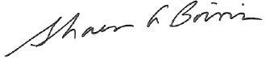
Sharon A. Boivin
Acting Associate Commissioner
Postsecondary, Adult, and Career Education Division
National Center for Education Statistics
Enclosure

Address Update Form – Sample Members
Study ID number: «caseid»

- Please review your current address and phone numbers displayed on the left side of the box below.

Check here if all information preprinted in this section is entirely correct............
If your address is not entirely correct or current, please update it in the space provided on the right side of the box. If you prefer to update your address information online, visit our secure website at https://surveys.nces.ed.gov/bps/ and refer to your Study ID number «caseid».

«fname» «mname» «lname» «suffix»  «addr1»  «addr2»  «city», «state» «zip» «zip4»  («area1») «phone1»  «panelinfo» |  | Name:
 |  | Address:
 |  | Home phone: | ( )
 |  | Work phone: | ( )
 |  | Cell phone: | ( )
2. We will send an e-mail to let you know that data collection has begun. Please provide an e-mail address that we can use to contact you.
Primary e-mail address:
Alternate e-mail address:

3. Would you like us to send you a text message on your cell phone when data collection is about to begin? Please check one.....................................................................Yes No

If yes, what cell number should we use?__________________________________________

What is your cell phone service provider (e.g. AT&T, Verizon, etc.)?* ___________________
__________________________________________________________________________
Thank you for your assistance.
Please return this page in the enclosed postage-paid envelope or return to:
RTI International
ATTN: Jeff Franklin (0212353.200.002.232)
PO Box 12194
Research Triangle Park, NC 27709-9935

* We ask for your cell phone service provider to enable us to identify the format of the text message we send.

Initial Contact Letter – Sample Member

Date

«fname» «mname» «lname» «suffix» Study ID: «caseid»
«addr1»
«addr2»
«city», «state» «zip»«zip4»

Dear «fname»,

You have been randomly selected to participate in the Beginning Postsecondary Students Longitudinal Study (BPS), sponsored by the National Center for Education Statistics (NCES) in the U.S. Department of Education’s Institute of Education Sciences. BPS will collect education, employment, and other information from you and others like you who first enrolled in college during the 2010–11 school year. Data collected from BPS will help educators, researchers, and policymakers better understand beginning students’ paths in postsecondary education. This is the first round of BPS. <<You may recall participating in the National Postsecondary Student Aid Study in 2011. >>
When BPS data collection begins in March 2013, you will receive a letter in a large white envelope that will provide specific information about how to participate. The letter will explain that if you complete the approximately <<time>> minute survey on the Web by the date indicated, you will receive <<INC_AMT>> as a token of our appreciation. In the meantime, we need to update our contact information for you.
Please help us now by providing your mailing address, telephone number(s), and e-mail address (es) online at https://surveys.nces.ed.gov/bps/. You will also find out more about BPS at this website. As a token of our appreciation for providing your contact information, you will receive <<UPDATE_INC_AMT>>.

NCES has contracted with RTI International to conduct BPS on its behalf. The enclosed brochure provides a brief description of BPS, findings from past studies, and a summary of our strict confidentiality procedures. If you have additional questions or concerns about the study after reviewing this material, please call the RTI study director, Jennifer Wine at 1-877-225-8470.

We thank you in advance for your participation in this important study. Your cooperation is greatly appreciated.

Sincerely,
To update your contact information online: Go to: https://surveys.nces.ed.gov/bps/
Enter Study ID number: «caseid»
Sharon A. Boivin
Acting Associate Commissioner
Postsecondary, Adult, and Career Education Division
National Center for Education Statistics
Enclosure

According to the Paperwork Reduction Act of 1995, no persons are required to respond to a collection of information unless it displays a valid OMB control number. The valid OMB control number for this voluntary information collection is XXXX–XXX. The time required to complete this information collection is estimated to average [if MODIFIED=1: 20; ELSE; 35] minutes per response, including the time to review instructions, gather the data needed, and complete and review the information collection. If you have any comments concerning the accuracy of the time estimate or suggestions for improving this survey, please write to: U.S. Department of Education, Washington, DC 20202–4537. If you have any comments or concerns regarding the status of your individual submission of this survey, write directly to: The 2012-14 Beginning Postsecondary Students Longitudinal Study (BPS:12/14), National Center for Education Statistics, 1990 K Street, NW, Washington, DC 20006.

Data Collection Announcement Letter
Date
«fname» «mname» «lname» «suffix» Study ID: «caseid»
«addr1»
«addr2»
«city», «state» «zip»-«zip4»

Dear «fname» «lname»:

Surveys for the Beginning Postsecondary Students Longitudinal Study (BPS) are now being conducted. The survey will take about <<time>> minutes to complete. As a token of our appreciation, once you complete the survey, we will mail you $«IncAmt» check.

You may access the survey by logging on to our secure website at https://surveys.nces.ed.gov/bps/ using the Study ID and password provided below. The password is case sensitive; you will need to enter it exactly as it appears here.

Study ID = «caseid»
Password = «password»m
Enclosed you will find a brochure with a brief description of findings from prior BPS studies and our strict security procedures. Federal law requires that we protect your privacy. Your responses will be secured behind firewalls and will be encrypted during internet transmission. Your responses will be used only for statistical purposes and may not be disclosed, or used, in identifiable form for any other purpose, except as required by law (20 U.S.C. § 9573). If you have questions, problems completing your survey online, or prefer to complete the survey over the telephone, simply call the BPS Help Desk at 1-XXX-XXX-XXXX. Your participation, while voluntary, is critical to the study’s success.
If you have any other questions or concerns about the study, please contact the BPS Project Director, Dr. Jennifer Wine, at 877-225-8470, jennifer@rti.org, or the NCES Project Officer, Dr. Sarah Crissey, at 202- 502-7395, Sarah.Crissey@ed.gov.

Thank you in advance for making BPS a success.

Sincerely,
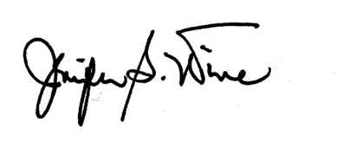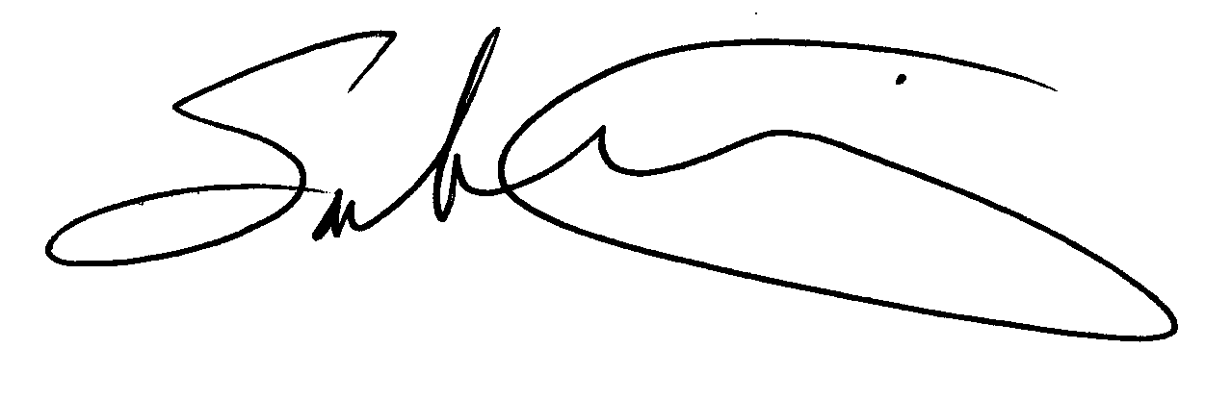
Jennifer Wine Sarah Crissey
BPS Project Director NCES Project Officer
Education Studies Division National Center for Education Statistics
RTI International U.S. Department of Education

Enclosure RTI USE ONLY: «panelinfo»

According to the Paperwork Reduction Act of 1995, no persons are required to respond to a collection of information unless it displays a valid OMB control number. The valid OMB control number for this voluntary information collection is xxxx-xxxx. The time required to complete this information collection is estimated to average [if MODIFIED=1: 20; ELSE; 35] minutes per response, including the time to review instructions, gather the data needed and complete and review the information collection. If you have any comments concerning the accuracy of the time estimate or suggestions for improving this survey, please write to: U.S. Department of Education, Washington, DC 20202–4537. If you have any comments or concerns regarding the status of your individual submission of this survey, write directly to: The 2012-14 Beginning Postsecondary Students Longitudinal Study (BPS:12/14), National Center for Education Statistics, 1990 K Street, NW, Washington, DC 20006

Reminder Letter
Dear <<fname>>,

Students who recently began their postsecondary education face many opportunities and challenges as they transition into the next phase of their lives. The Beginning Postsecondary Students Longitudinal Study (BPS) is collecting information from students who recently first enrolled in college about their lives, careers, and further education pursuits to help better understand beginning students’ paths in postsecondary education. Although participation in BPS is voluntary, we hope you will decide to complete the survey about your experiences.

For participating, you will receive a $<<INCAMT>> check as a token of our appreciation. The survey will take, on average, about <<time>> minutes to complete. Please access the BPS survey by logging on to our secure website at:

https://surveys.nces.ed.gov/bps/
Study ID = <<CASEID>>
Password = <<PSWD>>H
Note: The password is case sensitive; you will need to enter it exactly as it appears here.

Federal laws require that we protect your privacy. Your responses will be used only for statistical purposes and may not be disclosed, or used, in identifiable form for any other purpose, except as required by law (20 U.S.C. § 9573).

If you have questions, problems completing your survey online, or prefer to complete the survey over the telephone, simply call the BPS Help Desk at 1-877-262-4440.

Thank you, in advance, for your participation.

Sincerely,

Jennifer Wine
Director, Beginning Postsecondary Students Longitudinal Study

Thank You/Reminder Postcard
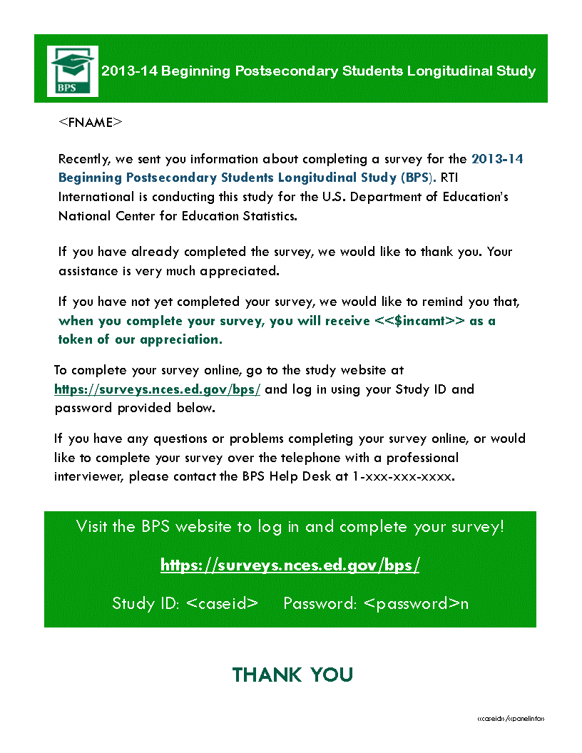
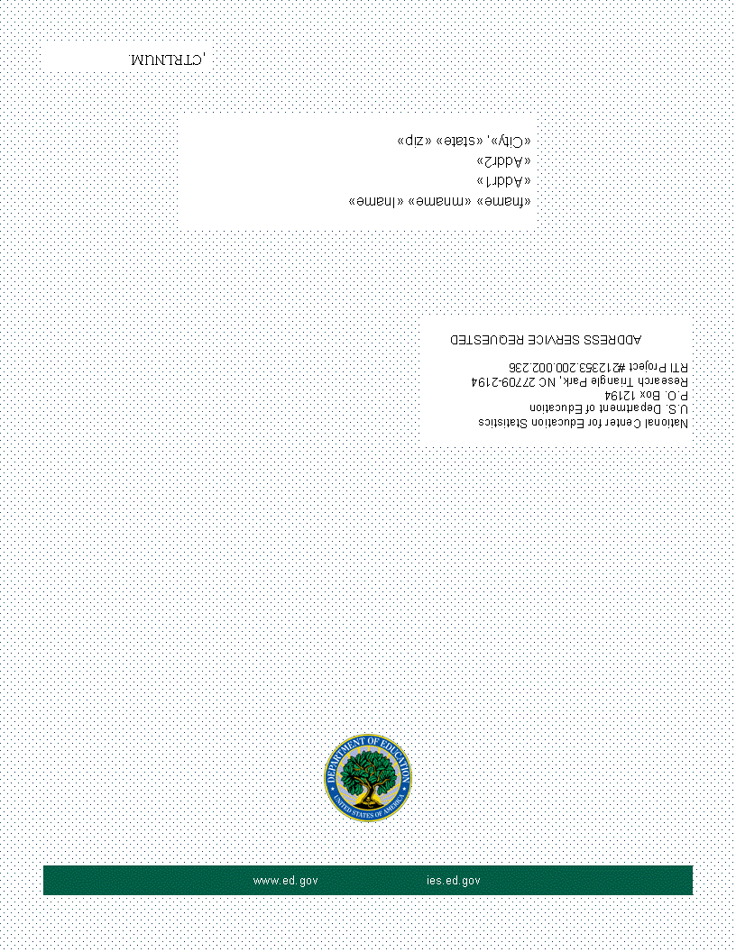

Reminder Folded Postcard
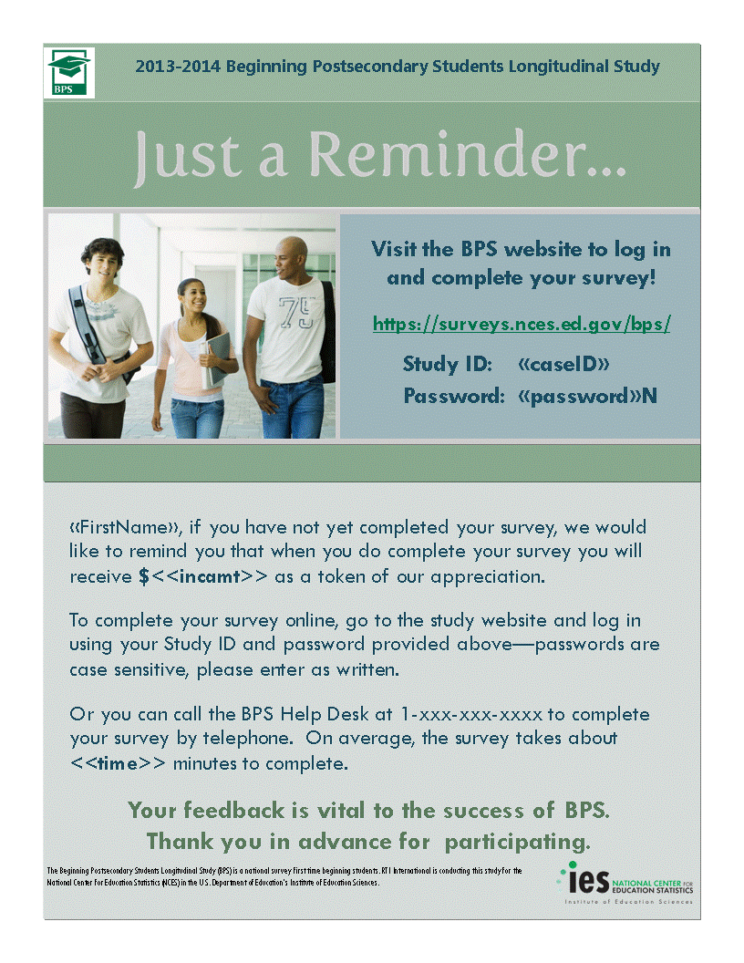
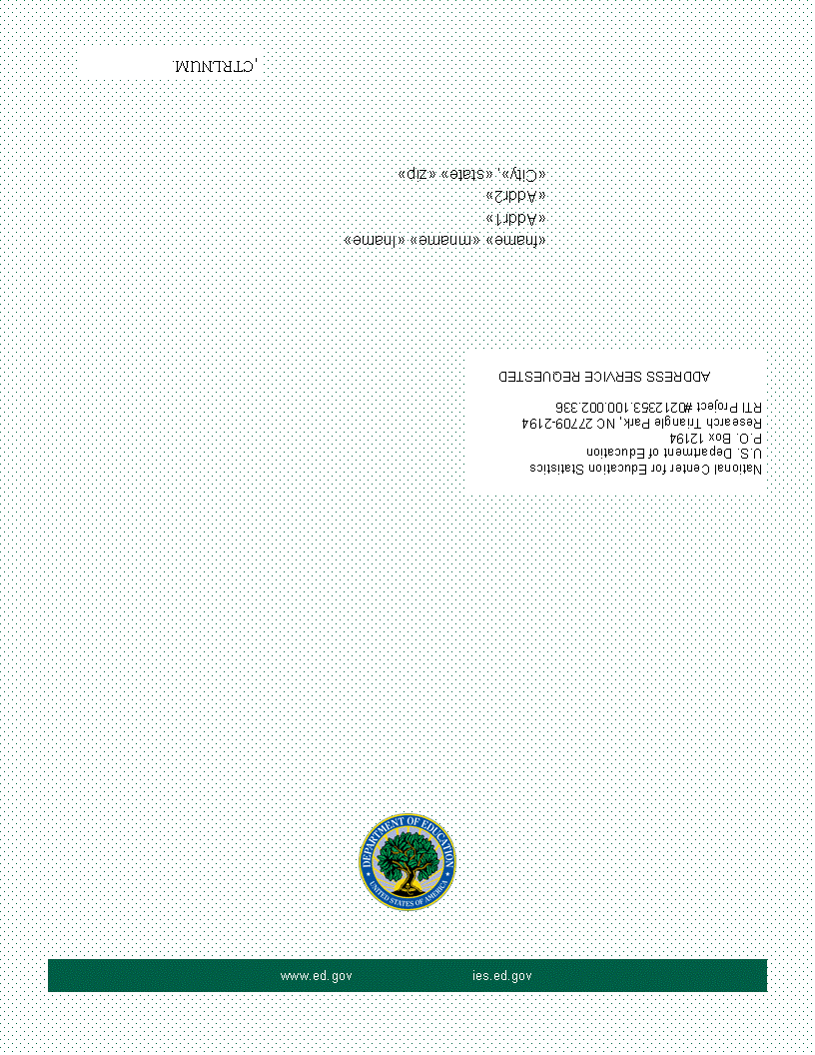

Thank You/Incentive Letter

(Date)

«fname» «mname» «lname» «suffix» Study ID: «caseid»
«addr1»
«addr2»
«city», «state» «zip» «zip4»
Dear «fname» «lname»:
On behalf of the National Center for Education Statistics (NCES) in the U.S. Department of Education’s Institute of Education Sciences and the staff of BPS, we would like to thank you for participating in the BPS survey. Your participation in BPS is very important in helping to ensure the success of the study.
Enclosed you will find a check for $«IncAmt» as a token of our appreciation.
If you have any questions, please do not hesitate to contact us at 1-877-225-8470.
Sincerely,



Jennifer Wine Sarah Crissey
BPS Project Director NCES Project Officer
Education Studies Division National Center for Education Statistics
RTI International U.S. Department of Education

Enclosure

Final Flyer
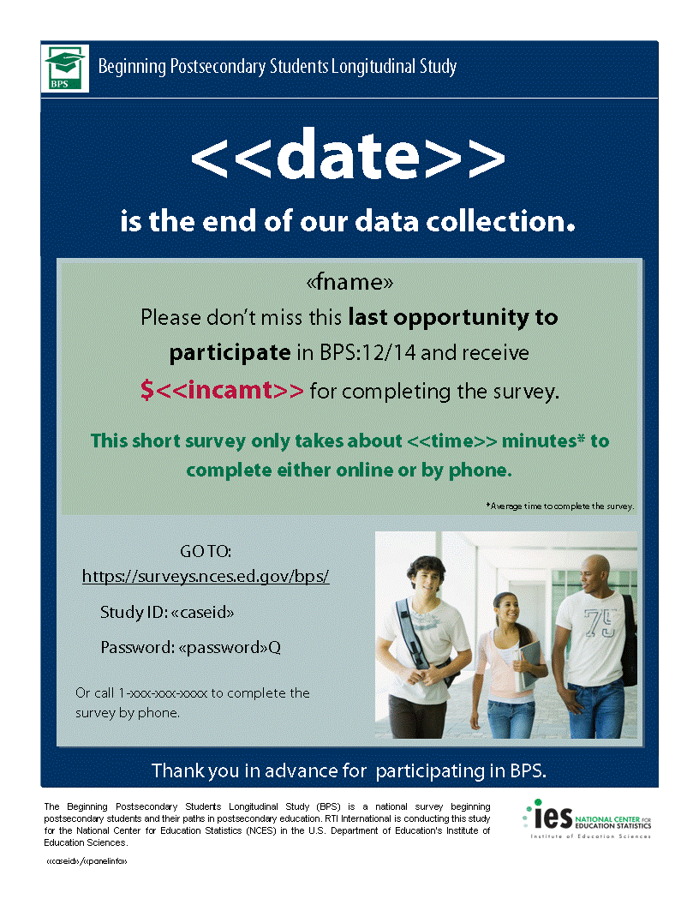

Data Collection Announcement E-mail

SUBJ: The BPS Survey Has Begun!

Dear <<fname>>,

Surveys for the Beginning Postsecondary Students Longitudinal Study (BPS) are now being conducted. The survey will take about <<time>> minutes to complete and the data collected from it will help researchers and policymakers to better understand beginning students’ paths in postsecondary education.

If you complete your BPS survey by [INCDATE], you will receive a $[INCAMT] check as a token of our appreciation. To access the online survey, just click here to get started or log in on our secure website.

To complete your survey:
https://surveys.nces.ed.gov/bps/
Study ID: <caseid>
Password: <password>e

If you have questions or problems completing your survey, or would like to complete the survey over the telephone, please call the BPS Help Desk at 1-8XX-XXX-XXXX.

Your participation is voluntary but critically important to the success of the study. To ensure confidentiality, your responses will be secured behind firewalls and will be encrypted during internet transmission. Federal law requires that we protect your privacy. Your responses will be used only for statistical purposes and will not be disclosed, or used, in identifiable form for any other purpose, except as required by law (20 U.S.C. § 9573).

RTI International is conducting BPS on behalf of the National Center for Education Statistics (NCES) in the U.S. Department of Education's Institute of Education Sciences. If you have any questions about the study, please contact me at 1-877-225-8470, e-mail: jennifer@rti.org, or the NCES Project Officer, Dr. Sarah Crissey, at 202- 502-7395, Sarah.Crissey@ed.gov.

Thank you for helping to make BPS a success.
Jennifer Wine
BPS Project Director

First Early Reminder E-mail
Subject: Don’t Forget to Complete Your BPS:12 Survey!
Dear [FIRSTNAME],

I would like to remind you that your participation in the Beginning Postsecondary Students Longitudinal Study (BPS) is still needed, and that I hope that you will participate in the study soon.

If you complete the BPS survey, you will receive a $[INCAMT] check as a token of our appreciation.

To access the online survey, just click here!

If you need help accessing the online survey, or if you prefer to complete the survey by telephone, please call our Help Desk at 1-877-262-4440.

RTI International is conducting this study for the National Center for Education Statistics (NCES) in the U.S. Department of Education's Institute of Education Sciences. If you have any questions or concerns about the study, please contact me at 1-877-225-8470 (e-mail: jennifer@rti.org), or the NCES Project Officer, Dr. Sarah Crissey, at 202- 502-7395, Sarah.Crissey@ed.gov.

Thank you in advance for your participation in this very important study.

Sincerely,

To complete your survey:
https://surveys.nces.ed.gov/bps/
Study ID: <caseid>
Password: <password>a

Jennifer Wine
BPS Project Director

Second Reminder E-Mail

Subject: Don’t Delay - Complete Your BPS:12 Survey Today!

Dear [FIRSTNAME],

I would like to remind you that data collection for the Beginning Postsecondary Students Longitudinal Study (BPS) is underway. I hope that you will participate in the study soon.

If you complete your survey, you will receive a $[INCAMT] check as a token of our appreciation.

To access the online survey on our secure website, click here!

If you need help accessing the online survey, or if you prefer to complete the survey by telephone, please call our Help Desk at 1-877-262-4440.

RTI International is conducting this study for the National Center for Education Statistics (NCES) in the U.S. Department of Education's Institute of Education Sciences. If you have any questions or concerns about the study, please contact me at 1-877-225-8470 (e-mail: jennifer@rti.org), or the NCES Project Officer, Dr. Sarah Crissey, at 202- 502-7395, Sarah.Crissey@ed.gov.

Thank you in advance for your participation in this very important study.

Sincerely,
To complete your survey:
https://surveys.nces.ed.gov/bps/
Study ID: <caseid>
Password: <password>b

Jennifer Wine
BPS Project Director

Example Text for Brief Reminder E-mails

<FirstName>,

It’s time to complete the Beginning Postsecondary Students (BPS) Survey and receive your check for $<incent>! The survey takes <<time>> minutes and can be completed online or over the phone.

It’s easy to participate in BPS on our secure website. Just click here to get started right away!
To complete your survey:
https://surveys.nces.ed.gov/bps/
Study ID: <caseid>
Password: <password>d

Or, you can complete the survey by phone by calling 1-877-262-4440.
If you have questions or problems completing your survey, please call the BPS Help Desk at 1-877-262-4440 or visit the study website at https://surveys.nces.ed.gov/bps/.
Thanks!

Jennifer Wine
Project Director, BPS
RTI International
jennifer@rti.org
1-877-225-8470

Brief E-mail Reminder 1

<FirstName>,

BPS data collection ends on <<Date>>, which means you only have [x] days left to participate! Complete your BPS survey by the deadline and receive $<incent> as a token of our appreciation.

The survey takes <<time>> minutes and can be completed online or over the phone. BPS is easy to do on our secure website – just click here to get started!
To complete your survey:
https://surveys.nces.ed.gov/bps/
Study ID: <caseid>
Password: <password>f
Or, you can complete the survey by phone by calling 1-877-262-4440.
If you have questions or problems completing your survey, please call the BPS Help Desk at 1-877-262-4440 or visit the study website at https://surveys.nces.ed.gov/bps/.
Thanks!

Jennifer Wine
Project Director, BPS
RTI International
jennifer@rti.org
1-877-225-8470

Brief E-mail Reminder 2

<FirstName>,

Don’t forget that we still need you to participate in the Beginning Postsecondary Students Longitudinal Study (BPS) for the U.S. Department of Education. It takes about <<time>> minutes and, once you’ve completed the survey, we’ll send you a check for $<incamt>!

Data collection ends on <<date>>, so you only have a few days left to participate! It’s easy to do on our secure website. You can click here to get started right away!
To complete your survey:
https://surveys.nces.ed.gov/bps/
Study ID: <caseid>
Password: <password>c
Or, you can complete the survey by phone by calling 1-877-262-4440.
If you have questions or problems completing your survey, please call the BPS Help Desk at 1-877-262-4440 or visit the study website at https://surveys.nces.ed.gov/bps/.
Thanks!

Jennifer Wine
Project Director, BPS
RTI International
jennifer@rti.org
1-877-225-8470

BPS CATI Consent Text

LTR_S

IF OUTBOUND CALL AND NOT ALREADY MENTIONED, READ: Hello, this is _________. I am
calling for the U.S. Department of Education about the Beginning Postsecondary Students Longitudinal Study of students who first enrolled in postsecondary education during the 2010-2011 school year.

READ VERBATIM: IF Y_MINOR=3: Recently, we sent material to you and your parents about the U.S. Department of Education's Beginning Postsecondary Students Longitudinal Study, or BPS. This survey is being conducted to better understand the education and employment experiences of students who began their postsecondary education during the 2010-2011 academic year. As a token of our appreciation, you will receive a <INC_AMOUNT> check once you complete the survey. Have you had a chance to read the material?

Non-minors: Recently, we sent you material about the U.S. Department of Education’s Beginning Postsecondary Students Longitudinal Study (BPS). This survey is being conducted to better understand the education and employment experiences of students who began their postsecondary education during the 2010-2011 academic year. As a token of our appreciation, you will receive a <INC_AMOUNT> check once you complete the survey. Have you had a chance to read the material?

If yes, read the material:
(Good.) The survey takes about [if MODIFIED=1: 20; ELSE; 35] minutes and may be monitored or recorded for quality assurance purposes. Your participation is voluntary and will not affect any aid or other benefits that you may receive. You may decline to answer any question or stop the survey at any time. If you have any questions about the study, please let me know. May we begin the survey now?

(You can contact the study's director, Jennifer Wine, at 1-877-225-8470. For questions about your rights as a study participant, please contact RTI's Office of Research Protection at 1-866-214-2043.)

TI: IF ENTIRE CONSENT WASN'T READ AND THE INTERVIEW ISN'T STARTED, PRESS THE

BREAK BUTTON.

If no, did not read the material (or did not receive it):

(At your request we can remail the material to you.) (If you can bear with me for a moment, I am required to read the following information about your rights as a participant.) The BPS survey takes about [if MODIFIED=1: 20; ELSE; 35] minutes and may be monitored or recorded for quality assurance purposes. Your responses, combined with student record information (such as financial aid data), may be used only for statistical purposes and may not be disclosed, or used, in personally identifiable form for any other purpose, unless otherwise required by law. (You are one of approximately 3,500 students who will be taking part in this study.) In addition to your survey responses, we collect financial aid, student records and related information from your school and sources such as student loan databases and admissions testing agencies.

Your participation is voluntary and will not affect any aid or other benefits that you may receive. You may decline to answer any question or stop the survey at any time. The risk of participating in this study is small and relates to data security. However, there are strict security procedures in place. If you would like us to remail the material to you, please let me know. May we begin the survey now? (You may contact the study's director, Jennifer Wine, at 1 877-225-8470. For questions about your rights as a study participant, please contact RTI's Office of Research Protection at 1-866-214-2043.)

TI: IF THE SURVEY ISN’T STARTED AND THE ENTIRE CONSENT WASN’T READ, PRESS THE BREAK BUTTON BELOW.

BPS:12/14 FS Panel Maintenance
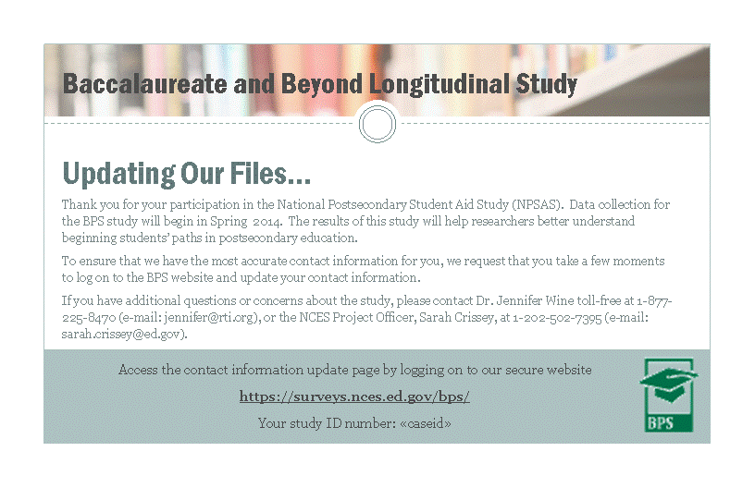
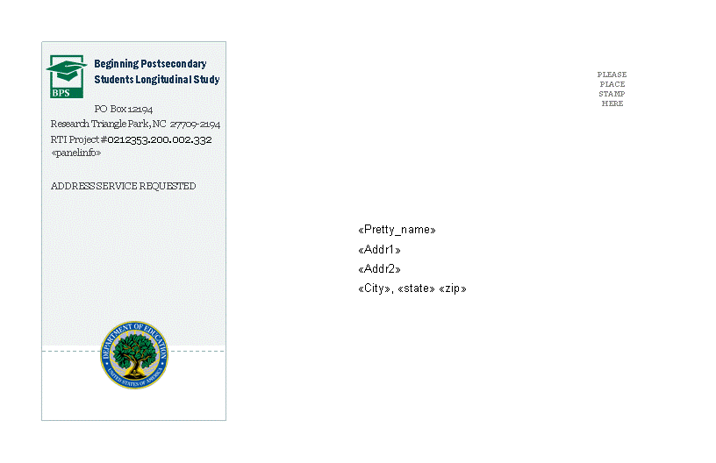

The institutional strata can be aggregated by control or level of the institution for the purposes of reporting institution counts.
The Hispanic-serving institutions (HSI) indicator no longer exists in IPEDS, so an HSI proxy was created using IPEDS Hispanic enrollment data.
Some Carnegie categories were collapsed for the purposes of implicit stratification.
Past rounds of NPSAS have included samples of first-professional students. However, IPEDS has replaced the term first-professional with doctoral-professional practice. We will work with the sample institutions when requesting enrollment lists to ensure that they understand how to identify doctoral-research/scholarship/other and doctoral-professional practice students.
“Other graduate” students are those who are not enrolled in a degree program, such as students just taking graduate courses.
The master’s and doctoral STEM programs as domains will be added at the same time FTB domains and outcomes are added.
NPSAS has many administrative data sources, along with the student interview. Key variables have been identified across the various data sources to determine the minimum requirements to support the analytic needs of the study. Sample members who meet these minimum requirements will be classified as study members. These study members will have enough information from these multiple sources to be included in the NPSAS analysis files.
Chromy, J.R. (1987). Design Optimization with Multiple Objectives. Proceedings of the American Statistical Association Section on Social Statistics, 194-199.

