Multicultural Youth Tobacco Prevention Campaign:
Pilot (Brand and Creative Concept Phase)
Brand Test Stimuli

The following brand names and logos, or the equivalent of, will be tested as part of the Campaign Brand Testing exercises. Stimuli will be inserted into the appropriate placeholders within the Hip Hop Campaign Brand Test Survey, Version A and Version B. Please note that Version A and Version B will contain the same stimuli but in reverse order for counterbalancing purposes.

- Brand Names

  - Free Era
  - DV8
  - Fresh Empire
  - One Hundred

- Logos
  - Free Era

1 2 3
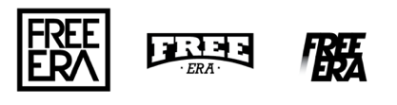

  - DV8

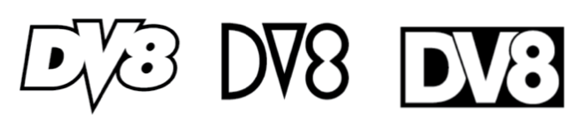
1 2 3

  - Fresh Empire

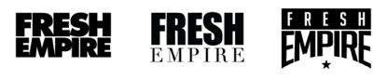
1 2 3

  - One Hundred
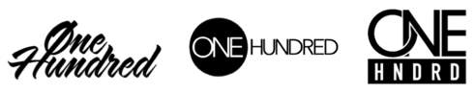
1 2 3

