Form Approved
OMB No. 0917-0036-20
Exp Date: 5/31/2015

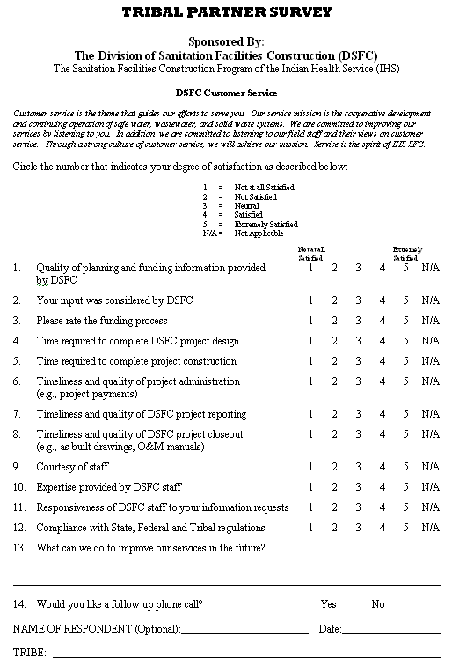

According to the Paperwork Reduction Act of 1995, no persons are required to respond to a collection of information unless it displays a valid OMB control number. The valid OMB control number for this information collection is 0917-0036-20. The time required to complete this information collection is estimated to average 3 minutes per response, including the time to review instructions, search existing data resources, gather the data needed, and complete and review the information collection. If you have comments concerning the accuracy of the time estimate(s) or suggestions for improving this form, please write to: U.S. Department of Health & Human Services, OS/OCIO/PRA, 200 Independence Ave., S.W., Suite 336E, Washington D.C. 20201, Attention: PRA Reports Clearance Officer.

