Form Approved
OMB No. 0920-0840
Expiration Date2/28/2016

“Informing the Development of Mobile Apps for HIV Prevention, Treatment, & Care”
Attachment 5f. Healthcare Provider Recruitment Flyer

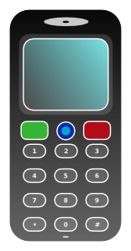

Are you interested in sharing your thoughts on the use of mobile technology for HIV+ patients?

We are conducting a study to learn more about the use of mobile technology for persons living with HIV.
You must be an HIV clinician or case manager and willing to spend about 1.5 hours discussing your thoughts about using mobile phones for HIV prevention treatment and care.

You will receive $50.00 as a token of appreciation.

If you would like to know more or would like to participate – Please call Marlene at (212) 305-2866 or mr3301@columbia.edu or Rebecca at 212-342-6886 or
email: rb897@columbia.edu

Mobile Phone focus group  Marlene @  212-305-2866 | Mobile Phone focus group  Marlene @  212-305-2866 | Mobile Phone focus group  Call Marlene @  212-305-2866 | Mobile Phone focus group  Marlene @  212-305-2866 | Mobile Phone focus group  Marlene @  212-305-2866 | Mobile Phone focus group  Marlene @  212-305-2866 | Mobile Phone focus group  Marlene @  212-305-2866 | Mobile Phone focus group  Marlene @  212-305-2866 | Mobile Phone focus group  Marlene @  212-305-2866

