**MOM-le Study Saliva Collection Take Home Kit**

This section of the manual describes the at-home saliva collection procedures and schedule.

**Supplies:**

**You should have the following supplies in your kit:**

* AARDEX container (bottle + cap)
* 6 cotton swabs (they are inside the bottle)
* 6 Salivette holders (tubes)
* 2 small Ziploc plastic bags (labeled Day 1, and Day 2)
* 2 small Ziploc plastic bags (labeled Collected Saliva Samples Day 1 and Collected Saliva Samples Day 2)
* 1 large Ziploc plastic bag (labeled “Saliva Tubes”)
* 1 large labeled padded envelope (with stamps)
* Saliva Collection Instructions (below)
* Saliva Collection Form

**Information**

* For 2 consecutive days you will collect 3 saliva samples each day.
* For each day you will have 3 cotton rolls and 3 labeled tubes to collect saliva samples throughout the day.
* One tube is labeled **+0** (take this sample as soon as you wake up in the morning).
* One tube is labeled **+30** (take this sample 30 minutes after the first sample).
* One tube is labeled **“bedtime”** (take this sample before you go to sleep).
* Record all the collection times on the “Saliva Collection Form.”

Example: If you wake up at 6:15 am, you would collect the samples at the following times:

Sample 1 Tube +0: 6:15 a.m. (As soon as you wake up. **Record time on form**)

Sample 2 Tube +30: 6:45 a.m. (30 min. after you wake up. **Record time on form**)

Sample 3 Bedtime 10:45 p.m. (Before you go to sleep. **Record time on form**)

**\*\*Important Notes:**

* Take all samples at the exact time that is noted. If you are unable to collect the saliva samples at the right time, please collect them as soon as you can.
* It is okay to either wake up naturally or to an alarm clock, but you should not lie in bed and snooze before you begin.
* As soon as you wake up, make sure to record your wake up time on the Saliva Collection Form and take your sample.
* DO NOT eat, drink, or brush your teeth before completing the morning samples.
* IF you eat, drink, or brush your teeth during the morning samples or less than 30 minutes before the bedtime sample, rinse your mouth thoroughly at least **5 minutes** before collecting the next sample. Please make this an exception.
* Only open the bottle when a sample is to be taken. Every time the bottle is opened, the cap records the time. If the cap comes off accidentally, please make a note on the “Saliva Collection Form.” Also, close the cap fully so the cap records the time correctly.
* DO NOT rinse your mouth less than 5 minutes before taking the sample.
* Make a note on the “Saliva Collection Form” if any samples have been affected.
* Please DO NOT put samples in the freezer.
* Please DO store samples in the refrigerator right after you collect them.

**Saliva Collection Instructions**

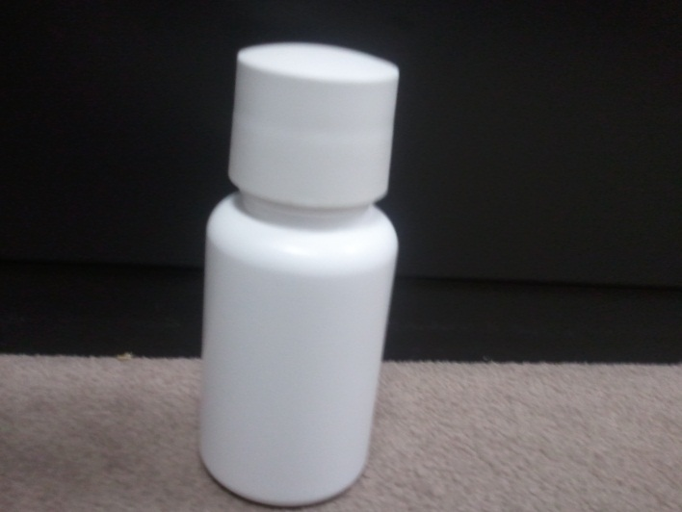**How to collect saliva samples**

1. For each saliva collection, open the white bottle containing the cotton rolls.
2. 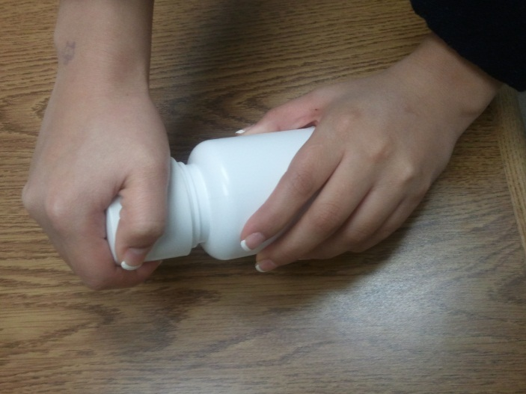To open the bottle, push down on the top with the palm of your hand. Turn the lid counter-clockwise.

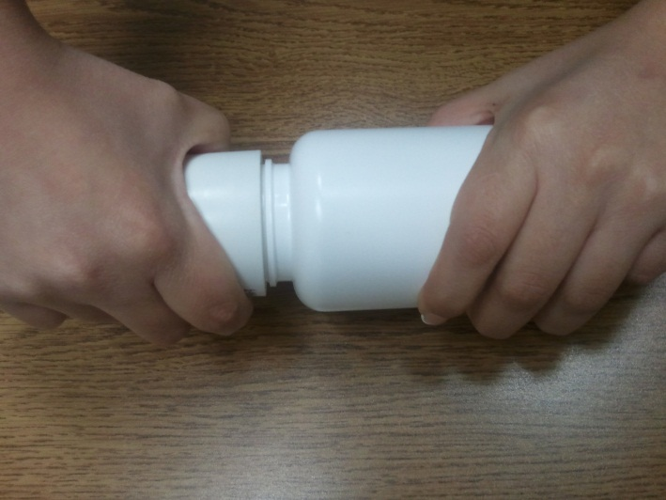**DO NOT** force open the bottle by turning without first pushing down.

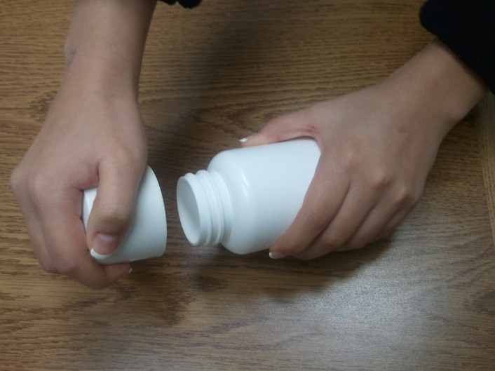

1. Then the cap can be easily removed from the bottle.

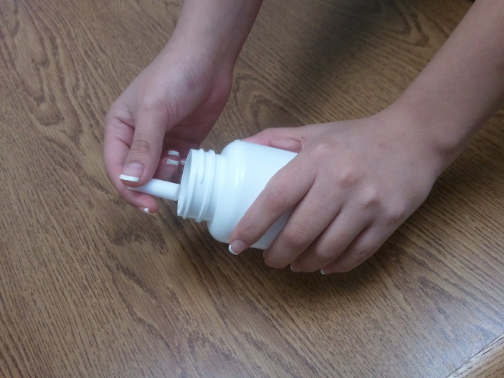

1. Take out only 1 cotton roll and close the container right away. (When you open and close the bottle, the cap records the time).

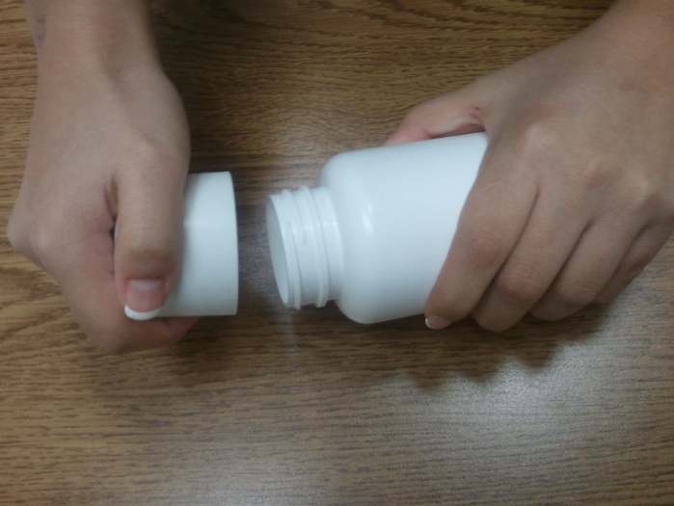

1. To close the bottle, push down slightly on the cap.

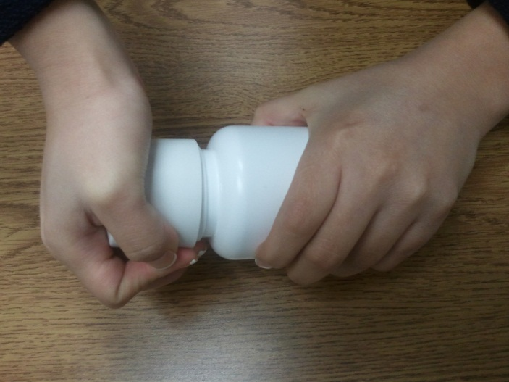

1. Securely tighten the MEMS cap onto the bottle.

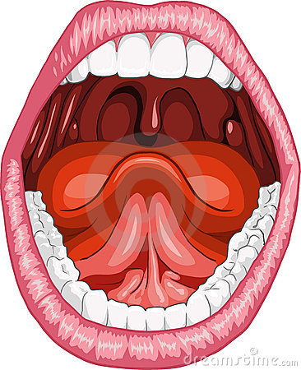

1. Place the cotton roll under your tongue for 1 minute. Make sure the cotton rolls gets as wet as possible.

**MC900056853[1]**

1. **Write down the exact time** you took the sample

on the “Saliva Collection Form.”

1. 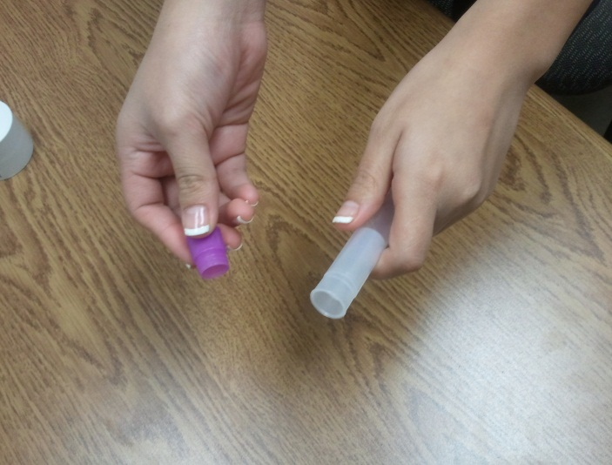Open the labeled tube.

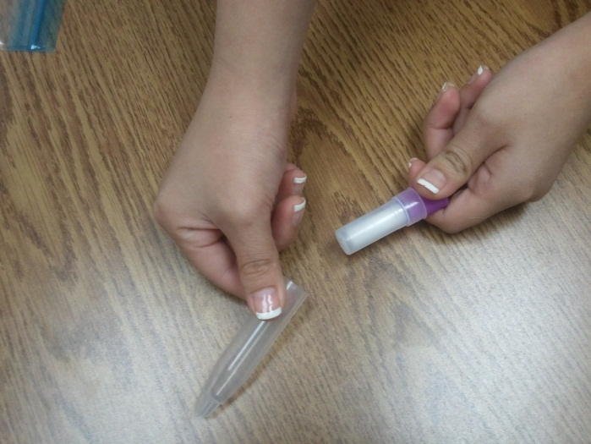

DO NOT separate the small tube from the large tube.

1. 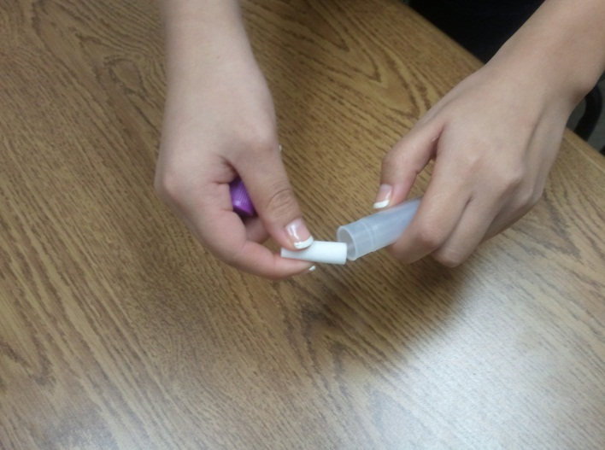Grab the cotton roll from your mouth and put it into the correctly labeled tube.
2. 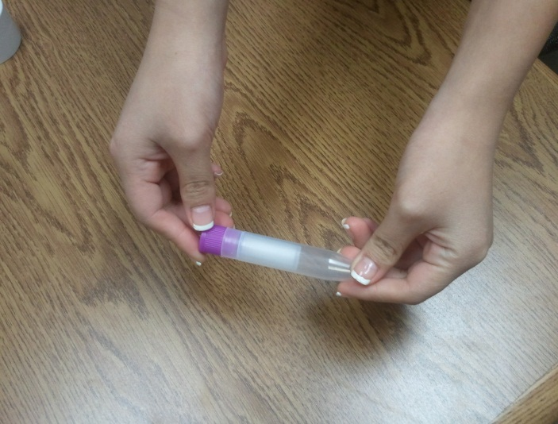Close the tube completely.
3. 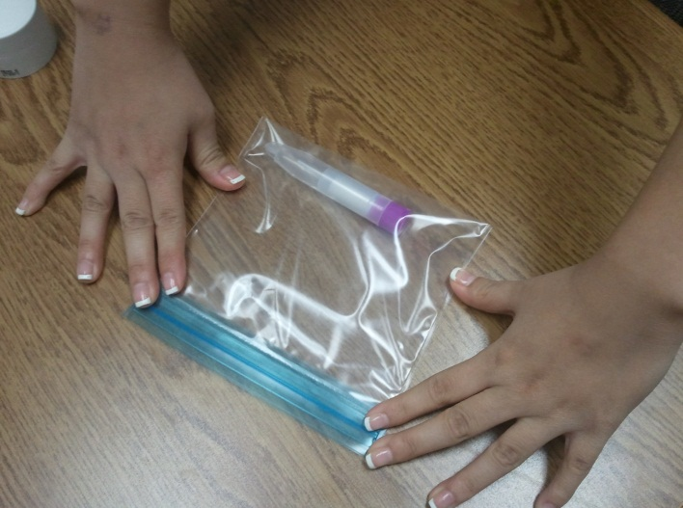Place the tube in the correct small Ziploc bag labeled “Collected Saliva Samples.”

C:\Users\student\AppData\Local\Microsoft\Windows\Temporary Internet Files\Content.IE5\0JU7ZL1Z\MC900335637[1].wmf

1. Store the sample in the refrigerator

(**DO NOT put in freezer!**).

1. Mail the following items to the MOM-le Study Research Assistant using the pre-addressed and stamped padded envelope you were given as part of the saliva take home packet. Be sure to include the following in the envelope: MC900389514[1]

* AARDEX container (bottle + cap)
* 3 salivette containers with the cotton swabs in the Ziploc bag labeled “Collected Saliva Samples Day 1”
* 3 salivette containers with the cotton swabs in the Ziploc bag labeled “Collected Saliva Samples Day 2”
* Saliva Collection Form

If you need the Research Assistant’s address, it is:

Kristina Nelson

Northwestern University

750 N. Lake Shore Drive, 10th Floor

Chicago, IL 60611-4550

**Thank you for participating in the MOM-le Study! Data from your saliva samples will help researchers learn more about how stress affects pregnancy. If you have any questions, please call Kristi Nelson at (312) 503-5547.**