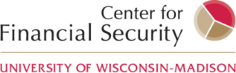
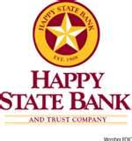

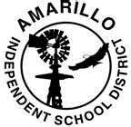

Smarter Texans Save Financial Education Study

Your 4th grade child has an opportunity to participate in a unique study. The Amarillo Independent School District and Happy State Bank are partnering with Opportunity Texas, the U.S. Department of the Treasury and the University of Wisconsin to identify effective strategies for teaching money management to kids. Amarillo will be at the forefront of important research that aims to prepare students for a healthy financial future. You should have received information about this study earlier from your child’s school. However, we still need your help!

During the spring of 2013, 4th grade students will take part in financial education lessons in the classroom as part of the standard curriculum. Lessons address important topics such as saving, banking, and money management. Amarillo ISD has partnered with Happy State Bank to expand an in-school banking program in Amarillo ISD’s elementary schools. To encourage students to open and use a bank account, half of the 4th grade students in selected schools will be offered $25 to be deposited into their Happy State Bank account through a lottery in the classrooms.

We are asking that you help us in this research by allowing us to use information about your child—including two assessments conducted in the classroom as part of the regular course of education. If your child has a youth savings account at Happy State Bank, we would also like to collect information about how much and how often your child uses the account. This will help us understand how financial learning affects money management. Identifying information such as your child’s name and account number will be removed before any data are released to the researchers. Any information we collect for the study will remain private. We would not use your name in the study, or your child’s name. You are also free to withdraw your child from the study at any time.

Your decision about participating in this study will not change any of your child's activities at school, and will not affect your child’s bank account in any way. Your decision will only affect whether or not we can use information related to your child in research. You may ask questions at any time. You can contact Laura Rosen with OpportunityTexas at 512-823-2868. If you have more questions, you can contact Professor Michael Collins at the University of Wisconsin (jmcollins@wisc.edu or 608-262-0369). If you want more information about your child’s rights as research participants, contact the Educational Research Institutional Review Board at 608-263-2320.

Our records show that we have not yet received your completed form. I am writing today to encourage you to fill out your form. If you agree to participate, we ask that you complete the enclosed form and return it as soon as you can. We have provided another copy of this short form along with a stamped, self-addressed envelope. If you have more than one child in 4th grade, please complete a separate form for each child.

We hope that you will help us with this important study. Thanks for your time!

Sincerely,
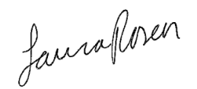
Laura Rosen
OpportunityTexas Coordinator

