Invitation Script (last paragraph):

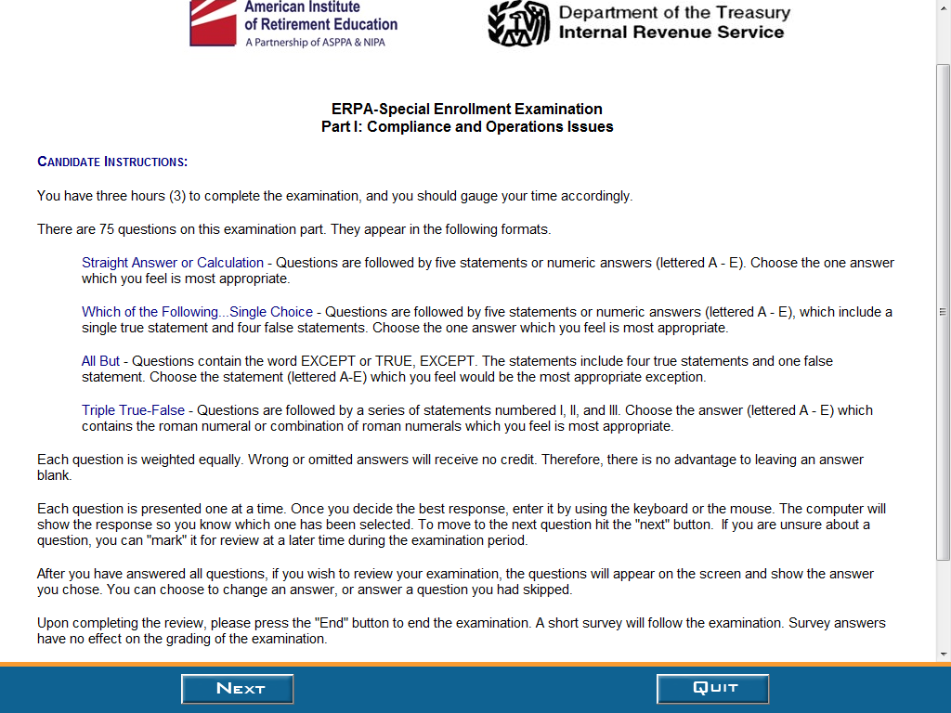

Script from first screen of survey
Your examination session is completed.
Please respond to the brief exit survey. Your feedback is important to us. This survey is voluntary and should take approximately three minutes.
The Paperwork Reduction Act requires that the IRS display an OMB control number on all public information requests. The OMB Control Number for this study is 1545-1432. Also, if you have any comments regarding the time estimates associated with this study or suggestions on making this process simpler, please write to the Internal Revenue Service, Tax Products Coordinating Committee, SE:W:CAR:MP:T:T:SP, 1111 Constitution Ave. NW, Washington, DC 20224.

ERPA-SEE Survey

1. What was the PRIMARY motivation in becoming an ERPA?
- To represent clients before the IRS
- Company requirement
- Promotion, salary, or bonus purposes
- To increase employment value
- To increase pension knowledge
- All of the above
- Other, please indicate:

2. Have you or your firm ever been denied practice before the IRS due to lack of ERPA enrollment status?
- Yes
- No
- Unsure

3. What was your PRIMARY form of preparation for this examination?
A. ERPA-SEE Syllabus
B. ERPA-SEE Study Guide
C. ERPA-SEE Licensure Information Bulletin
D. The ERISA Outline Book
E. AIRE Recorded Review Session(s)
G. AIRE Practice Examination
H. Study Group
I. Other, please indicate:

4. Please indicate below if you are any of the following (check all that apply):
A. Enrolled Agent
B. Enrolled Actuary
C. Certified Public Accountant
D. Attorney
E. ASPPA credentialed member
F. NIPA credentialed member
G. None of the above
H. Other, please indicate:

5. How many years have you been practicing in the retirement plan benefits field?
- 0-2
- 3-5
- 6-9
- 10-15
- Over 15

6. How satisfied were you with the staff’s helpfulness while at this test center?
A. Very Satisfied
B. Satisfied
C. Dissatisfied
D. Very Dissatisfied

7. How satisfied were you with the performance of the testing system during your test?
A. Very Satisfied
B. Satisfied
C. Dissatisfied
D. Very Dissatisfied

8. How satisfied are you with the total experience of taking your test at the Prometric Test Center?
A. Very Satisfied
B. Satisfied
C. Dissatisfied
D. Very Dissatisfied

9. Please provide suggestions for improving the testing program, including comments about specific test questions, the registration and scheduling processes, your satisfaction with customer service and test center staff, etc.

