# **IRS Data Book Redesign**

# **Webpage Survey**

Purpose:

This survey will open when visitors click the hyperlink displayed on various SOI Tax Statistic web pages. It is intended to quickly collect demographic information and website feedback in order to help SOI continuously improve the IRS Data Book as it exists online, as well as the overarching Tax Stats website.

Link to Survey:

A hyperlink will be available from each of the top visited SOI web pages for customers to participate in the survey.

Webpage Request for Users

“The IRS Statistics of Income (SOI) Division is committed to excellence in providing statistical data and customer service. Please take a moment to complete the Customer Survey and tell us how we can enhance your experience using Tax Stats. Your input is important to us.”

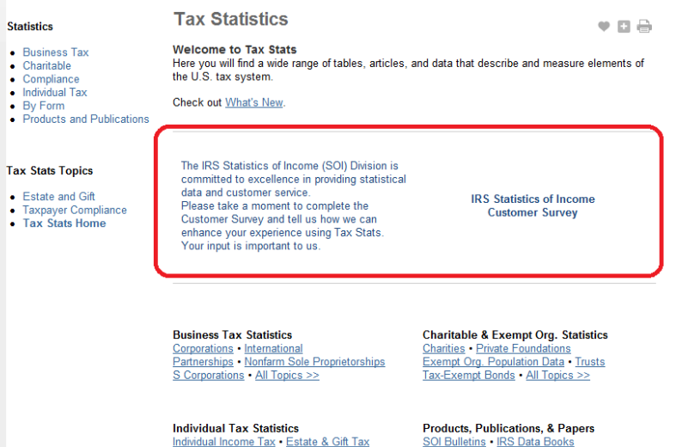

Displays Before Taking the Survey:

*The following will appear in the web pop-up window solicitation for participation in the survey:*

IRS’ Statistics of Income (SOI) Division needs your feedback in order to provide you with the online information and services that will meet your statistical needs. Please share your preferences for online information and services with us by completing a voluntary survey. The survey takes less than three minutes to complete and your feedback will be used to improve our online content, and services offered. No personal identifying information will be gathered. All responses are anonymous to the extent allowed by law.

To take the survey, please click on the link below.

Survey:

1. **What is your Occupation?**
   1. Note: Responses will be listed in drop-down form – Select single answer
   2. Answers:
      1. **Economist**
      2. **Professor or Student**
      3. **Journalist**
      4. **Blogger**
      5. **Federal Government Employee**
      6. **State/Local Government Employee**
      7. **Tax Preparer/Accountant**
      8. **Consultant/Auditor**
      9. **Other** ((if the individual picks other, bring up a free text field)
2. **What is your Industry?**
   1. Note: Responses will be listed in drop-down form – Select single answer
   2. Answers:
      1. **Academia**
      2. **Media**
      3. **Consulting**
      4. **Tax Advisory**
      5. **Federal Government**
      6. **State/Local Government**
      7. **Other** (if the individual picks other, bring up a free text field)
3. **What did you come here for today?**
   1. Note: Responses will be listed in drop-down form – Allow to select multiple answers if possible
   2. Answers:
      1. **Individual Tax Statistics**
      2. **Business Tax Statistics**
      3. **Charitable & Exempt Org. Statistics**
      4. **IRS Operations and Budget Statistics**
      5. **Geographical Data**
      6. **Time Series / Panel Data**
      7. **Publications**
      8. **Other** (if the individual picks other, bring up a free text field)
4. **How are you going to use the data?**
   1. Note: Responses will be listed in drop-down form – Allow to select multiple answers if possible
   2. Answers:
      1. **Article or blog**
      2. **Advise clients on tax decisions**
      3. **Academic report**
      4. **Support policy decisions**
      5. **Support decisions relevant to IRS operations**
      6. **Other** (if the individual picks other, bring up an open text field)
5. **Were you able to find the information you wanted?** 
   1. Note: Responses will be listed in drop-down form – Select single answer
   2. Answers:
      1. [radio button] **Yes** – [in a free text field] **Please Explain**
      2. [radio button] **No** – [in a free text field] **Please Explain**

Displays After Taking the Survey:

*The following will appear on the survey:*

Thanks again for agreeing to participate in our web survey. The Paperwork Reduction Act requires that the IRS display an OMB Control Number on all public information requests along with the address where you can send comments regarding the study. The OMB number for this study is 1545-1432. If you have any comments regarding this study, please write to, IRS, Tax Products Coordinating Committee, SE:W:CAR:MP:T:T:SP, 1111 Constitution Avenue, NW, Washington, DC  20224