Dear

We need your help with an important initiative we are undertaking to improve our service to America's taxpayers. We want to get feedback from taxpayers like you who received a notice from the Internal Revenue Service (IRS) pointing out a possible discrepancy between the information reported on their tax return and the information provided to the IRS by organizations such as banks and employers.

In a few days, you will receive a survey asking your opinions about the process of resolving such discrepancies. Please give this survey to the person in your household who had the most contact with the IRS on this matter. Answering these questions should take less than 5 minutes. Your answers will be combined with responses from other taxpayers to help measure taxpayer satisfaction with IRS service.

The primary purpose for requesting this information is to help the IRS improve its service to taxpayers. Our authority for requesting the information is 5 USC and 26 USC 7801.

Providing information is voluntary. However, if you do not answer all or part of the survey questions, the IRS may lack information it could use to improve taxpayer service. The information you provide may be disclosed to an IRS contractor when authorized by law. The contractor is required to follow protections required by the Privacy Act and/or Internal Revenue Code section 6103.

We are committed to improving IRS service to every taxpayer. Please help us in this effort by completing and returning the survey as soon as possible. If you do not receive a survey within the next week, please contact the Survey Helpline at 1-888-260-0052.

Thank you in advance for your cooperation.

Sincerely,

James P. Clifford
Director, Compliance
Wage and Investment Division

Denice D. Vaughan
Director, Campus Compliance Services
Small Business/Self Employed Division

L1_14384

Dear

A few days ago, you received a letter from James Clifford, Director, Compliance, Wage and Investment Division, and Denice D. Vaughan, Director, Campus Compliance Services, Small Business/Self-Employed Division, asking for your help with an important research project.

ICF International is administering a nationwide survey among people who have had contact with the Internal Revenue Service (IRS). We want to know your opinions about the process of resolving a possible discrepancy between the information reported on your tax return and information provided to the IRS by organizations such as banks and employers. Your responses are critical to the accuracy of this research. If any other person was primarily responsible for dealing with the IRS on this matter, please give the survey to that person and encourage him or her to respond.

You may complete the survey either by mail or online. If you choose to complete it online, please enter the following internet address in your web browser: www.IRSsurvey.com

Once you access the website for the survey, you will be asked for a unique password. Please enter the password below:

PASSWORD:

The password will save any answers you've entered in the event of computer disruptions. ICF will not share your password with the IRS at any time during or after this study.

ICF will hold your identity anonymous and will not provide any of your identifying information to the IRS. Your answers will be grouped with others, so that no individual reply can be traced back to a person or case number.

This brief survey should take less than 5 minutes to complete. We have included a postage-paid reply envelope for you to return your completed survey. If you have any questions or concerns, please feel free to contact ICF's Survey Helpline at 1-888-260-0052.

Thank you in advance for your participation.

Sincerely,

John Hurley
Project Director
ICF International

L2_14384

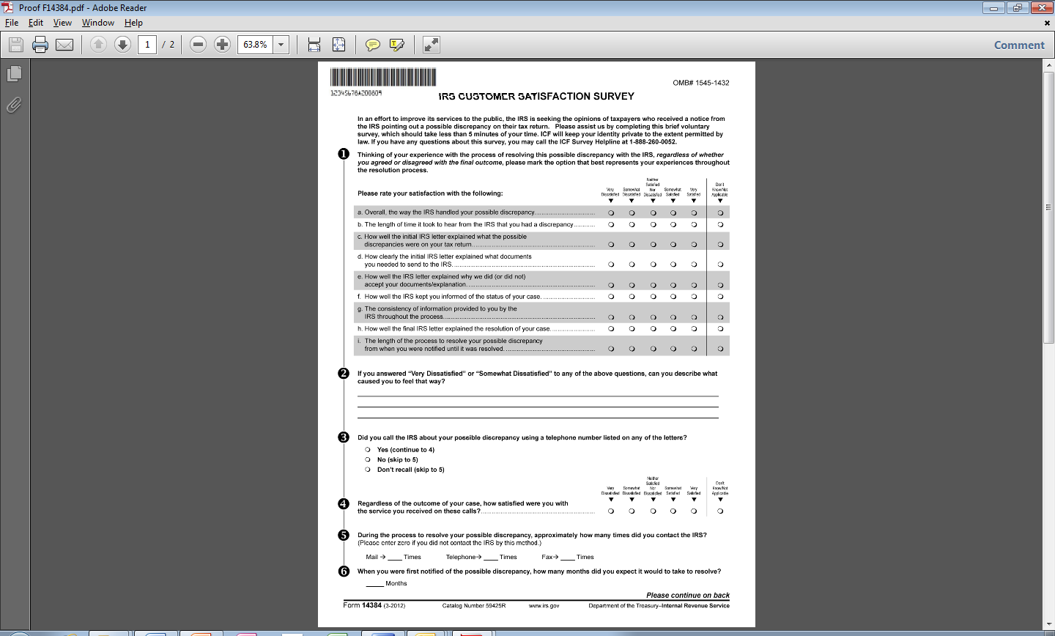

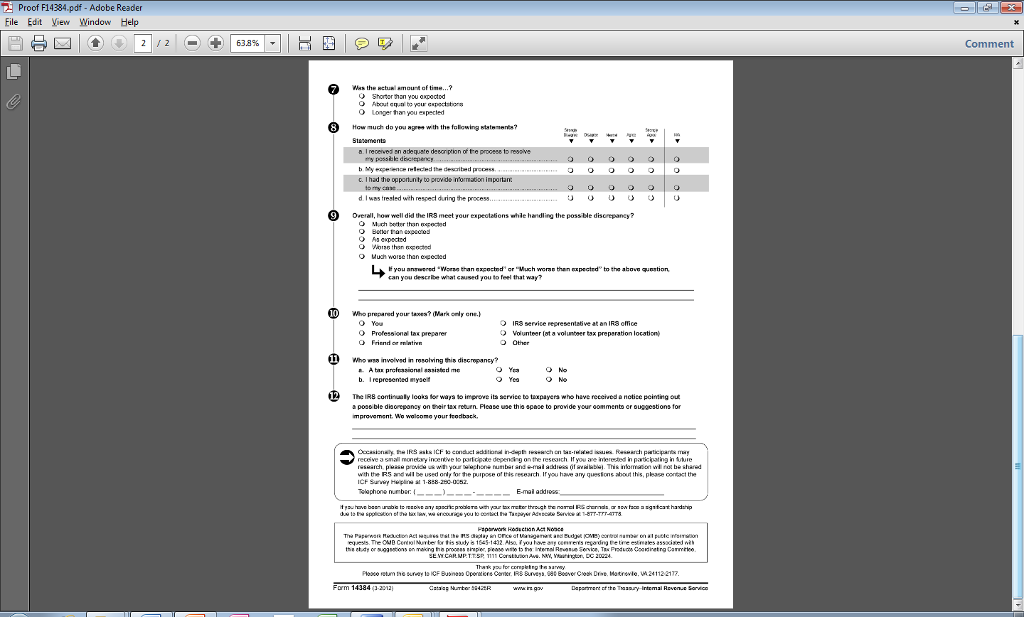

Do We Have Your Input Yet?

Recently, you received a survey asking your opinions about the service
you received from the IRS. If you have already completed and returned
the survey, please accept our sincere thanks. If not, please take a few minutes
to complete and return it today. We want to be sure we have your opinions
and suggestions for improving the IRS’s service to the public.

If you did not receive the survey, or it has been misplaced, please call us
at 1-888-260-0052.

John Hurley
Project Director
ICF International

L3_14384
Dear

Recently you received a letter requesting your help with an important research project. So far, we have not received your completed survey. If you have already completed and returned the survey questions, thank you. If you have not completed the survey, please take a few minutes to fill in your responses. If another person was primarily responsible for dealing with the Internal Revenue Service (IRS) on this matter, please give the survey to that person and encourage him or her to respond.

As described in our previous communication, ICF International is administering a nationwide survey among people who have had contact with the IRS. We want to know your opinions about the process of resolving a possible discrepancy between the information reported on your tax return and information provided to the IRS by organizations such as banks and employers. Your responses are critical to the accurate evaluation of the IRS's service.

You may complete the survey either by mail or online. If you choose to complete it online, please enter the following internet address in your web browser: www.IRSsurvey.com

Once you access the website for the survey, you will be asked for a unique password. Please enter the password below:

PASSWORD:

The password will save any answers you've entered in the event of computer disruptions. ICF will not share your password with the IRS at any time during or after this study.

ICF will hold your identity anonymous and will not provide any of your identifying information to the IRS. Your answers will be grouped with others, so that no individual reply can be traced back to a person or case number. Your participation is voluntary.

The survey should take less than 5 minutes to complete. We have included a postage-paid reply envelope for you to return your completed survey. If you have any questions or concerns, please feel free to contact ICF's Survey Helpline at 1-888-260-0052.

The IRS is committed to improving its performance and service to the American public. A first step in this process is to gather reliable information from those who have had contact with IRS employees and services. Your honest opinions will help bring about this improvement.

Thank you in advance for your participation.

Sincerely,

John Hurley
Project Director
ICF International

L4_14384

