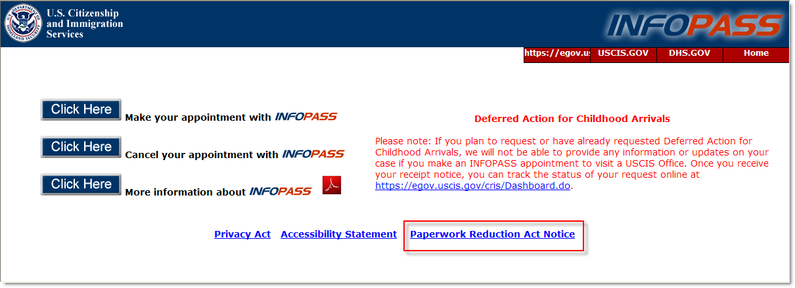

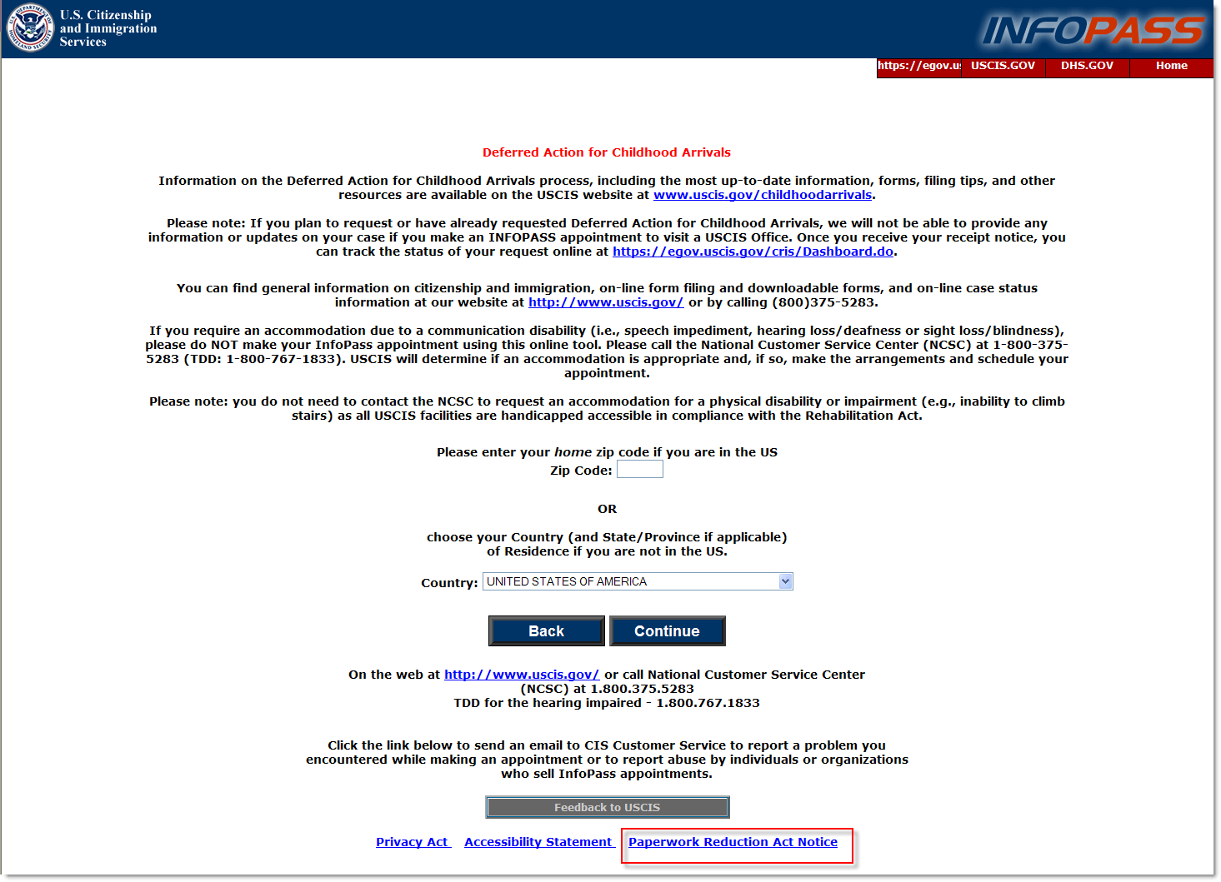

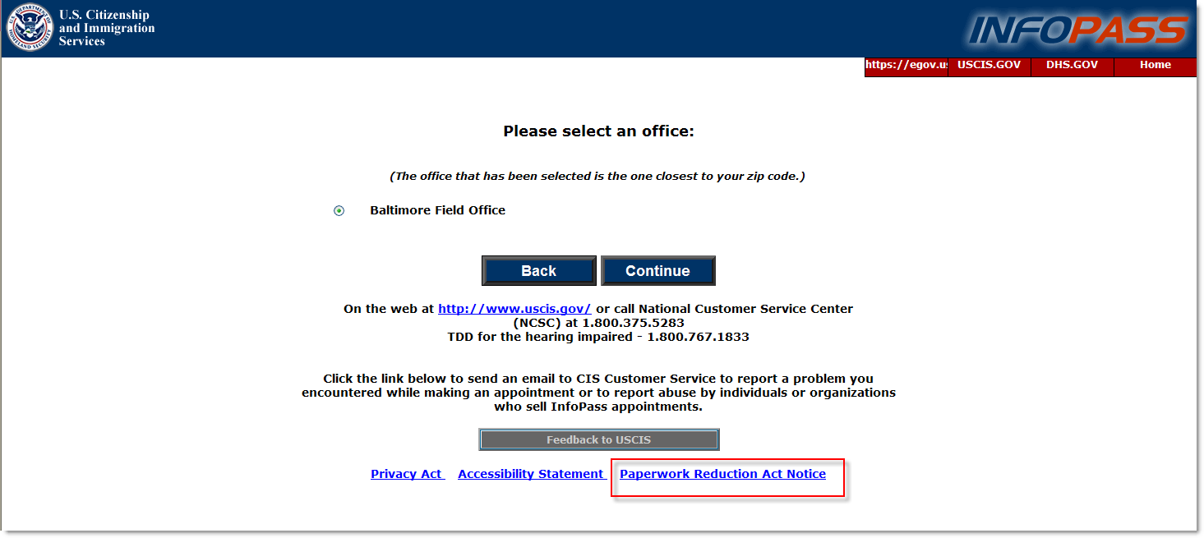

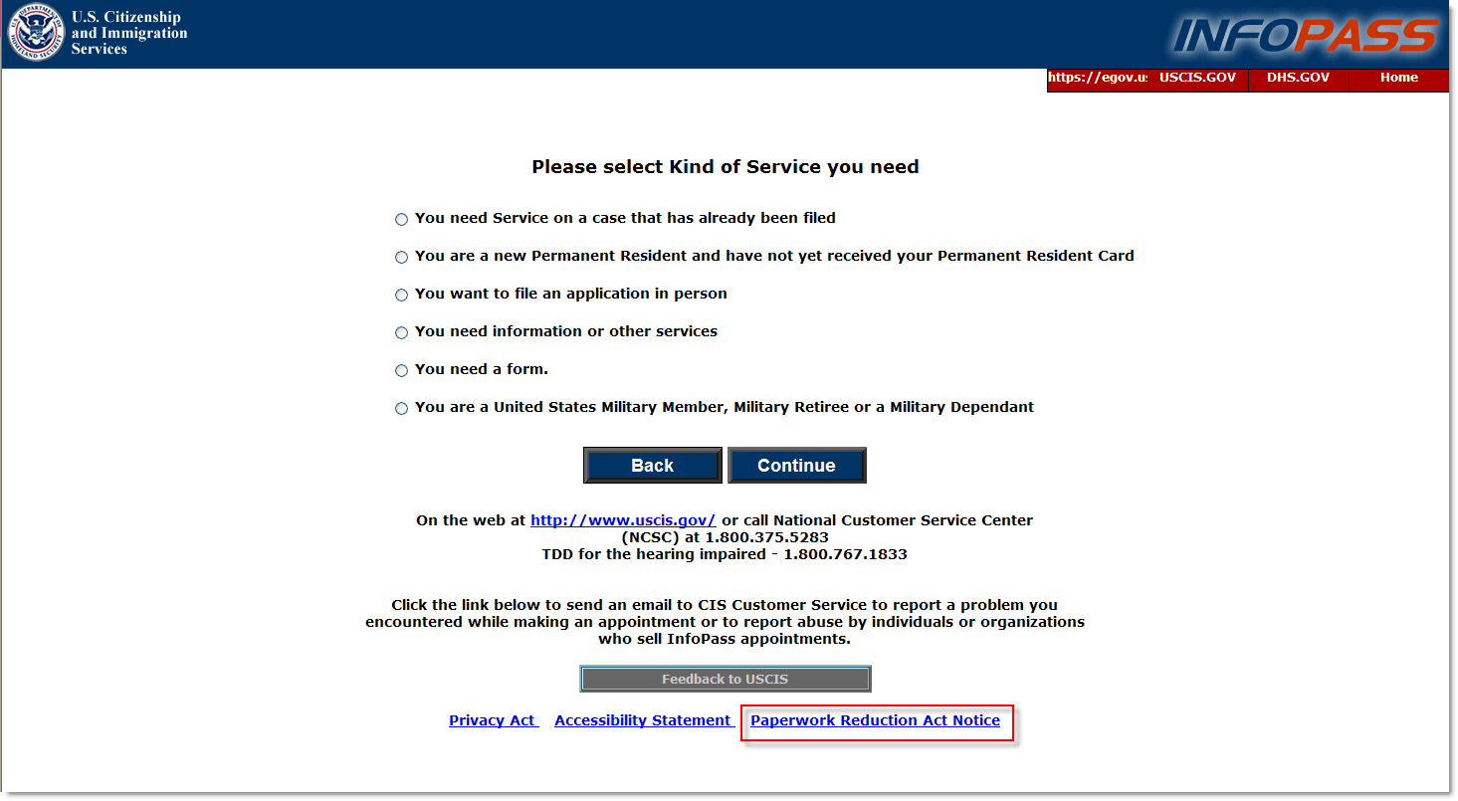

OMB Control Number: 1615-0113
Expiration Date: 02-28-2013

An agency may not conduct or sponsor an information collection, and a person is not required to respond to a collection of information unless it displays a currently valid OMB control number. The public reporting burden for this collection of information is estimated at 6 minutes per response, including the time for reviewing instructions and completing and submitting the information. Send comments regarding this burden estimate or any other aspect of this collection of information, including suggestions for reducing this burden, to: U.S. Citizenship and Immigration Services, Office of Policy and Strategy, Regulatory Coordination Division, 20 Massachusetts Avenue, N.W., Washington, DC 20529. OMB No. 1615-0113. Do not mail your application to this address.

