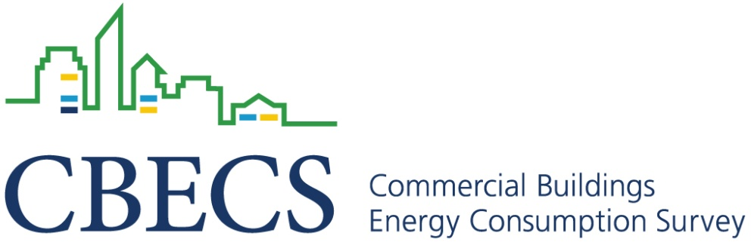

The following organizations recognize that the Commercial Buildings Energy Consumption Survey (CBECS) provides critically important information to support programs that promote energy efficiency in commercial buildings in the U.S. These organizations strongly encourage participation in the 2012 CBECS.

*A.I.D. Development Group*

*American Council for an Energy-Efficient Economy (ACEEE)*

*American Hotel & Lodging Association*

*American Society of Civil Engineers (ASCE)*

*American Society of Interior Designers (ASID)*

*APPA, "Leadership in Educational Facilities"*

*Architecture 2030*

*ASHRAE*

*Boston Properties*

*Brandywine Realty Trust*

*Building Owners and Managers Association (BOMA) International*

*CannonDesign*

*Cassidy Turley*

*Center for Environmental Innovation in Roofing*

*Center for Small Business and the Environment*

*Cushman & Wakefield*

*Duke Realty*

*Energy Design Service Systems*

*Forest City Enterprises*

*Green Building Initiative (GBI)*

*Grundfos*

*Illuminating Engineering Society of North America*

*Institute for Market Transformation (IMT)*

*International Association of Lighting Designers (IALD)*

*International Council of Shopping Centers*

*LonMark International*

*Lord Green Strategies*

*Malachite LLC*

*National Association of Electrical Distributors*

*National Association of Real Estate Investment Trusts*

*National Environmental Balancing Bureau (NEBB)*

*National Fenestration Rating Council (NFRC)*

*National Fire Protection Association*

*National Institute of Building Sciences (NIBS)*

*National Insulation Association (NIA)*

*Servidyne*

*Sheet Metal and Air Conditioning Contractors National Association, Inc (SMACNA, Inc)*

*Siemens*

*Spray Polyurethane Foam Alliance (SPFA)*

*SUN DAY Campaign*

*The American Institute of Architects (AIA)*

*The International Association of Plumbing and Mechanical Officials (IAPMO)*

*The Real Estate Roundtable*

*Thomas Properties Group, Inc.*

*Transwestern*

*U.S. Green Building Council*

*U.S. Environmental Protection Agency ENERGY STAR Program*

*U.S. Environmental Protection Agency WaterSense Program*

*USAA Real Estate Company*

*Vornado Realty Trust*