Screen Shots for CEEMP PRA

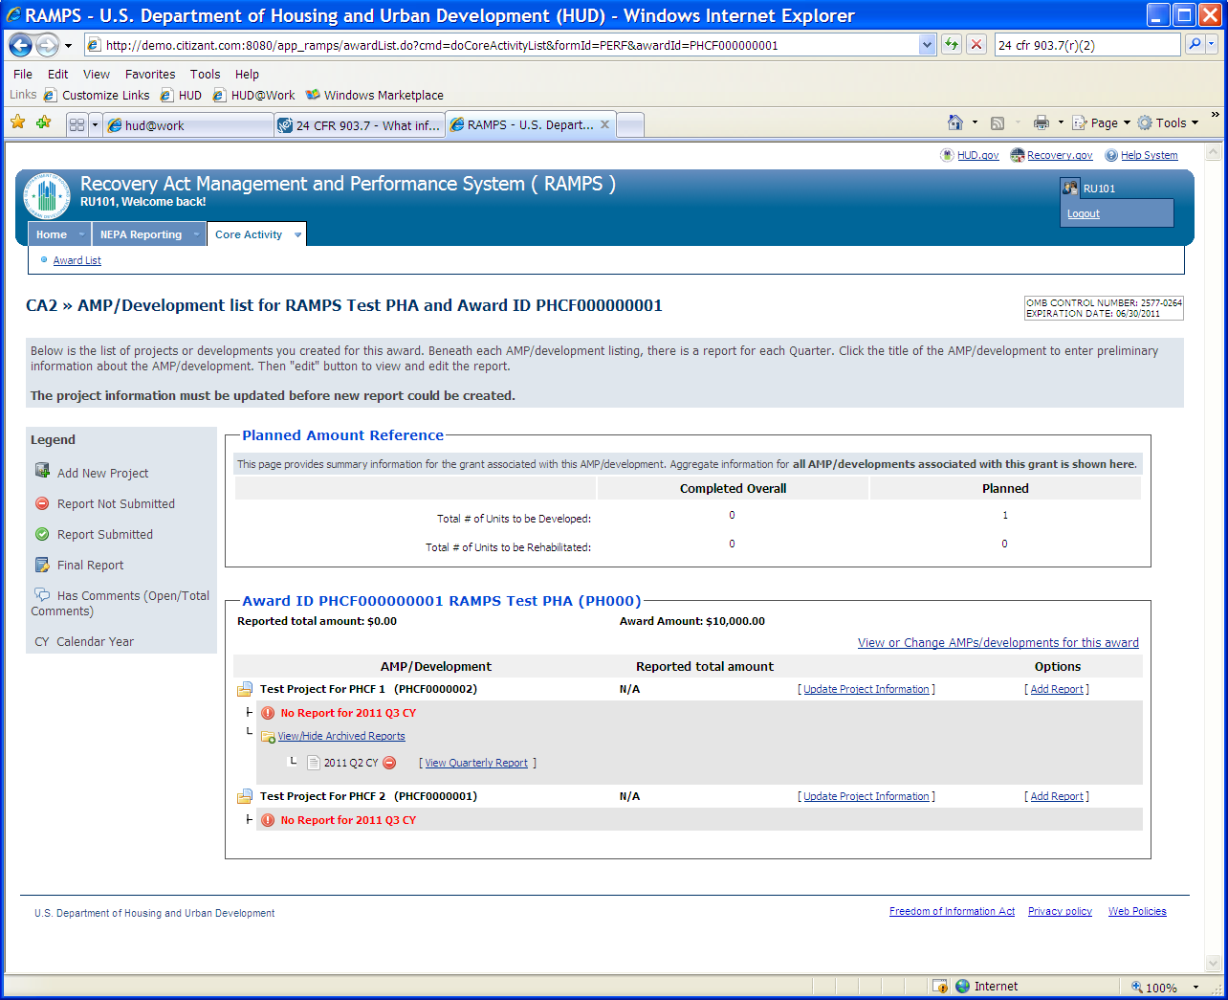
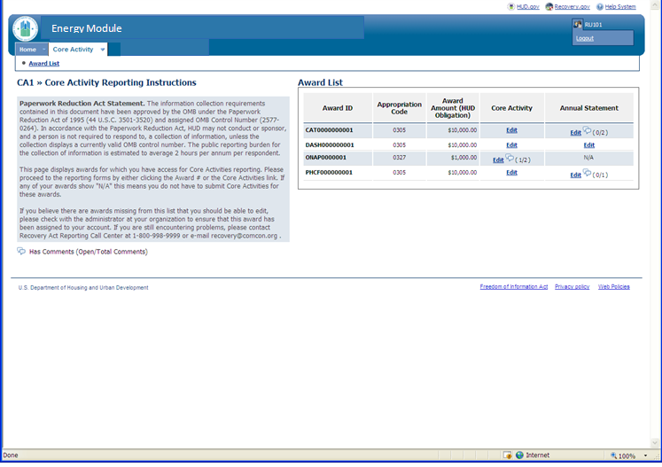
Figure 1 - Opening screen. User selects Award.
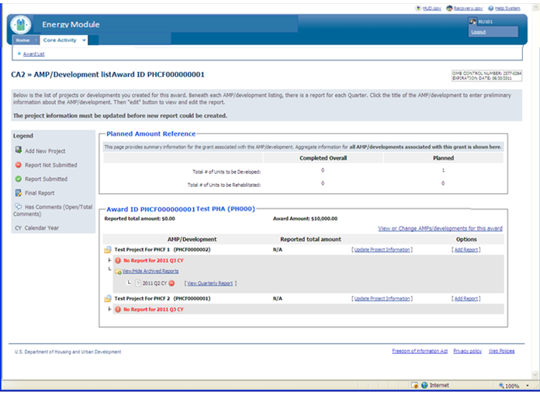
Figure 2 - User selects Development/AMP
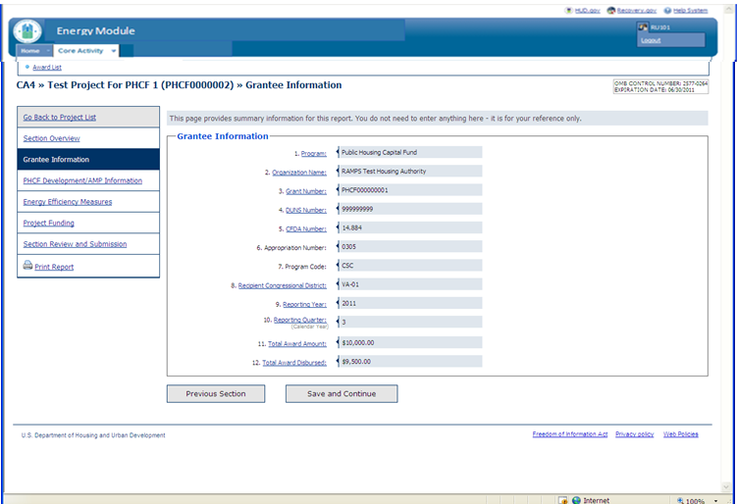
Figure 3 Grantee Information screen pre-populated.

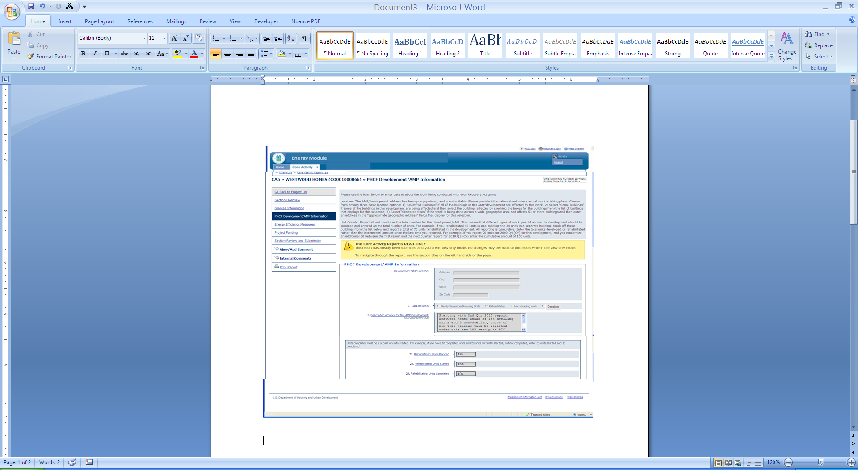
Figure 4 - Development Information. Address information will be pre-populated. User will provide work type information, description and numbers for units impacted.

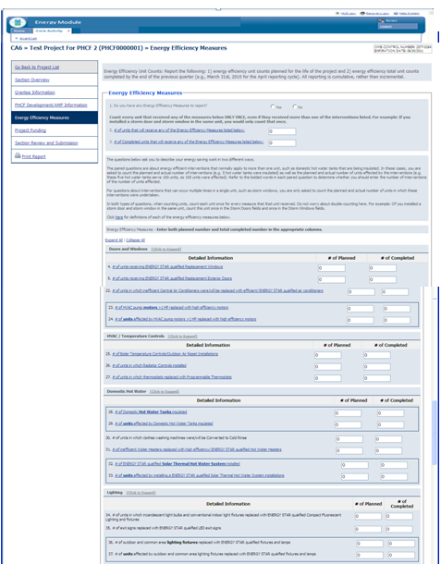

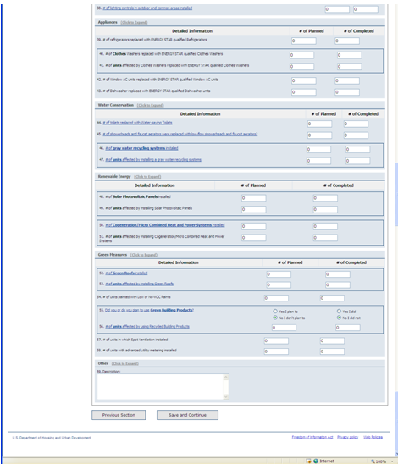

Figure 5 - User inputs number of units receiving energy conservation measures and enumerates specific measures being implemented.

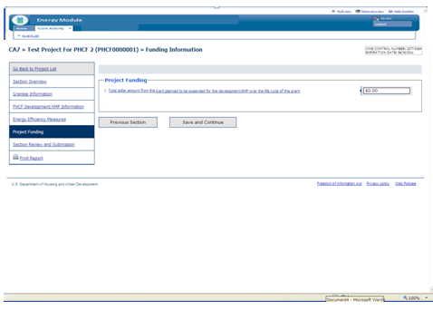
Figure 6 - User asked to input amount of grant being used for this project.

