NMFS Recreational HMS Reporting Website Screen Shots
15 November 2012

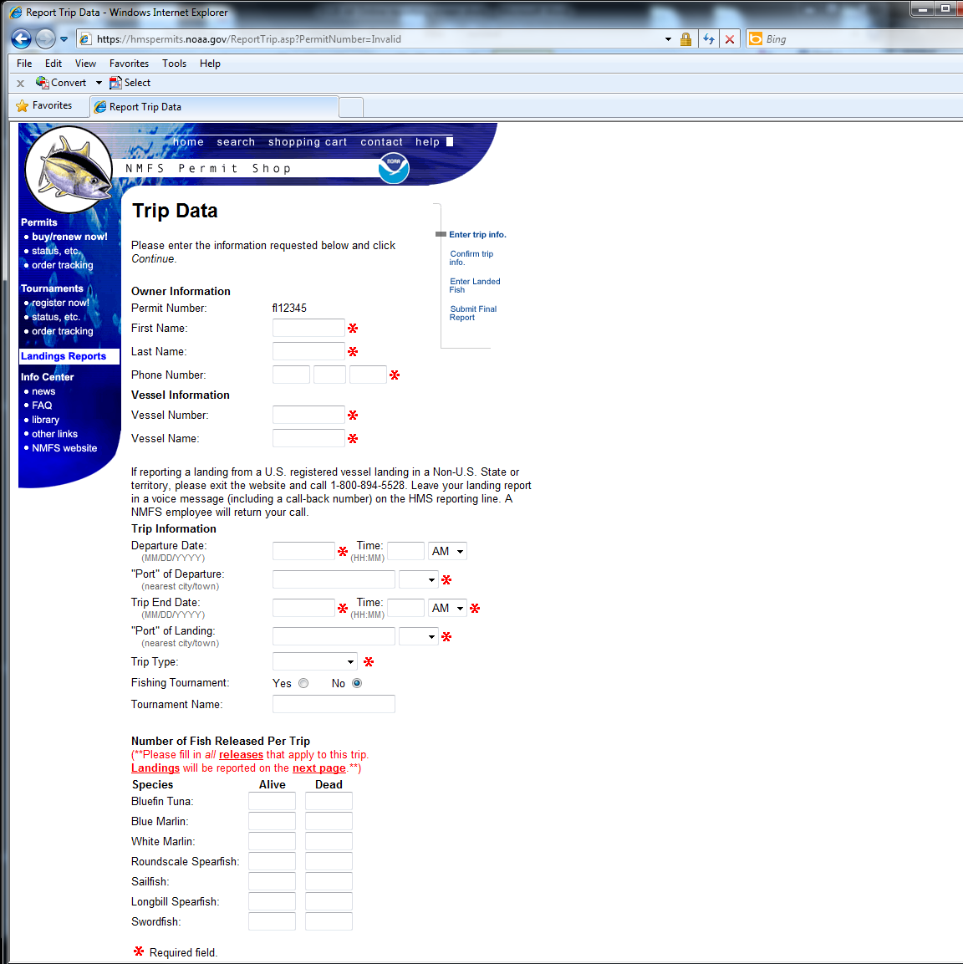

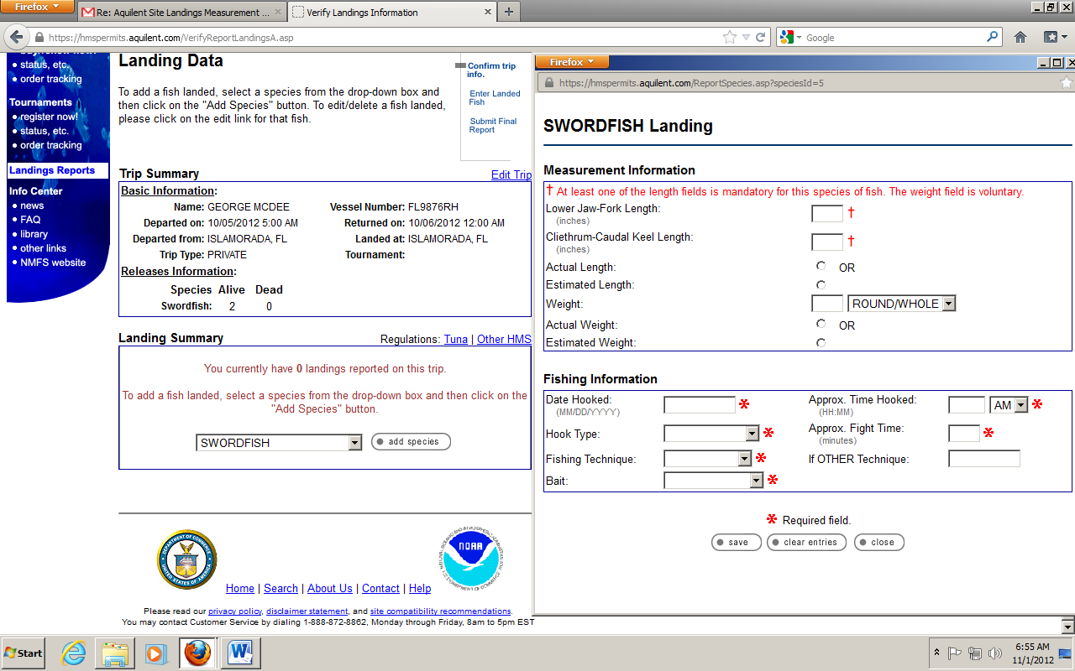
Clicking Paperwork Reduction Act Statements opens a .doc containing the following text:
The following Paperwork Reduction Act (PRA) Statements supercede other PRA statements for Atlantic HMS and Atlantic tunas permitting (OMB control number 0648-0327) and mandatory catch reporting for bluefin tuna (OMB control number 0648-0328).
PAPERWORK REDUCTION ACT STATEMENT: Collection of information through annual permitting serves three purposes: (1) it provides current information on the vessel owners participating in the Atlantic HMS and tuna fisheries. (2) it provides an up-to-date sampling frame that is the basis for fleet size calculations used for catch and effort estimates in fisheries that do not require mandatory reporting, thus enabling the U.S. to meet international obligations to report catch statistics for Atlantic tunas, and (3) aids NMFS in the enforcement of fishery regulations. Public reporting burden for this initial permit application of information is estimated to average 30 minutes per response, including time for reviewing instructions, searching existing data sources, gathering and maintaining data needed, and completed & reviewing the collection of information. Permit renewals are accomplished by using an automated phone system at (888) 872-8862 or by accessing the web site at www.nmfspermits.com. Public reporting burden for renewal by telephone or web is estimated to average 6 minutes per response. Send comments regarding this burden estimate or any other aspect of this collection of information, including suggestions for reducing this burden to: National Marine Fisheries Service, F/SF1, 1315 East West Highway, Silver Spring, MD 20910. Providing the requested information in the permit application is mandatory for managing the Atlantic HMS and tuna fisheries in accordance with the Atlantic Tunas Convention Act (16 U.S.C. 971 et seq.) and the Magnuson-Stevens Fishery Conservation and Management Act (Magnuson-Stevens Act). It is agency policy not to release confidential information, other than in aggregate form, as the Magnuson-Stevens Act protects (in perpetuity) the confidentiality of those submitting information. Summaries of permit information by category may be released. Notwithstanding any other provision of the law, no person is required to respond to, nor shall any person be subject to a penalty for failure to comply with a collection of information subject to the requirements of the Paperwork Reduction Act, unless that collection of information displays a currently valid OMB Control Number. This is an approved information collection under OMB #0648-0327 and expires July 31, 2015.
PAPERWORK REDUCTION ACT STATEMENT: Mandatory catch reporting provides essential information for the conservation and management of Atlantic bluefin tuna. Information on catch levels will be reported to the International Commission for the Conservation of Atlantic Tunas and will be used for stock assessment and in developing international catch sharing agreements. Public reporting burden for this collection of information is estimated to average 5 minutes per response for telephone (1-888-872-8862) or internet reports (at www.nmfspermits.com), and 10 minutes per response for landing card reports. These response burden estimates include the time for reviewing instructions, searching existing data sources, gathering and maintaining the data needed, and completing and reviewing the collection of information. Send comments regarding these burden estimates or any other aspect of this collection of information, including suggestions for reducing this burden, to: NMFS, Highly Migratory Species (F/SF1), 1315 East-West Highway, Silver Spring, MD 20910. Catch reporting is required under the authority of the Atlantic Tunas Convention Act. It is NOAA policy to preserve the confidentiality of information submitted under this reporting requirement, except that NMFS may release such information in aggregate or summary form, such that individual identifiers are not disclosed (NAO 216-100). Notwithstanding any other provision of the law, no person is required to respond to, nor shall any person be subject to a penalty for failure to comply with, a collection of information subject to the requirements of the Paperwork Reduction Act, unless that collection of information displays a currently valid OMB Control Number. This information collection is approved under OMB Control # 0648-0328. The OMB expiration date for this data collection may be obtained by contacting the HMS management division at 301-713-2347 or by calling customer service at 888-872-8862.

