Ambulatory Component, National Hospital Care Survey
OMB No. 0920-0212 Exp. Date: XX/XX/XXXX
Assurance of confidentiality – All information which would permit identification of an individual, a practice, or an establishment will be held confidential, will be used for statistical purposes only by NCHS staff, contractors, and agents only when required and with necessary controls, and will not be disclosed or released to other persons without the consent of the individual or establishment in accordance with section 308(d) of the Public Health Service Act (42 USC 242m) and the Confidential Information Protection and Statistical Efficiency Act (PL-107-347).
Notice – Public reporting burden for this collection of information is estimated to average 0 minutes per response, including time for reviewing instructions, searching existing data sources, gathering and maintaining the data needed, and completing and reviewing the collection of information. An agency may not conduct or sponsor, and a person is not required to respond to, a collection of information unless it displays a current valid OMB control number. Send comments regarding this burden estimate or any other aspect of this collection of information, including suggestions for reducing burden to: CDC/ATSDR Information Collection Review Office, 1600 Clifton Road, MS D-74, Atlanta, GA 30333, ATTN: PRA (0920-0212).

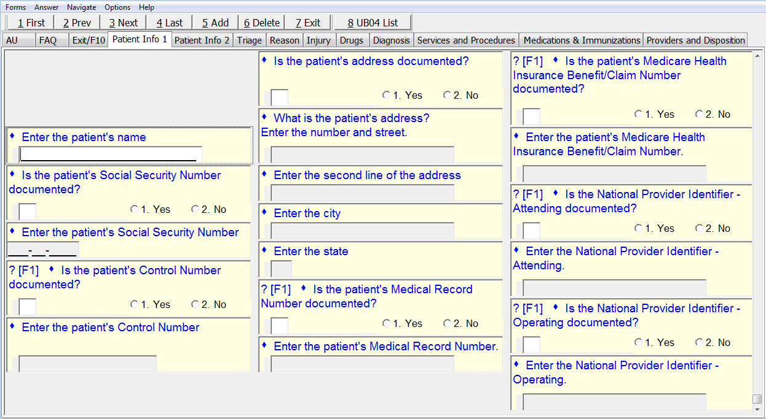

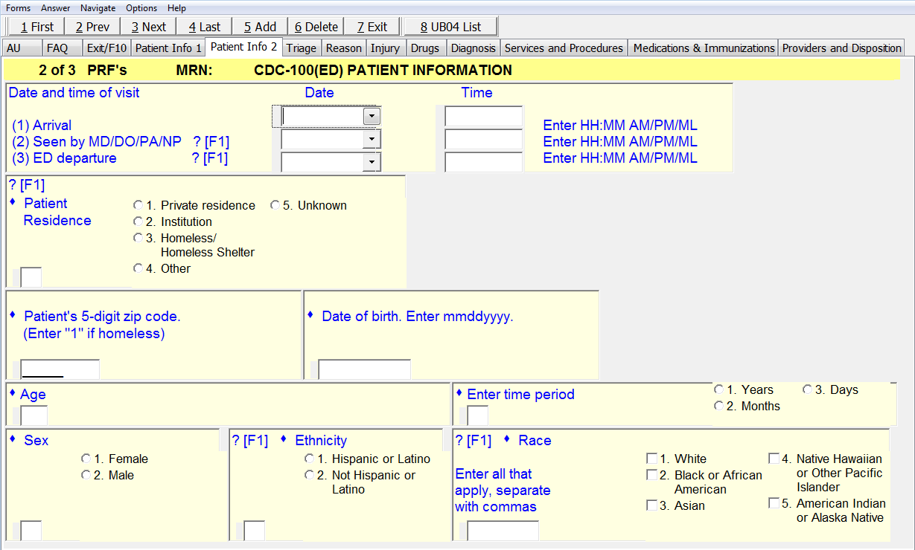
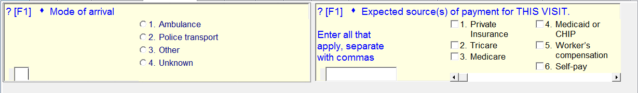

Payment sources 6-9.
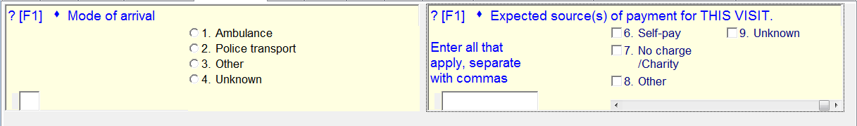

Not shown (not new):
For “Patient Residence” checkbox 2 “Institution”, the subcategories are Nursing home, Supportive housing/Group home, Jail/Prison, and Other.

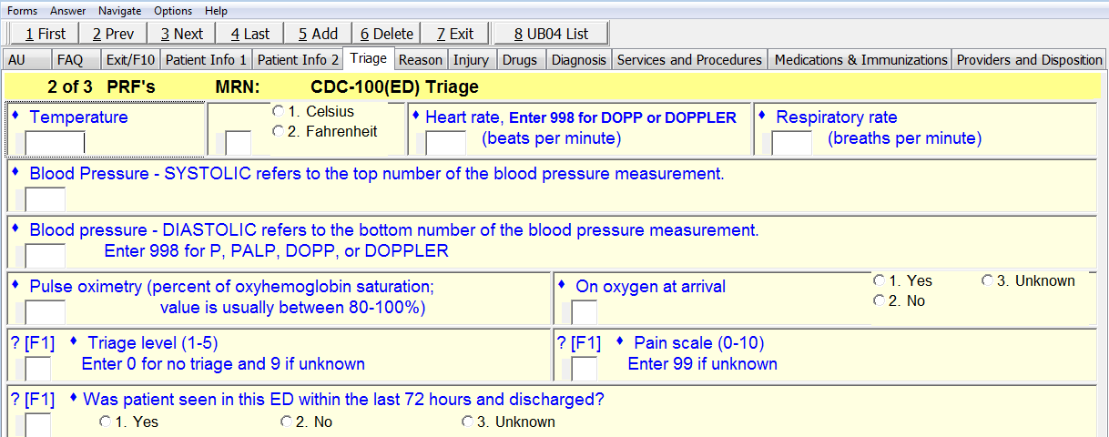
Initial vital signs
New:
Vital signs on ED discharge – Temperature, Heart rate, Respiratory rate, Blood pressure – systolic and diastolic

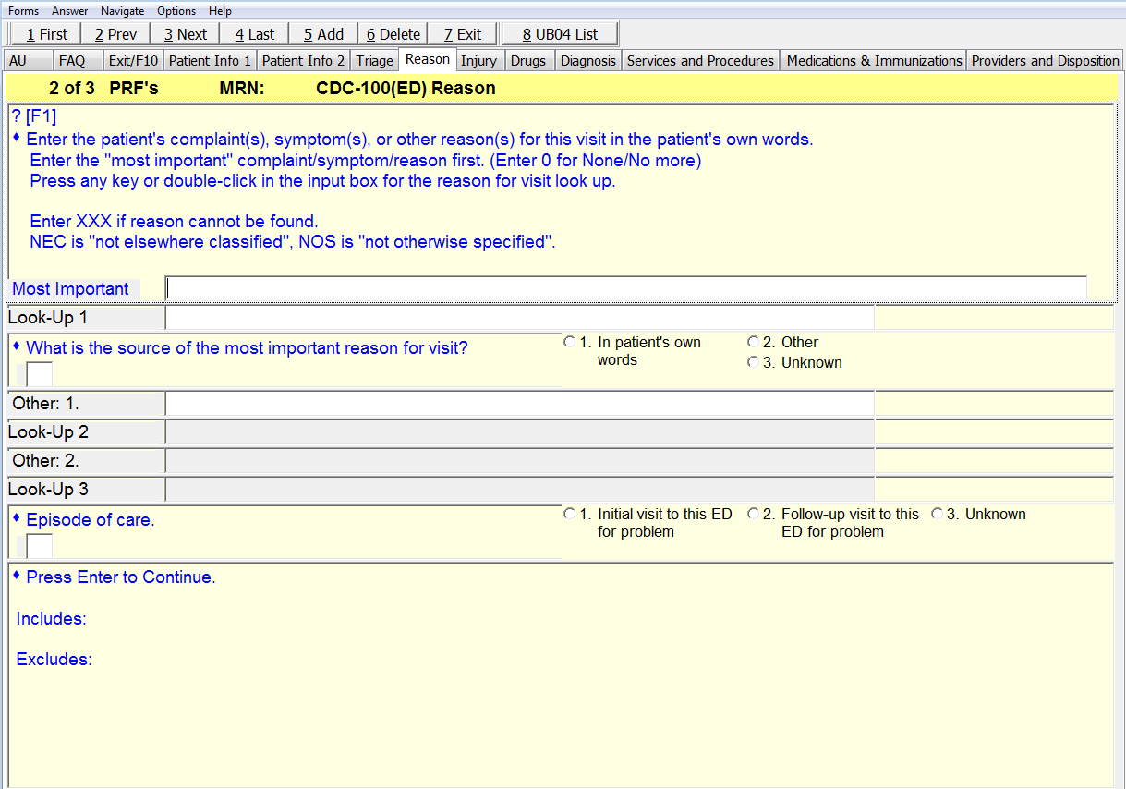
Revised: This question was moved from the SUBSTANCES INVOLVED item and will come after REASON FOR VISIT. It was also modified.
Did alcohol cause or contribute to this visit?
- Yes, patient’s own use
- Yes, other person’s use
- No
- Unknown

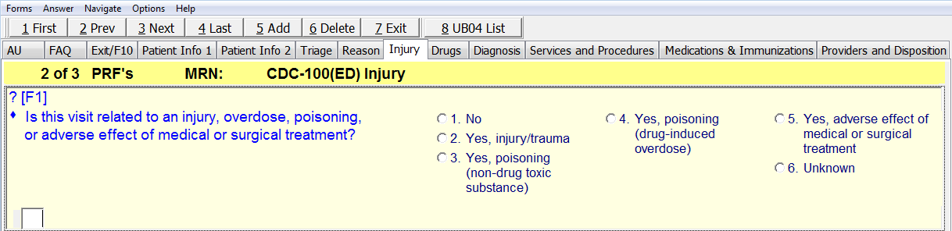
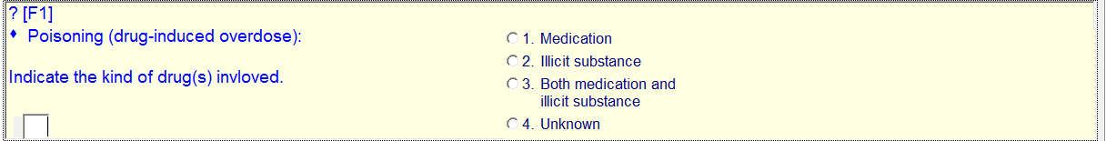
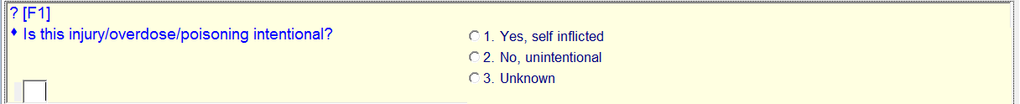
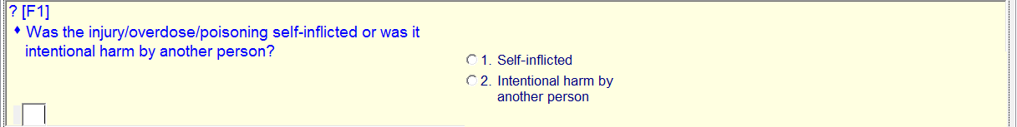

For “Is this injury/overdose/poisoning intentional?” the first checkbox “Yes, self-inflicted” should be replaced with “Yes, intentional (e.g., accidental).”
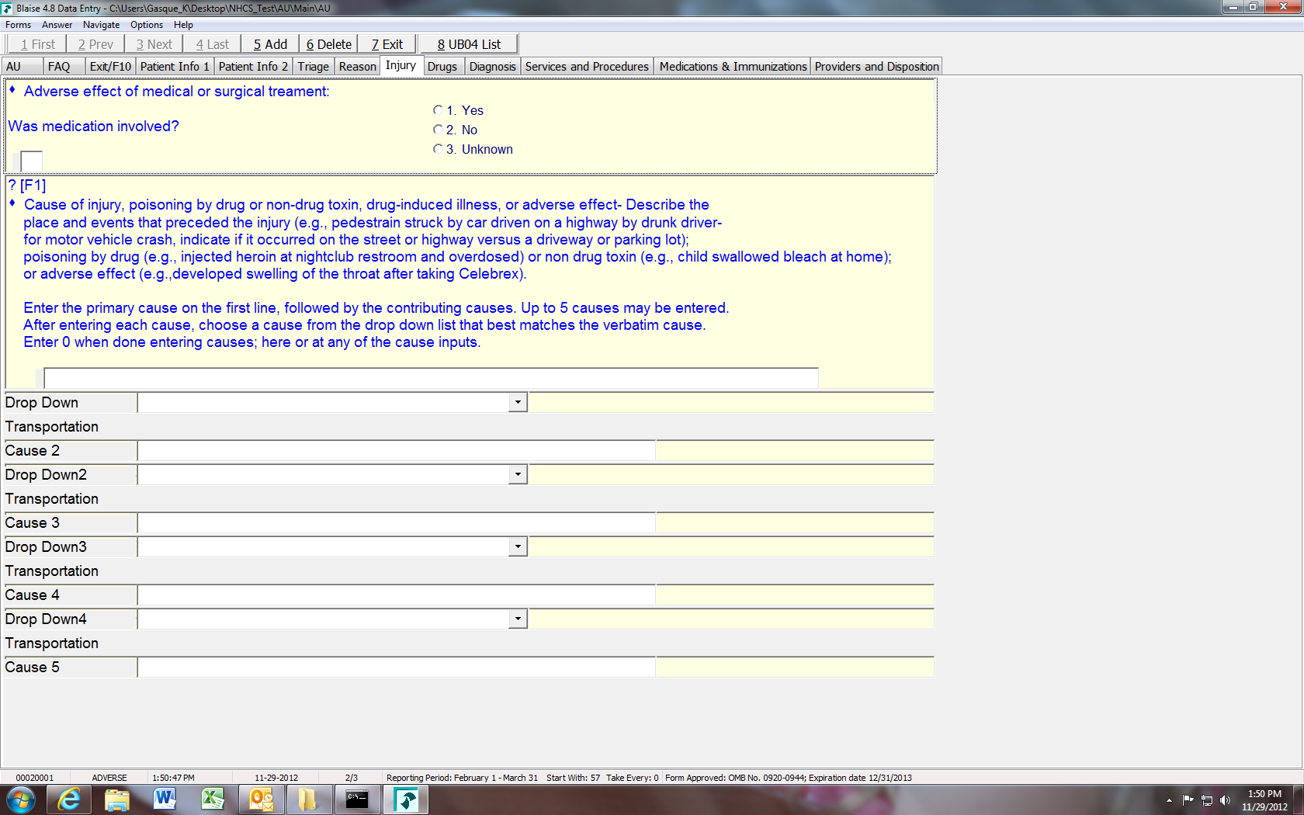

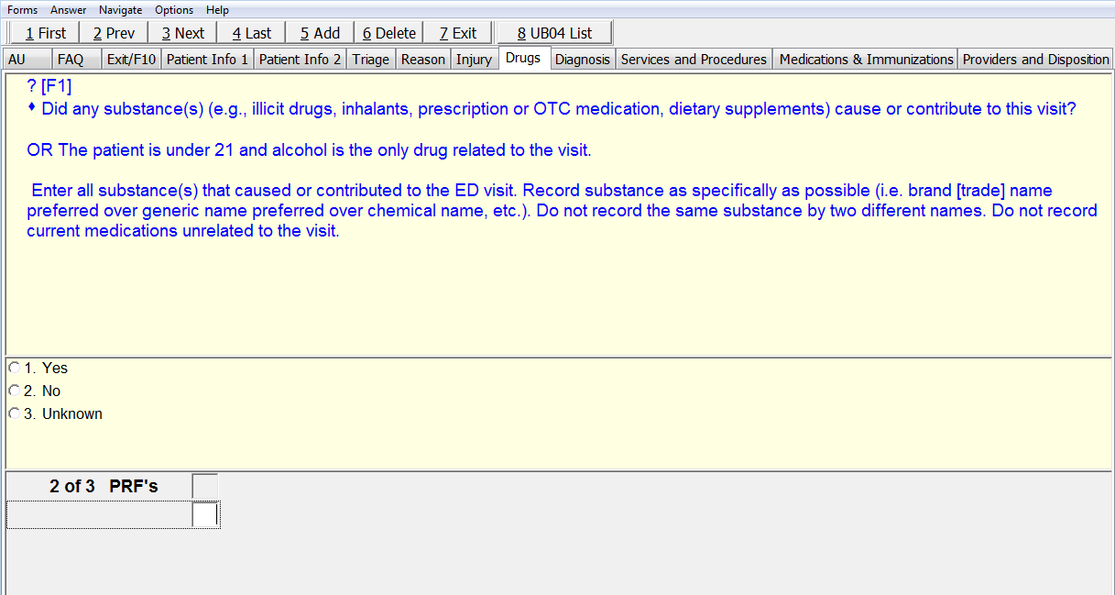
The 3rd checkbox should read “Unknown/Not documented.”
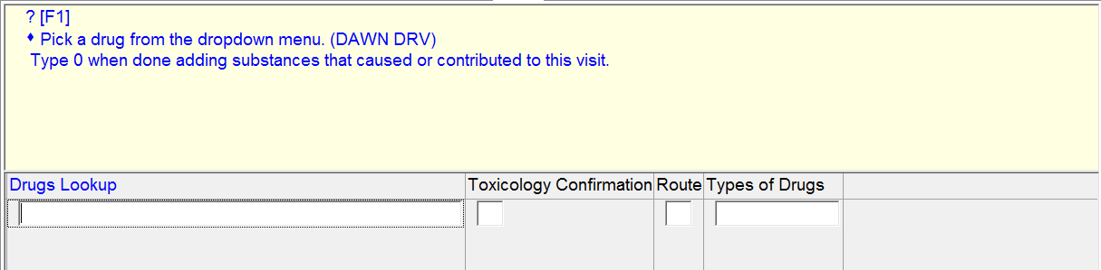
For “toxicology report” there should be a 3rd checkbox “Not documented.”
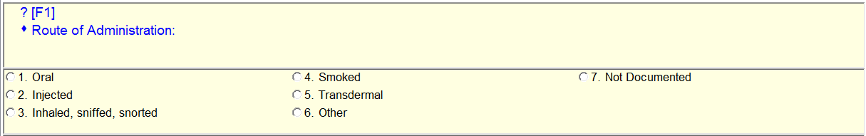
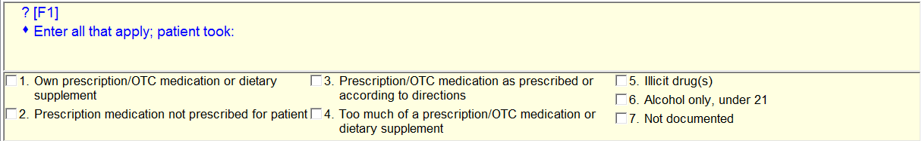
This question was moved to come after REASON FOR VISIT and was modified:
Was alcohol involved in this visit?

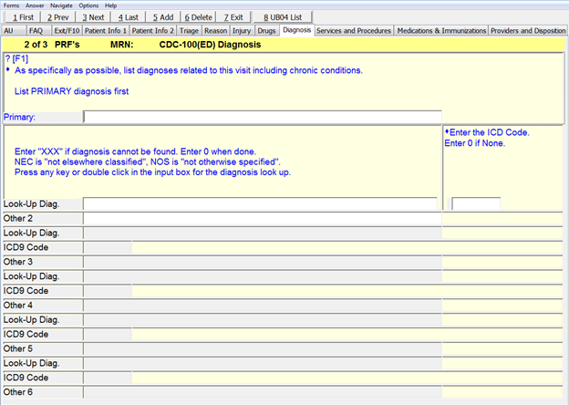
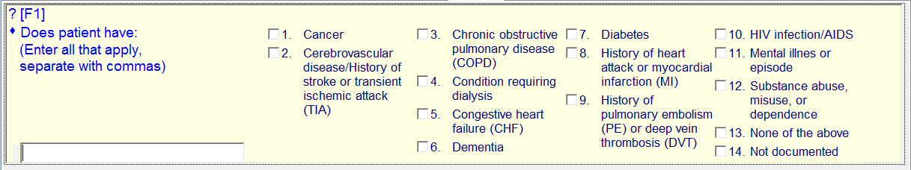
Not shown (not new except for PTSD):
Under checkbox 11 – Mental illness or episode are checkboxes for Bipolar disorder/Manic depression; Depression, excluding manic depression; Post-traumatic stress disorder (PTSD); Schizophrenia; Suicidal ideation; and Other.
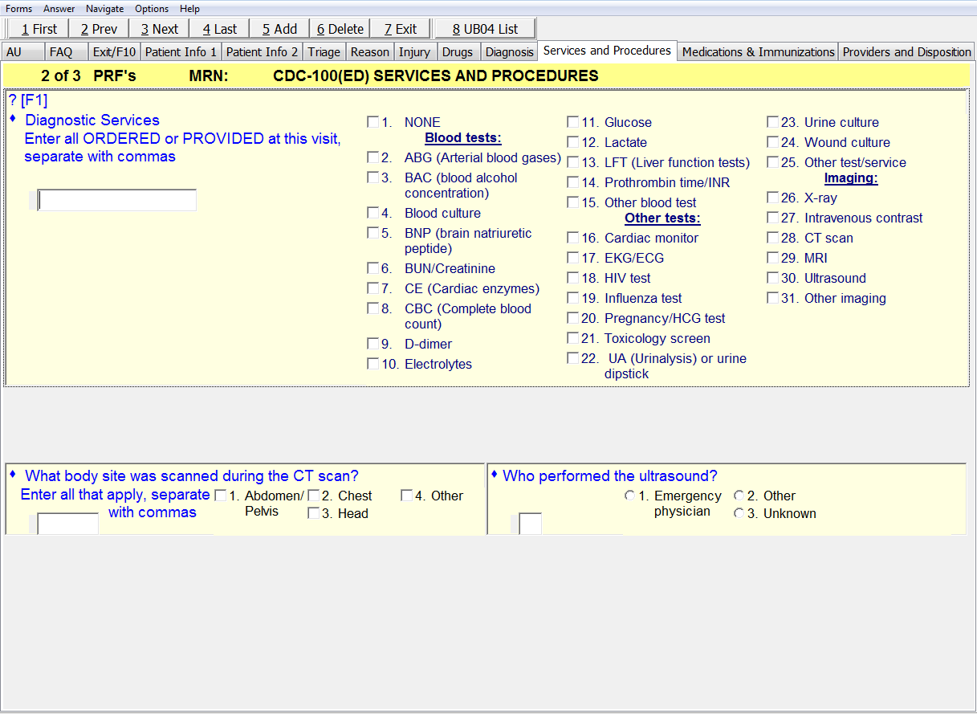
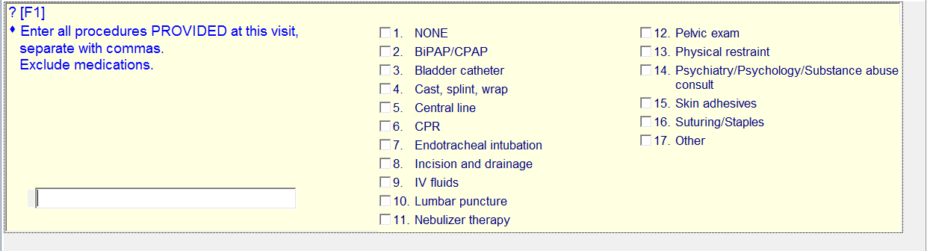

Not shown (not new):
Blood tests, checkbox 3 – BAC result will be entered.

New (revision):
Blood tests, checkbox 14 – “Prothrombin time/PTT/INR.”
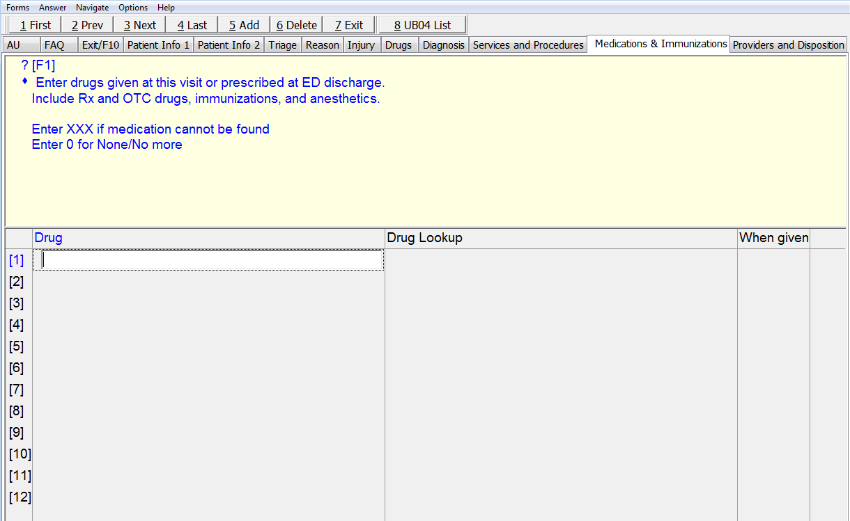

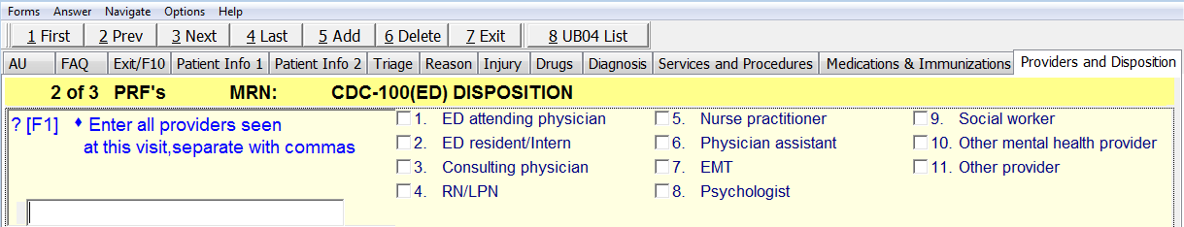
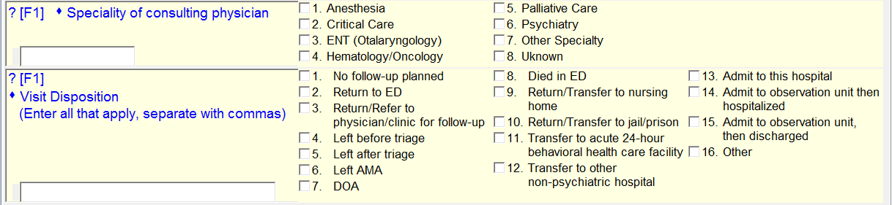
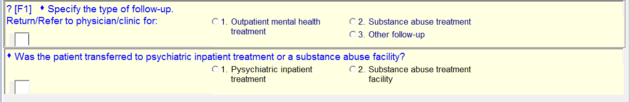
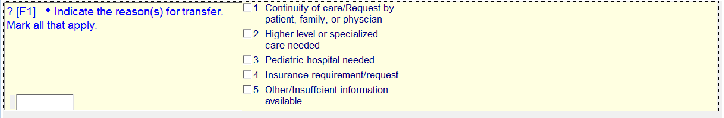
New:
For “Specialty of consulting physician” – add checkbox “General/Trauma Surgery”

New: (revision)
For “Visit disposition” checkbox 10 should read “Return/Transfer to jail/prison/law enforcement.”
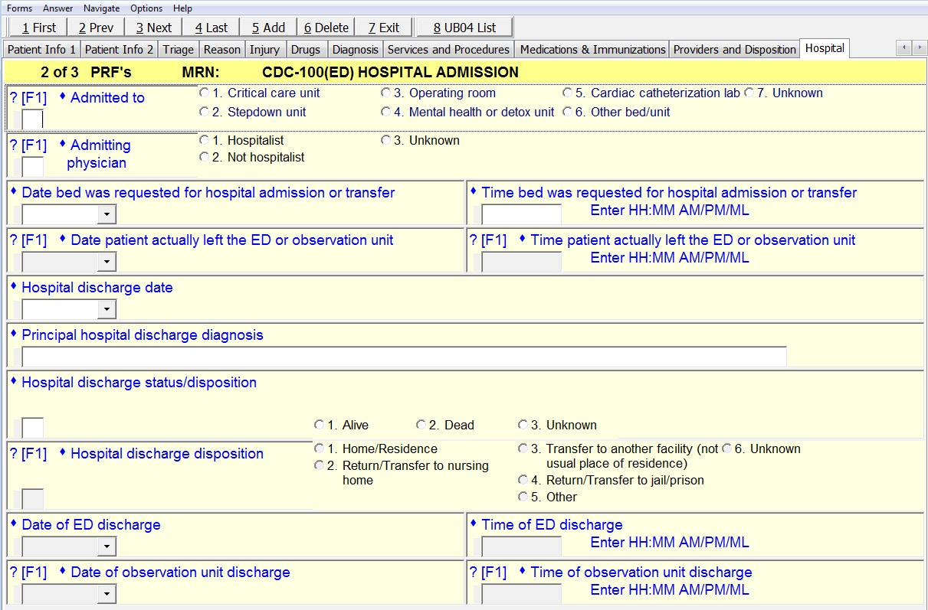

(Not shown – not new)
Under “Principal hospital discharge diagnosis” the second hospital discharge diagnosis will be collected.

