Ambulatory Component, National Hospital Care Survey
OMB No. 0920-0212 Exp. Date: XX/XX/XXXX
Assurance of confidentiality – All information which would permit identification of an individual, a practice, or an establishment will be held confidential, will be used for statistical purposes only by NCHS staff, contractors, and agents only when required and with necessary controls, and will not be disclosed or released to other persons without the consent of the individual or establishment in accordance with section 308(d) of the Public Health Service Act (42 USC 242m) and the Confidential Information Protection and Statistical Efficiency Act (PL-107-347).
Notice – Public reporting burden for this collection of information is estimated to average 0 minutes per response, including time for reviewing instructions, searching existing data sources, gathering and maintaining the data needed, and completing and reviewing the collection of information. An agency may not conduct or sponsor, and a person is not required to respond to, a collection of information unless it displays a current valid OMB control number. Send comments regarding this burden estimate or any other aspect of this collection of information, including suggestions for reducing burden to: CDC/ATSDR Information Collection Review Office, 1600 Clifton Road, MS D-74, Atlanta, GA 30333, ATTN: PRA (0920-0212).

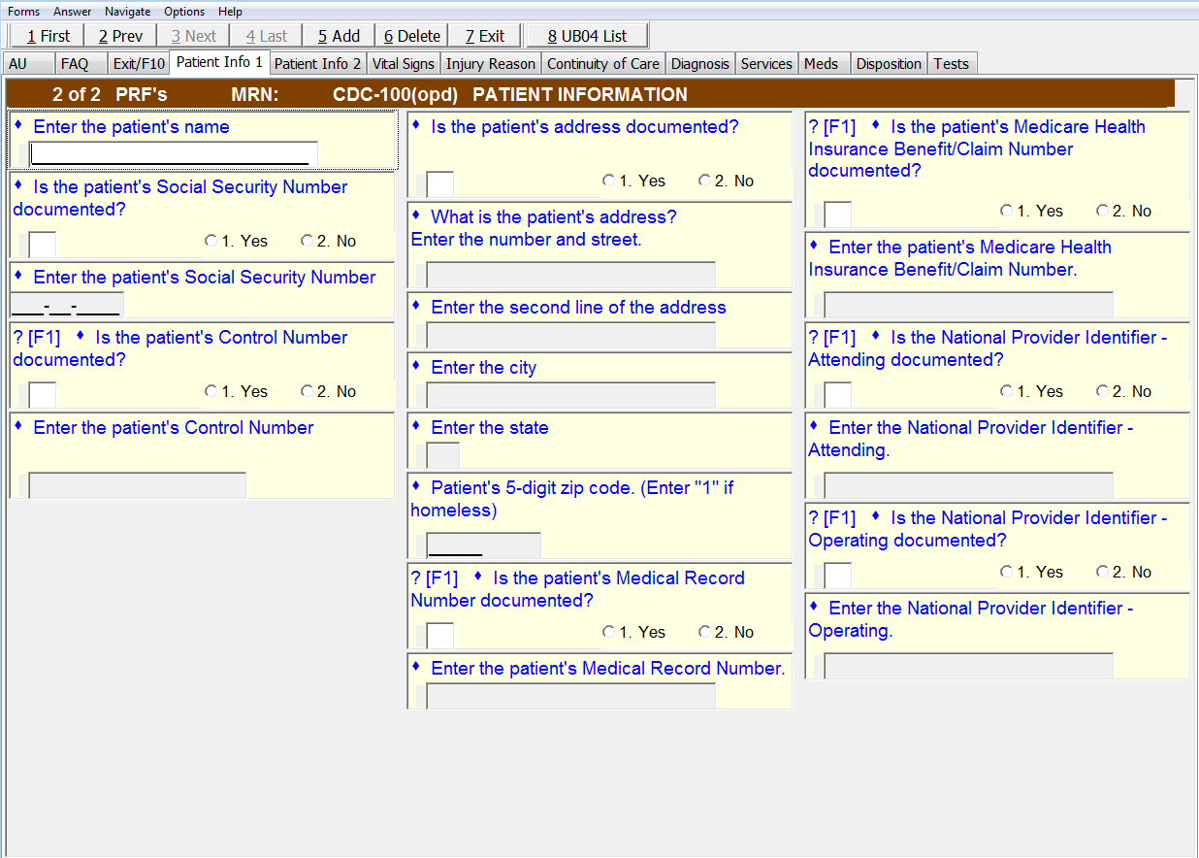
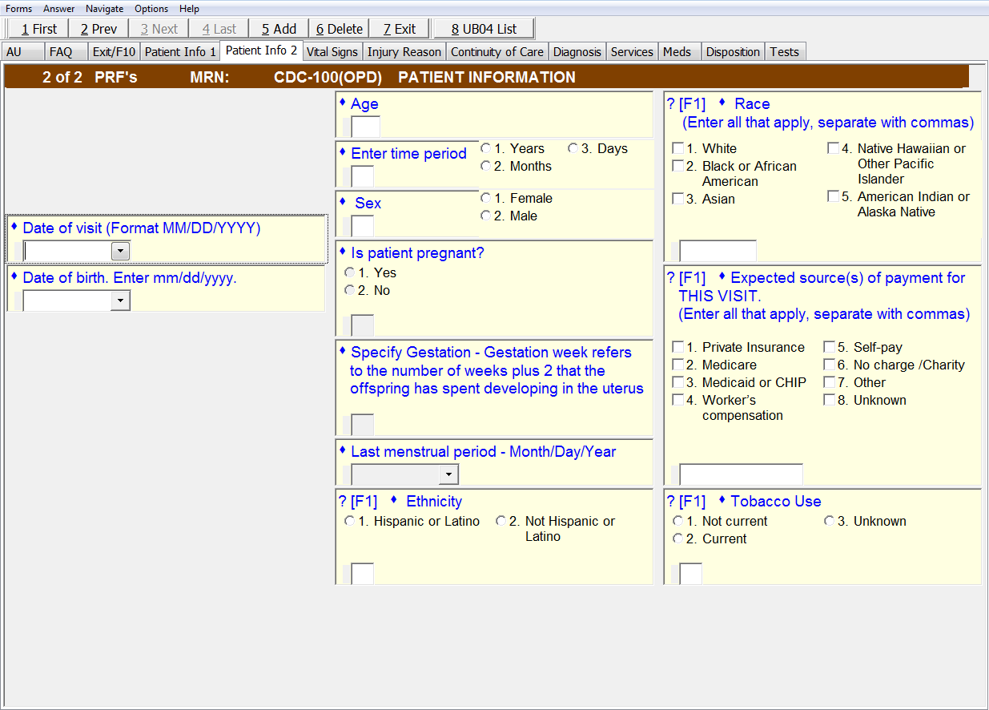

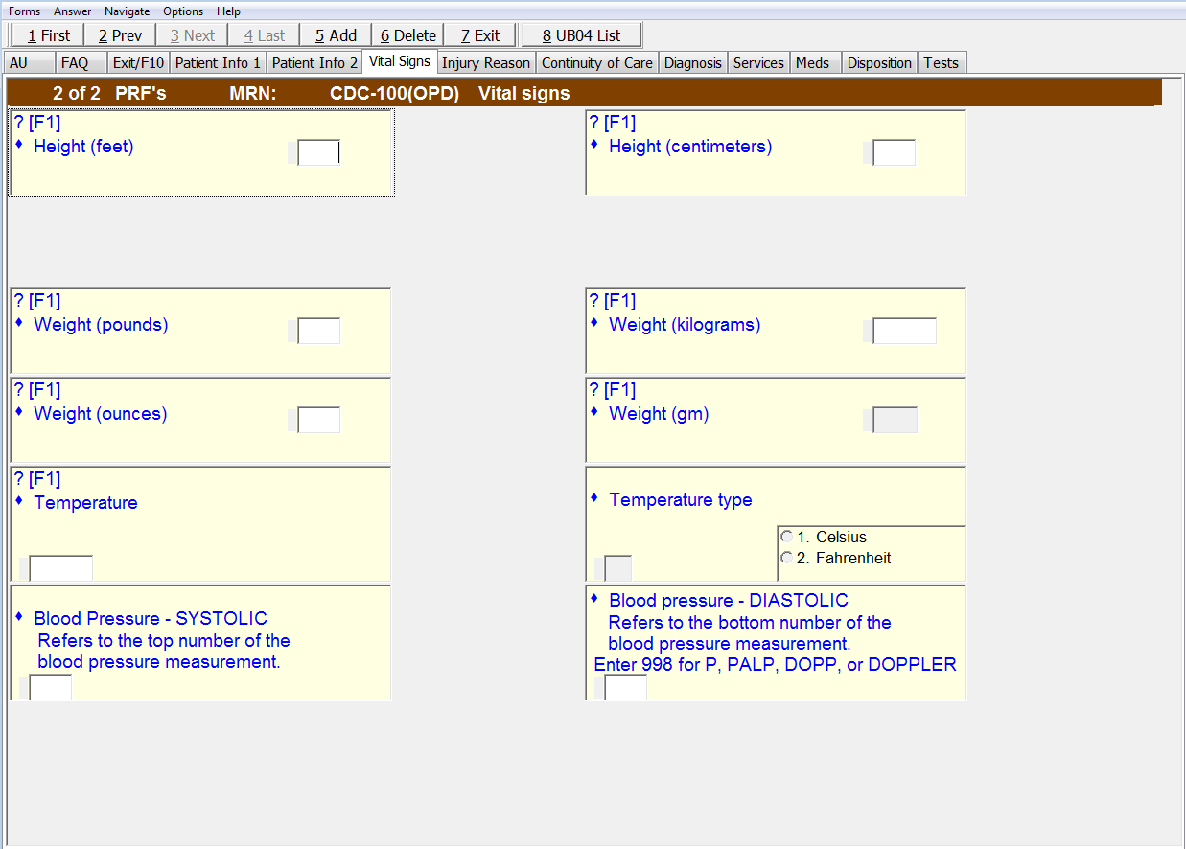

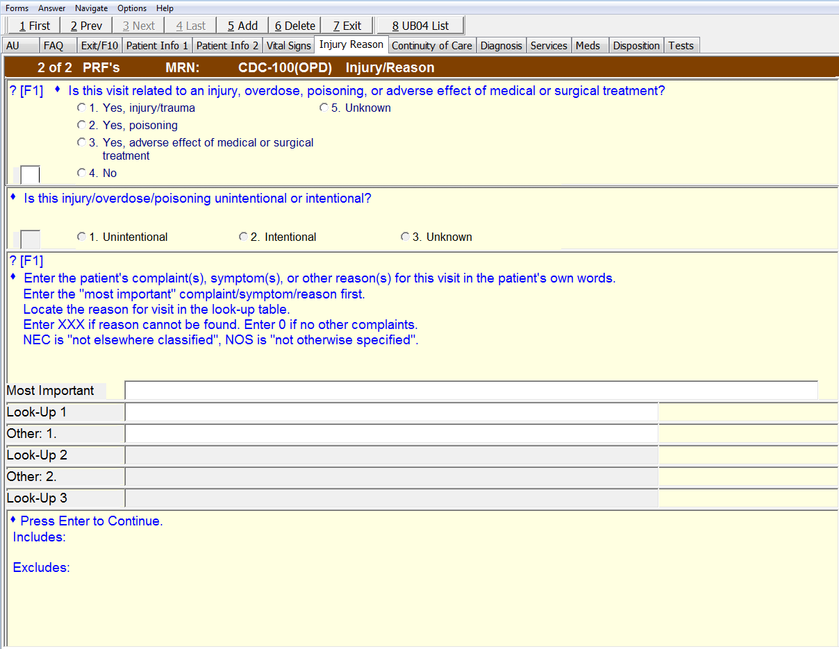
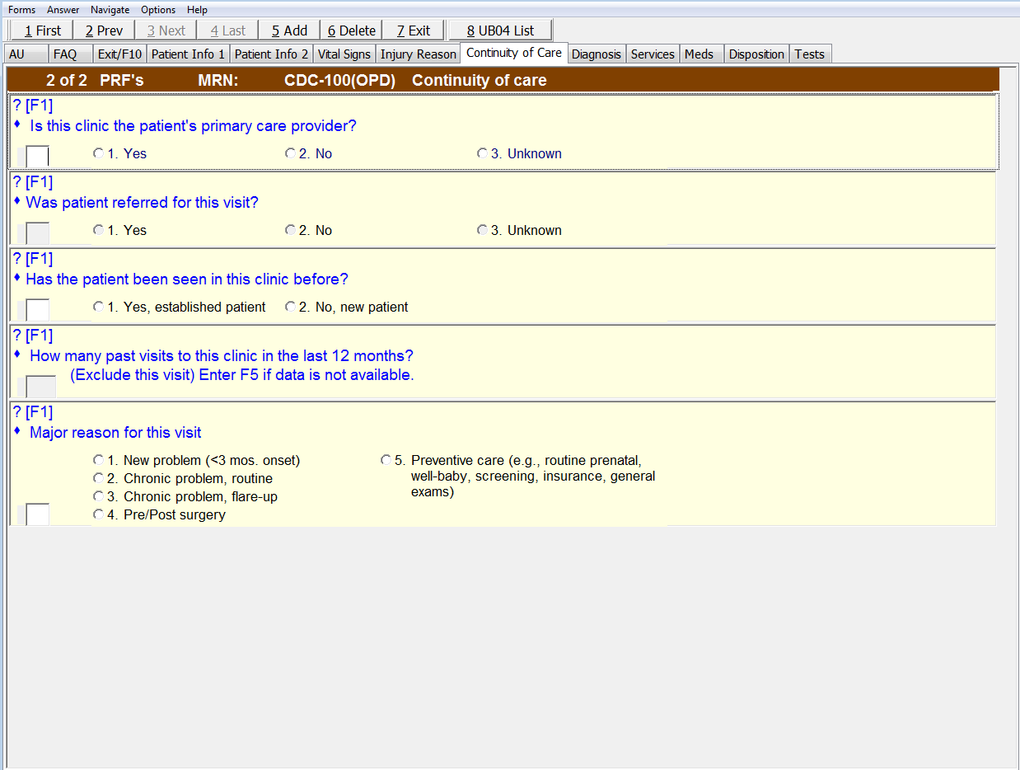

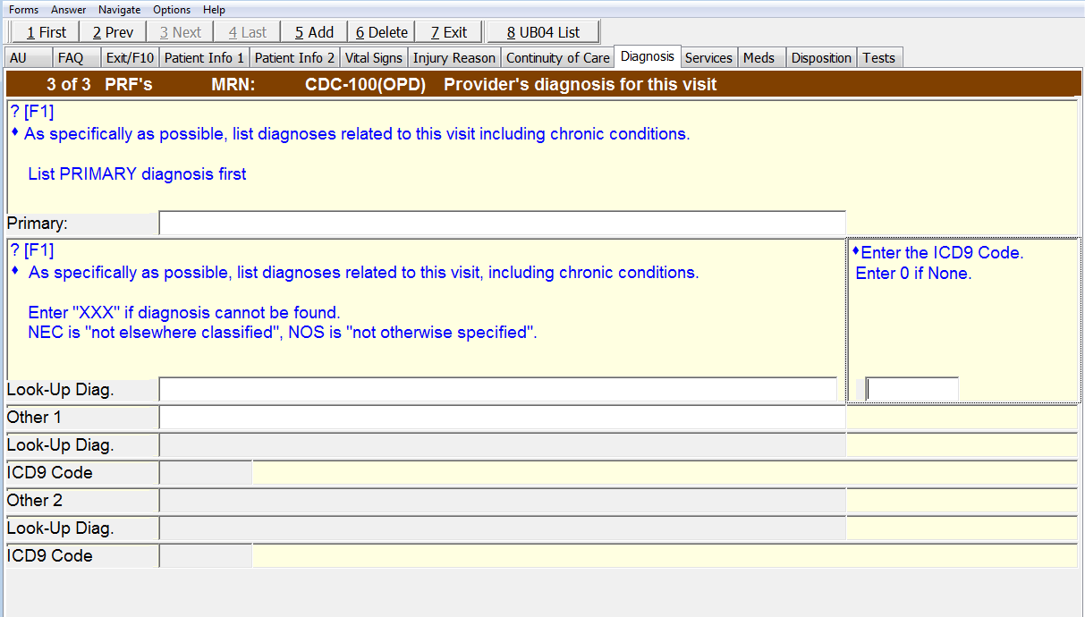
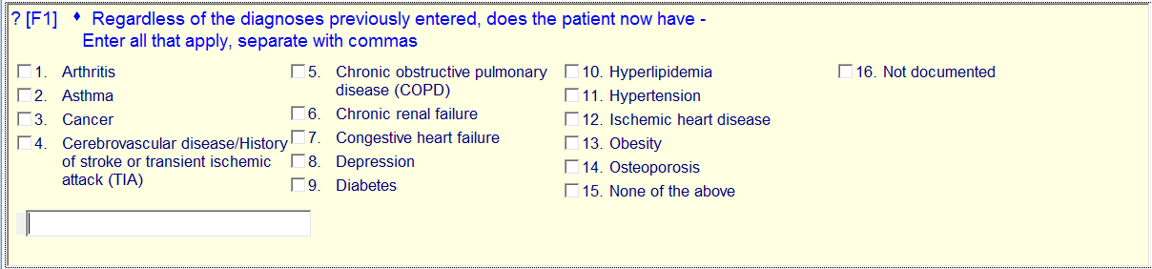
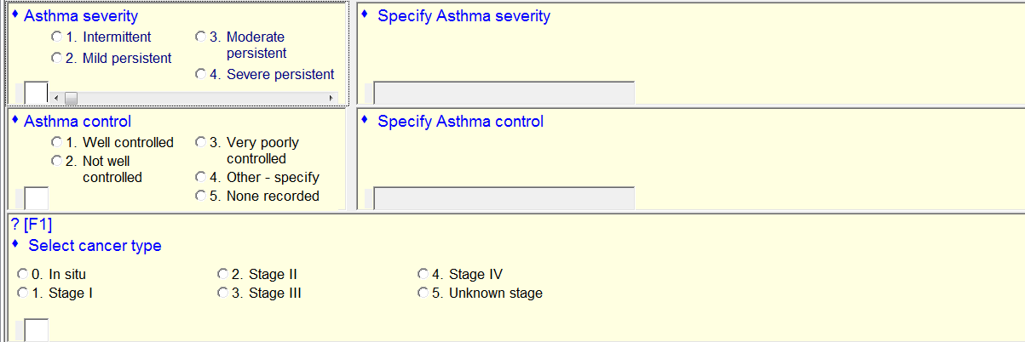

Delete: Cancer type

Asthma Severity responses 5 and 6.
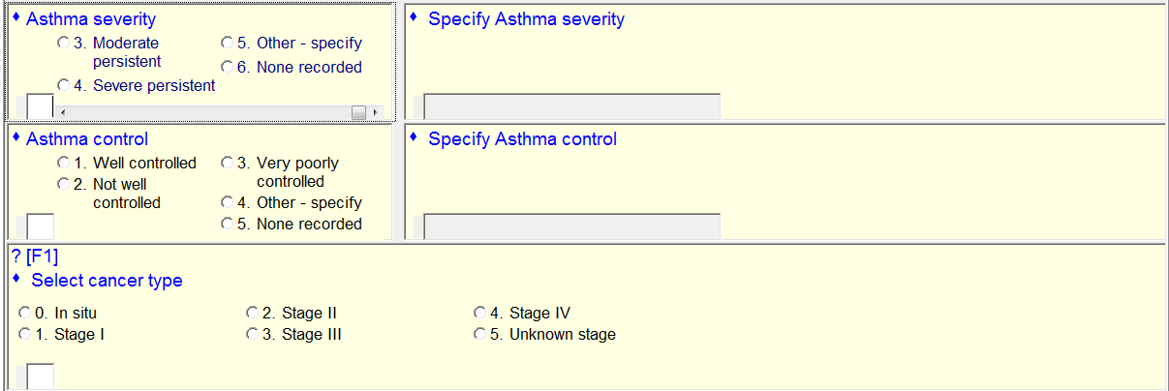

Delete: Cancer type

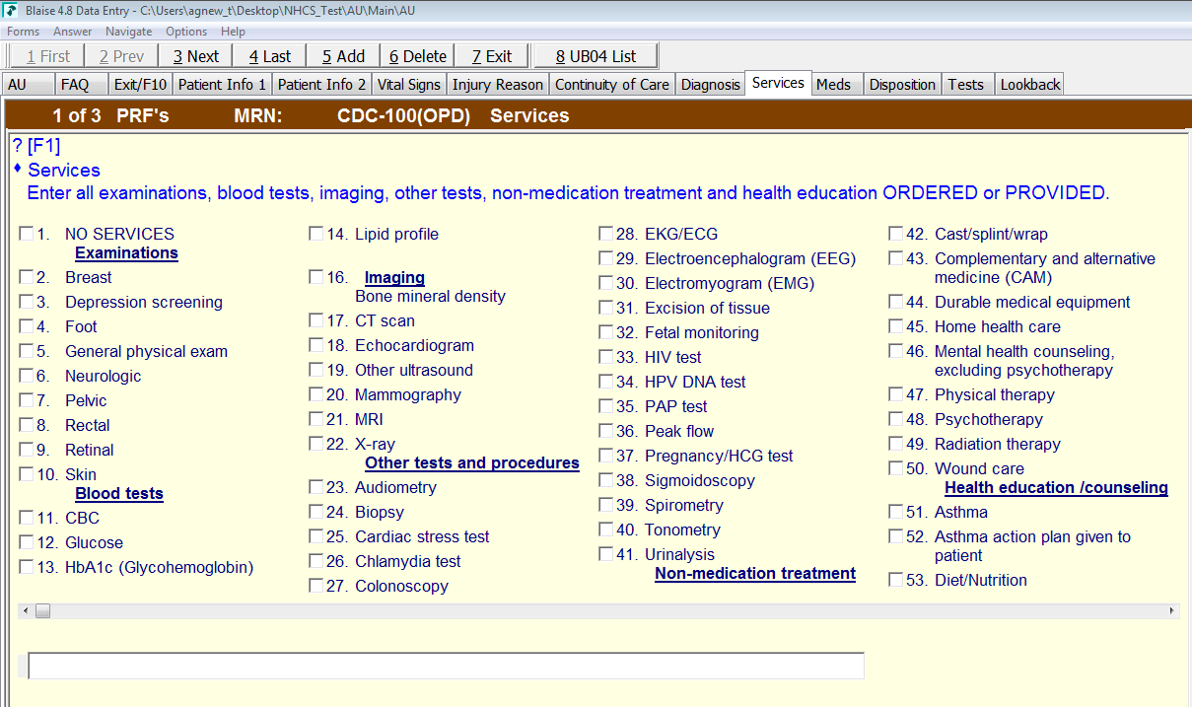

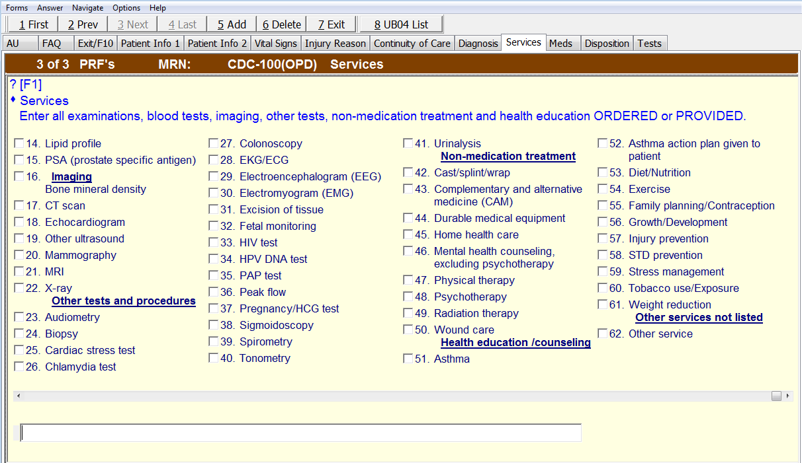
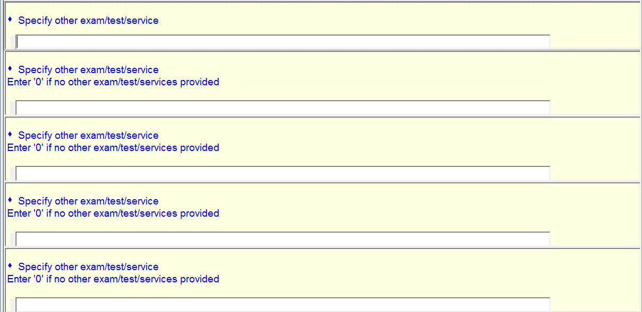

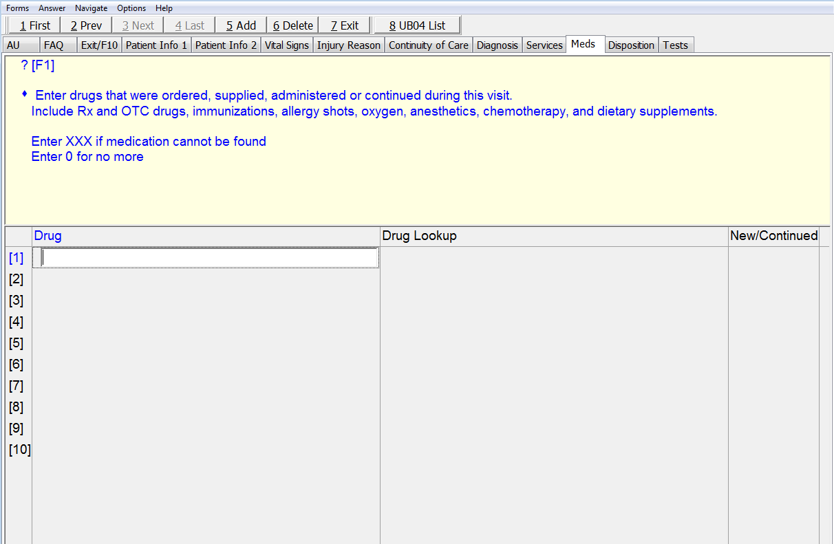
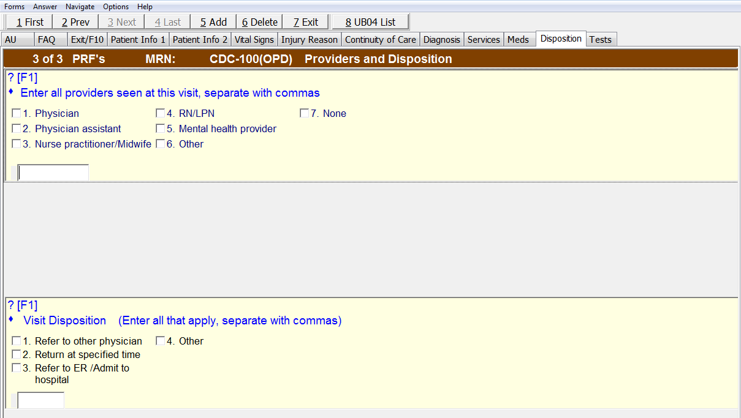

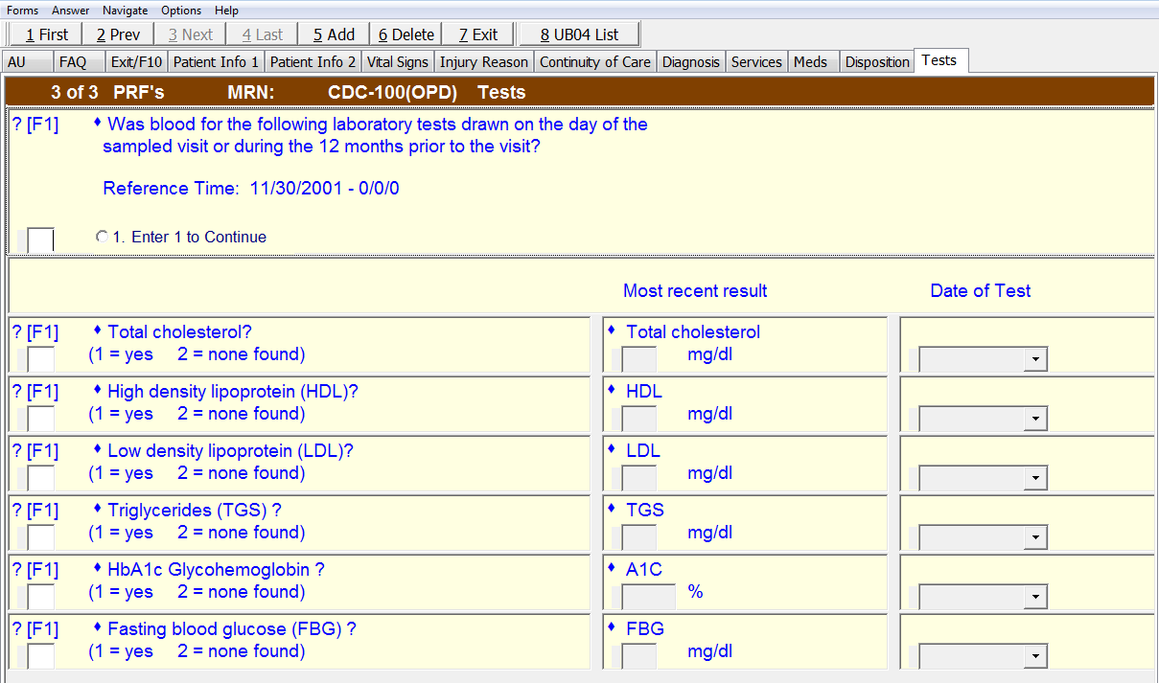
Most recent result Date of test
Add: Serum creatinine Serum creatinine
1 = yes 2 = none found _____ mg/dL _____________

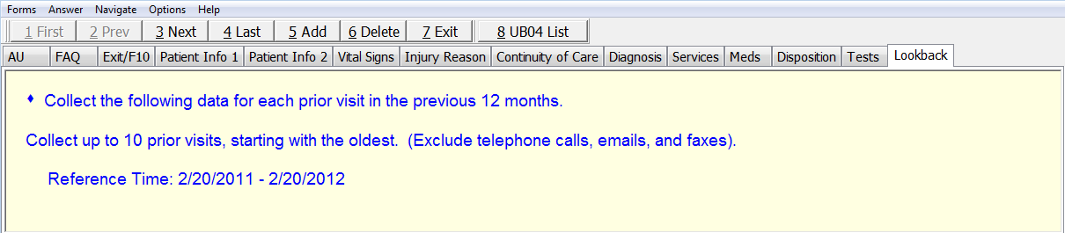
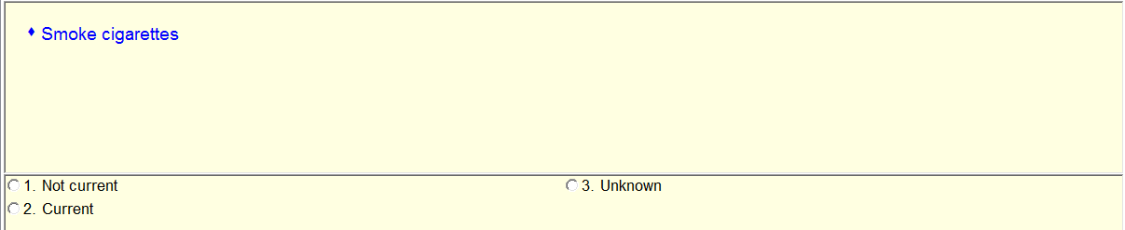
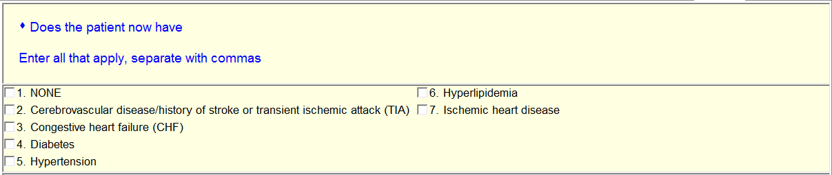
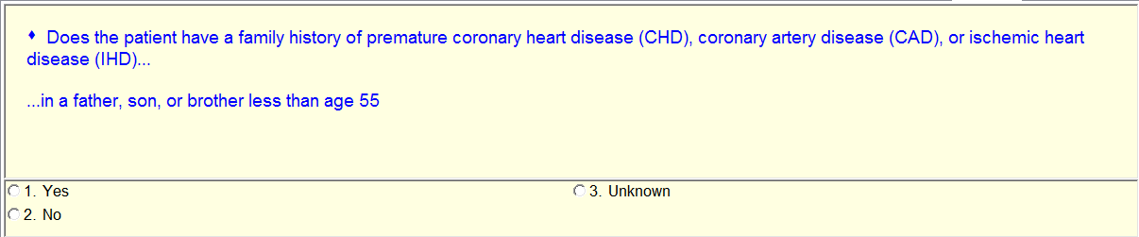
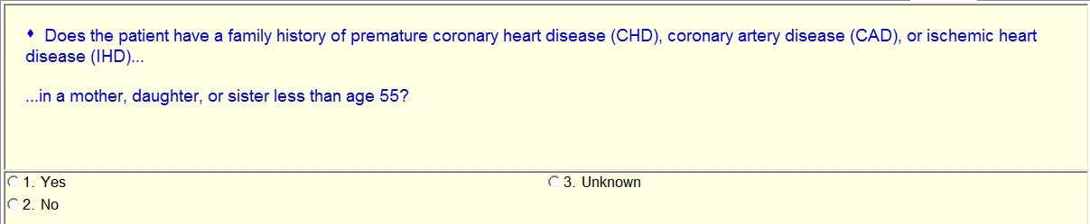

Modify: Does the patient have a family history of premature coronary heart disease (CHD), coronary artery disease (CAD), or ischemic heart disease (IHD) in a mother, daughter, or sister less than 65?
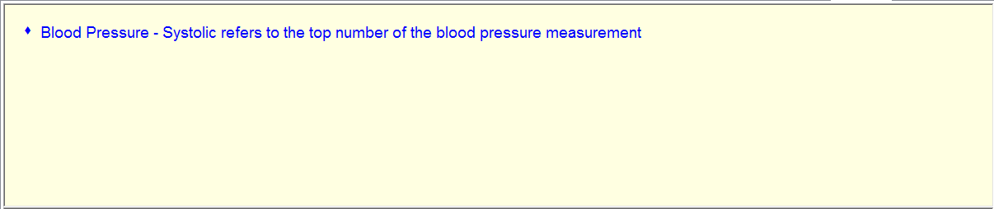
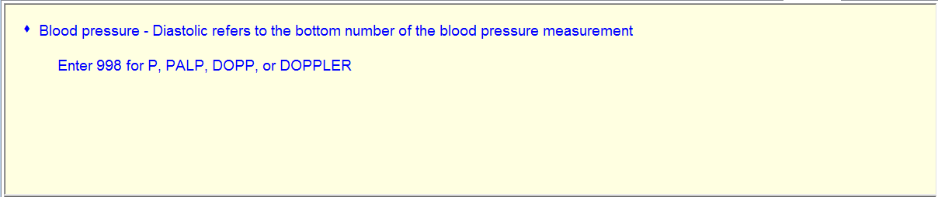
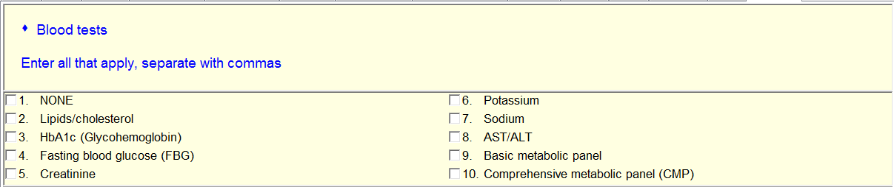
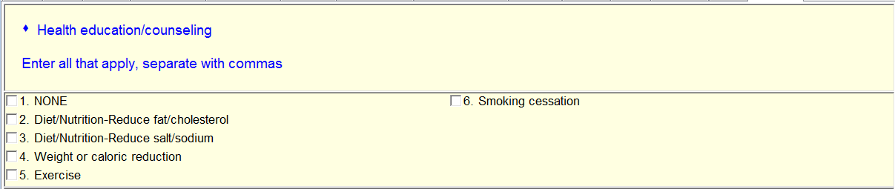
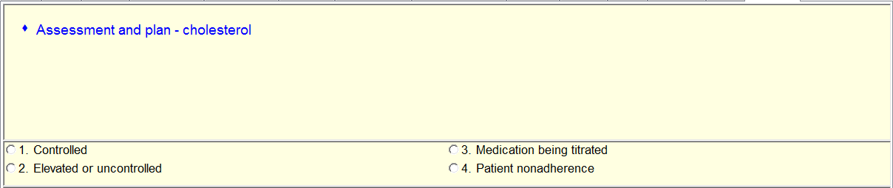
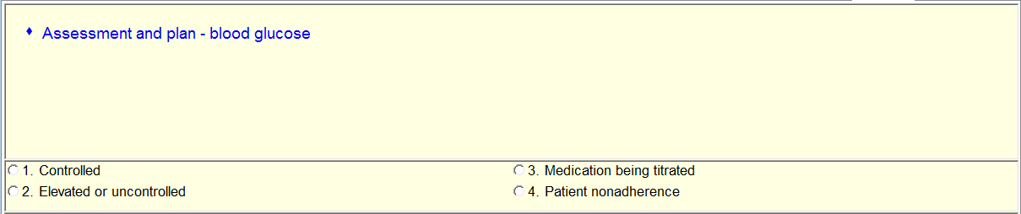
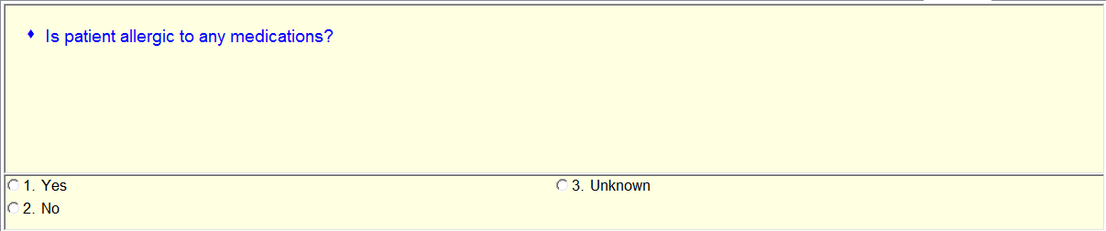
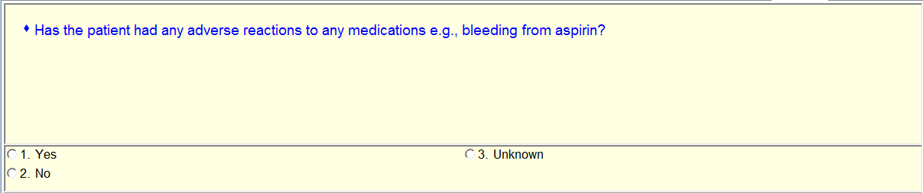
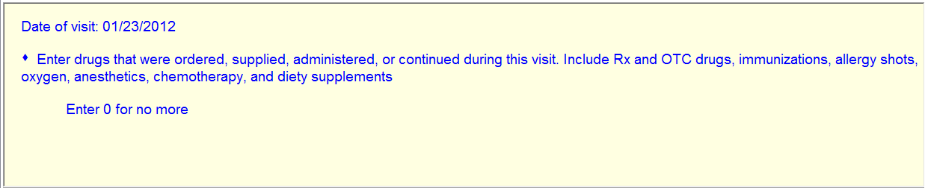
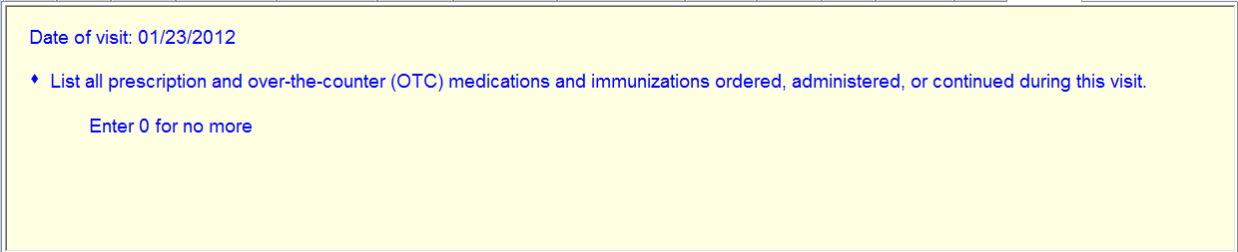
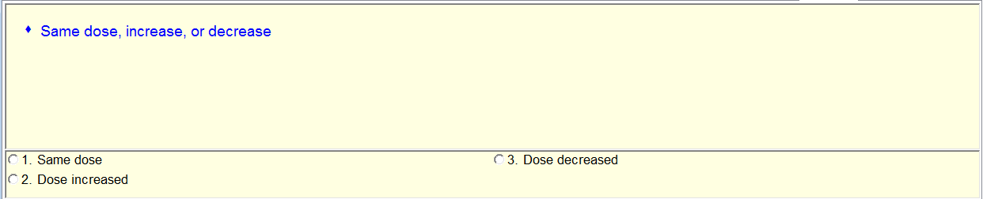
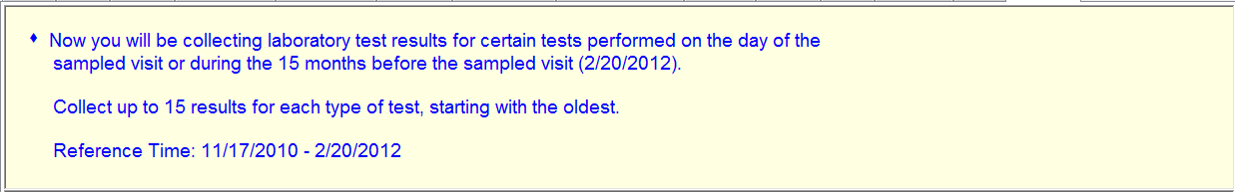
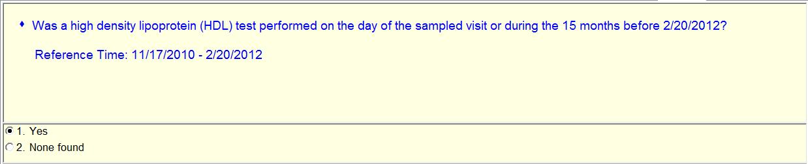
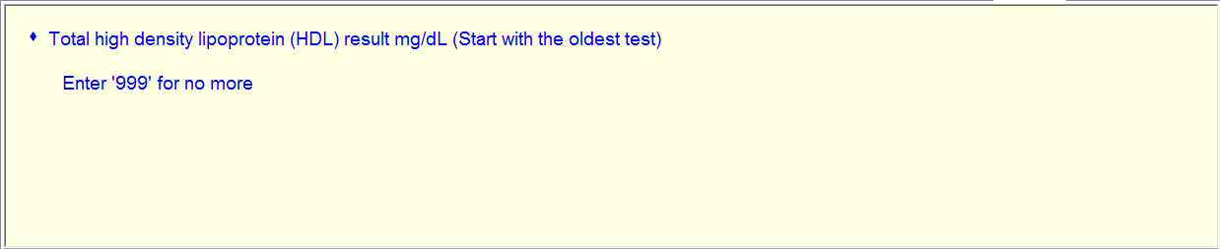
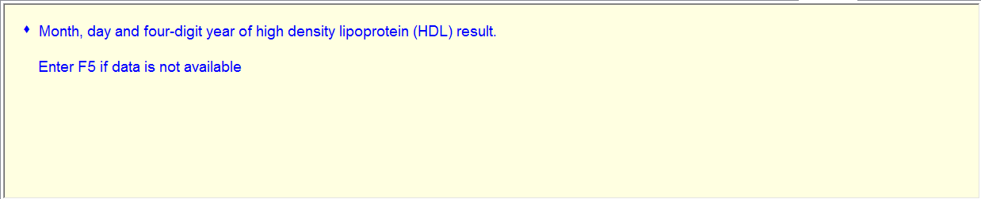
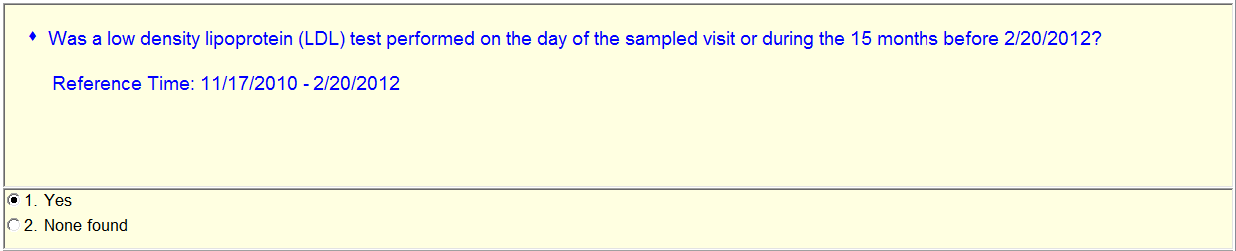
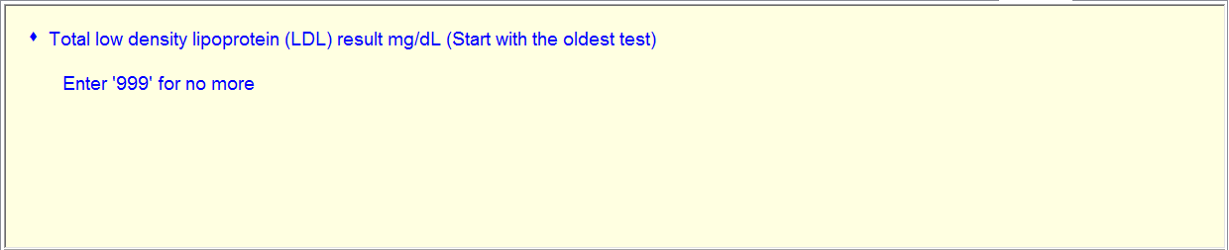
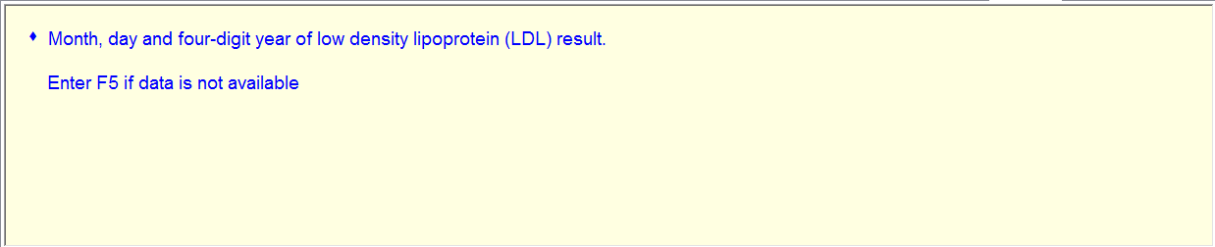
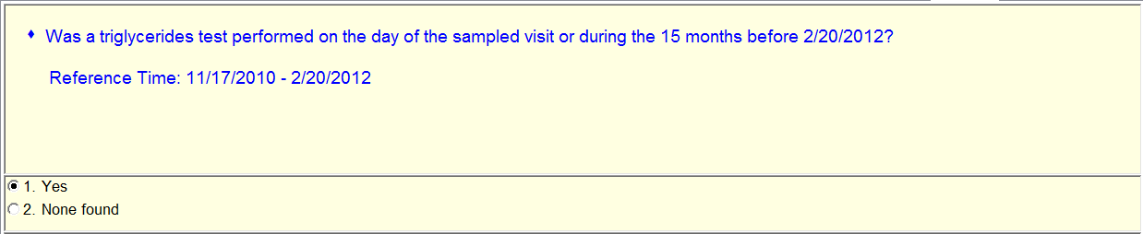
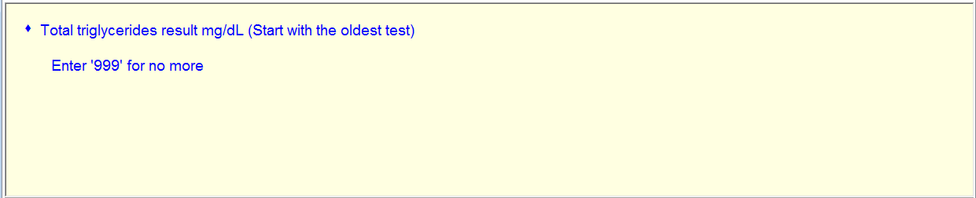
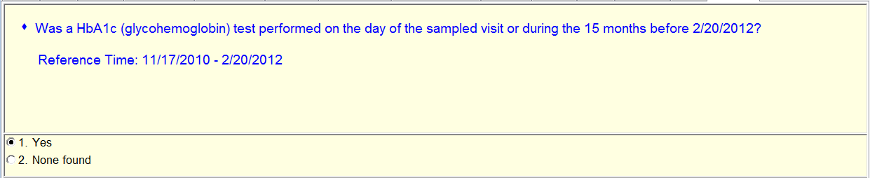
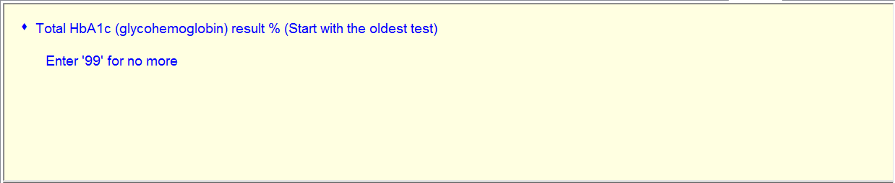
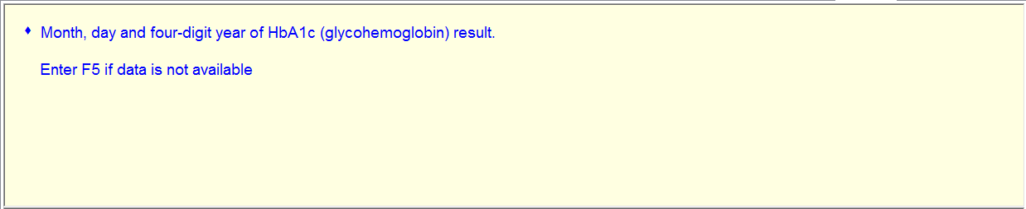
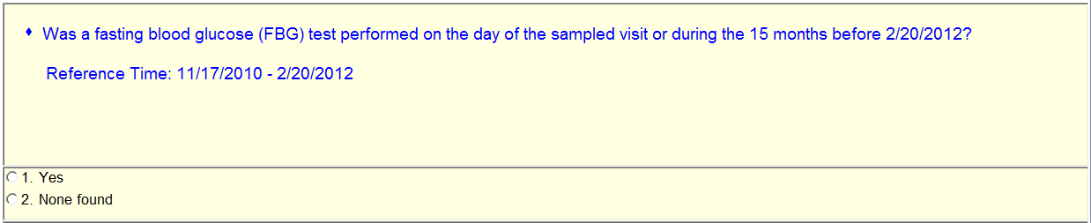
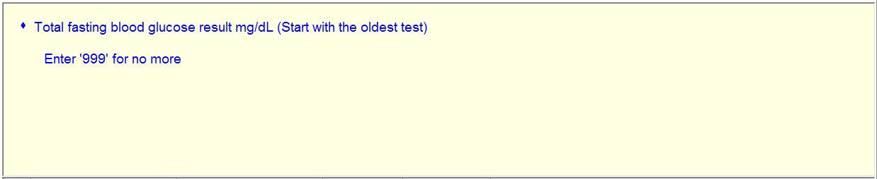
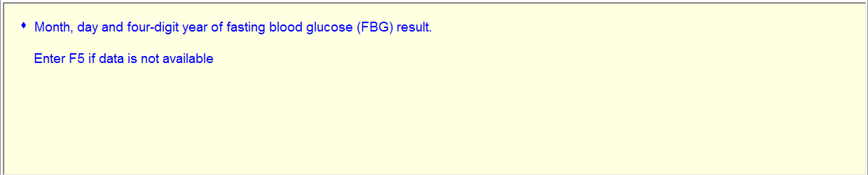

Add:

Was a serum creatinine test performed on the day of the sampled visit or during the 15 months before xx/xx/201x?
1 = Yes 2 = None found
Serum creatinine result mg/dL (Start with the oldest test)
Month, day and four-digit year of serum creatinine result.

