OMB No. 0952-0589
Exp. 04/30/2014

HINTS 4, FDA CYCLE DRAFT INSTRUMENT FOR TESTING
ALL QUESTIONS HIGHLIGHTED IN YELLOW ARE NEW QUESTIONS FOR HINTS FDA AND WILL BE TESTED. ALL OTHER QUESTIONS ARE INCLUDED FOR CONTEXT ONLY.

STATEMENT OF PRIVACY: Collection of this information is authorized by The Public Health Service Act, Sections 411 (42 USC 285 a) and 412 (42 USC 285a-1.a and 285a1.3). The purpose of this data collection is to evaluate whether the survey questions are easy to understand. The results of the data collection will be used to improve the survey instrument. Rights of study participants are protected by The Privacy Act of 1974. Participation is voluntary, and there are no penalties for not participating or withdrawing from the study at any time. Refusal to participate will not affect your benefits in any way. The information collected in this study will be kept private under the Privacy Act and will only be seen by people authorized to work on this project. The report summarizing the findings will not contain any names or identifying information. Identifying information will be destroyed when the project ends.

NOTIFICATION TO RESPONDENT OF ESTIMATED BURDEN: Public reporting burden for this collection of information is estimated to average 90 minutes per response, including the time for reviewing instructions, searching existing data sources, gathering and maintaining the data needed, and completing and reviewing the collection of information. An agency may not conduct or sponsor, and a person is not required to respond to, a collection of information unless it displays a currently valid OMB control number. Send comments regarding this burden estimate or any other aspect of this collection of information, including suggestions for reducing this burden to: NIH, Project Clearance Branch, 6705 Rockledge Drive, MSC 7974, Bethesda, MD 20892-7974, ATTN: PRA (0925-0589). Do not return the completed form to this address.

A: Looking For Health Information

A1. Have you ever looked for information about health or medical topics from any source?
Yes
No GO TO A7 in the next column

A2. The most recent time you looked for information about health or medical topics, where did you go first?
Mark only one.
X
Books
Brochures, pamphlets, etc.
Public Health organization
Family
Friend/Co-worker
Doctor or health care provider
Internet
Library
Magazines
Newspapers
Telephone information number
Complementary, alternative, or unconventional practitioner

Other-Specify

A3. Did you look or go anywhere else that time?
Yes
No

A4. The most recent time you looked for information about health or medical topics, who was it for?
Myself
Someone else
Both myself and someone else
No one in particular

A5. Based on the results of your most recent search for information about health or medical topics, how much do you agree or disagree with each of the following statements?
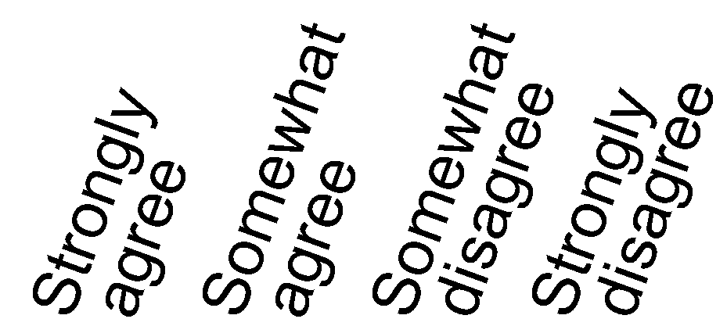
a. It took a lot of effort to get the information you needed
b. You felt frustrated during your search for the information
c. You were concerned about the quality of the information
d. The information you found was hard to understand

A6. Overall, how confident are you that you could get advice or information about health or medical topics if you needed it?
Completely confident
Very confident
Somewhat confident
A little confident
Not confident at all

A7. In general, how much would you trust information about health or medical topics from each of the following?
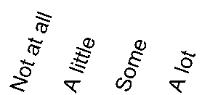
a. A doctor
b. Family or friends
c. Government health agencies (e.g., the Food and Drug administration (FDA), National Institutes of Health (NIH) or Centers for Disease Control and Prevention (CDC))
d. Health organizations or groups (such as the American Cancer Society, American Lung Association or others)
e. Charitable organizations
f. Religious organizations and leaders

A8. Imagine that you had a strong need to get information about health or medical topics. Where would you go first?
Mark only one.
X
Books
Brochures, pamphlets, etc.
Cancer organization
Family member
Friend/Co-worker
Doctor or health care provider
Internet
Library
Magazines
Newspapers
Telephone information number
Complementary, alternative, or unconventional
practitioner

Other-Specify

A9. How much attention do you pay to information about health or medical topics from each of the following sources?

a. Online newspapers
b. Print newspapers
c. Special health or medical magazines or newsletters
d. The Internet
e. The radio
f. Local television news programs
g. National or cable television news programs
h. TV in general
h. Social networking sites such as Facebook or Twitter

A10. On a typical weekday, about how many hours do you watch television?
_____ hours

A11. On a typical weekday, about how many hours do you listen to the radio?
_____ hours

A12. During a typical weekend, about how many hours do you watch television?
_____ hours

A13. During a typical weekend, about how many hours do you listen to the radio?
_____ hours

A14. During a typical weekend, about how many hours do you use the Internet for personal reasons?
_____ hours

A15. In the past seven days, how many days did you read a newspaper?
_____ hours

A16. Have you ever looked for information about tobacco from any source?
Yes
No GO TO Section B

A17. What kinds of information on tobacco products have you ever looked for from any source?
Mark all that apply.
X
Health effects
Products that claim to reduce exposure to certain chemicals or present less rish of disease
Quitting help/information
List of chemicals in tobacco products
Cost/Coupons
Instructions/tutorials
Where to buy
Information about new kinds of tobacco products
Something else-Specify

A18. If you have looked for information on tobacco products, what information did you look for the most recent time you looked?
Mark only one.
X
Health effects
Products that claim to reduce exposure to certain chemicals or present less rish of disease
Quitting help/information
List of chemicals in tobacco products
Cost/Coupons
Instructions/tutorials
Where to buy
Information about new kinds of tobacco products
Something else-Specify

A19. Overall, how confident are you that you could get advice or health information about tobacco products if you needed it?
Completely confident
Very confident
Somewhat confident
A little confident
Not confident at all

A20. In general, how much would you trust information about the health effects of using tobacco or information about stopping tobacco use from each of the following?
a. A doctor / pharmacist / health care provider
b. Family or friends
c. Government health agencies (e.g., the Food and Drug administration (FDA), National Institutes of Health (NIH) or Centers for Disease Control and Prevention (CDC))
d. Health organizations or groups (such as the American Cancer Society, American Lung Association or others)
e. Religious organizations and leaders
f. Tobacco companies

B: Using the Internet to Find Information

B1. Do you ever go on-line to access the Internet or World Wide Web, or to send and receive e-mail?
Yes
No GO TO SECTION C

B2. When you use the Internet, do you access it through...
 | Yes | No
a. Computer at home
b. Computer at work
c. Computer at school
d. Computer in a public place (library, community center, other)
e. On a mobile device (cell phone/smart phone/tablet)
f. On a gaming device / “Smart TV”
g. Other

B3. Where do you use the Internet most often?
Mark only one.
Computer at home
Computer at work
Computer at school
Computer in a public place (library, community center, other)
On a mobile device (cell phone/smart phone/tablet)
On a gaming device / “Smart TV”

B4. Is there a specific Internet site you like to go to for health or medical information?
Yes
No GO TO B6 on the next page

B5. Specify which Internet site you especially like as a source of health or medical information:

B6. In the last 12 months, have you used the Internet for any of the following reasons?
 | Yes | No
a. Visited a social networking site, such as Facebook or LinkedIn
b. Wrote in an online diary or blog (i.e., Web log)
c. Shared photos, videos, or other multimedia content on sites such as YouTube or Instagram
d. Downloaded to a mobile device, such as an MP3 player, cell phone, tablet computer or electronic book device

B7. Some people notice information about health on the Internet, even when they are not trying to find out about a health concern they have or someone in the family has. Have you read such health information on the Internet in the past 12 months?
Yes
No

B8. About how often have you read this sort of information in the past 12 months?
Once a month or more
Less than once a month

B9. In the last 12 months, have you used the Internet for any of the following reasons?
 | Yes | No
a. Looked for health or medical information for yourself?
b. Looked for health or medical information for someone else
c. Looked for information about quitting smoking
e. Participated in an online forum or support group for people with a similar health or medical issue
f. Used a website to help you with your diet, weight, or physical activity
g. Looked for a health care provider
h. Downloaded health information to a mobile device, such as an MP3 player, cell phone, tablet computer or electronic book device
i. Shared health information on social media sites, such as Facebook or Twitter
j. Exchanged social support about health concerns with family or friends
k. Kept track of personal health information such as care received, test results, or upcoming medical appointments
l. Watched a health-related video on YouTube

C: Tobacco Products

C1. Have you smoked at least 100 cigarettes in your entire life?
Yes
No GO TO C7

C2. Do you now smoke cigarettes every day, some days or not at all?
Everyday
Some days GO TO C4
Not at all GO TO C5

C3. If you now smoke every day or some days, on the days that you smoke, how many cigarettes did you smoke on average?
_____ number of cigarettes

Don’t know

C4. Are you seriously considering quitting smoking in the next six months?
Yes GO TO C7
No GO TO C7

C5. About how long has it been since you completely quit smoking cigarettes? (Write a number in one box below)
Less than 2 weeks
2 weeks to less than 1 month ago
1 month to less than 3 months ago
3 months to less than 6 months ago
6 months to less than 1 year ago
1 year to less than 5 years ago
5 years to less than 15 years ago
5 years ago

C6. When you last smoked every day, how many cigarettes did you usually smoke each day?
1-9
10-19
20-29
30-39
40+

C7. How much do you agree or disagree with this statement: “Smoking behavior is something basic about a person that they can’t change very much.”
Strongly agree
Somewhat agree
Somewhat disagree
Strongly disagree

C8. There are a number of resources that people use to help them stop smoking. Before being contacted for this survey (and regardless of whether or not you smoke), had you ever heard of telephone quit lines such as a toll-free number to call (e.g., 1-800-QUIT-NOW) or websites (e.g., www.smokefree.gov) for help in quitting smoking?
Yes
No

C9. Have you ever called a telephone quitline?
Yes
No

C10. How likely would you be to call a quitline or visit a smoking cessation website in the future, for any reason?
Very likely
Somewhat likely
Somewhat unlikely
Very unlikely

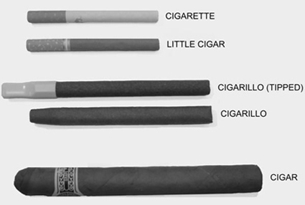

C11. How many cigars (such as Macanudo, Romeo y Julieta, Arturo Fuente or others), cigarillos (such as Black and Mild, Swisher Sweets, Dutch Masters, Phillies Blunts, or others) or little filtered cigars (such as Prime Time or Winchester little filtered cigars, or others) have you smoked in your entire life?
None
1-10
11-20
20-50
30-99
At least 100 or more

C12. Do you now smoke cigars, cigarillos, or little cigars every day, some days or not at all?
Everyday
Some days GO TO C14
Not at all GO TO C15

C13. How many cigars (such as Macanudo, Romeo y Julieta, Arturo Fuente or others), cigarillos (such as Black and Mild, Swisher Sweets, Dutch Masters, Phillies Blunts, or others) or little filtered cigars per day do you smoke?
_____ number of cigars

Don’t know

C14. Is the size of the cigars, cigarillos, or little filtered cigars that you usually smoke…
Regular or large cigars like Macanudo, Romeo y Julieta, Arturo Fuente, or others
Medium cigars or “cigarillos” like Black and Mild, Swisher Sweets, Dutch Masters, Phillies Blunts, or others
Little filtered cigars like Prime Time little filtered cigars, Winchester little filtered cigars, or others

C15. Have you used chewing tobacco, snuff or dip, such as Redman, Levi Garrett, Beechnut, Skoal or Copenhagen, at least 20 times in your entire life?
Yes
No GO TO C18

C16. Do you now use chewing tobacco, snuff, or dip, such as Redman, Levi Garrett, Beechnut, Skoal or Copenhagen, every day, some days or not at all?
Everyday
Some days
Not at all GO TO C18

C17. How many containers of smokeless tobacco (including containers of snus) per week do you use?
None
Half of a container or less
1 container
2 containers
3 containers
More than 3 containers

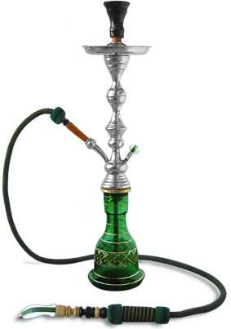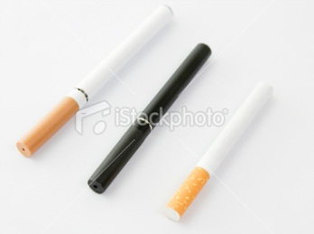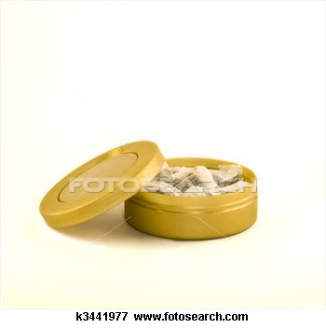

C18. Which of the following tobacco products have you ever heard of?
Hookah or water pipe filled with tobacco
Electronic Cigarettes (such as blu, NJOY or Ruyan)
Pipe filled with tobacco
“Roll your own” cigarettes
Snus (such as Camel, Marlboro, Skoal or Swedish Match snus)

C19. Which of the following tobacco products have you ever tried?
Hookah or water pipe filled with tobacco
Electronic Cigarettes (such as blu, NJOY or Ruyan)
Pipe filled with tobacco
“Roll your own” cigarettes
Snus (such as Camel, Marlboro, Skoal or Swedish Match snus)

C20. Were any of the tobacco products you used in the past 30 days flavored to taste like menthol (mint), clove, spice, alcohol (wine, cognac), candy, fruit, chocolate, or other sweets?
Yes
No
Don’t know

C21. Of the five closest friends or acquaintances that you spend time with on a regular basis, how many of them use any kind of tobacco?
0
1
2
3
4
5

C22. How soon after you wake up do you usually use a tobacco product?
I do not use tobacco products
Within 5 minutes
From 6 to 30 minutes
From 30 minutes to 1 hour
From 1 hour but less than 24 hours
I rarely want to use a tobacco product

C26. On a scale of one to five, where one is strongly disagree, and five is strongly agree, please indicate how much you agree or disagree with the following statements
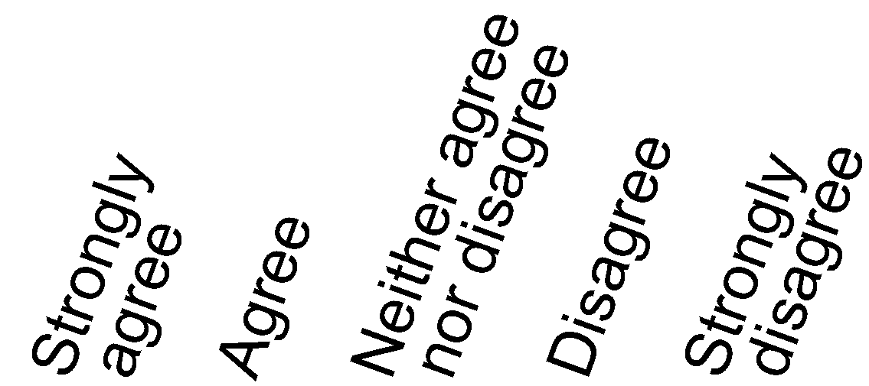
a. Nicotine is the main substance in tobacco that makes people want to smoke.
b. The nicotine in cigarettes is the substance that causes most of the cancer caused by smoking
c. Addiction to nicotine is something that I am concerned about

C27. Overall, how addictive do you believe each of the following is?
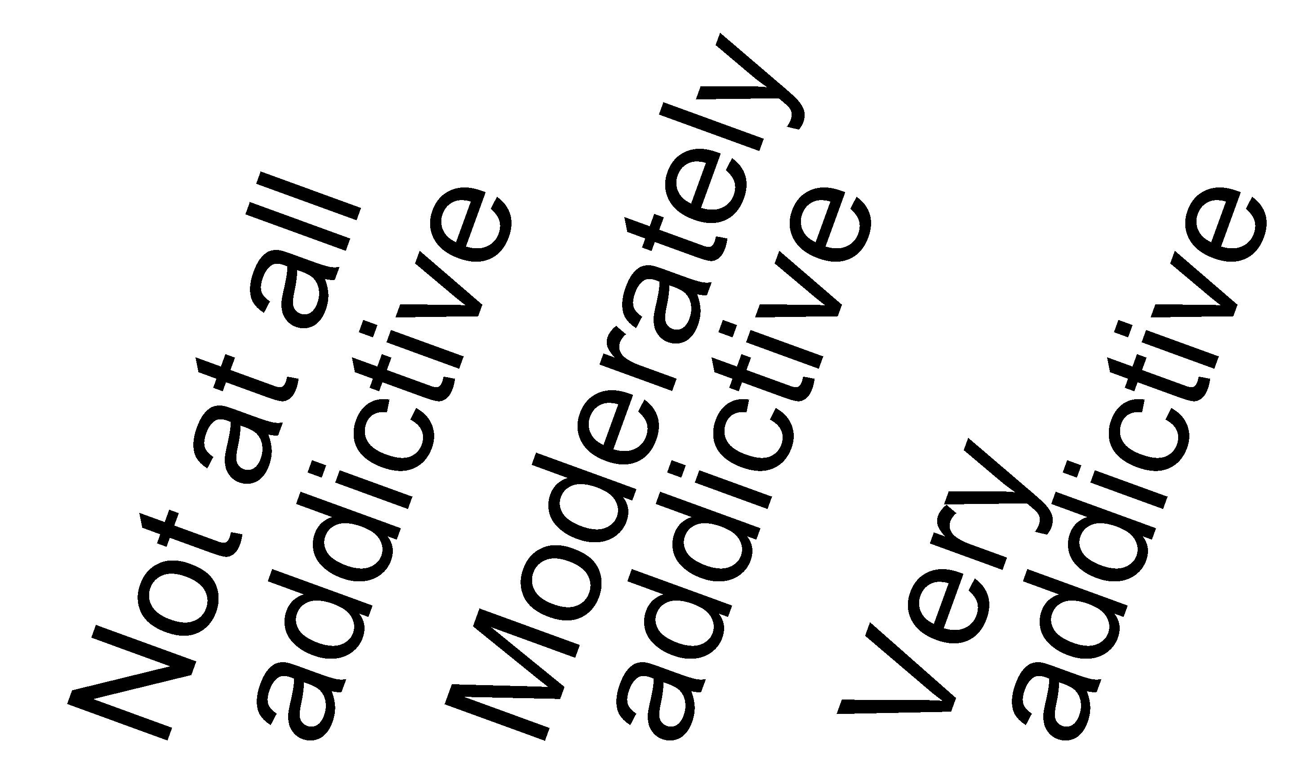
a. Cigarette smoking
b. Cigar smoking
c. Smokeless tobacco use
d. Electronic cigarettes
e. Smoking tobacco in a hookah
f. Smoking “roll your own” cigarettes
g. Pipe filled with tobacco

D: Exposure to Messages About Tobacco

D1. In the past 30 days, how often have you seen, heard, or read a message about Health effects of tobacco use on tobacco users from each of the following sources?
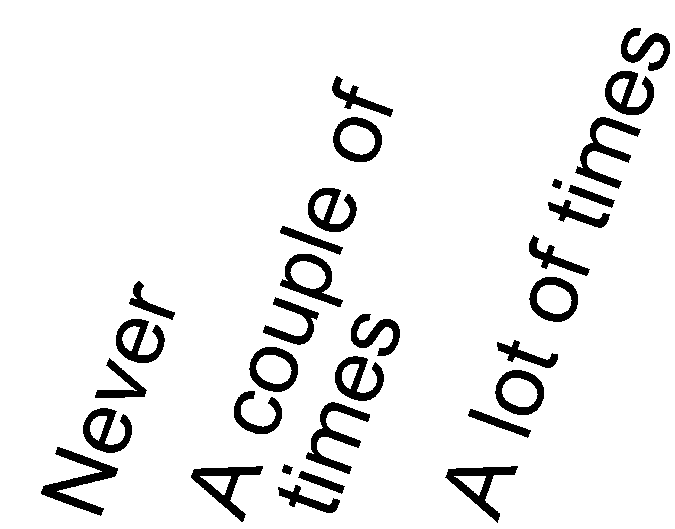
Newspaper (online format)
Newspaper (print format)
Alternative newspaper (print format)
Television
Magazine
Radio
Internet (social media)
Internet (company/org website)
Internet (health-specific website)
Internet (government website)
Billboard
Public transportation
Coupon/Mailings
Community event
Point of sale (such as at or inside convenience stores, drug stores or supermarkets)

D2. In the past 30 days, how often have you seen, heard, or read a message about Health effects of tobacco use during
pregnancy from each of the following sources?
Newspaper (online format)
Newspaper (print format)
Alternative newspaper (print format)
Television
Magazine
Radio
Internet (social media)
Internet (company/org website)
Internet (health-specific website)
Internet (government website)
Billboard
Public transportation
Coupon/Mailings
Community event
Point of sale (such as at or inside convenience stores, drug stores or supermarkets)

D3. In the past 30 days, how often have you seen, heard, or read a message about Prevention of tobacco use among youth from each of the following sources?
Newspaper (online format)
Newspaper (print format)
Alternative newspaper (print format)
Television
Magazine
Radio
Internet (social media)
Internet (company/org website)
Internet (health-specific website)
Internet (government website)
Billboard
Public transportation
Coupon/Mailings
Community event
Point of sale (such as at or inside convenience stores, drug stores or supermarkets)

D4. In the past 30 days, how often have you seen, heard, or read a message about National Smoking Quitline or 1-800-QUIT-NOW from each of the following sources?
Newspaper (online format)
Newspaper (print format)
Alternative newspaper (print format)
Television
Magazine
Radio
Internet (social media)
Internet (company/org website)
Internet (health-specific website)
Internet (government website)
Billboard
Public transportation
Coupon/Mailings
Community event
Point of sale (such as at or inside convenience stores, drug stores or supermarkets)

D5. In the past 30 days, how often have you seen, heard, or read a message about Smokefree.gov or BeTobaccoFree.gov from each of the following sources?
Newspaper (online format)
Newspaper (print format)
Alternative newspaper (print format)
Television
Magazine
Radio
Internet (social media)
Internet (company/org website)
Internet (health-specific website)
Internet (government website)
Billboard
Public transportation
Coupon/Mailings
Community event
Point of sale (such as at or inside convenience stores, drug stores or supermarkets)

D6. In the past 30 days, how often have you seen, heard, or read a message about Addictive Nature of Smokingfrom each of the following sources?
Newspaper (online format)
Newspaper (print format)
Alternative newspaper (print format)
Television
Magazine
Radio
Internet (social media)
Internet (company/org website)
Internet (health-specific website)
Internet (government website)
Billboard
Public transportation
Coupon/Mailings
Community event
Point of sale (such as at or inside convenience stores, drug stores or supermarkets)

D7. In the past 30 days, how often have you seen, heard, or read a message about Health effects of harmful chemicals in tobacco products from each of the following sources?
Newspaper (online format)
Newspaper (print format)
Alternative newspaper (print format)
Television
Magazine
Radio
Internet (social media)
Internet (company/org website)
Internet (health-specific website)
Internet (government website)
Billboard
Public transportation
Coupon/Mailings
Community event
Point of sale (such as at or inside convenience stores, drug stores or supermarkets)

D8. In the past 30 days, how often have you seen, heard, or read a message about Advertising messages about menthol cigarettes from each of the following sources?
Newspaper (online format)
Newspaper (print format)
Alternative newspaper (print format)
Television
Magazine
Radio
Internet (social media)
Internet (company/org website)
Internet (health-specific website)
Internet (government website)
Billboard
Public transportation
Coupon/Mailings
Community event
Point of sale (such as at or inside convenience stores, drug stores or supermarkets)

D9. In the past 30 days, how often have you seen, heard, or read a message about Health effects of second-hand smoke from each of the following sources?
Newspaper (online format)
Newspaper (print format)
Alternative newspaper (print format)
Television
Magazine
Radio
Internet (social media)
Internet (company/org website)
Internet (health-specific website)
Internet (government website)
Billboard
Public transportation
Coupon/Mailings
Community event
Point of sale (such as at or inside convenience stores, drug stores or supermarkets)

D10. In the past 30 days, how often have you seen, heard, or read a message about Advertising messages about e-cigarettes from each of the following sources?
Newspaper (online format)
Newspaper (print format)
Alternative newspaper (print format)
Television
Magazine
Radio
Internet (social media)
Internet (company/org website)
Internet (health-specific website)
Internet (government website)
Billboard
Public transportation
Coupon/Mailings
Community event
Point of sale (such as at or inside convenience stores, drug stores or supermarkets)

E: Contents of Tobacco Products

E1. In the past year, how often have you seen a list of the chemicals that are in tobacco products?
Never GO TO E4
Rarely
Sometimes
Often

E2. Where have you seen a list of the chemicals that are in tobacco products?
Mark all that apply.
X
On a government website (e.g., the Food and Drug Administration (FDA), National Institutes of Health (NIH) or Centers for Disease Control and Prevention (CDC) or others)
From health organizations or groups (such as the American Cancer Society, American Lung Association or others)
From a tobacco company
At a Doctor’s office/From a health professional
In a newspaper
In a magazines
On the radio
In a TV ads
On a TV news program
Smartphone App

Other internet-Specify

Other source -Specify

E3. If you haven’t seen a public list of the chemicals in tobacco products, where do you think you would be able to find that list?
Mark all that apply.
X
On a government website (e.g., the Food and Drug Administration (FDA), National Institutes of Health (NIH) or Centers for Disease Control and Prevention (CDC) or others)
From health organizations or groups (such as the American Cancer Society, American Lung Association or others)
From a tobacco company
At a Doctor’s office/From a health professional
In a newspaper
In a magazines
On the radio
In a TV ads
On a TV news program
Smartphone App

Other internet-Specify

Other source -Specify

E4. In the past year, how often have you thought about the chemicals contained in tobacco products?
Never
Rarely
Sometimes
Often

E5. Where do you think chemicals in cigarettes come from?
 | Yes | No
a. The tobacco leaf
b. Tobacco smoke
c. The cigarette carton
d. Glues, inks, and paper
e. The filter
f. Things added to the cigarettes
g. N/A. There are no chemicals in cigarettes

E6. How many of the chemicals in cigarettes do you think come from the tobacco leaf and the smoke? (Mark one)
None of the chemicals
A few of the chemicals
Many of the chemicals
All of the chemicals

E7. How many of the chemicals in smokeless tobacco products do you think come from the tobacco leaf? (Mark one)
None of the chemicals
A few of the chemicals
Many of the chemicals
All of the chemicals

E8. How interested would you be in seeing a list of chemicals in tobacco products listed by each brand?
Not at all interested GO TO E10
A little interested
Somewhat interested
Very interested

E9. Why would you be interested in seeing that list?
Mark all that apply.
X
To find general information on the health effects of tobacco products for me
To find information on the health effects of tobacco products someone else
To find information on the levels of a specific chemical(s) in the brand I use
To find information on the levels of a specific chemical(s) in the brand someone else uses
To find a brand to switch to lower my risk of health problems
To find a brand to switch to lower the risk of health problems for someone else
Curiosity to see what chemicals in are a specific brand
To verify claims made about health effects of a specific brand
To figure out what brand is the most cost-effective
To compare brands
Even if it will upset me, I want to know about chemicals in tobacco products
It is important to know about chemicals in tobacco products
For research or educational purposes
My health care provider or family member told me to
My friend, teacher, physician, told me to
To use as motivation to quit for myself or someone else
Use as motivation to not start using tobacco products

Other reason -Specify

E10. Why would you not be interested in seeing that list?
Mark all that apply.
X
I don’t use tobacco products
Nobody close to me uses tobacco products
I already know everything about the chemicals in them
I don’t care about the chemicals in tobacco products
I don’t trust that such a list would be accurate/unbiased
Scared to know what’s on the list (similar to ‘don’t want to be reminded’, but slightly different perspective)
I already know about the risk I am taking by using tobacco products
Too much effort to find the list
Wouldn’t know where to find it
I have already seen the list –where did you see it?
I don’t want to be reminded about the chemicals in tobacco/ Don’t want to be reminded about the health effects of tobacco
When it comes to information about tobacco, sometimes ignorance is bliss.
I would rather not know about the chemicals in tobacco
I wouldn’t understand the list
I don’t have time
I don’t smoke (or use tobacco products) that much …social smoker
I’m not addicted to tobacco products (I can quit anytime)
I would look at it is someone put it in front of me, but wouldn’t look for it myself
I don’t have a computer/Don’t have access to it

Other source -Specify

Haven’t heard of the list
E11. Formaldehyde is a chemical that has been linked to cancer. Now imagine one brand of tobacco product has more formaldehyde in it than another brand. Do you think you can tell which of these brands is more likely to cause cancer?
Yes
No
Don’t know

E12. For each of the following statements, please Mark True or False.
Mark one for each statement.
X
 | True | False
a. All tobacco products contain chemicals that may cause harm
b. Research is ongoing to find out which chemicals cause harm

E13. How much do you agree or disagree with the following statement? There is no safe tobacco product. (Mark one)
Strongly agree
Agree
Neither agree nor disagree
Disagree
Strongly disagree

E14. As far as you know, does anyone review tobacco products before they are marketed to consumers?
Yes
No
Don’t know

E15. As far as you know, does anyone review statements that tobacco companies make about the contents/chemicals or health effects of their products before they are marketed to consumers?
Yes
No
Don’t know
E16. Do you believe that tobacco products are tested for harmful chemicals?
Yes
No
Don’t know

E17. Who tests tobacco products for harmful chemicals?
Mark only one.
X
 | Yes | No | Not sure
a. Tobacco farmers
b. Federal government
c. State and local health departments
d. Tobacco companies
e. Independent companies/organizations
f. None of the above
g. Other-Specify

E18. How qualified is each of the following to review tobacco products?
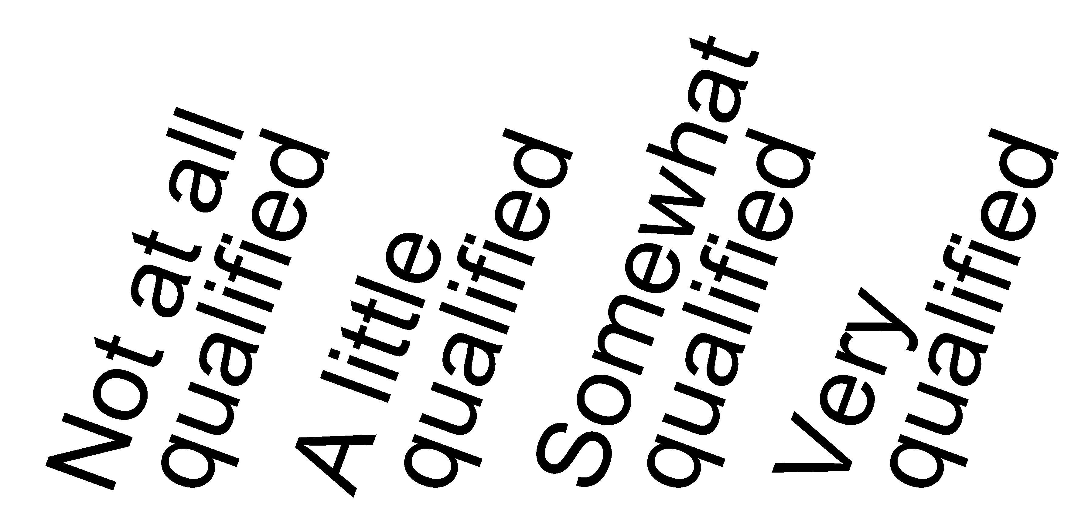
a. Centers for Disease Control and Prevention (CDC)
b. Federal Trade Commission (FTC)
c. Food and Drug Administration (FDA)
d. Independent groups
d. National Institutes of Health (NIH)
d. Surgeon General
d. Tobacco industry/tobacco companies
d. US Board of Cancer Prevention (USBCP)

E19. How unbiased [fair\impartial\biased] is each of the following to review tobacco products?

a. Centers for Disease Control and Prevention (CDC)
b. Federal Trade Commission (FTC)
c. Food and Drug Administration (FDA)
d. Independent groups
d. National Institutes of Health (NIH)
d. Surgeon General
d. Tobacco industry/tobacco companies
d. US Board of Cancer Prevention (USBCP)

E20. The next few questions ask about the priorities of the government to improve people’s health. Please state for each item, whether it should be a high priority, medium priority, low priority, or if the government should not address this issue.
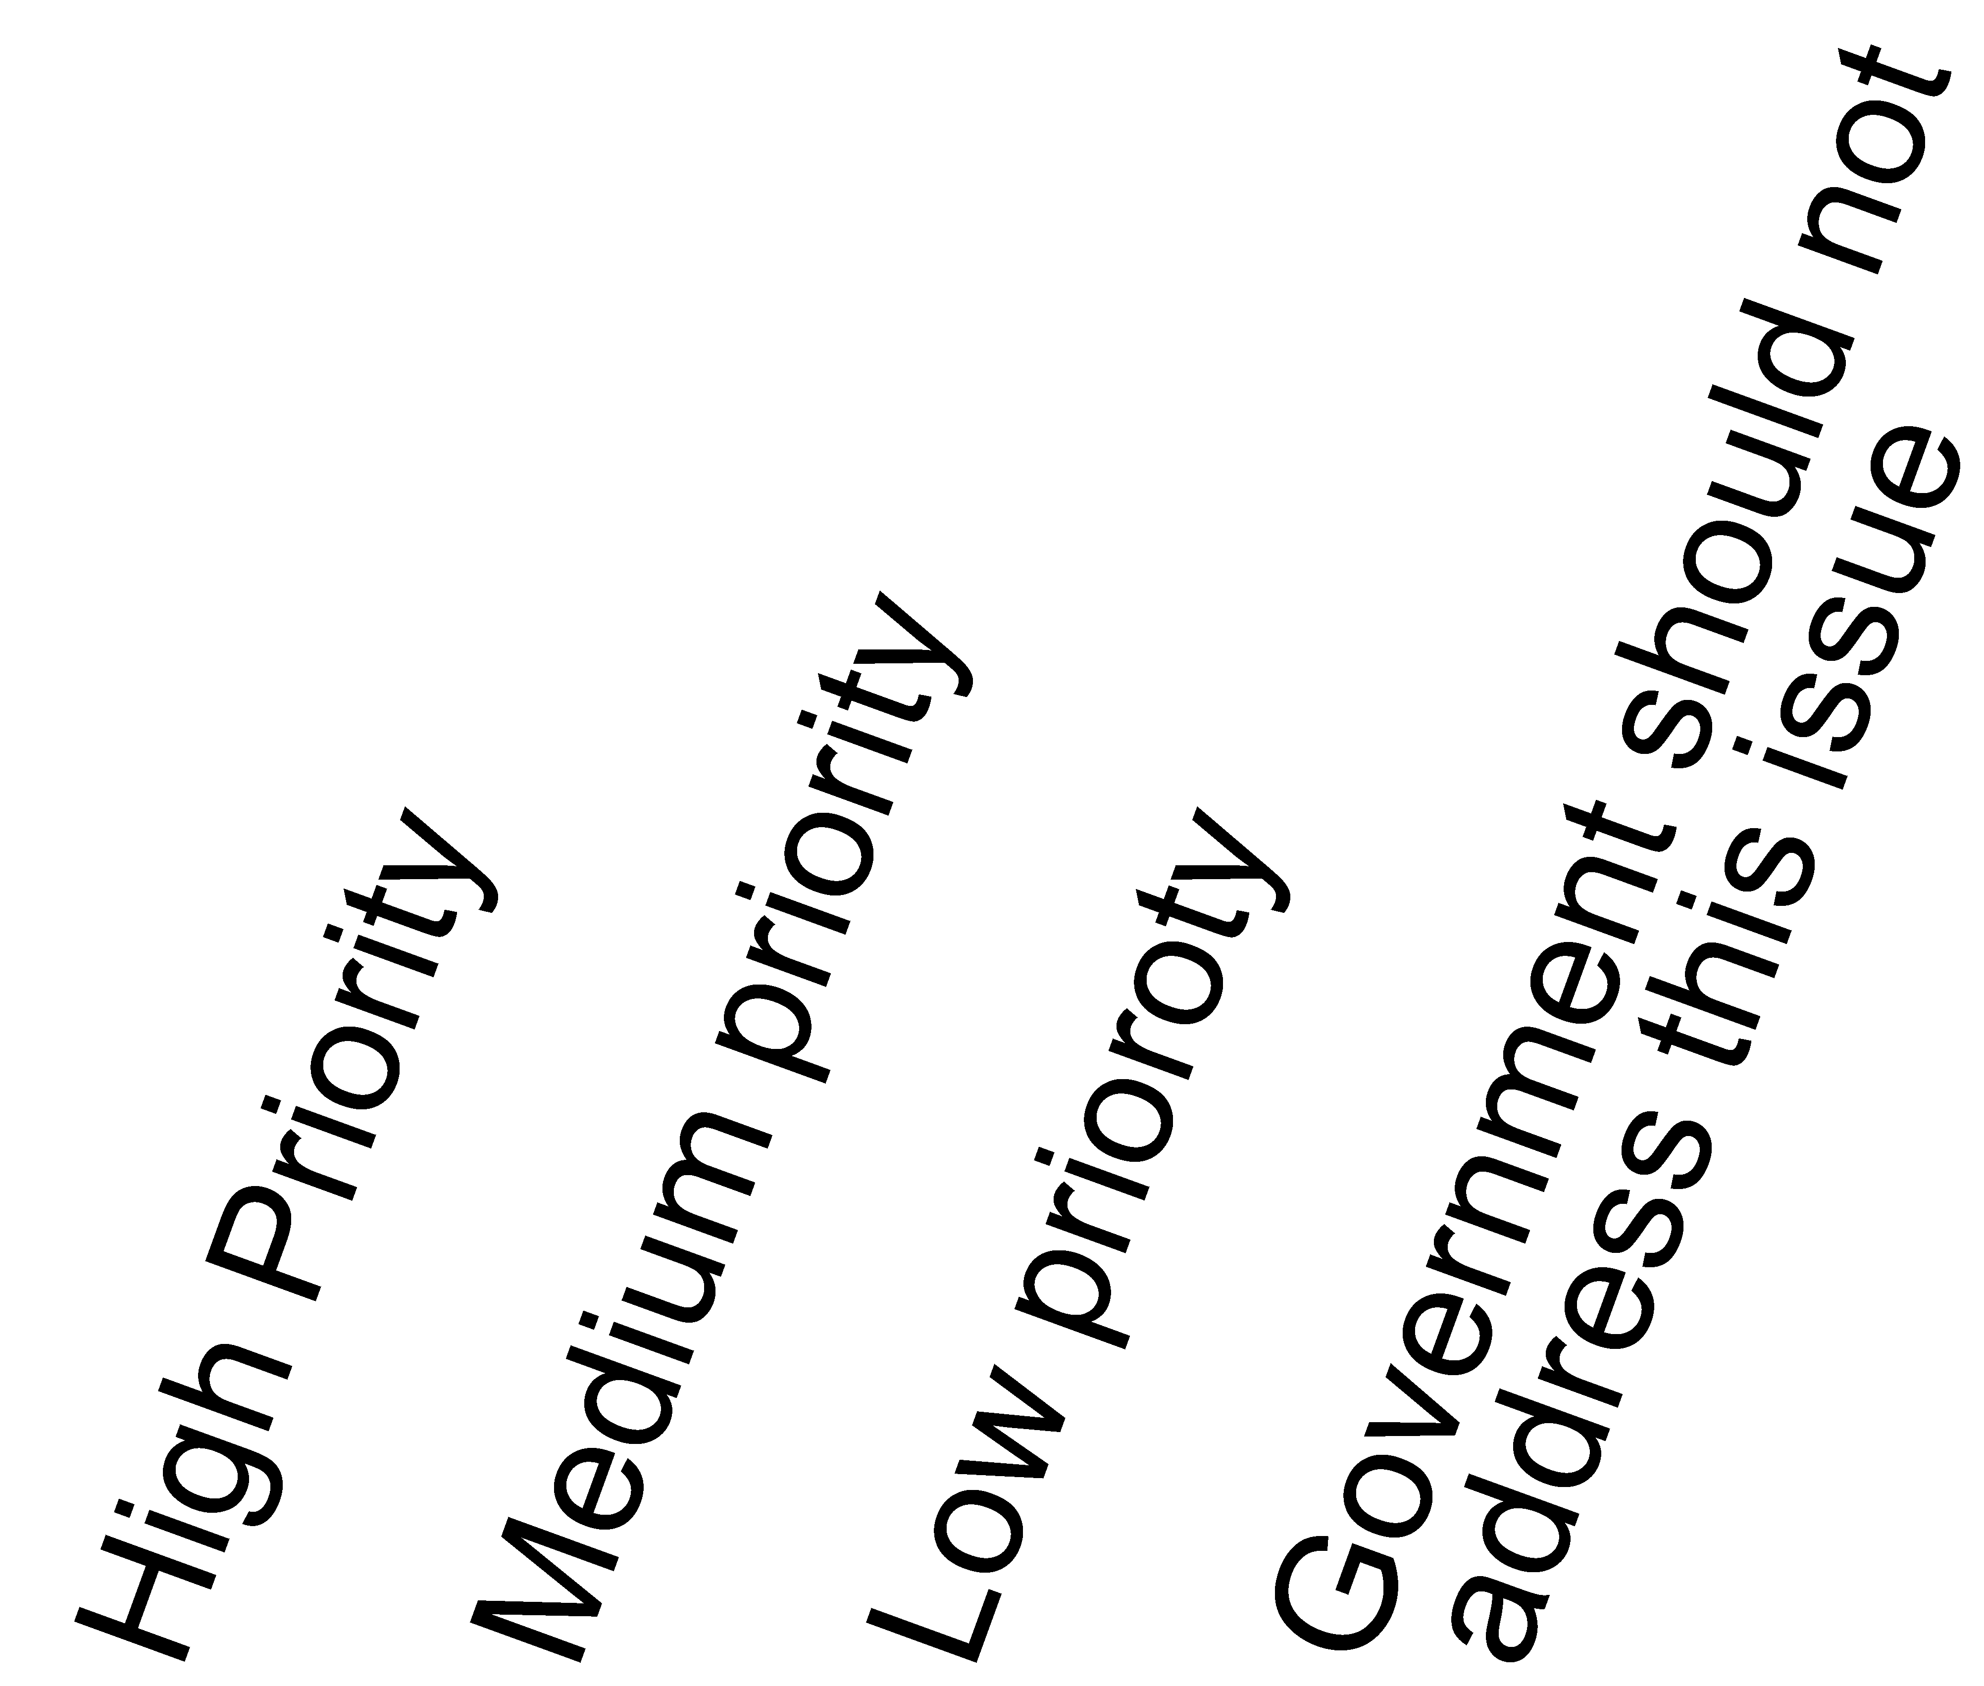
a. Promoting health education programs
b. Improving people’s knowledge of health
c. Encouraging people to quit smoking through willpower
d. Providing support like nicotine patches to help people quit smoking
e. Protecting children from tobacco companies advertising and marketing
f. Encouraging people to seek counseling to quit smoking

E21. How much of the time do you trust the government in Washington to do what is right?
Just about all of the time
Most of the time
Only some of the time
Never

E22. How harmful do you think each of the following is to a person’s health?
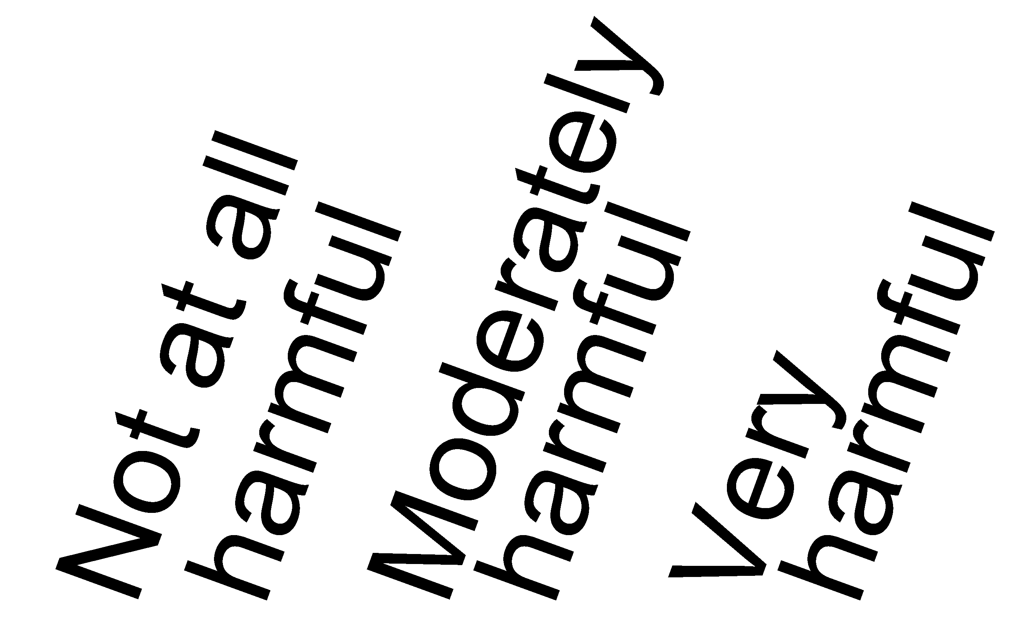
a. Cigarette smoking
b. Cigar smoking
c. Smokeless tobacco use
d. Electronic cigarettes

E23. How long do you think someone has to smoke cigarettes before it harms their health?
Less than 1 year
1 year
5 years
10 years
20 years or more

E24. How much do you think people harm themselves when they smoke a few cigarettes every day?
No harm
Little harm
Some harm
A lot of harm

E25. How much do you think people harm themselves when they smoke 10 or more cigarettes every day?
No harm
Little harm
Some harm
A lot of harm

E26. Do you believe that electronic cigarettes or e-cigarettes, (such as blu, NJOY or Ruyan) are LESS HARMFUL to health, EQUALLY HARMFUL to health, or MORE HARMFUL to health than regular cigarettes?
Less harmful
Equally harmful
More harmful
I have never heard of electronic cigarettes or e-cigarettes
I don’t know enough about these products

E27. How much do you think people harm themselves when they use smokeless tobacco, such as chewing tobacco, snuff, dip, or snus, every day?
No harm
Little harm
Some harm
A lot of harm

E28. How much do you think people harm themselves when they use smokeless tobacco, such as chewing tobacco, snuff, dip, or snus, some days but not every day?
No harm
Little harm
Some harm
A lot of harm

E30. Please indicate how much you agree or disagree with the following statement:
Tobacco is safer to use now than it was 5 years ago.

Strongly agree
Agree
Disagree
Strongly disagree

E31. Do you believe that some cigarettes are less harmful to health than others?
Yes
No

E32. Do you believe that some smokeless tobacco products, such as chewing tobacco and snuff, are less harmful to health than cigarettes?
Yes
No

E33. If a tobacco product made a claim that it was less harmful to health than other tobacco products, how likely would you be to use that product?
Very likely
Somewhat likely
Somewhat unlikely
Very unlikely
Don’t know

E34. If a tobacco product made a claim that it was less addictive than other tobacco products, how likely would you be to use that product?
Very likely
Somewhat likely
Somewhat unlikely
Very unlikely
Don’t know

F: Beliefs About Cigarette Claims

The next few questions ask you to evaluate certain cigarettes. The cigarettes shown in these questions are not currently available, but could be in the future. Please answer the next questions even if you do not currently use tobacco products.



F1. Compared to a typical cigarette, would you think that a cigarette pictured above would be…
Much more harmful to your health than a typical cigarette.
Slightly more harmful to your health than a typical cigarette.
Equally harmful to your health as a typical cigarette.
Slightly less harmful to your health as a typical cigarette.
Much less harmful to your health than a typical cigarette.

For the next THREE questions look at the two packs of cigarettes below.
Cigarette A
Cigarette B
\
Low nicotine cigarettes

F2. Which cigarette do you think is more harmful to your health?
Cigarette A would be much more harmful to your health
Cigarette A would be slightly more harmful to your health
Both cigarettes would be equally harmful to your health
Cigarette B would be slightly more harmful to your health
Cigarette B would be much more harmful to your health

F3. Which cigarette do you think is more addictive?
Cigarette A would be much more addictive
Cigarette A would be slightly more addictive
Both cigarettes would be equally addictive
Cigarette B would be slightly more addictive
Cigarette B would be much more addictive

F4. How believable is it that Cigarette B shown above on the right could be “Low nicotine”?
Not at all believable
A little believable
Somewhat believable
Very believable



F5. Compared to a typical cigarette, would you think that a cigarette pictured above would be
Much more harmful to your health than a typical cigarette
Slightly more harmful to your health than a typical cigarette
Equally harmful to your health as a typical cigarette
Slightly less harmful to your health as a typical cigarette
Much less harmful to your health than a typical cigarette

For the next THREE questions look at the two packs of cigarettes below.
Cigarette A
Cigarette B
TSNA free

F6. Which cigarette do you think is more harmful to your health?
Cigarette A would be much more harmful to your health
Cigarette A would be slightly more harmful to your health
Both cigarettes would be equally harmful to your health
Cigarette B would be slightly more harmful to your health
Cigarette B would be much more harmful to your health

F7. Which cigarette do you think is more addictive?
Cigarette A would be much more addictive
Cigarette A would be slightly more addictive
Both cigarettes would be equally addictive
Cigarette B would be slightly more addictive
Cigarette B would be much more addictive

F8. How believable is it that Cigarette B shown above on the left could be “TSNA Free”?
Not at all believable
A little believable
Somewhat believable
Very believable

F9. Compared to a typical cigarette, would you think that a cigarette advertised as “low nicotine” would be…
Much more harmful to your health than a typical cigarette?
Slightly more harmful to your health than a typical cigarette?
Equally harmful to your health as a typical cigarette?
Slightly less harmful to your health than a typical cigarette?
Much less harmful to your health than a typical cigarette?

F10. Compared to a typical cigarette, would you think that a cigarette advertised as “low nicotine” would be…
Much more addictive than a typical cigarette?
Slightly more addictive than a typical cigarette?
Equally addictive as a typical cigarette?
Slightly less addictive than a typical cigarette?
Much less addictive than a typical cigarette?

F11. How believable is it that a cigarette could be “low nicotine”?
Not at all believable
A little believable
Somewhat believable
Very believable

F12. Compared to a typical cigarette, would you think that a cigarette advertised as “TSNA Free” would be…
Much more harmful to your health than a typical cigarette?
Slightly more harmful to your health than a typical cigarette?
Equally harmful to your health as a typical cigarette?
Slightly less harmful to your health than a typical cigarette?
Much less harmful to your health than a typical cigarette?

F13. Compared to a typical cigarette, would you think that a cigarette advertised as “TSNA Free” would be…
Much more addictive than a typical cigarette?
Slightly more addictive than a typical cigarette?
Equally addictive as a typical cigarette?
Slightly less addictive than a typical cigarette?
Much less addictive than a typical cigarette?

F14. How believable is it that a cigarette could be “TSNA Free”?
Not at all believable
A little believable
Somewhat believable
Very believable

G: Dietary Supplements

These next questions ask about dietary supplements such as vitamins, minerals, herbs, and other supplements that you may take in addition to your regular diet.

G1. If you hear or read that a dietary supplement product "may produce anticarcinogenic effects in the body," does this mean that the product may do any of the following things?
 | Yes | No
a. Reduce the risk of cancer(s)
b. Treat cancer(s)
c. Completely prevent cancer(s)
d. Cure cancer(s)

G2. If a dietary supplement product says on its package that it "may produce anticarcinogenic effects in the body," does this mean the product may reduce the risk of:
A single type of cancer?
A few or some types of cancer?
or all cancers?

G3. If a dietary supplement product says on its package that it "may reduce the risk of certain cancers," does this mean the product may reduce the risk of:
A single type of cancer?
A few or some types of cancer?
or all cancers?

G4. How much do you agree or disagree with each of the following statements?
a. Cancer is most often caused by a person's behavior or lifestyle
b. Getting checked regularly for cancer helps find cancer when it's easy to treat
c. Cancer is an illness that when detected early can typically be cured
d. It seems like everything causes cancer
e. There's not much you can do to lower your chances of getting cancer
f. There are so many different recommendations about preventing cancer, it's hard to know which ones to follow
g. All cancers have the same causes
h. All cancers can be prevented in the same ways
i. All cancers can be treated in the same ways
j. All cancers can be cured in the same ways
k. All cancers can be avoided through what one eats and drinks
l. All cancers can be avoided by using dietary supplements
m. All cancers can be treated by using dietary supplements instead of drugs or surgery
n. The information you found was hard to understand

Please think about dietary supplements such as vitamins, minerals, herbs, and other supplements that you may take in addition to your regular diet.
G5. Please indicate whether or not you have taken one or more of the following types of dietary supplement(s) in the past 12 months:
 | Yes | No
a. Vitamin or Mineral supplements, such as Vitamin C, Vitamin E, iron, or calcium
b. Supplements for enhancing athletic performance
c. Supplements for inducing weight loss
d. Supplements for enhancing sexual or reproductive function
e. Supplements for improving mood or mental health
f. Supplements for pain relief
g. Other supplements to address a health problem or enhance health,including herbs or botanicals

G6. Have you given any dietary supplements to any infant(s), child(ren), or adolescent(s) in your family?
Yes
No

G7. If yes, what was the reason for using the supplement

G8. If yes, please provide the name(s) of the supplement(s):

G9. In the past 12 months, have you experienced any health problem that you thought might be related to any dietary supplements you took?
Yes
No

G10. The last time you had such a problem, what were the major symptoms of the problem?
Heart problems/chest pain
Abdominal pain
Headache
Rashes
Allergy/reaction
Nausea
Blood pressure problems
Diarrhea
Cramping/muscle aches
Sleep problems
Dizziness/fainting
Itching
Anxiety/nervousness
Drowsiness
Vomiting

Other symptom -Specify

G11. What supplement(s) did you think was(were) related to your problem?
Mark all that apply.
X
Multi-vitamins
“Xenadrine”
Unspecified vitamins/minerals
Iron
Ginko Biloba
Vitamin C
Calcium
“Metabolife”
Vitamin E
Ginseng
“Phen Phen”
St. John’s wort
Vitamin B

Other supplement(s) -Specify

G12. Did you report your problem to any of the following institutions or professional?
 |  | Yes | No
 | a. The Food and Drug Administration
 | b. The CDC, Centers for Disease Control and Prevention
 | c. A health department or poison control center
 | d. The manufacturer of the dietary supplement
 | e. Your doctor
H: Food and Drug Administration
Let’s think about news reports you hear on medical-product and food safety, the Food and Drug Administration’s (FDA) activities, and how these affect your choices.
H1. What do you think are FDA’s main purposes for requiring product information on medical products?
Mark all that apply.
X
Legal requirement
Describing how to use the product safely
Manufacturer advertising
Explaining the potential negative effects of using the product
Explaining the benefits from using the product

H2. If the FDA reports that it is investigating an approved drug, does it mean ...
 | Yes | No | Not Sure
a. The drug is not safe to use.
b. It is unclear whether the drug is safe to use.
c. The drug is safe to use as directed.
d. I need to ask my doctor whether it’s safe to use the drug.

H3. If a drug you need to take is recalled, would you...
 | Yes | No | Not Sure
a. Examine the lot number on my pill bottle?.
b. Stop taking the drug immediately?.
c. Call my doctor to help me understand what to do?.
d. Be careful taking the drug by paying attention to side-effects?.
e. Continue taking the drug as directed?

H4. Under what conditions would you pay attention to reports of an FDA investigation?
 | Yes | No | Not Sure
a. If it’s a product you use.
b. If it’s a product that a loved one or a friend uses.
c. You follow all FDA investigations that you hear about
d. You pay little or no attention to FDA investigations.

H5. The FDA uses many sources to share information from investigations into medical products and food that directly affect you. Where would you prefer that FDA present this information?
Mark all that apply.
X
E-mail
FDA website (http://www.FDA.gov)
MedWatch (http://www.fda.gov/Safety/MedWatch)
Other health or medical-related websites
(e.g., webMD, healthfinder)
Facebook
Twitter
Televised interview with FDA physician
Printed interview with FDA physician in newspaper
YouTube video

H6. If a food you had bought were recalled, would you…
 | Yes | No | Not Sure
a. Throw it out.
b. Call your doctor to help you understand what to do with the food.
c. Be careful using the food washing it well and cooking it thoroughly)
d. Continue to eat the food as usual.

H7. How much do you trust the FDA to keep your medical products and foods safe?
Not at all
Somewhat
A lot

H8. How much do you believe those listed below will give you a clear recommendation about how to manage a problem with medical products?
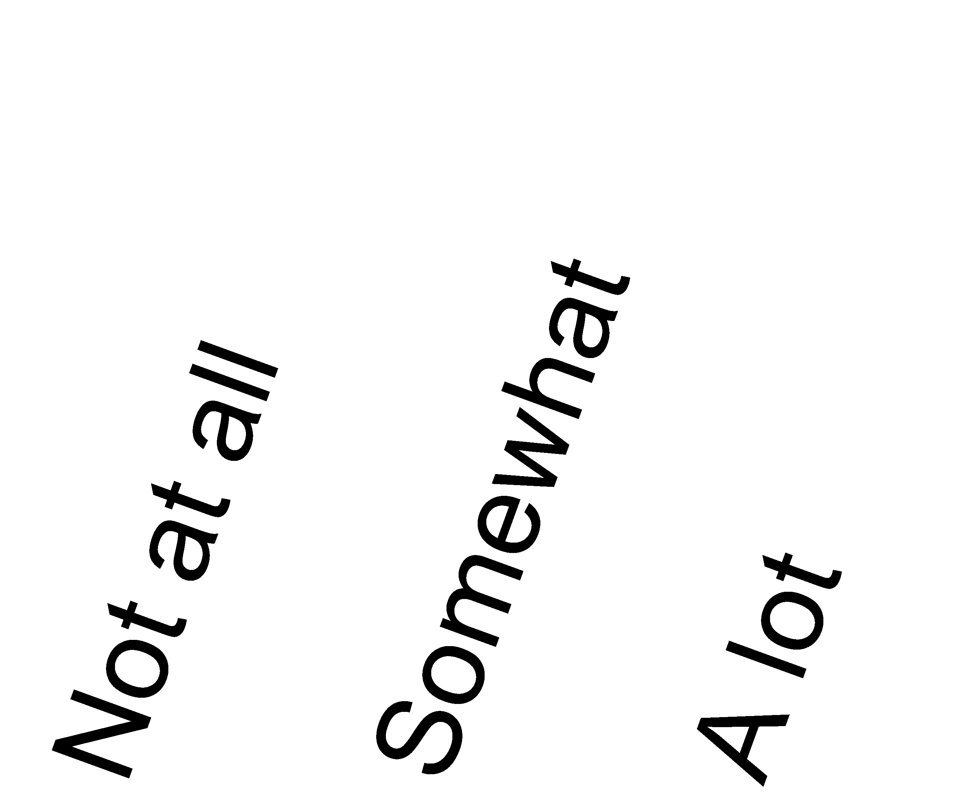
a. Food and Drug Administration (FDA)
b. The manufacturer
c. My doctor
d. The industry’s professional association

H9. How much do you believe those listed below will give you a clear recommendation about how to manage a food safety problem?
a. Food and Drug Administration (FDA)
b. Centers for Disease Prevention & Control (CDC)
c. My doctor
d. USDA (Department of Agriculture)

H10. Do you AGREE or DISAGREE with each of the following statements?
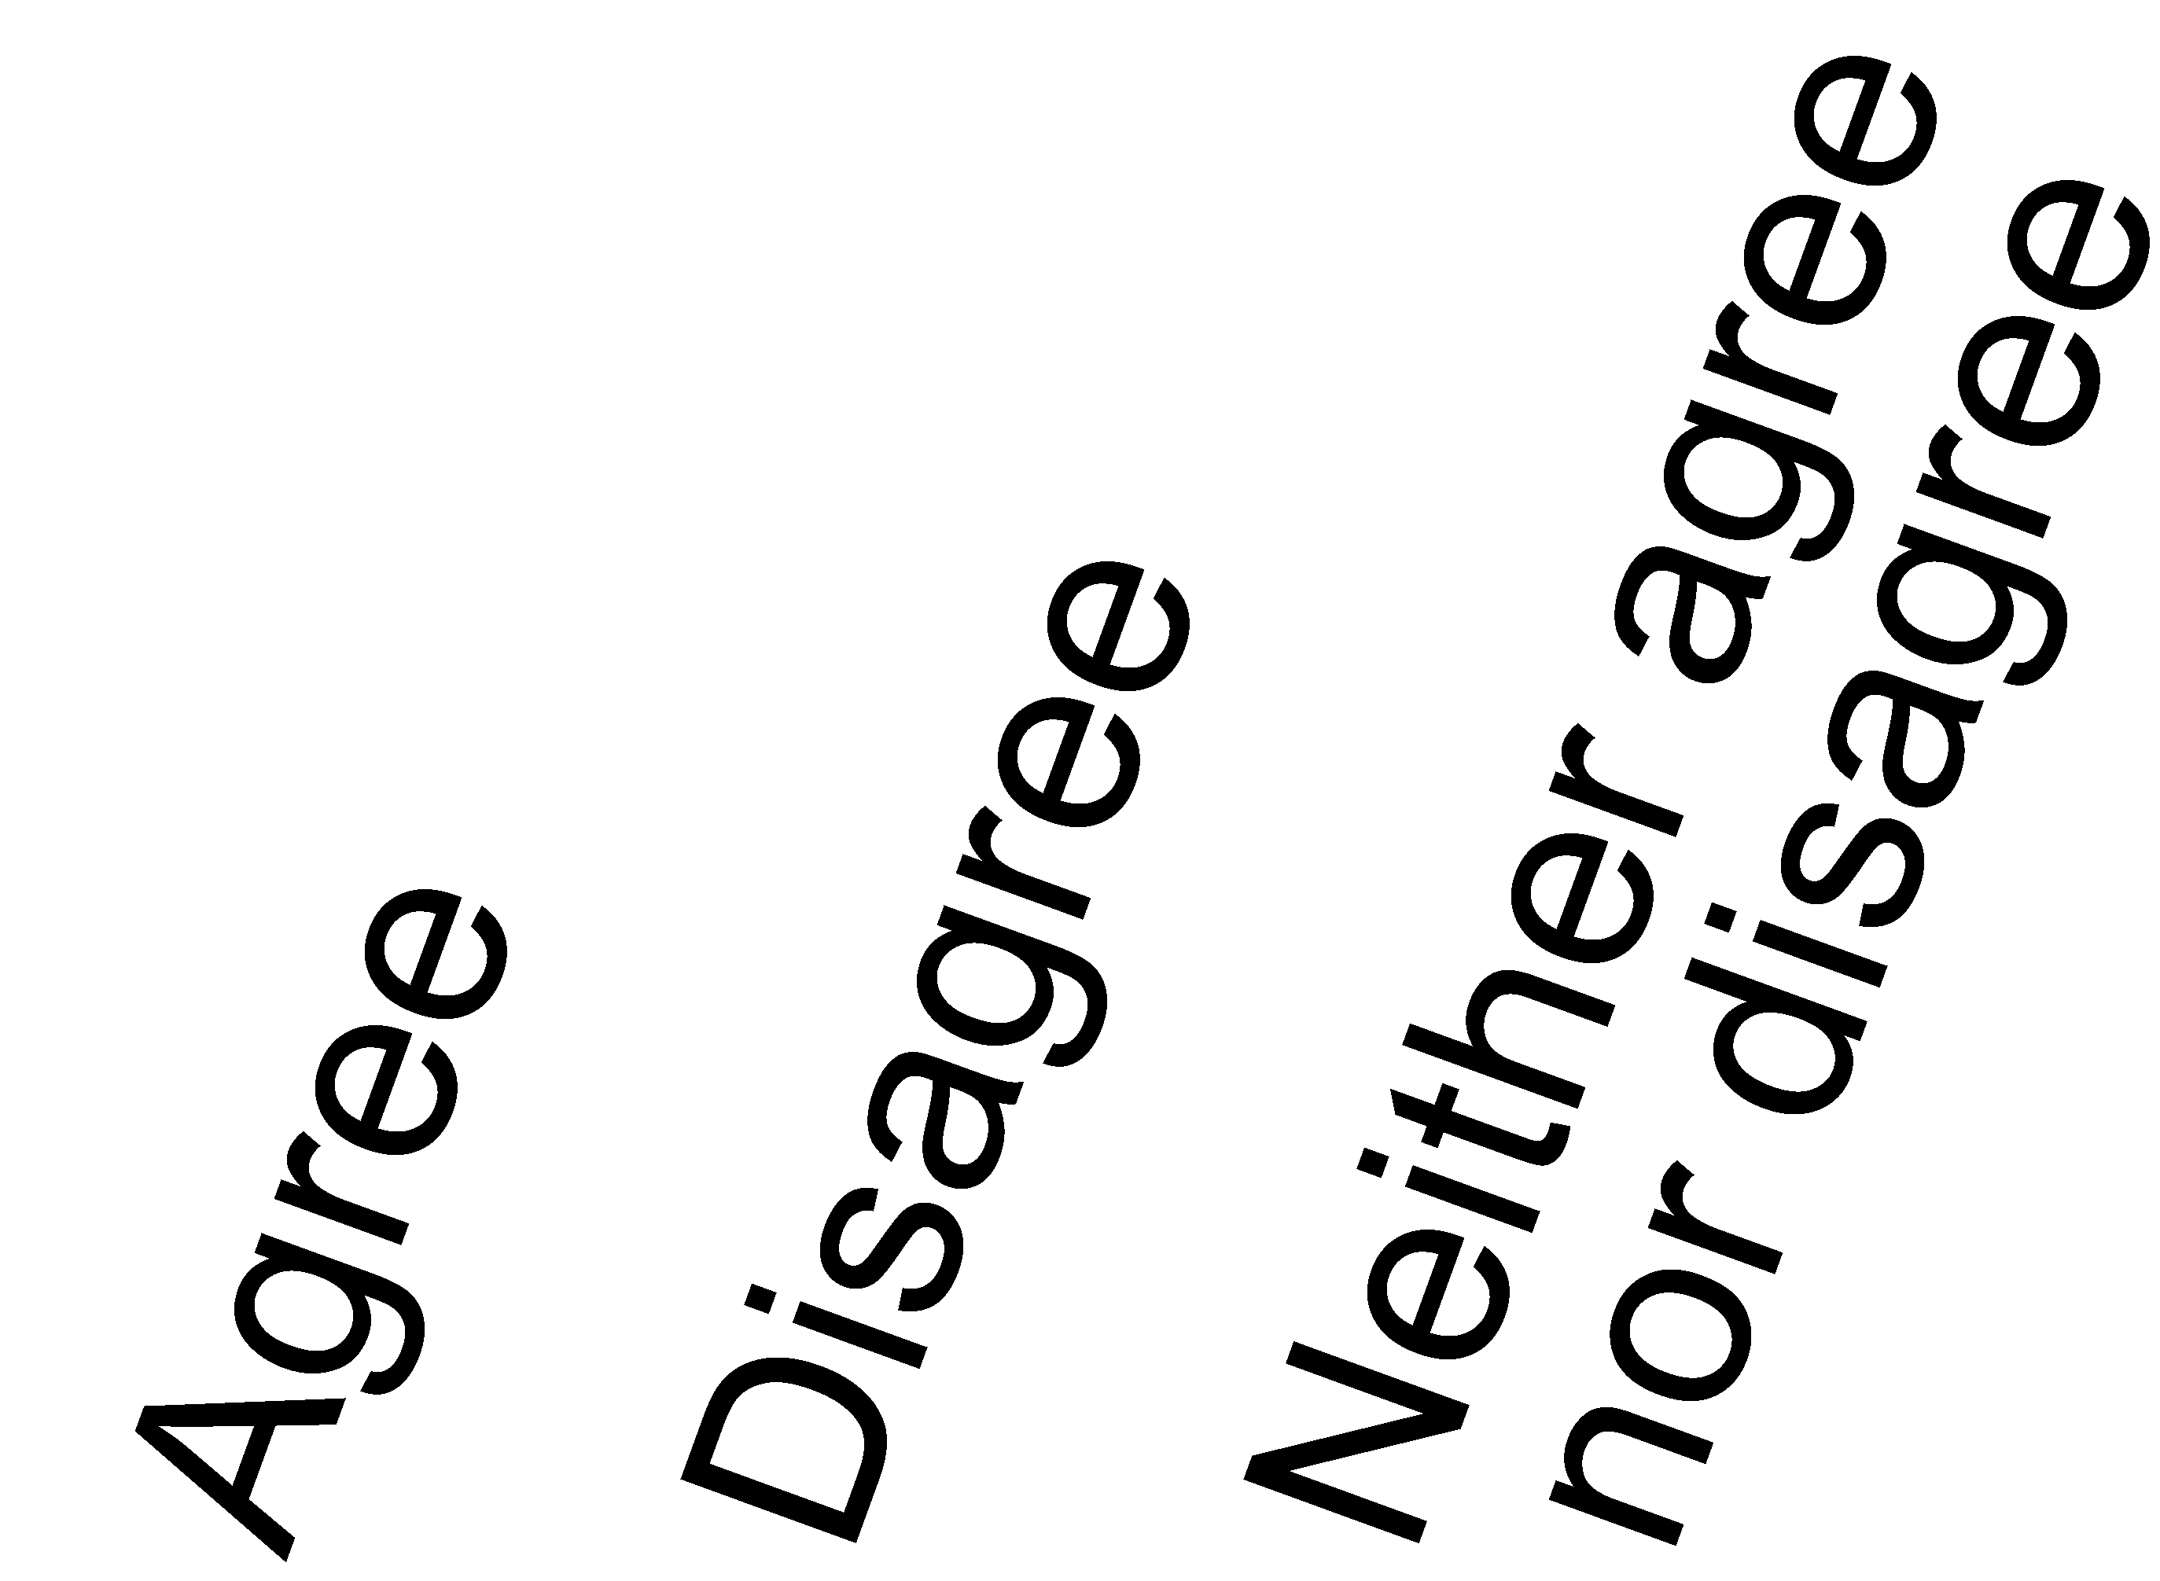
a. The food I buy is safe to eat.
b. The medications I buy are safe to use.
c. The medications I buy are effective.
b. Vaccines that I get are safe.
c. Vaccines that I get are effective.
b. Cosmetics are tested and proved safe before they are sold.
c. Pet food is safe for animals to consume.
b. My medical equipment is safe to use.
c. My medical equipment works well.

I: You and Your Household

I1. What is your age?
Years old

I2. What is your current occupational status?
X
Mark only one.
Employed
Unemployed
Homemaker
Student
Retired
Disabled

Other-Specify

I3. Have you ever served on active duty in the U.S. Armed Forces, military Reserves or National Guard? Active duty does not include training in the Reserves or National Guard, but DOES include activation, for example, for the Persian Gulf War.
Yes, now on active duty
Yes, on active duty in the last 12 months but
not now
Yes, on active duty in the past, but not in the
last 12 months
No, training for Reserves or
National Guard only
No, never served in the military

I4. What is your marital status?
Married
Living as married
Divorced
Widowed
Separated
Single, never been married

I5. What is the highest grade or level of schooling you completed?
Less than 8 years
8 through 11 years
12 years or completed high school
Post high school training other than college
(vocational or technical)
Some college
College graduate
Postgraduate

I6. Were you born in the United States?
Yes GO TO I9 below
No

I7. In what year did you come to live in the United States?
Year

I8. How well do you speak English?
Very well
Well
Not well
Not at all

I9. Are you of Hispanic, Latino/a, or Spanish origin? One or more categories may be selected.
X
Mark one or more.
No, not of Hispanic, Latino/a, or Spanish origin
Yes, Mexican, Mexican American, Chicano/a
Yes, Puerto Rican
Yes, Cuban
Yes, another Hispanic, Latino/a, or Spanish origin

I10. What is your race? One or more categories may be selected.
Mark one or more.
X
White
Black or African American
American Indian or Alaska Native
Asian Indian
Chinese
Filipino
Japanese
Korean
Vietnamese
Other Asian
Native Hawaiian
Guamanian or Chamorro
Samoan
Other Pacific Islander

I11. Including yourself, how many people live in your household?
Number of people

I12. Starting with yourself, please mark the sex, and write in the age and month of birth for each adult 18 years of age or older living at this address.
 | Sex | Age | Month Born  (01-12)
SELF | Male  Female
Adult 2 | Male  Female
Adult 3 | Male  Female
Adult 4 | Male  Female
Adult 5 | Male  Female

I13. How many children under the age of 18 live in your household?
Number of children under 18

I14. Do you currently rent or own your home?
Own
Rent
Occupied without paying monetary rent

I15. Does anyone in your family have a working cell phone?
Yes
No

I16. Is there at least one telephone inside your home that is currently working and is not a cell phone?
Yes
No

I17. Thinking about members of your family living in this household, what is your combined annual income, meaning the total pre-tax income from all sources earned in the past year?
$0 to $9,999
$10,000 to $14,999
$15,000 to $19,999
$20,000 to $34,999
$35,000 to $49,999
$50,000 to $74,999
$75,000 to $99,999
$100,000 to $199,999
$200,000 or more

I18. Do you think of yourself as…
Heterosexual, or straight
Homosexual, or gay or lesbian
Bisexual

Something else -Specify

I19. Do you live in the same household with someone who uses tobacco products?
Yes
No

I20. How many people in your household use tobacco products?
Number of tobacco users

I21. Are you deaf or do you have serious difficulty hearing?
Yes
No

I22. Are you blind or do you have serious difficulty seeing, even when wearing glasses?
Yes
No

I23. Because of a physical, mental, or emotional condition, do you have serious difficulty concentrating, remembering, or making decisions?
Yes
No

I24. Do you have serious difficulty walking or climbing stairs?
Yes
No

I25. Do you have difficulty dressing or bathing?
Yes
No

I26. Because of a physical, mental, or emotional condition, do you have difficulty doing errands alone such as visiting a doctor’s office or shopping?
Yes
No

I27. About how long did it take you to complete the survey?
Write a number in one box below.
 |  | Minutes |  |  | Hours

I28. At which of the following types of addresses does your household currently receive residential mail?
X
Mark all that apply.
A street address with a house or building number
An address with a rural route number
A U.S. post office box (P.O. Box)
A commercial mail box establishment (such as Mailboxes R Us, and Mailboxes Etc.)

