1st mailing printed on a scenic park postcard (sent to all participants 11 working days after mailing of the questionnaire)

Dear Visitor,

Thank you for participating in the Cape Lookout National Seashore visitor study. We are really looking forward to hearing from you soon.

Only a select number of people were contacted to participate in this study, so your opinions are very important.

If you have already returned your questionnaire, we would like to thank you. If you have not returned or completed the questionnaire, we are asking that you please take the time to complete and return it to us by mail today. If you have misplaced the questionnaire, please contact us and we will be happy to send you a replacement copy.

Thank you for your help with this study. After eight months, the results of the survey will be available at: www.psu.uidaho.edu/vsp.reports.htm.

Pat Kenney
Superintendent
Cape Lookout National Seashore

2nd follow-up note and letter with replacement questionnaire (sent to all non-respondents within 21 working days after mailing of questionnaire)

  : | United States Department of the Interior  NATIONAL PARK SERVICE  Cape Lookout National Seashore  131 Charles Street  Harkers Island, NC 28531 | 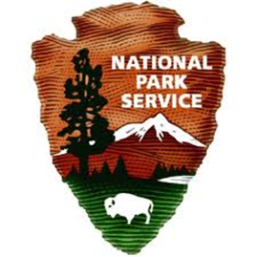

Month Day, 2013

Dear Visitor,

The National Park Service would like to thank you for agreeing to participate in the Cape Lookout National Seashore visitor study. As you are aware, we selected a small number of visitors to participate in this study; therefore, the return of each questionnaire is very important to complete this study.

If you have already returned your questionnaire, we would like to thank you; however, if you have not, we are asking you to please return it by mail today. Since we have not received yours as of today, we have included a replacement questionnaire for your convenience.

If you have any questions regarding your questionnaire, please contact Lena Le, Director, Visitor Services Project, by phone: 208-885-2585 or: lenale@uidaho.edu (email).

Thank you for your help with this study. In approximately eight months, the results of the survey will be posted on the Visitor Services Project website at www.psu.uidaho.edu/vsp.reports.htm.

Sincerely,

[insert signature]

Pat Kenney
Superintendent

3rd follow-up (and final) letter with replacement questionnaire (sent to all non-respondents within 35 working days after mailing of questionnaire)

IN REPLY REFER TO: | United States Department of the Interior  NATIONAL PARK SERVICE  Visitor Services Project  PSU, College of Natural Resources  University of Idaho  P.O. Box 441139  Moscow, Idaho 83844-1139

Month Day, 2013

Dear Visitor,

About three weeks ago, you agreed to complete a survey for a visitor study at Cape Lookout National Seashore. As of today we have not received your completed questionnaire and the period to receive questionnaires is almost over. I am writing to let you know that I would appreciate you completing and returning your survey (unless you mailed it within the past few days).

The staff of Cape Lookout National Seashore is anxious to receive the survey results. They would like to have the ideas and opinions of this survey group to help make decisions about the services and programs they will provide in the future.

I would like to encourage you to complete the enclosed questionnaire and return it by {month and day}. Your contribution will add to the success of this study and your time is greatly appreciated.

If you have any questions regarding your questionnaire, please contact Lena Le, Director, Visitor Services Project, by phone: 208-885-2585 or: lenale@uidaho.edu (email).

In approximately eight months, the results of this survey will be posted on the Visitor Services Project website at www.psu.uidaho.edu/vsp.reports.htm.
Sincerely,

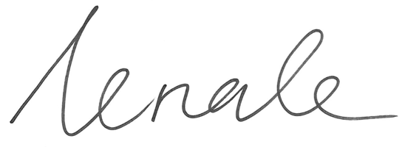
Lena Le
Director, Visitor Services Project

