Changes to Form WD-10

Previous form  
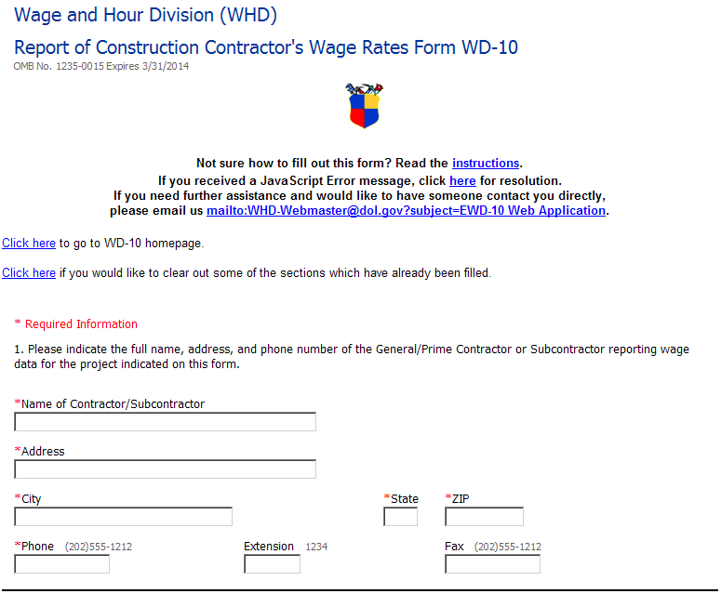Current form  
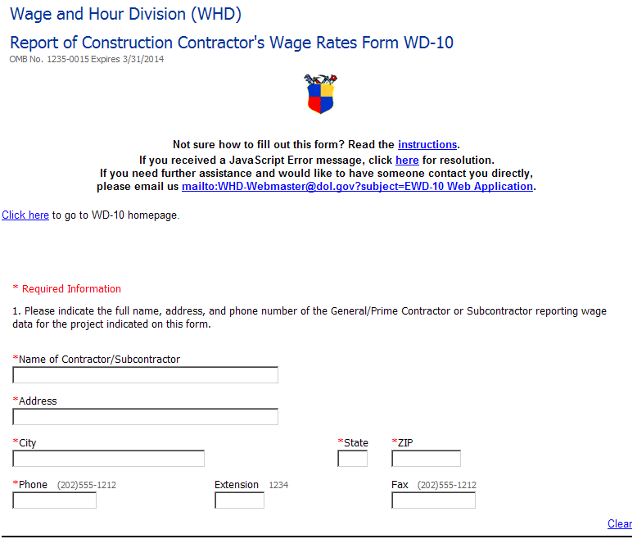

Added Clear button for each section

Removed link to clear filled sections

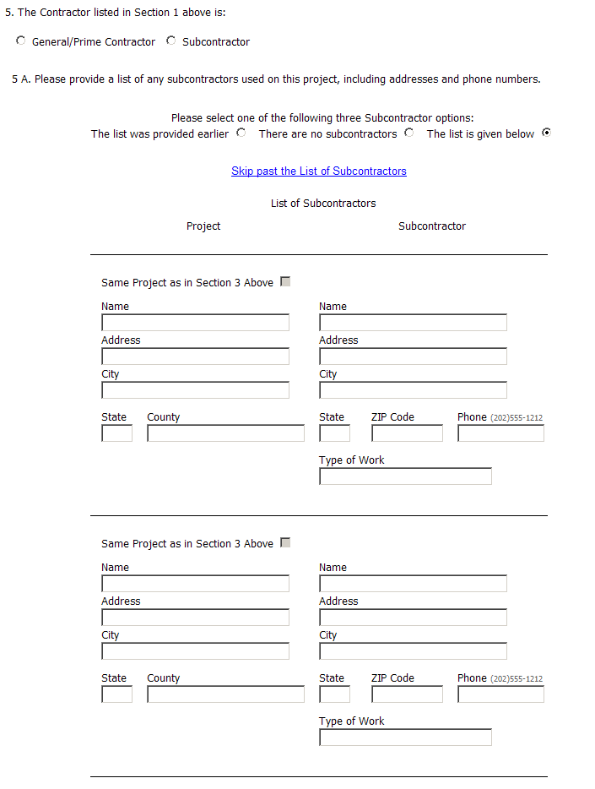

Synchronized instruction with construction type terminology in list

Subcontractor entries are added individually, instead of defining 15 entries to the form

The project entry is no longer required for each Subcontractor entry

Subcontractor list not displayed  
unless “The list is given below”  
is selected

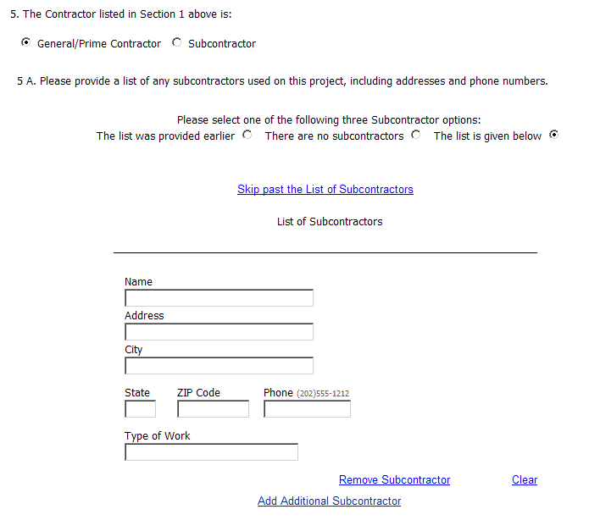

Added button to remove subcontractors individually

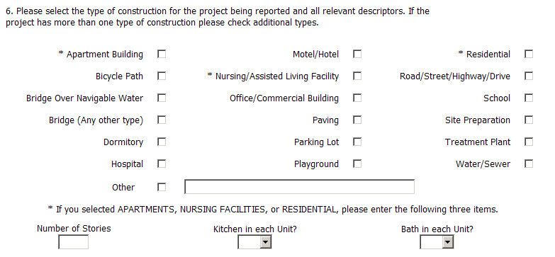 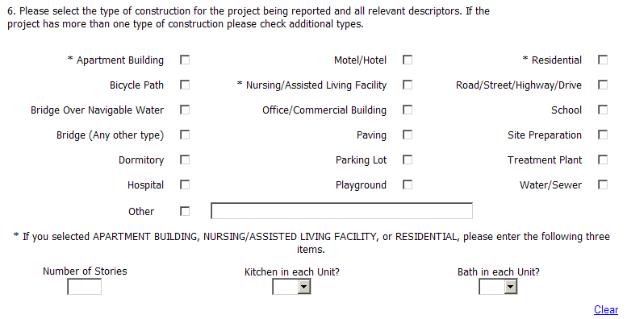

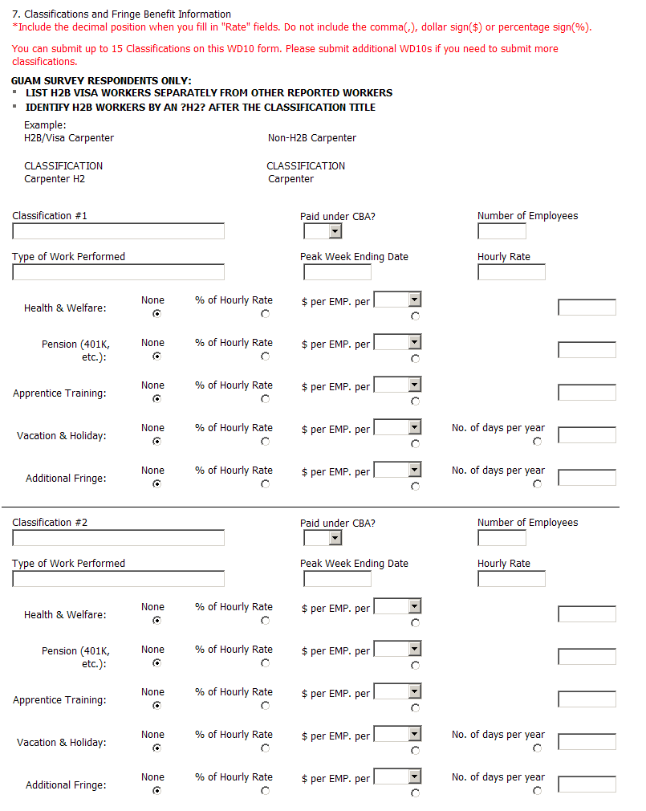

Classification entries are added individually, instead of defining 15 entries to the form

Removed text

More compact layout – text contained on individual lines

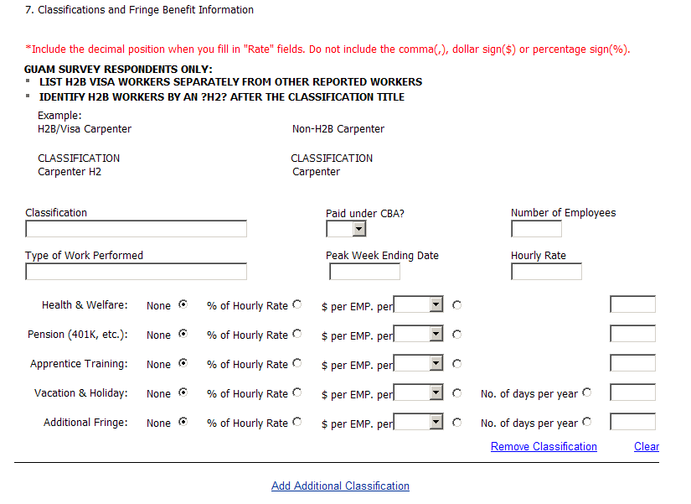

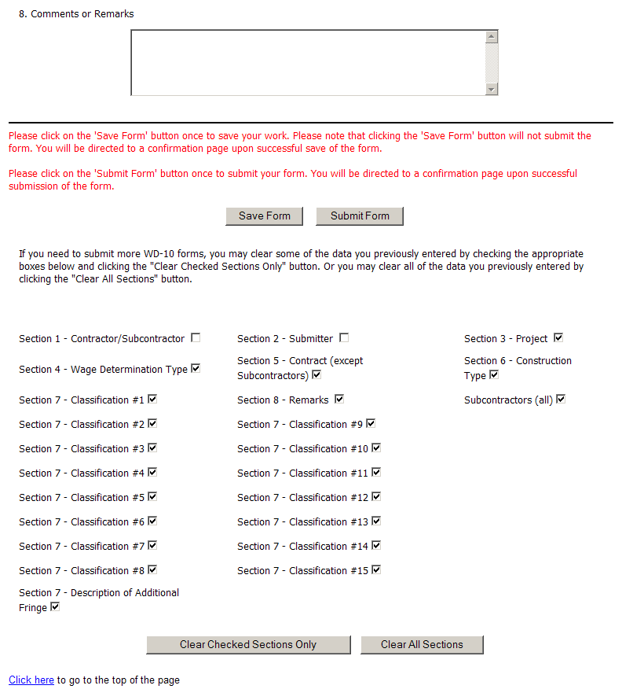 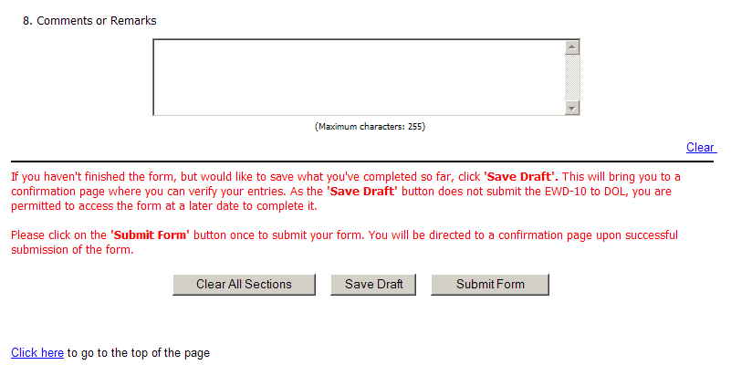

Added button to remove classifications individually

Removed “Clear Section” text

Removed “Clear Section” options and button

Revised instruction text in red

Bolded button names

Clarified save versus submit processes

Aligned buttons

Renamed Save Form button to Save Draft