Changes to Form WD-10
Previous form
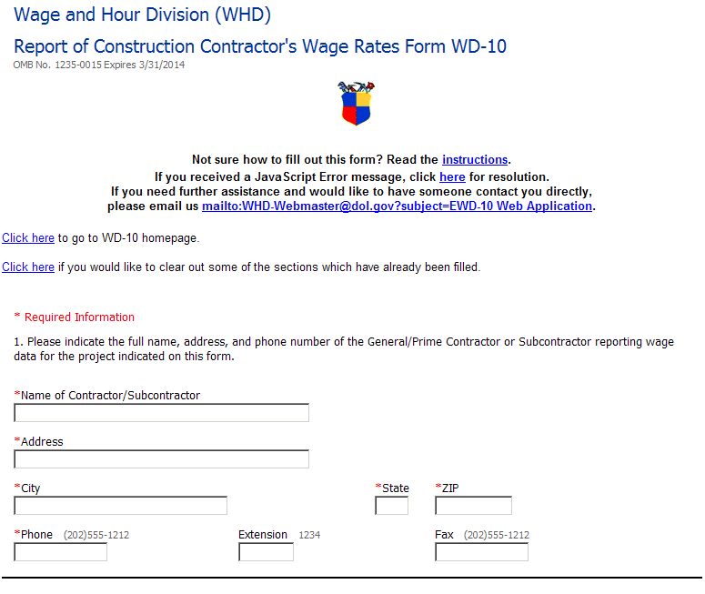
Current form
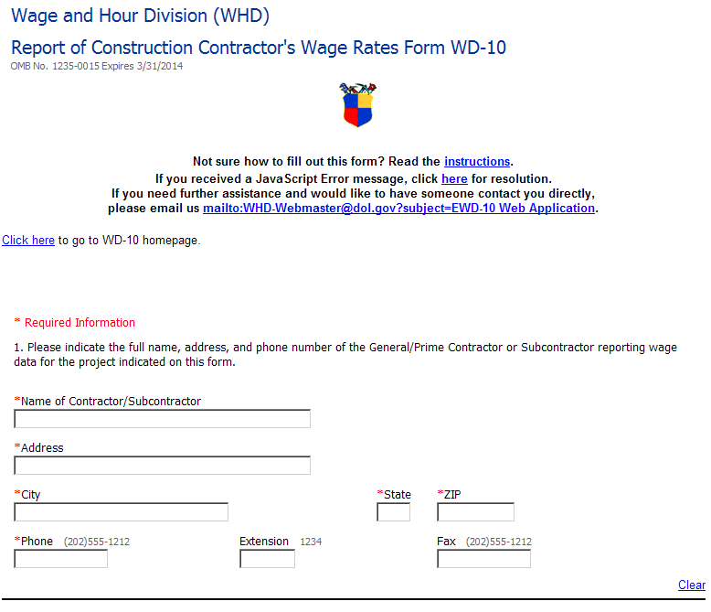
Added Clear button for each section
Removed link to clear filled sections

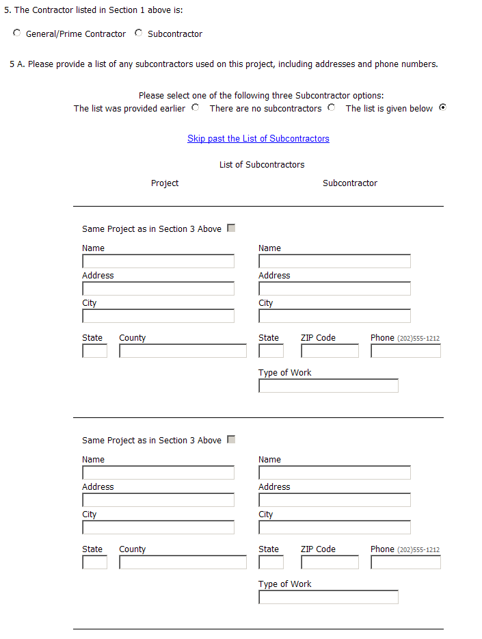
Synchronized instruction with construction type terminology in list
Subcontractor entries are added individually, instead of defining 15 entries to the form
The project entry is no longer required for each Subcontractor entry
Subcontractor list not displayed
unless “The list is given below”
is selected

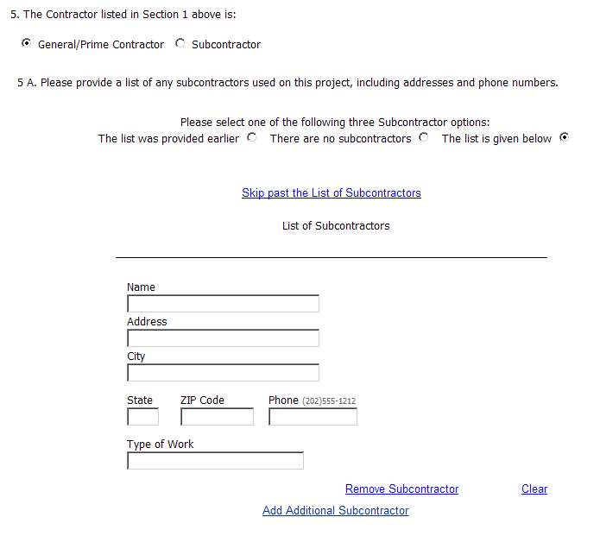
Added button to remove subcontractors individually

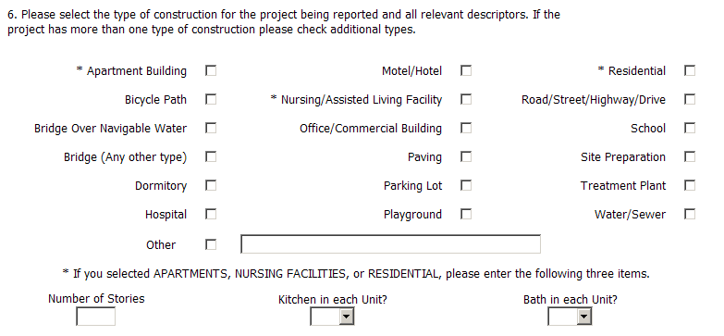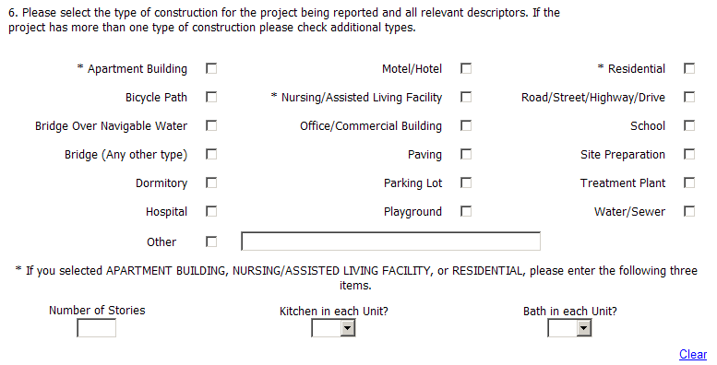

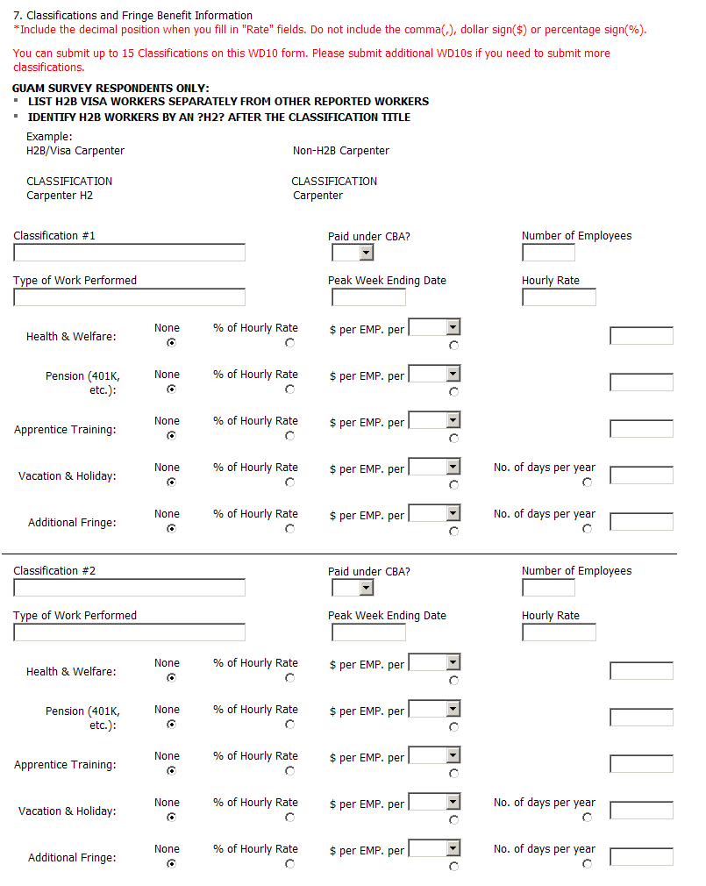
Classification entries are added individually, instead of defining 15 entries to the form
Removed text
More compact layout – text contained on individual lines

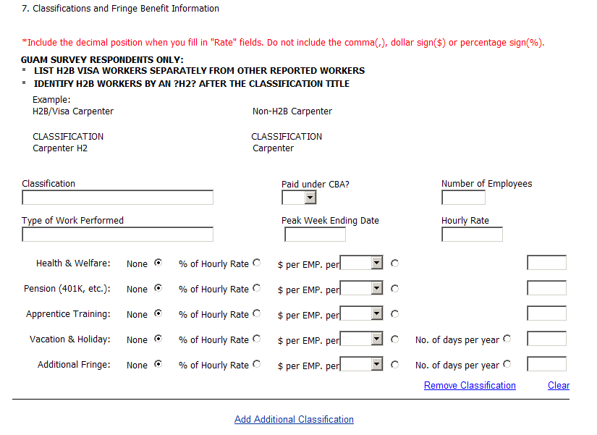
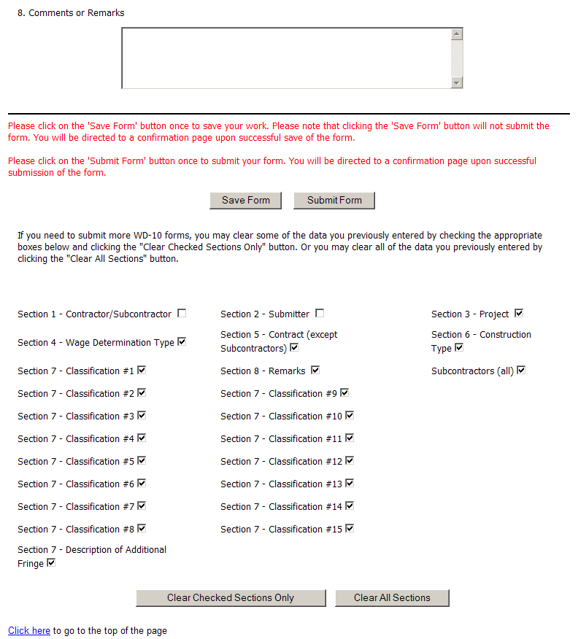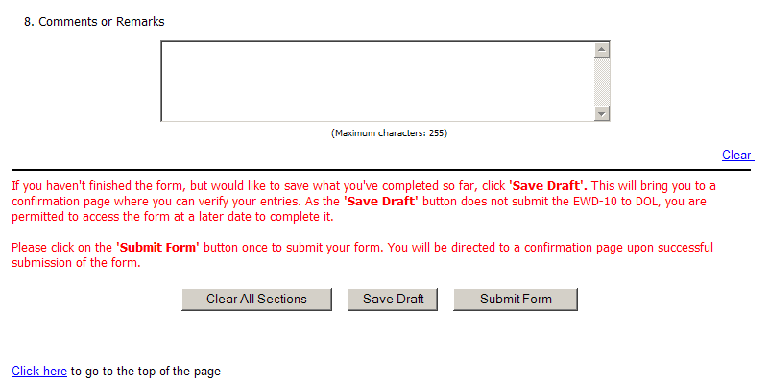
Added button to remove classifications individually
Removed “Clear Section” text
Removed “Clear Section” options and button
Revised instruction text in red
Bolded button names
Clarified save versus submit processes

Aligned buttons
Renamed Save Form button to Save Draft

