<DATE>

Dear Respondent:

The Energy Information Administration (EIA) is conducting the EIA-64A Survey, *Annual Report of the Origin of Natural Gas Liquids Production*, for calendar year 2012. Please see the 2012 survey form and instructions for filing the 2012 data contained within this package. Copies are also available on the Internet at <http://www.eia.gov/survey/#eia-64a>. You may submit your data to EIA via E-mail at [OOG.SURVEYS@eia.gov](mailto:OOG.SURVEYS@eia.gov) or by fax at (202) 586-1076.

Please complete this form and return it to the EIA by xxxxx xx, xxxx.

According to our records, you are the person responsible for submitting information for (company/plant list):

Plant ID: Company Name: Plant Name:

<DUPLICATE_ID_NAME1_NAME2>

All operators of natural gas processing plants are required to respond to this survey. These data, together with data reported by operators of oil and gas wells on Form EIA-23, *Annual Survey of Domestic Oil and Gas Reserves*, will enable EIA to estimate regional and national volumes of natural gas liquids and dry natural gas proved reserves and production. The development of high quality annual oil and gas reserves and production estimates, in the timeliest manner possible, is a priority effort of EIA. These estimates are vital to the analysis of major domestic energy policy issues. By providing the 2012 data by the xxxx xx,xxxx deadline, you will be helping us assure the continued availability of up-to-date reserves estimates.

The domestic oil and gas reserves estimates generated from these data are published in the EIA annual report, *U.S. Crude Oil, Natural Gas and Natural Gas Liquids Reserves*. Our publications are available on the Internet at http://www.eia.gov.

Thank you for your cooperation and participation in this important survey. If you have any questions or need assistance in completing the form, please contact the EIA-64A Coordinator at 1-800-879-1470 between 8:30 a.m. and 4:30 p.m. Eastern Time.

Sincerely,

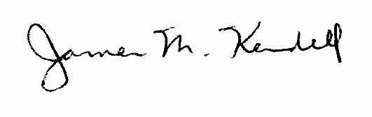

James M. Kendell

Director

Office of Oil, Gas & Coal Supply Statistics

Office of Energy Statistics

Energy Information Administration