INSTRUCTIONS
The ENERGY STAR Multifamily High Rise Submittal Validation Form is used by the licensed professional to validate submittals. This form must be signed and stamped by a professional engineer or registered architect and submitted to EPA or its designated agent for approval. For more information on program submittals see the Licensed Professional’s Guide to the ENERGY STAR Label for MFHR Buildings.

BUILDING INFORMATION

Building Address ENERGY STAR Developer Partner Licensed Professional
Project Name: Street: City, State:  ZIP: | Company Name: Contact Name: Phone:  Email: | Company Name: Contact Name: Phone:  Email:

SUBMITAL VALIDATION
This building is earning the ENERGY STAR using the following (Please check the appropriate box):

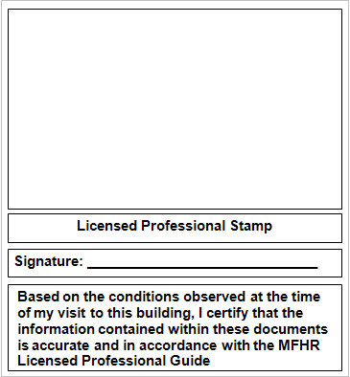Performance Path
OMB Control No. 2060-0586

Prescriptive Path

This validation form pertains to the following (please check the appropriate box)

Proposed Building Submittal (The following documents must be included as part of the submittal)

1. Proposed Building Reporting Summary (Performance
Path Only)
2. Testing and Verification Worksheets

As-Built Building Submittal (The following documents must be part of the submittal)

1. As-Built Building Reporting Summary (Performance
Path Only)
2. Testing and Verification Worksheets
3. Photo Template

By signing and stamping this form the licensed professional is not guaranteeing performance of the operating building nor does it require that the licensed professional certify that the building will perform to any specified level. By validating the submission, the licensed professional is certifying that the information contained within the submitted documents is accurate and in accordance with the program’s guidelines, based on the conditions observed.

HOW TO SUBMIT DOCUMENTS

To ensure that EPA or its designated agent has a complete file for each project participating in the program the
Proposed and As-Built Building Submittals should be submitted as indicate below.

1. The following documents must be submitted in Portable Document Format (PDF)

- Proposed Building Reporting Summary
- As-Built Building Reporting Summary
- ENERGY STAR MFHR Submittal Validation Form
- Photo Template

2. The Testing and Verification Worksheets Excel file must be submitted in its entirety

All documents should be emailed as an attachment to mfhr@energystar.gov with the following the subject line,
[Proposed] or [As-Built] Building Submittal (Project Name, Address, City, State).

Contact information for questions:
• Email: mfhr@energystar.gov
• Website: www.energystar.gov/mfhr

If the licensed professional chooses to submit hard copy documents to EPA they should be sent to the following address

Mailing Address
ENERGY STAR Label for Multifamily High Rise Buildings
U. S. Environmental Protection Agency (6202J)
1200 Pennsylvania Avenue, NW Washington, DC 20460

Express Mail and Courier
ENERGY STAR Label for Multifamily High Rise Buildings
Room 927P
1310 L Street, NW Washington, DC 20005

EPA Form 5900-270
The government estimates the average time needed to fill out this form is 0.10 hours and welcomes suggestions for reducing this effort. Send comments (referencing OMB Control Number) to the Director, Collection Strategies Division, U.S. EPA (2822T), 1200 Pennsylvania Ave., NW, Washington, D.C. 20460.

