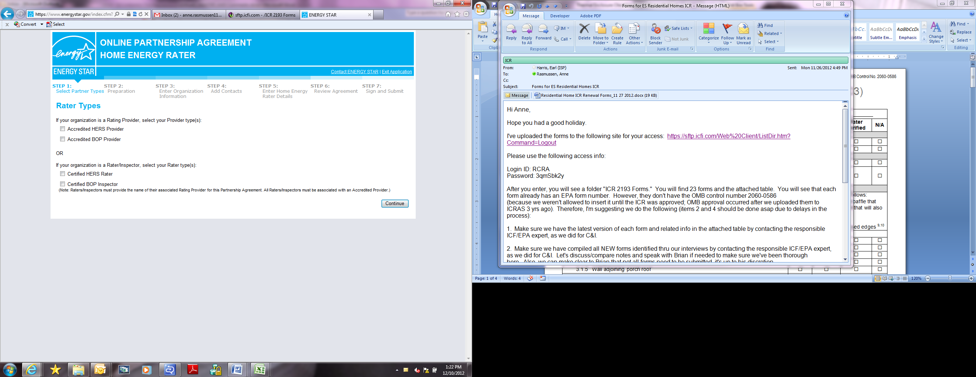

EPA Form 5900-188

The government estimates the average time needed to fill out this form is 0.16 hours and welcomes suggestions for reducing this effort. Send comments (referencing OMB Control Number) to the Director, Collection Strategies Division, U.S. EPA (2822T), 1200 Pennsylvania Ave., NW, Washington, D.C. 20460.

OMB Control No. 2060-0586