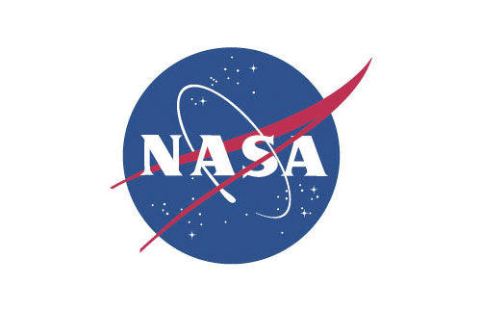
Registration Information to Attend Pre-Proposal/Pre-Bid Conferences Sponsored by NASA

Offerors, individuals, or interested parties who plan to attend the pre-proposal/pre-bid conference must provide the Contracting Officer in writing, at a minimum:
- full name of the attendee(s)
- identification of nationality (U.S. or specify other nation citizenship)
- lawful permanent resident numbers in the case of foreign nationals
- affiliation and full office address/phone number.
Center-specific security requirements for this pre-proposal/pre-bid conference will be given to a company representative prior to the conference or will be identified in this solicitation as follows: (fill-in).
Examples of specific identification information which may be required include state driver’s license and social security number. Except for foreign nationals, the identification information must be provided at least (fill-in) working days in advance of the conference. This information shall be provided at least (fill-in) working days in advance of the conference for foreign nationals due to the longer badging and clearance processing time required. However, the Center reserves the right to determine foreign nationals may not be allowed on the Government site.
The Government is not responsible for offerors’ inability to obtain clearance within sufficient time to attend the conference. Due to space limitations, representation of any potential Offeror may not exceed (fill-in) company representatives/persons per Offeror. Any “lobbying firm or lobbyist” as defined in 2 U.S.C. 1602(9) and (10), or any Offeror represented by a lobbyist under the Lobbying Disclosure Act of 1995 shall be specifically identified.

