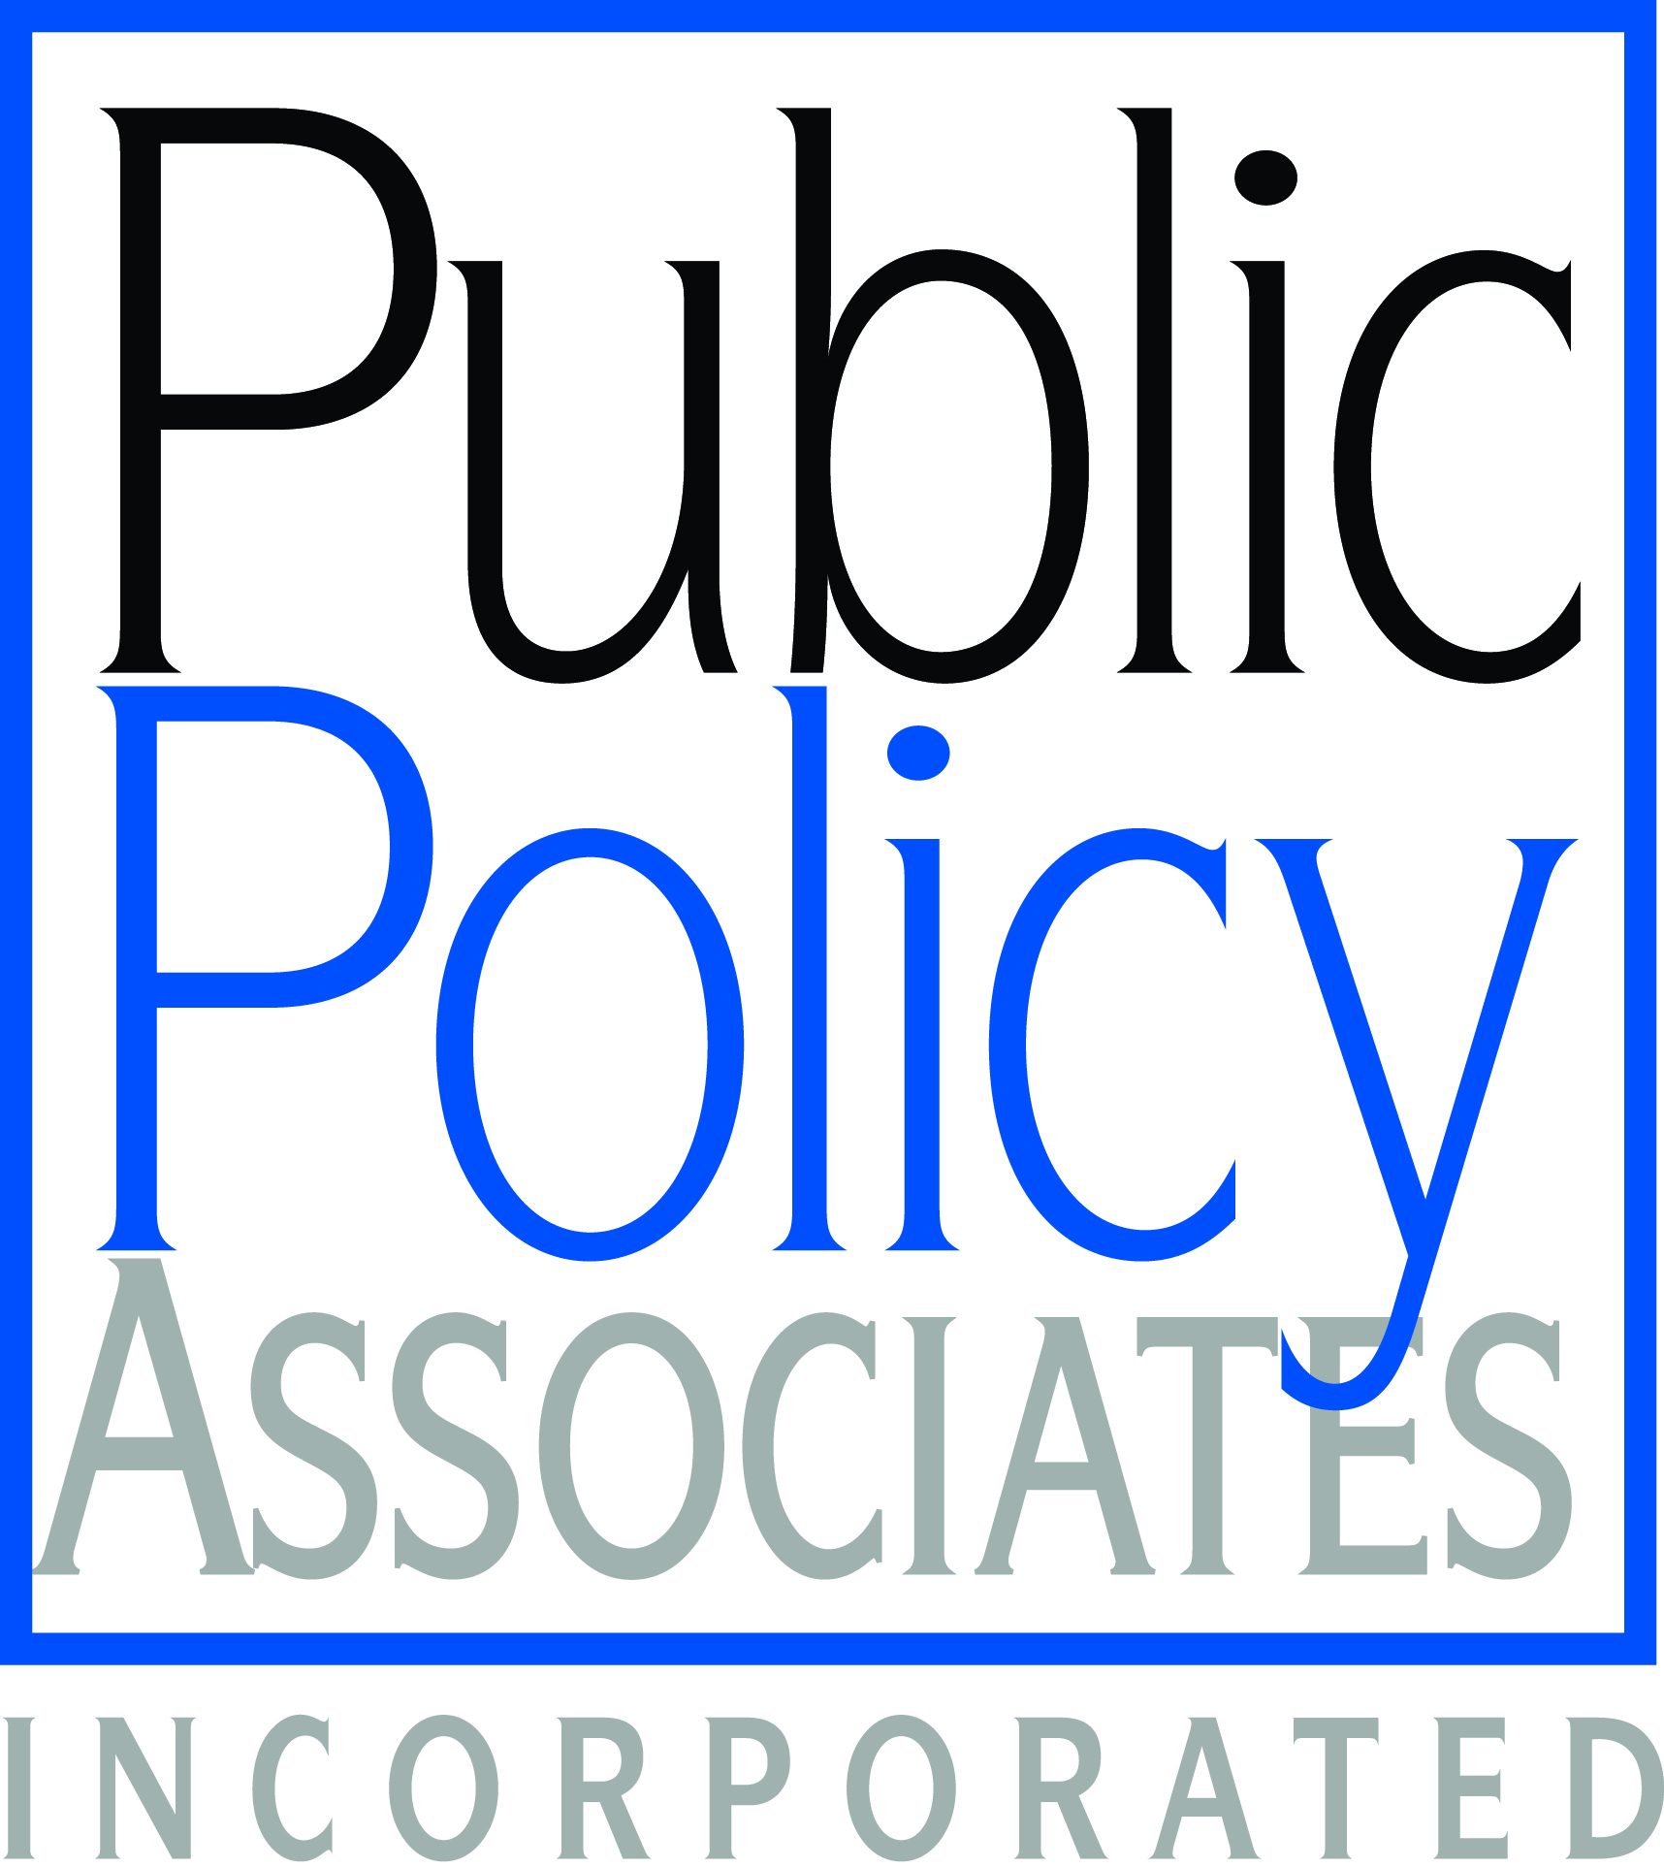
Research Consent Form

I acknowledge that I am volunteering to participate in this focus group, and that I understand the following:

- This research is being conducted on behalf of the National Women’s Business Council, an advisory group to the President, Congress, and the U.S. Small Business Administration.
- The session could not go forward without approval from the federal Office of Management and Budget (OMB). The control number, indicating approval, is [OMB control number].
- This session is being videotaped.
- The information I share may be used to inform further research, decisions, and actions by the National Women’s Business Council.
- There are no known risks or costs associated with participating in the focus group.
- I will receive $25 for participating, plus the opportunity to receive an additional $150 through a drawing, at the close of the focus group session.
- The session will take two hours.
- All responses I give will be held confidential by PPA. My name will not be shared beyond the PPA research team, whether in reports, transcripts, or data sets, unless I give written permission. The data from the focus group research will only be reported in aggregate.

Print name: ____________________________________

Signature: _____________________________________

Date: ___________________

NWBC-0001

