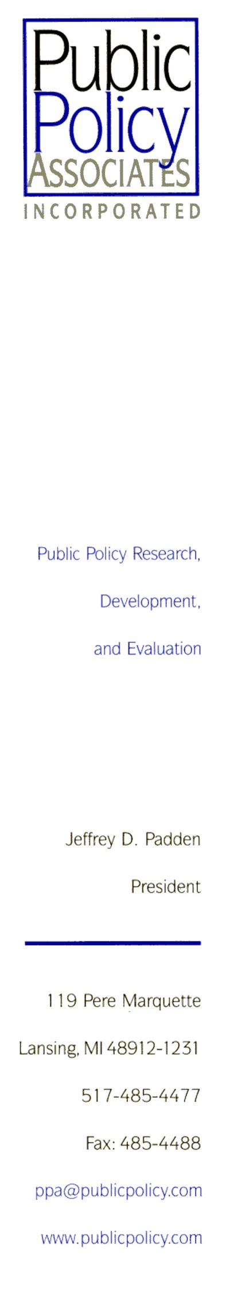[Date]

Dear [Name]:

Thank you for agreeing to participate in our upcoming focus group about issues that affect women business owners like yourself, conducted on behalf of the National Women’s Business Council. You are registered for the following session:

*Date:*  [Date]

*Time:* [Start Time] – [End Time]

*Location:* [Building]

[Room]

[Address]

Light refreshments will be provided. Please note that we cannot accommodate late arrivals or children. You must remain for the entire discussion in order to receive the $25 incentive and be eligible to participate in the $150 drawing.

A map with directions to the focus group location is enclosed. We will contact you a day or two before the session as a reminder. If you have any questions or cannot participate in the focus group for any reason, please contact me at 1‑800-665-8449.

We look forward to seeing you on [date]!

Sincerely,

[PPA focus group assistant name]

NOTE:

This study has been reviewed and approved by the federal Office of Management and Budget (OMB); without OMB’s approval the session could not be conducted.