OMB Control number 0505-XXXX

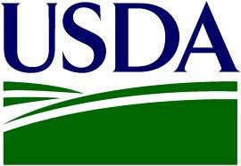

Expiration Date:

[insert date]

ABC Vendor

12345 Monterey Road

Morgan Hill, CA 95037

Attention: Accounts Receivable

In an effort to maintain the integrity of the USDA’s records, this office is requesting some documentation from selected vendors. Unless questions arise from this information, no further action will be required on your part.

Please provide an aged trial balance or statement of our account. Whichever form of documentation you provide, please ensure that all open items including invoices, credits, rebates and deductions are clearly shown. The version you send should include applicable document numbers such as P.O. or invoice. If multiple agencies are served, please also include corresponding account information when available.

Mail, fax or email this documentation to:

|  |  |
| --- | --- |
| Vendor Compliance Office | (504) 254-8610 phone |
| 6221 S. Claiborne Avenue #637 | (504) 254-8652 fax |
| New Orleans, LA 70125 | [compliance@USDAvendors.us](mailto:compliance@USDAvendors.us) |

Please provide contact information for an individual who can answer questions on the information provided.

|  |  |
| --- | --- |
| Name: | Phone: |
| Email: | Fax: |

Thank you for your assistance with this request – the USDA values our vendor relationships! Should you have any questions, please call an auditor in the Vendor Compliance Office at the phone number above.

Questions regarding this project should be referred to [client contact name and phone number].

Sincerely,

[Signers Name] [Signers Title]

Wording will be removed prior to distribution to vendors.

***Proprietary Sensitive*** *Not to be disclosed without prior written authorization from Gryphon Financial Group, Inc.*