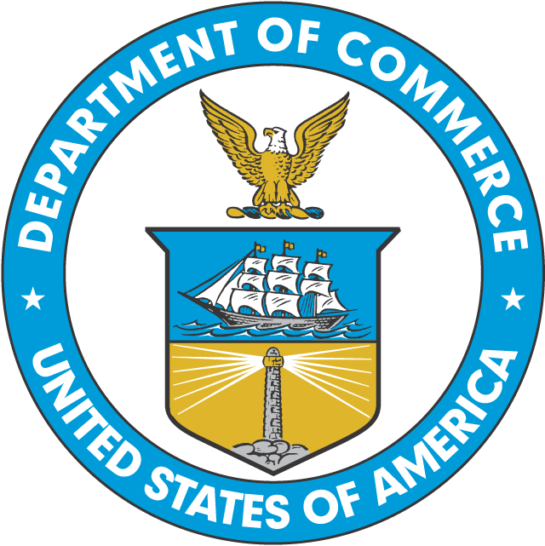
UNITED STATES DEPARTMENT OF COMMERCE
Application to Shuck Surfclams/Ocean Quahogs at Sea
National Oceanic and Atmospheric Administration
National Marine Fisheries Service
Northeast Region
55 Great Republic Drive
Gloucester, MA 01930-2298

In order to receive authorization to shuck surfclams or ocean quahogs at sea, please provide the information requested below and mail to:

Regional Administrator
National Marine Fisheries Service
55 Great Republic Drive
Gloucester, MA 01930

This application is required under 50 CFR 648.75 in order to obtain a shucking-at-sea permit for the Atlantic surfclam and ocean quahog fisheries. Information provided on the application will allow the Regional Administrator to determine if a vessel has the capability to calculate the amount of surfclams or ocean quahogs harvested in the shell. This information is needed to execute the individual transferable quota system which uses unshucked bushels as a standard unit of measure.

Name:
(Print legibly)
Vessel Name:
Federal Permit #:
Doc/Reg #:
Street:
City/ State/ Zip:
Telephone:
U.S. citizen requirement. By checking this box you are indicating that you are eligible to own a documented vessel under the terms of 46 U.S.C. 12102(a) and are able to provide documentation attesting to such eligibility if requested by the National Marine Fisheries Service.

On an attachment, or the back of this form, please describe the method to be used to calculate the amount of surfclams or ocean quahogs harvested in the shell.

Vessel Dimensions:  (Length and Gross Tonnage) | Observer Accommodations:
Anticipated Trip Length:

Signature: | Date:

Public reporting burden for this collection of information is estimated to average 30 minutes per response, including time for reviewing instruction, searching existing data sources, gathering and maintaining data needed, and completing and reviewing the information. Send comments regarding this burden estimate to: NMFS, 55 Great Republic Drive, Gloucester, MA 01930. Notwithstanding any other provisions of the law, no person is required to respond to, nor shall any person be subjected to a penalty for failure to comply with, a collection of information subject to the requirements of the Paperwork Reduction Act, unless that collection of information displays a currently valid OMB Control Number. The information collected is confidential under section 402(b) of the Magnuson-Stevens Act(16 U.S.C. 1801, et seq.). The information is also confidential under NOAA Administrative Order 216-100, which sets forth procedures to protect confidentiality of fishery statistics

OMB Control No. 0648-0240 Expiration Date: 12/31/2015

