DEPARTMENT OF HEALTH & HUMAN SERVICES Public Health Service _________________________________________________________________________________________________
Centers for Disease Control and Prevention
Atlanta, GA 30333

[INSERT DATE]
[INSERT MAILING ADDRESS]

Dear [INSERT HEALTH CENTER NAME],

We are writing to ask for your help!

You will find enclosed two surveys developed by the Centers for Disease Control and Prevention (CDC) and the HHS Office of Population Affairs (OPA), in cooperation with the American Academy of Family Physicians (AAFP), the American Academy of Pediatrics (AAP), the American College of Obstetricians and Gynecologists (ACOG), the American Society for Reproductive Medicine (ASRM), the National Family Planning and Reproductive Health Association (NFPRHA), and the Planned Parenthood Federation of America (PPFA).

These surveys measure the attitudes, practices, and protocols of providers and administrators who work at health centers that provide family planning services. If your health center no longer provides family planning services, please indicate this on the survey cover page and return the blank survey in the enclosed postage-paid return envelope.

Your health center has been selected randomly from a list of publicly-funded health centers across the country.

The first survey, 2012-2013 Survey of Health Care Providers, is to be completed by a clinician in your health center who provides family planning services to women of reproductive age at least twice per week. The survey should take on average 15 minutes to complete, and includes questions on:
- attitudes regarding the safety of various contraceptive practices;
- practices for prescribing contraceptives to patients with certain characteristics; and
- sources of information used for staying informed about recommended practices.

The second survey, 2012-2013 Survey of Administrators of Publicly-Funded Health Centers that Provide Family Planning Services, is to be completed by a health center administrator. The survey should take 20-40 minutes to complete, and includes questions on:
- services provided at the health center and linkages with other providers and agencies;
- aspects of the health center’s clinical practices and guidelines; and
- characteristics of the health center’s infrastructure and quality improvement efforts.

The information gathered will be used to develop educational materials and tools for providers and administrators related to family planning service provision, and to help plan for the implementation of forthcoming national guidance on the provision of quality family planning services.

All survey responses will be maintained in a secure manner and results will only be released in summary form. The information will not be used to assess compliance with federal or other regulations, or as part of your agency’s performance reviews.

We would greatly appreciate learning about your health center’s experiences; however, your health center’s participation is completely voluntary. If you prefer not to participate, please return the blank surveys in the enclosed postage-paid return envelopes. As a token of our appreciation, participating health centers will receive a package of provider tools related to family planning service provision at the end of data collection.

If you have any questions, please do not hesitate to contact Dr. Lauren Zapata (770-488-6358), or send an email to: familyplanningsurvey@cdc.gov. Thank you for participating in these important surveys!

Sincerely,

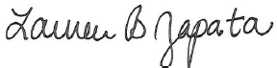
Lauren B. Zapata, PhD
Epidemiologist
CDC, Division of Reproductive Health

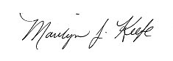 |  |  | 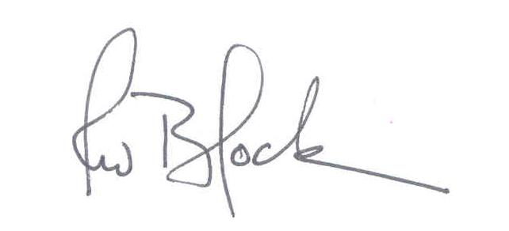
Marilyn J. Keefe, MPH | [insert name] | Glen R. Stream, MD | Robert W. Block, MD
Deputy Assistant Secretary | [insert title] | President | President
HHS OPA | HRSA BPHC | AAFP | AAP
 | 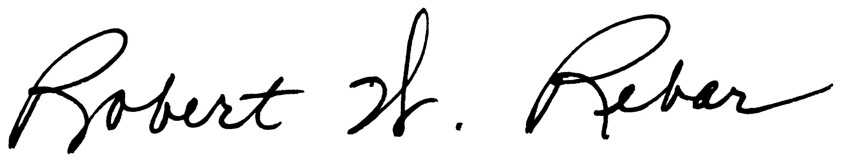 |  | 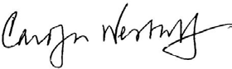
Hal C. Lawrence III, MD | Robert W. Rebar, MD | Clare Coleman | Carolyn Westhoff, MD
Executive Vice President | Executive Director | President & CEO | Senior Medical Advisor
ACOG | ASRM | NFPRHA | PPFA

