DEPARTMENT OF HEALTH & HUMAN SERVICES Public Health Service _________________________________________________________________________________________________
Centers for Disease Control and Prevention
Atlanta, GA 30333

[INSERT DATE]
[INSERT MAILING ADDRESS]

Dear [INSERT PHYSICIAN NAME],

We are writing to ask for your help!

You will find enclosed a survey developed by the Centers for Disease Control and Prevention (CDC) and the HHS Office of Population Affairs (OPA), in cooperation with the American Academy of Family Physicians (AAFP), the American Academy of Pediatrics (AAP), the American College of Obstetricians and Gynecologists (ACOG), the American Society for Reproductive Medicine (ASRM), the National Family Planning and Reproductive Health Association (NFPRHA), and the Planned Parenthood Federation of America (PPFA).

The survey measures attitudes and practices of health care providers related to family planning. If you do not provide family planning services to at least 2 women of reproductive age per week, please indicate this on the survey cover page and return the blank survey in the enclosed postage-paid return envelope.

You have been selected randomly from a list of practicing physicians across the country to participate in this survey. The survey should take on average 15 minutes to complete, and includes questions on:
- attitudes regarding the safety of various contraceptive practices;
- practices for prescribing contraceptives to patients with certain characteristics; and
- sources of information used for staying informed about recommended practices.

The information gathered will be used to develop educational materials and tools for providers related to family planning service provision, and to help plan for the implementation of forthcoming national guidance on the provision of quality family planning services.

All survey responses will be maintained in a secure manner and results will only be released in summary form.

We would greatly appreciate learning about your experiences; however, your participation is completely voluntary. If you prefer not to participate, please return the blank survey in the enclosed postage-paid return envelope. As a token of our appreciation, participating physicians will receive a package of provider tools related to family planning service provision at the end of data collection.

If you have any questions, please do not hesitate to contact Dr. Lauren Zapata (770-488-6358), or send an email to: familyplanningsurvey@cdc.gov. Thank you for participating in this important survey!

Sincerely,


Lauren B. Zapata, PhD
Epidemiologist
CDC, Division of Reproductive Health

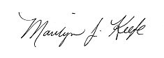 |  |  | 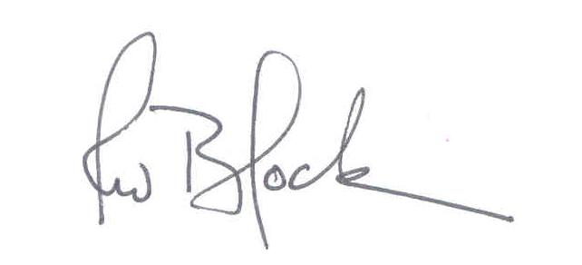
Marilyn J. Keefe, MPH | [insert name] | Glen R. Stream, MD | Robert W. Block, MD
Deputy Assistant Secretary | [insert title] | President | President
HHS OPA | HRSA BPHC | AAFP | AAP
 | 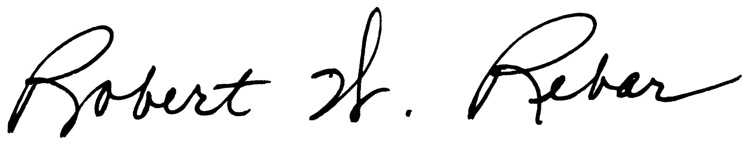 |  | 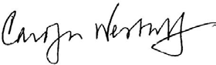
Hal C. Lawrence III, MD | Robert W. Rebar, MD | Clare Coleman | Carolyn Westhoff, MD
Executive Vice President | Executive Director | President & CEO | Senior Medical Advisor
ACOG | ASRM | NFPRHA | PPFA

