Form Approved

OMB Approval Number: ________________

Expires: XX-XX-XXXX

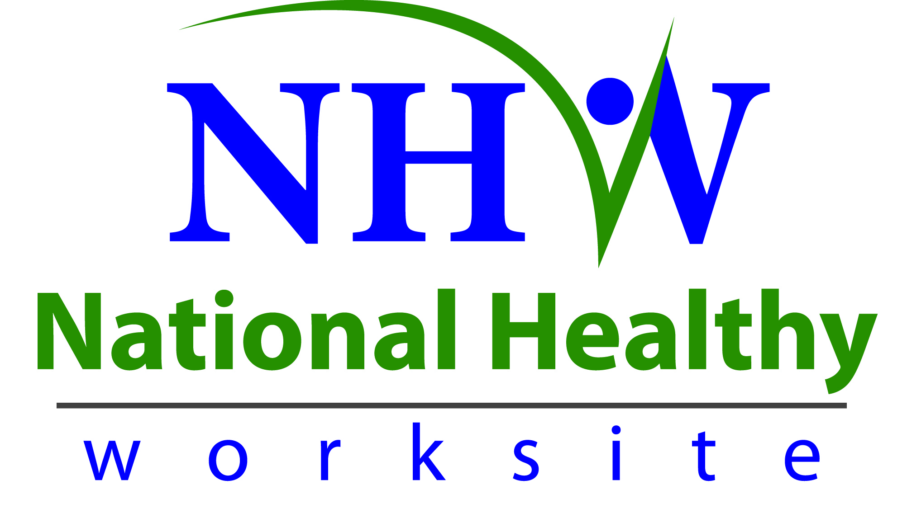

**National Healthy Worksite Program (NHWP) Employer Interviewer Instructions**

Public reporting of this collection of information is estimated to average 20 minutes per response, including the time for reviewing instructions, searching existing data sources, gathering and maintaining the data needed, and completing and reviewing the collection of information. An agency may not conduct or sponsor, and a person is not required to respond to a collection of information unless it displays a currently valid OMB control number. Send comments regarding this burden estimate or any other aspect of this collection of information, including suggestions for reducing this burden to CDC/ATSDR Reports Clearance Officer, 1600 Clifton Road NE, MS D-74, Atlanta, Georgia 30333; ATTN: PRA (0920-XXXX).

Employers that have completed the certification process to participate in the NHWP and are located in one of the seven selected program site locations will be contacted for a telephone interview. The interviewer will ask, write, and score responses to the appropriate questions posed on the NHWP Employer Phone Interview Form. The responses to the National Healthy Worksite Program (NHWP) Phone Interview Form (Attachment D-2) will help to select 70 – 115 employers to participate in the NHW program.

The interview process, questioning and documentation need to be consistent throughout the interview process. Please follow the script below.

Introduce yourself

“I am [your name] calling on behalf of the Centers for Disease Control and Prevention in regards to your company’s interest in participating in the CDC National Healthy Worksite program”.

We have developed questions that are most easily answered by a Senior Leader (SL) in your organization. That can be the President, CEO or General Manager. May I please be connected to that individual?”

If the person you are connected with is not a senior leader:

1. Respond: ”The questions in the NHW phone interview will need to be answered by a senior leader of the organization.”
2. “Who is the person I should connect with to conduct the phone interview?”
3. Write down the name and title on the form.
4. Ask to speak with a senior leader in the organization

If the senior leader is not available leave a message with your name, phone number and email address with a request to return the call and your availability.

When you have reached the senior leader introduce yourself.

“I am [name] calling on behalf of the Centers for Disease Control and Prevention (CDC) to conduct a phone interview regarding your interest in becoming a participating employer in the CDC National Healthy Worksite program”.

Ask the senior leader if she/he is the person who can provide answers to the phone interview on behalf of [employer name]. If so, proceed. If not, go back to 1-4 above.

The interview will ask questions regarding existing health promotion programs and activities. It will be helpful for the senior leader to have an additional person(s) available during the interview such as a human resources manager, health benefits manager, or member of an existing worksite health committee, who has strong knowledge of the organization’s health promotion program(s) and activities to accurately complete the interview, if the senior leader cannot provide this information. Please inquire if an additional staff member(s) needs to participate. If so, ask if all parties are present for the interview and if “yes”, proceed. If not, arrange for a date/time that is mutually convenient for everyone.

When you have reached the appropriate person(s) let them know the phone interview will take approximately 20 minutes to complete. Ask them if they have time to conduct the interview now. If not, arrange for a date/time that is mutually convenient. If they are available proceed with interview.

**Provide a general description of the interview process**

“We are conducting interviews with those employers that have completed the certification process to capture additional information to verify that they meet the program eligibility requirements, and help us select program participants.”

***Informed Consent***

Before you get started, we’d like need to give you some more information to help you decide whether or not you would like to participate.

* This project is funded by the Centers for Disease Control and Prevention. Many parts of the project are being managed by Viridian Health Management (Viridian). Viridian is a private health and wellness company based in Phoenix, AZ. Viridian provides customized solutions to building comprehensive healthy worksite programs. They are helping CDC implement the National Healthy Worksite (NHW) program.
* You were asked to participate because you certified your organization to participate in the National Healthy Worksite Program
* Your participation in this discussion is voluntary. In the course of this discussion, you may refuse to answer specific questions. You may also choose to end the discussion at any time.
* The survey is designed to take about 20 minutes.
* There are no right or wrong answers or ideas—we want to hear about YOUR experiences and opinions.
* All of the comments you provide will be maintained in a secure manner. We will not disclose your responses or anything about you unless we are compelled by law. Your responses will be combined with other information we receive and reported in the aggregate as feedback from the group. In our project reports, your name/ your organization will not be linked to the comments you provide in this discussion.
* CDC is authorized to collect information for this project under the Public Health Services Act.
* There are no personal risks or personal benefits to you for participating in this discussion.
* We are interested in your comments so that we can select participating employers for the NHW program for future participants. Please feel free to contact [INSERT WORKSITE NHWP COMMUNITY DIRECTOR]. [HIS/HER] number is [INSERT TEL #]. You can also call Viridian Health Management toll-free at 1-877-486-0140.

“I will be asking questions to verify that you meet the National Healthy Worksite Program eligibility requirements, and to better understand the reasons why your organization would like to participate in the program. The responses are yes/no with the exception of 5 questions at the end.”

“To maintain consistency of the interview process we will need to proceed through the interview with yes/no answers until the last 5 questions.”

“Employers must meet certain criteria to participate in the National Healthy Worksite program. Let me start by asking you questions to verify [company] meets the program eligibility requirements.”

**Employer Profile Questions**

Ask for and enter the following information:

* Name of employer
* Contact name and title
* Contact email and phone number
* Employer’s physical address
* Employer’s type of industry
* Number of full-time employees - If the employer has between 500 and 1,000 full-time employees they must answer “yes” to question 2 to be eligible. If employer has more than 1000 employees and answers “no” to any part of question 1 (a-c) the employer is not eligible to be a NHW Program Participant.

**Skip question 1 if the employer has less than 1000 full-time employees.**

**Question 1a,1b, and 1c**. If the employer responds “No” to any part of question 1, respond:

“Employers larger than 1000 full-time employees must nominate a specific individual worksite location not exceeding 1000 full-time employees to participate in the NHW program. This individual worksite must be an independent business or autonomous unit of the larger organization. The individual worksite must be able to make independent decisions regarding worksite policies and environmental supports to create a healthy culture and sustainable worksite health program. The ability to make independent decisions is integral to implementation of the NHW program in order to create an infrastructure for worksite health and the adoption of policies that foster a healthy worksite. Unfortunately, [employer name] does not meet this NHWP eligibility requirement. However, we invite and encourage you to participate in the NHWP as a Community Participant and take advantage of community-based training and networking opportunities. Additionally, the tools and resources generated from the NHW program will be available to all employers and can be accessed at the program web site [www.cdc.gov/NationalHealthyWorksite](http://www.cdc.gov/NationalHealthyWorksite) as they become available. Thank you for your commitment to the health of your employees and your interest in implementing a comprehensive worksite health program. We look forward to working with you as a Community Participant.”

**Skip question 2 if the employer has 500 or fewer full-time employees.**

**Question 2.** If the employer responds “No,” respond:

If the employer has between 500 and 1,000 full-time employees ask question 2. Employers with 500 or more full-time employees that voluntarily seek to participate in the program are required to invest the equivalent to $50,000 over the next two years to expand and enhance their worksite health program. Selected employers will work with the NHW Program team to develop an in-kind investment plan and budget based on the guidelines below. The investment 1) should be linked to an area of health need determined after the onsite baseline assessment period and 2) must be approved by the NHW Program team. The investment plan will be implemented beginning in the 4th quarter of 2012.

This investment may consist of enhancements to the activities being coordinated by the NHWP or new activities that expand the scope of the current program. Current workplace health activities (see eligibility requirements) in place at the time the employer is selected to participate in the NHWP are not counted toward the overall investment. Appropriate activities include, but are not limited to, the following examples:

* Capital improvements such as fitness facilities (new or converted) or cafeterias/vending offering healthy options such as adding a salad bar or a refrigerated vending machine for fresh fruit.
* Systems improvements such as those used for data collection or reporting for ongoing quality improvement and evaluation of the workplace health program.
* Equipment such as treadmills, recumbent bicycles, weight lifting equipment scales, or blood pressure monitors.
* Staffing such as:
  + Hiring or reassigning a part-time or full-time staff to provide internal coordination or management of the workplace health program.
  + Hiring or reassigning a part-time or full-time health coach to provide more total coaching hours to employees.
* Non-financial incentives such as paid time off, merchandise or prizes, employee recognition
* Additional programs or environmental supports not part of the core workplace health program such as adding a garden or farmer’s market, or adding additional educational programs for employees.

If the employer has between 500 and 1,000 full-time employees and answers “No” respond:

“It is a requirement that employers with more than 500 employees agree to contribute $50,000 towards their worksite health program during the two-year implementation period. Unfortunately, [employer name] does not meet this eligibility requirement. However, we invite and encourage you to participate in the NHWP as a Community Participant and take advantage of community-based training and networking opportunities. Additionally, the tools and resources generated from the NHW program will be available to all employers at no cost and can be accessed at the program Web site [www.cdc.gov/NationalHealthyWorksite](http://www.cdc.gov/NationalHealthyWorksite) as they become available. Thank you for your commitment to the health of your employees and your interest in implementing a comprehensive worksite health program. We look forward to working with you as a Community Participant.”

**Question 3**. If the employer answers “no” to any part of Question 3 respond:

“It is a requirement that participating employers provide medical benefits to least 50% of eligible employees. The health insurance plan needs to include routine medical care, mental health, and preventive care. Unfortunately, [employer name] does not meet this NHW eligibility requirement. However, we invite and encourage you to participate in the NHWP as a Community Participant and take advantage of community-based training and networking opportunities. Additionally, the tools and resources generated from the NHW program will be available to all employers at no cost and can be accessed at the program web site: [www.cdc.gov/NationalHealthyWorksite](http://www.cdc.gov/NationalHealthyWorksite) as they become available. Thank you for your commitment to the health of your employees and your interest in implementing a comprehensive worksite health program. We look forward to working with you as a Community Participant.”

”The next part of the interview will be about leadership and the existing workplace health activities of the organization.”

Proceed with question **4. Leadership**.

“The intent of the National Healthy Worksite Program to implement comprehensive worksite health programs with employers who do not currently have comprehensive programs in place. I will be asking you questions regarding programs, policies, environmental supports, worksite infrastructure and data collections that you may be currently providing at your worksite. We expect that you may already being doing some of these activities, and this will not exclude you from being selected to participate in the program. Please answer yes or no to each of these questions.”

Proceed with **questions 5 – 9**

“One of the goals of the program is to create a sustainable worksite health model; the next few questions will ensure that the program’s sustainability will not be impacted by [employer name] business strategies or financial plans. Your responses to these questions are confidential.”

Proceed with **question 10. Stability**.

“The last 5 questions are open-ended questions.”

Proceed with **questions 11 – 15**.

“Thank you for taking the time today to complete the NHWP employer interview questions. We appreciate your input very much. The information you provided will be used to select employers to participate in the program. We will contact you shortly by phone or letter to let you know if you have been selected as a Program Participant.” Regardless of whether you are selected as a Program Participant or not, you are more than welcome to continue to participate in the community-based training and networking opportunities as a Community Participant. And we hope that you will.” Thank you again.

Complete “Interviewer” section at the end of the NHW Employer Interview Form and send to Viridian Health Management by email or fax (602-249-8128).