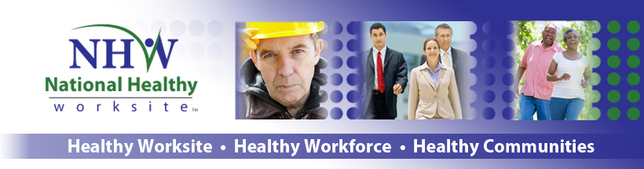

Frequently Asked Questions

What is the CDC National Healthy Worksite Program?
The CDC National Healthy Worksite Program (NHWP) is a health promotion program offered voluntarily as a benefit to all employees. It includes health screenings, health assessments, health information, health and safety programs, as well as ongoing onsite support provided by a Health Coach. The program launched in October 2011 and will run until September 2013.
Why is my employer participating in this program?
Because they are committed to the health, well-being, and safety of their employees. The goal of this program is to learn more about the effects of workplace health promotion activities on the health and well-being of employees. About 15,000 employees from multiple employers across the country will participate in this project. The number of employees participating may vary at each work site.

Does the CDC National Healthy Worksite Program Cost Anything?

No. The Health Screening, Health Assessment, individual health coaching, group classes, and health education materials are voluntary and free for all employees your employers specify are eligible at your worksite.

Who is providing this program?

The NHWP is funded by the Centers for Disease Control and Prevention (CDC). Viridian Health Management is implementing the workplace programs and collecting data, in collaboration with the University of Connecticut Health Center. Research Triangle Institute International, an independent non-profit institute, is conducting a national evaluation of the NHW program which will run through August 2014.
Do I have to participate?

No. Knowing your current health status is the first step toward making healthy lifestyle changes and preventing chronic diseases. However, the program is voluntary. You can participate as much or as little as you want to or chose not to participate at all. Once you begin a survey or onsite health coaching, you are not required to complete it and you can stop at any time.

Why am I eligible to participate?
Your employer has agreed to be a part of the NHW program. How do I participate?
You will be asked to complete a survey about your worksite and to complete an onsite health screening and health assessment at the beginning of the program and 12 months later. This voluntary health screening includes some biometric screening tests and questions about your health and health habits.
For the biometric screening, we will:
- Take your blood pressure and pulse using a manual blood pressure method (blood pressure cuff, stethoscope, and sphygmomanometer)
- If you are able to stand unassisted, measure your height while you are standing
- If you are able to stand unassisted, ask you to stand on a scale to measure your weight
- Use a finger prick to obtain a small blood sample to obtain a lipid profile and blood glucose
- If you are able to stand unassisted, measure your waist circumference with a flexible tape measure

The biometric screening and health assessment will take approximately 30 minutes and most people find it very interesting. Adding the Health Screening results to your Wellness Assessment will give a more complete report of your health status and risk for chronic disease.

Will eating affect blood sugar and cholesterol results?

We recommend you do not eat or drink for nine hours prior to the finger-stick blood test. During this time, you may drink water and take any necessary medications. While a fasting result is the most accurate, a normal “random” test (without considering when you last ate) will provide an indication of typical blood levels for total cholesterol, HDL, and blood glucose. If one or more of the test values are out of range, the Health Coach will advise you to see your doctor or health care provider.

What happens to health screening and health assessment results, and are they private?

Each participant will receive a Personal Health Report that analyzes their results and includes recommendations to improve your health. The personal information provided as part of the Health Screening and Health Assessment are private, and will be maintained in a secure manner. Your responses will be combined with other information we receive and reported in the aggregate. Your employer will only receive a summary report of aggregate results recommending the types of health promotion programs that would be most beneficial to employees.

What if I can’t attend an onsite
Health Screening?

If you are unable to attend an on-site Health Screening, you can complete your screening by visiting your personal physician. A Health Data Form for your physician visit can be acquired from your Health Coach.

What is a Health Coach?

A Health Coach is a health educator who provides onsite information and support to help you set and reach goals to maintain and improve your health. Health Coaches work with you to identify opportunities for improvement and help you assemble the tools and resources for success. A Health Coach also assists you in reviewing your Personal Health Report to select the best course of action specific to your health improvement goal. Once you select a course of action, your Health Coach will motivate you with ongoing support.
How are privacy and security maintained?

The CDC National Healthy Worksite program is strongly committed to respecting your privacy and to maintaining the security of the information you provide us. Your name will be replaced with a number for the purposes of evaluating program results. Information will be combined with data from other participants in the program and only group results will be reported to your employer. Your individual data will also be shared with Viridian Health Management onsite Health Coaches to provide individual health coaching interventions specific to your current health status and lifestyle habits.
How else can I participate?

There will be opportunities available at your worksite to work individually with a Health Coach, attend onsite classes or seminars, participate in wellness challenges, and serve on a worksite health committee. The program is voluntary, and you do not need to participate. You will also be asked to complete satisfaction surveys throughout the program so that we can improve the program.
What are the benefits of participating?

You may benefit from learning more about your health. You will receive a card with your blood pressure and BMI results and information on what they may mean. You can show the results to your doctor for follow-up questions. This is an opportunity for you to make a valuable contribution to your workplace. The results of this program will describe the health and well-being of employees and will also provide valuable information about your workplace support for health promotion programs.

What are the potential risks involved in participating?

The risks related to participating in the basic health measures and health assessments are minimal. It is possible that some of the questions in the health assessment may make you feel slightly uncomfortable, but you can skip any questions you don’t want to answer. You may also learn that you are at risk for a future health condition, which you may prefer not to know.
Call
1-877-486-0141
for more information

How can I get more information?
Visit www.cdc.gov/nhwp
You may also see your onsite health coach or call the Health Coaching line at: 1-877-486-0141.

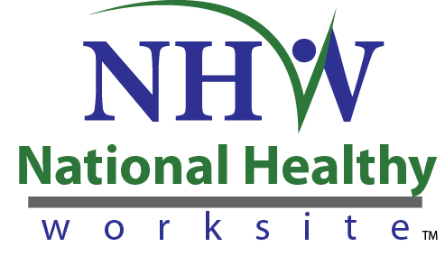
For more information visit www.cdc.gov/nhwp
You may also see your onsite Health Coach or call 1-877-486-0141

