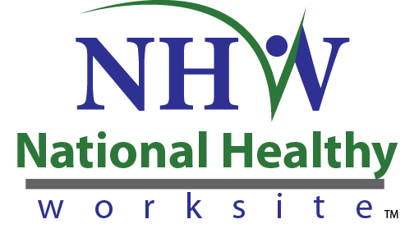
Form Approved
OMB No. 0920-XXXX
Exp. Date: XX-XX-XXXX

CDC National Healthy Worksite Program (NHWP)
Employer Information Form

Public reporting of this collection of information is estimated to average 30 minutes per response, including the time for reviewing instructions, searching existing data sources, gathering and maintaining the data needed, and completing and reviewing the collection of information. An agency may not conduct or sponsor, and a person is not required to respond to a collection of information unless it displays a currently valid OMB control number. Send comments regarding this burden estimate or any other aspect of this collection of information, including suggestions for reducing this burden to CDC/ATSDR Reports Clearance Officer, 1600 Clifton Road NE, MS D-74, Atlanta, Georgia 30333; ATTN: PRA (0920-XXXX).
Informed Consent
Before you get started, we’d like need to give you some more information to help you decide whether or not you would like to participate.
- This project is funded by the Centers for Disease Control and Prevention. Many parts of the project are being managed by Viridian Health Management (Viridian). Viridian is a private health and wellness company based in Phoenix, AZ. Viridian provides customized solutions to building comprehensive healthy worksite programs. They are helping CDC implement the National Healthy Worksite (NHW) program.
- You were asked to participate because your worksite is participating in the National Healthy Worksite (NHW) program as a benefit to employees. All employers in the NHW program will be asked to complete this questionnaire at the beginning of the NHW program.
- Your participation in completing this form is voluntary. In the course of completing this form, you may refuse to answer specific questions.
- Completing this form is designed to take about 30 minutes.
- All of the information you provide will be maintained in a secure manner. We will not disclose your responses or anything about you unless we are compelled by law. Your responses will be combined with other information we receive and reported in the aggregate as feedback from the group. In our project reports, your name will not be linked to the comments you provide in this discussion.
- CDC is authorized to collect information for this project under the Public Health Services Act.
- There are no personal risks or personal benefits to you for participating in this discussion.
- We are interested in your comments so that we can improve the NHW program for future participants. Please feel free to contact [INSERT WORKSITE NHWP PROGRAM MANAGER]. [HIS/HER] number is [INSERT TEL #]. You can also call Viridian Health Management toll-free at 1-877-486-0140.

Instructions
This form is used to ascertain the necessary information in order to successfully implement your Healthy Worksite Program.
A National Healthy Worksite Program Community Director will facilitate a meeting with your firm’s primary program representative (HR Director, Benefits Administrator, C-level representative) using this form as a guide. The information will be captured, retained, and updated by your National Healthy Worksite Program Community Director until the conclusion of the program.
Employer Information
Name of Client
Community
Headquarter Address
Primary Contact(s) Name(s) and Title
Primary Contact(s) Email Address
Primary Contact(s) Phone Number
Primary Contact(s) Physical Address
Secondary Contact(s) Name(s) and Title
Secondary Contact(s) Email Address
Secondary Contact(s) Phone Number
Secondary Contact(s) Physical Address
Date of Kick Off Event(s)
Dates of Biometric Screenings

Staff Assigned
Community Director
Onsite Health Coach

Broker Information
Name of Broker
Address
Contact Name
Contact Email Address

About the Employer:
Industry
# of Location(s) (please list)
# of Shifts
# Eligible by Shift
Predominate Job Series/Types (engineer, nurse, machinist, manager, accountant, etc.?)
Language Needs(by location/communications)
Program Eligibility (full time benefit eligible, full time, part time, etc.)
Wireless Internet Access (Y/N)
Health Coach Access to Wireless Internet during onsite hours (Y/N)
Gender Distribution
Average Age of Population
Average Income of Population
% of Population with Internet Access
Education Level of Population
Turnover rate
Medical Carrier
Medical Plan Design
Dental Carrier
Dental Plan Design
Vision Carrier
Vision Plan Design
EAP Provider

Teams
Does the employer have a Healthy Worksite Team (Wellness Champions)?
Does the client have a Safety Committee?
If yes, please list schedule of meetings:
Business Units / Departments

Communications Specifications
Program Name
What does the client call employees?
Language Needs (print / electronic)
Communications and graphic standards
Usual communication channels (email, kiosk, bulletin board, newsletter, home mailer, etc.)

FOR INTERNAL USE ONLY
Existing Worksite Health Initiatives: Please reference NHWP Employer Phone Interview Guide Responses

