Form Approved
OMB No. 0920-XXXX
Exp. Date: XX-XX-XXXX

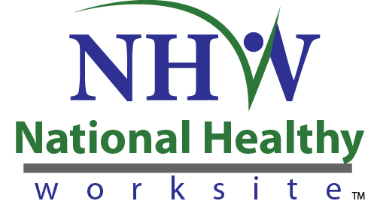

CDC National Healthy Worksite Program
Employer Discussion Guide: Wellness Committee (Case Studies)

Public reporting of this collection of information is estimated to average 30 minutes per response, including the time for reviewing instructions, searching existing data sources, gathering and maintaining the data needed, and completing and reviewing the collection of information. An agency may not conduct or sponsor, and a person is not required to respond to a collection of information unless it displays a currently valid OMB control number. Send comments regarding this burden estimate or any other aspect of this collection of information, including suggestions for reducing this burden to CDC/ATSDR Reports Clearance Officer, 1600 Clifton Road NE, MS D-74, Atlanta, Georgia 30333; ATTN: PRA (0920-XXXX).
Respondents/Sources | Method | Content | Timing/Frequency | Respondents | Time
Wellness committee members at worksites  ~12 Case study sites  (2-5 employees/site) | In-depth or small-group telephone Discussions | Opinions about programming and workplace changes. | Month 20 (near end of program delivery) | 575 | @ 0.5 hrs

Implementation: These are planned as facilitated small group discussions to be conducted near the end of the implementation period (~ 20 months following project start) with employees who participate in the worksite health wellness committees. These will be used to produce 12 case studies.

Introduction
Thank you for taking time today to help us better understand issues related to the National Healthy Worksite (NHW) program. Our task is to provide the Centers for Disease Control and Prevention (CDC) with an evaluation that will further CDC’s understanding of factors related to employee engagement, program implementation, and outcomes.
Informed Consent
Before we get started, I’d like need to give you some more information to help you decide whether or not you would like to participate.
- This project is funded by the Centers for Disease Control and Prevention. Many parts of the project are being managed by Research Triangle Institute International (RTI). RTI is an independent, non-profit institute headquartered in Research Triangle Park, NC. RTI provides technical services to clients worldwide. They are helping CDC evaluate the National Healthy Worksite (NHW) program.
- You were asked to participate because of your role in your company’s health promotion activities. We will be having similar discussions with others who are knowledgeable about the NHW program.
- Your participation in this discussion is voluntary. In the course of this discussion, you may refuse to answer specific questions. You may also choose to end the discussion at any time.
- The discussion is designed to take about 30 minutes.
- There are no right or wrong answers or ideas—we want to hear about YOUR experiences and opinions.
- All of the comments you provide will be maintained in a secure manner. We will not disclose your responses or anything about you unless we are compelled by law. Your responses will be combined with other information we receive and reported in the aggregate as feedback from the group. In our project reports, your name will not be linked to the comments you provide in this discussion.
- CDC is authorized to collect information for this project under the Public Health Services Act.
- There are no personal risks or personal benefits to you for participating in this discussion.
- We are interested in your comments so that we can improve the NHW program for future participants. Please feel free to contact Dr. Laurie Cluff at RTI. Her toll-free number is 1-800-334-8571 x 6514. You can also call RTI’s Office of Research Protection and Ethics toll-free at 1-866-214-2043.

Participant Information:
1. What is your worksite?
2. What is your role in the organization?

Program Establishment and Engagement
3. What were the biggest challenges you encountered when establishing the programming?
Probe: What strategies did you use to overcome these challenges?
4. What strategies were most effective for encouraging participation?
5. Were incentives used to encourage participation?
Probes:
- [If yes]: What were they?
- [If yes]: What incentives do you think were most effective, and why?

Results
6. In what ways has health promotion been incorporated into organizational policies?
7. What are the most positive changes you have seen at the organizational level?
Probes:
- Policy changes?
- Physical/structural changes?
- Social/cultural changes?
8. How supportive have employees been of these organizational level changes?
Probe: In what ways have employees shown support?

9. What do you think will be required to sustain the program?

10. What have you learned that you would share with others trying to start health promotion programs at their worksites?

Program Participation:
11. What programming or services have you participated in or used?
12. What factors made it easier for you to participate?
13. What changes you have seen in your own health or health behaviors?
14. Is there anything else you would like to tell us about the program?

For INTERNAL USE ONLY
Date of Interview:_______________ Interview Site:__________________
Interviewer:____________________ Interviewer:____________________

