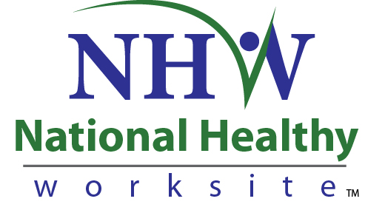
Form Approved
OMB No. 0920-XXXX
Exp. Date: XX-XX-XXXX

CDC National Healthy Worksite Program (NHWP)
Success Story Consent Form

Public reporting of this collection of information is estimated to average 10 minutes per response, including the time for reviewing instructions, searching existing data sources, gathering and maintaining the data needed, and completing and reviewing the collection of information. An agency may not conduct or sponsor, and a person is not required to respond to a collection of information unless it displays a currently valid OMB control number. Send comments regarding this burden estimate or any other aspect of this collection of information, including suggestions for reducing this burden to CDC/ATSDR Reports Clearance Officer, 1600 Clifton Road NE, MS D-74, Atlanta, Georgia 30333; ATTN: PRA (0920-XXXX).

Informed Consent
Before you get started, we’d like need to give you some more information to help you decide whether or not you would like to participate.
- This project is funded by the Centers for Disease Control and Prevention. Many parts of the project are being managed by Viridian Health Management (Viridian). Viridian is a private health and wellness company based in Phoenix, AZ. Viridian provides customized solutions to building comprehensive healthy worksite programs. They are helping CDC implement the National Healthy Worksite (NHW) program.
- You were asked to participate because your worksite is participating in the National Healthy Worksite (NHW) program as a benefit to employees.
- Your participation in program communications is voluntary. In the course of completing this form, you may refuse to answer specific questions. You may also choose to end completing the form at any time.
- The form is designed to take about 10 minutes.
- All of the comments you provide will be maintained in a secure manner. We will not disclose your responses or anything about you unless we are compelled by law. In our program communications, your name or image will not be linked to the comments you provide unless you authorize us to do so.
- CDC is authorized to collect information for this project under the Public Health Services Act.
- There are no personal risks or personal benefits to you for participating in this discussion.
- We are interested in your comments so that we can improve the NHW program for future participants. Please feel free to contact [INSERT WORKSITE NHWP PROGRAM MANAGER]. [HIS/HER] number is [INSERT TEL #]. You can also call Viridian Health Management toll-free at 1-877-486-0140.

Instructions
When you have completed this form, please give it to [INSERT WORKSITE NHWP PROGRAM MANAGER]. If you have any questions, Please feel free to contact [INSERT WORKSITE NHWP PROGRAM MANAGER]. [HIS/HER] number is [INSERT TEL #].

Authorization to Use Personal Information
Employee’s Name: ____________________________________ Date of Birth: _______________
Previous Name:_______________________________________ ID #:_______________________
I request and authorize Viridian Health Management, LLC to use my personal / healthcare information that I disclose and my photo as part of the National Healthy Worksite Program (NHWP) communications.
My information and image will be distributed as follows:
Website URL:
Printed communications
Email communications
Other (please describe):
The image
will NOT be distributed externally
will be distributed externally as follows:_________________________________________________________
Project Description / Purpose____________________________________________________________________
Employee Signature: ___________________________________________ Date Signed:_______________
Viridian Health Management Signature:____________________________ Date Signed:_______________
Please return this form with all signatures to:
Viridian Health Management, LLC
22601 North 19th Avenue, Suite #240
Phoenix, AZ 85027
For Internal Use Only
Date received:_______________
Approval Date: _____________
Approval Signature:____________________________________

1. What were your biggest health challenges or areas for improvement at the beginning of the program?
2. What factors motivated you to make changes?
Probes:
-Was it information you learned through your health assessment?
-Was it the availability of programs and information at the worksite?
-Were you motivated by coworkers and/or leaders at your organization?
3. What kinds of changes did you make in the way you think about things, and in your behavior?
Probes:
-What specific steps have you taken?
-What is the most positive effect you have noticed?
4. Tell me about the components of your employer’s healthy worksite program that you found most helpful to your own health improvements (what was helpful and why)?
Probe: Coaching sessions, educational materials, workshops, environmental changes (e.g., healthy food availability, fitness facilities, stairwells, walking trails), group activities (e.g., walking clubs, competitions).
What about the program specifically motivated these changes you described?
5. What additional changes or enhancements would you like to see in your employer’s healthy worksite program?
6. Have you noticed any changes in your work behavior since you became involved in the healthy worksite program? Please describe.
7. Have you noticed any changes in the behavior of your coworkers since the program began? Please describe.
8. Have you noticed any changes in the overall work environment since the program began? Please describe.
9. How do you plan to maintain your healthy behaviors?
10. What advice would you give employees like you who would like to improve their health?

