Form Approved
OMB No. 0920-XXXX
Exp. Date XX-XX-XXXX

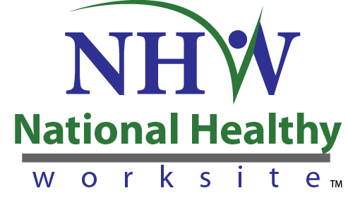

CDC National Healthy Worksite Program
Health Coach Discussion Guide

Public reporting of this collection of information is estimated to average 30 minutes per response, including the time for reviewing instructions, searching existing data sources, gathering and maintaining the data needed, and completing and reviewing the collection of information. An agency may not conduct or sponsor, and a person is not required to respond to a collection of information unless it displays a currently valid OMB control number. Send comments regarding this burden estimate or any other aspect of this collection of information, including suggestions for reducing this burden to CDC/ATSDR Reports Clearance Officer, 1600 Clifton Road NE, MS D-74, Atlanta, Georgia 30333; ATTN: PRA (0920-XXXX).

Respondents/  Sources | Method | Content | Timing/Frequency | Respondents | Time
Health Coaches | Small Group Discussions / Individual Interviews | Strategies to encourage participation and follow-up; strategies to encourage employee behavior change; success stories | 2 times, (3 months following start of implementation and at project month 18-20) | 20 | 2 times  @ 0.5 hours

Implementation: These are planned as telephone interviews or small group discussions to be conducted 3 months following program implementation and at approximately project month 18-20 with Health Coaches providing services as participating employers.

Introduction

Thank you for taking time today to help us better understand issues related to the National Healthy Worksite (NHW) program. Our task is to provide the Centers for Disease Control and Prevention (CDC) with an evaluation that will further CDC’s understanding of factors related to employer engagement, program implementation, and outcomes.

Informed Consent

Before we get started, I need to give you some more information about this discussion guide to help you decide whether or not you would like to participate:

- This project is funded by the Centers for Disease Control and Prevention. Many parts of the project are being managed by Research Triangle Institute International (RTI). RTI is an independent, non-profit institute headquartered in Research Triangle Park, NC. RTI provides technical services to clients worldwide. They are helping CDC evaluate the National Healthy Worksite (NHW) program.
- You were asked to participate because of your role as a Health Coach. We will be having similar discussions with others who are knowledgeable about the NHW program in your company’s health promotion activities.
- Your participation in this discussion is voluntary. In the course of this discussion, you may refuse to answer specific questions. You may also choose to end the discussion at any time.
- The discussion is designed to take about 30 minutes.
- There are no right or wrong answers or ideas—we want to hear about YOUR experiences and opinions.
- All of the comments you provide will be maintained in a secure manner. We will not disclose your responses or anything about you unless we are compelled by law. Your responses will be combined with other information we receive and reported in the aggregate as feedback from the group. In our project reports, your name will not be linked to the comments you provide in this discussion.
- CDC is authorized to collect information for this project under the Public Health Services Act.
- There are no personal risks or personal benefits to you for participating in this discussion.
- We are interested in your comments so that we can improve the NHW program for future participants. Please feel free to contact Dr. Laurie Cluff at RTI. Her toll-free number is 1-800-334-8571 x 6514. You can also call RTI’s Office of Research Protection and Ethics toll-free at 1-866-214-2043.

Participant Information:
1. Which worksites do you serve? Which community(s) are these in?

Engagement and Maintenance
2. What were the most effective strategies used by organizations to encourage employees to participate in the program?
3. [At the second interview only:] What strategies help employees to continue in the program?

Areas of Accomplishment
4. What were the most common areas in which you helped employees?
5. What strategies did you find most effective for motivating employees to make changes?

Barriers
6. What were the major challenges that employees faced in making changes?
7. What did you find was helpful in getting employees to address those challenges?

Implementation
8. What are some modifications you have seen (or foresee) in the continued delivery of program components?
9a ( ~3 months post implementation). What changes has the worksite made to encourage a healthy work environment and healthy employee behavior?
9b (12 months post implementation). What changes has the worksite made to sustain a healthy work environment and healthy employee behavior?
Probes:
- Physical or structural changes?
- Policy or rule changes?
- Cultural changes?

Examples of Success
10. What about the wellness program/services appeals most to employees?
11. Without identifying anyone by name, can you describe an employee who made an important change that affected his or her health, and tell me how the program may have influenced the change?

THANK YOU!

For INTERNAL USE ONLY
Date of Interview:_______________ Interview Site:__________________
Interviewer:____________________ Interviewer:____________________

