Attachment 3: CORRESPONDENCE

Email invitation to participate in survey

Subject line: NINR Pilot Campaign Survey – Invitation

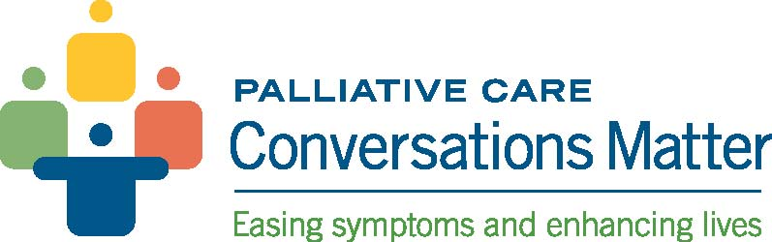

Dear Pilot Program Participant,

Thank you for your willingness to participate in the Palliative Care: Conversations Matter pilot campaign led by the National Institute of Nursing Research (NINR), part of the National Institutes of Health. We appreciate your time and commitment to strengthen and advance the national focus on pediatric palliative care.
As part of our effort to evaluate the effectiveness of the campaign and its materials, NINR will be collecting feedback from participants through an online survey. This survey will be administered at the end of the nine month pilot campaign. For the survey, you will be alerted by email and provided an active link to the survey. The survey will take approximately 30 minutes to complete. Your opinions will be kept secure to the extent permitted by law and all insights will be viewed in aggregate. Your input is voluntary and very important to us as it will help improve materials and guide the program to ensure future success.

You will receive a login code and link to complete the survey in a separate email.

If you have questions about the campaign, please contact me directly at 301-496-0256 or adrienne.burroughs@nih.gov.

Your insights are invaluable to NINR and to the overall success of the pilot campaign. Again, thank you for your participation.

Sincerely,
Adrienne Burroughs, MHS
Health Communications Specialist
National Institute of Nursing Research
Office of Communications and Public Liaison
adrienne.burroughs@nih.gov
301.496.0256

Log in information

Subject line: NINR Pilot Campaign Survey – Action Required

Dear Pilot Program Participant,

The Palliative Care: Conversations Matter survey is now ready to be completed.

Your unique login code is: [LOGIN CODE]. This login code is used to keep the survey responses anonymous.

Please click on the following link to complete the survey: [SURVEY LINK EMBEDDED].

The survey will take approximately 30 minutes to complete. Your opinions will be kept secure to the extent permitted by law and all insights will be viewed in aggregate. Your input is voluntary and very important to us as it will help improve materials and guide the program to ensure future success.

The survey will be open until [insert date, day, and time]. We ask that you complete the survey at your earliest convenience.
If you have questions about the campaign, please contact me directly at 301-496-0256 or adrienne.burroughs@nih.gov. For technical issues, please email Technical Support at NINR_Conversations@mail.nih.gov.

Thank you for your participation.

Sincerely,
Adrienne Burroughs, MHS
Health Communications Specialist
National Institute of Nursing Research
Office of Communications and Public Liaison
adrienne.burroughs@nih.gov
301.496.0256

Reminder email to take survey (This will only be sent if needed.)
Subject line: Reminder: NINR Pilot Campaign Survey – Action Required

Dear Pilot Program Participant,

This is a reminder to complete the end-point survey for Palliative Care: Conversations Matter, a pilot campaign of the National Institute of Nursing Research (NINR).

At your earliest convenience, please complete the survey by clicking on the following link: [SURVEY LINK EMBEDDED]. The survey will close on [insert date, day, and time].

As a reminder, your unique login code is: [LOGIN CODE]. This login code is used to keep the survey responses anonymous.
The survey should take approximately 30 minutes to complete. As always, all opinions and answers will be kept secure to the extent permitted by law and insights will be viewed in aggregate.

Your input is invaluable to NINR and will help us improve the pilot campaign and its materials for future use. If you have questions about the campaign, please contact me directly at 301-496-0256 or adrienne.burroughs@nih.gov. For technical issues, please email Technical Support at NINR_Conversations@mail.nih.gov.

Sincerely,
Adrienne Burroughs, MHS
Health Communications Specialist
National Institute of Nursing Research
Office of Communications and Public Liaison
adrienne.burroughs@nih.gov
301.496.0256

