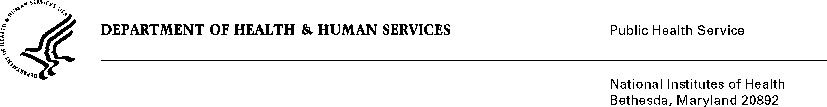
DATE: March 19, 2013

TO: Adrienne Burroughs, MHS
Health Communications Specialist
Office of Communications and Public Liaison
National Institute of Nursing Research

FROM: NIH Privacy Act Officer

SUBJECT: Applicability of the Privacy Act: “Pediatric Palliative Care Campaign Pilot Survey”
I have reviewed the NINR submission to OMB, which proposes to address the communication challenges faced by health care providers, including physicians and nurses who recommend and provide palliative care to children living with serious illness or life-limiting conditions. I have determined the Privacy Act does not apply to this information collection.

Two hospitals with neonatal and/or pediatric intensive care units will participate in the pilot campaign. Interactive tear-off pads and video modules will be provided to health care providers to help frame conversations with pediatric patients and their family members. The tear-off will include static information in lay terms and can be customized with information about available services and/or treatment. The modules will convey the benefits of palliative care and provide tips that providers can incorporate into practice.

An e-mail will be sent to the providers to invite them to complete a web-based survey deployed by the NIH Center for Information Technology. Providers will be able to consent to participation. The survey will ask 26 questions pertaining to perceptions of and behaviors toward pediatric palliative care as well as the campaign, materials and pilot program. It will also ask for background information related to the health care provider’s discipline, area of specialty, training and resource needs. No personally identifiable information will be collected. A separate e-mail will be sent that includes a URL link to a secure website and a unique login code (i.e., ID number) which the participants can use to complete the survey anonymously and enter data directly into a database. Files and transcripts of questionnaires will be kept in a secure environment and no one outside of the research study will have access to them. The final report will aggregate the respondent characteristics. No individual survey data will be displayed.

If you have any questions, please contact my office at (301) 496-2832.

Karen M. Plá

cc: Amanda Green, NINR OMB Project Clearance Liaison

