Contents
Remote Registration Terms of Service 2
In-person Registration – Finish Setup 3
Reset Extra Security 4
Login 5
Add Extra Security 6

Remote Registration Terms of Service

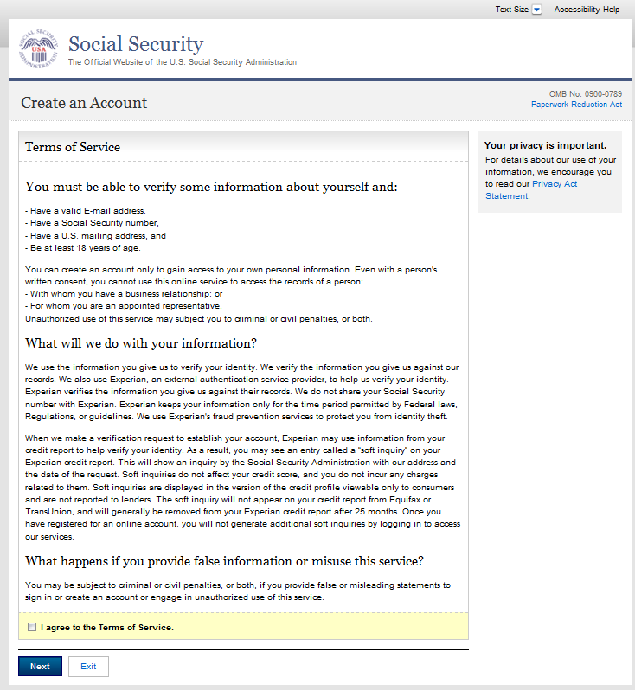

In-person Registration Terms of Service

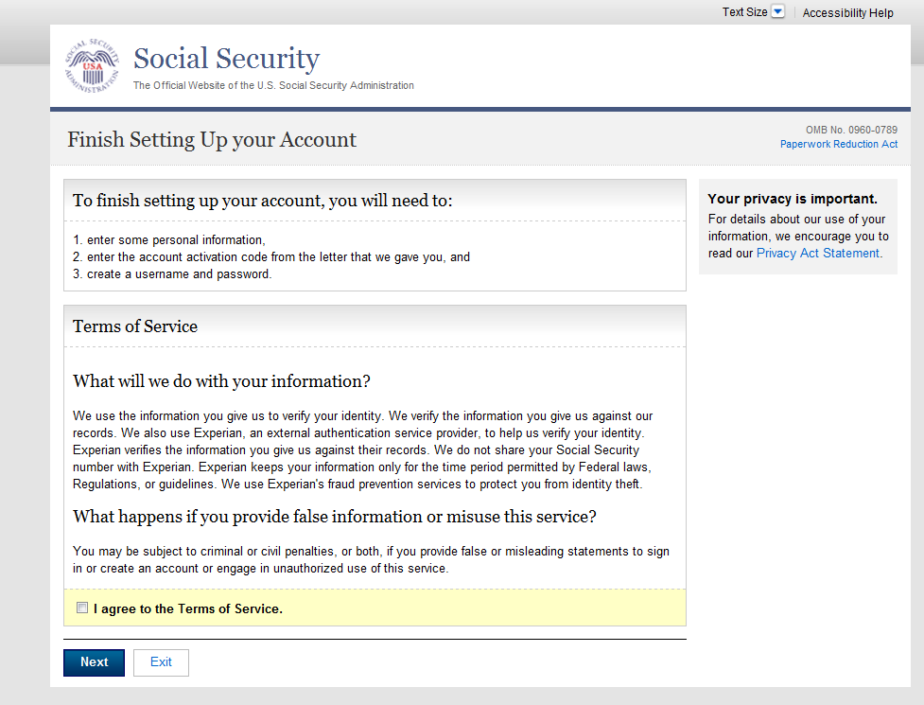

Reset Extra Security Terms of Service

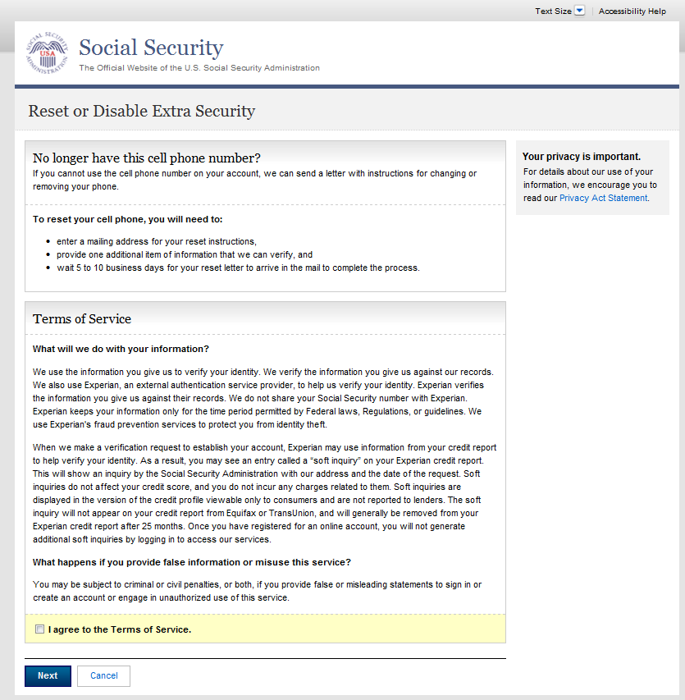

Login Terms of Service

