Note to the Reviewer: The text in the shaded boxes below will not be included in the survey (the visitors will not read this as a part of the survey process). This text is used to annotate the questions in response to Part A question 2 of the PRA Supporting Statement. The text boxes will be removed and will not be printed on the final version of the approved questionnaire.

NPS Study of Value of Natural Sounds: A Pilot Study
General Population Survey
Focus Group Exercise

OMB Control Number 1024-0XXX
Expiration Date: XX/XX/XXXX

Thank you for agreeing to participate in this focus group. We are asking for your help to improve this version of a survey that we will use in the future to measure visitor perception of sounds in National Parks. Your participation will help us to make sure that other visitors like you will be able to complete the questions in our survey. This study has been have been approved by the Office of Management and Budget and the control number and expiration date is available upon your request. Your participation is voluntary and your responses will be completely anonymous. During the time that we are together, we will ask you to answer a series of questions and then we will ask you to listen to some recorded sounds. After that we would like to spend some time as a group to debrief about your experience taking the survey. In total this should take about 90 minutes to complete. Are you ready to get started?

This will serve as an introduction to the survey. The text and the map will be used to provide an orientation to the area. For the purposes of this submission we are using Bryce Canyon National Park as the example in the exercises below.
This survey regards one park in particular: Bryce Canyon National Park
Bryce Canyon National Park is a 56.2 square mile national park in southwestern Utah. Bryce Canyon National Park is famous for its unique rock formations, consisting of a series of horseshoe-shaped amphitheaters carved from the eastern edge of the Paunsaugunt Plateau in southern Utah. The forces of ice and rain have shaped the colorful limestone rock of the Claron Formation into unique shapes including slot canyons, windows, fins, and spires.
Because Bryce Canyon National Park is higher than 2,000 feet (650 m) in elevation, the park exists in three distinct climatic zones: spruce/fir forest, Ponderosa Pine forest, and Pinyon Pine/Juniper forest. This diversity of habitat allows many different wildlife and plant species to exist, including 100 species of birds, dozens of mammals, and more than a thousand plant species.
More than 1 million people visit Bryce Canyon National Park each year. The park’s most popular activities are sightseeing/scenic driving, day hiking, and camping.
Sounds of Nature at Bryce Canyon
This survey relates to the sounds of nature at Bryce Canyon

Examples of sounds of nature include:
- birdsong
- rustling leaves
- rushing water
- insect chorus

Wildlife at national parks can be affected by sound conditions. Predators rely on sounds to detect prey and likewise sound often alerts prey to the presence of predators. Some species use sound to locate and attract mates. Man-made sounds such as talking, road vehicles, and aircraft have the potential to cover up the sounds of nature that wildlife use to survive.
Man-made sounds may also affect a visitor’s experience at a national park. The man-made sounds heard in the front country at national parks (scenic overlooks, trail heads, portions of hiking trails close to trail heads and developed campsites) are generally louder and more prevalent than the man-made sounds heard in the back country. However, man-made sounds heard in the back country can disturb a visitor’s feeling of solitude.
The instructions below are for the exercises that follow. There is an explanation of how the sound conditions are described (the metrics used) and that each trip has a corresponding change in costs. The instructions also contain a reminder of the respondent’s budget constraint and the availability of substitute goods, following standard protocols for stated preference valuation work.

Instructions for Exercises
On the following pages you will find a series of exercises that will ask you to choose between three possible scenarios at Bryce Canyon In all the exercises, the first option (Scenario A) represents the current typical conditions at Bryce Canyon during the summer. The other two scenarios are hypothetical.
The scenarios have different sound conditions described using the phrase “the percent of time only the sounds of nature are heard.” This means that there are no man-made sounds during that time. The rest of the time some amount of man-made sounds could be heard. The man-made sounds would be like those that are currently heard at Bryce Canyon.
The sound conditions are described separately for front country and back country. On the map on the following page, the green shaded area marks the front country. The front country includes scenic overlooks, trail heads, hiking trails within a half mile of trail head, and developed campsites. The backcountry is the rest of park, including hiking trails further than a half mile from trail heads and primitive campsites.
The scenarios are also described by a change in the amount of your household’s federal income taxes. Assume that all other characteristics of Bryce Canyon would remain the same. Also assume that sound conditions during spring, winter, and fall would remain the same.
Please keep in mind your financial situation and that you may prefer to use that money for other purposes. Also keep in mind that there are other natural areas (for example: other national parks, national forests, and state parks) where the sounds of nature may be heard.

Please carefully consider each exercise separately. There are no right or wrong answers; we are interested in learning what characteristics of Bryce Canyon are important to you.

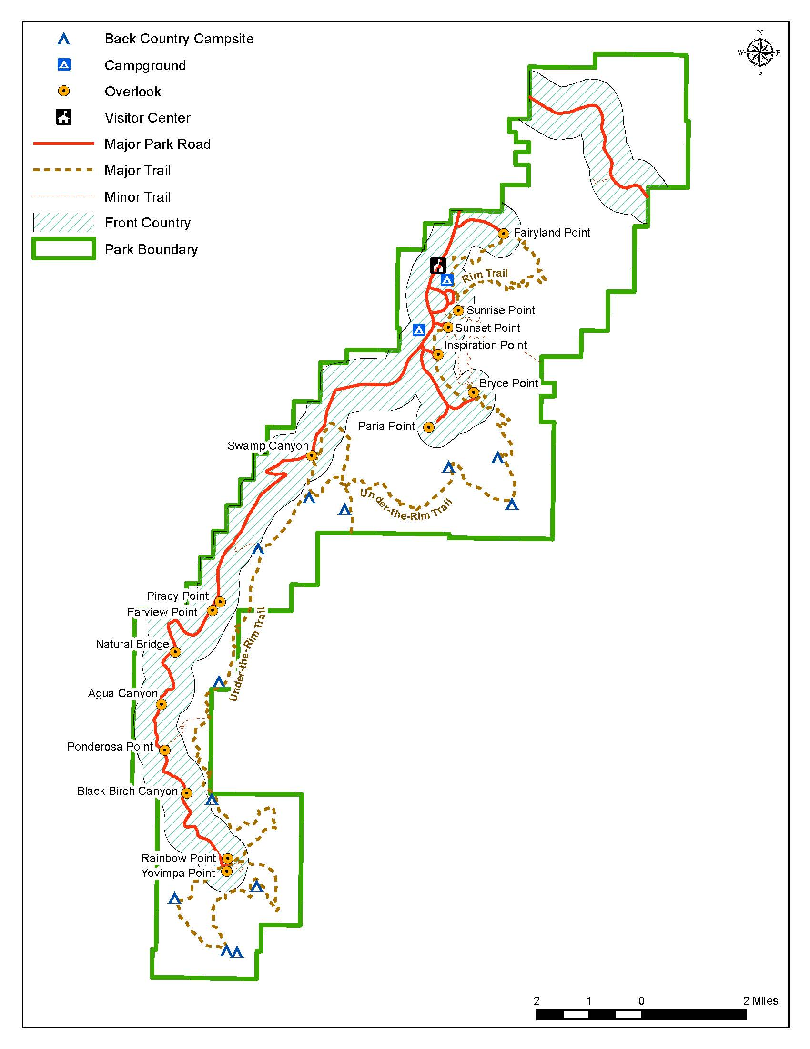
Bryce Canyon National Park
The following three questions are an example of one of the options. The values in each cell are examples. The values for the cells in the final survey will be determined from an experimental design which will maximize the efficiency of the choice options. The responses to the three exercises below from the full survey will be used for estimating a logit choice model.
Exercise 1: Please read all the information in the table below, and then select the scenario you would prefer.
I would prefer (choose only one)
- Scenario A
- Scenario B
- Scenario C
 |  | Scenario A  No change from current typical summer conditions | Scenario B  Hypothetical change from current typical summer conditions | Scenario C  Hypothetical change from current typical summer conditions
 |  | Below is the percent of time only the sounds of nature are heard (during a 12 hour period)
In the Front Country at one of the following locations:  - scenic overlooks  - trail heads  - hiking trails within 1/2 miles of trail head  - developed campsites | Daytime | 60% | 50% | 40%
 | Nighttime | 75% | 75% | 75%
In the Back Country at one of the following locations:  - hiking trails further than 1/2 miles from trail heads  - primitive campsites | Daytime | 80% | 90% | 70%
 | Nighttime | 85% | 85% | 85%
The change in annual household federal income tax (each year) would be |  | No Change | $15 increase | $5 decrease

Exercise 2: Please read all the information in the table below, and then select the scenario you would prefer.
I would prefer (choose only one)
- Scenario A
- Scenario B
- Scenario C
 |  | Scenario A  No change from current typical summer conditions | Scenario B  Hypothetical change from current typical summer conditions | Scenario C  Hypothetical change from current typical summer conditions
 |  | Below is the percent of time only the sounds of nature are heard (during a 12 hour period)
In the Front Country at one of the following locations:  - scenic overlooks  - trail heads  - hiking trails within 1/2 miles of trail head  - developed campsites | Daytime | 60% | 60% | 60%
 | Nighttime | 75% | 85% | 65%
In the Back Country at one of the following locations:  - hiking trails further than 1/2 miles from trail heads  - primitive campsites | Daytime | 80% | 60% | 70%
 | Nighttime | 85% | 90% | 95%
The change in annual household federal income tax (each year) would be |  | No Change | $10 increase | $25 increase

Exercise 3: Please read all the information in the table below, and then select the scenario you would prefer.
I would prefer (choose only one)
- Scenario A
- Scenario B
- Scenario C
 |  | Scenario A  No change from current typical summer conditions | Scenario B  Hypothetical change from current typical summer conditions | Scenario C  Hypothetical change from current typical summer conditions
 |  | Below is the percent of time only the sounds of nature are heard (during a 12 hour period)
In the Front Country at one of the following locations:  - scenic overlooks  - trail heads  - hiking trails within 1/2 miles of trail head  - developed campsites | Daytime | 60% | 65% | 70%
 | Nighttime | 75% | 65% | 70%
In the Back Country at one of the following locations:  - hiking trails further than 1/2 miles from trail heads  - primitive campsites | Daytime | 80% | 65% | 70%
 | Nighttime | 85% | 90% | 80%
The change in annual household federal income tax (each year) would be |  | No Change | $25 decrease | $5 decrease

This contingent valuation is included as additional method for estimating that respondent’s value for natural sound conditions. (This method was suggested by a member of the expert review panel in case the more complicated choice exercises do not work out.)

Exercise 4: Currently at [insert name of park] only natural sounds are heard 60% of the time during in the day in the front country. What would you pay (in higher household federal income tax each year) to improve conditions so that only natural sounds are heard 75% of the time during the day in the front country? Circle the one amount that best represents your answer.
$0.00 | $2 | $8 | $25 | $60 | $150 | $400
$0.50 | $3 | $10 | $30 | $75 | $200 | $500
$1.00 | $4 | $15 | $40 | $100 | $250 | $750
$1.50 | $5 | $20 | $50 | $125 | $300 | $1,000
 |  |  |  |  | Don’t know | More than $1,000

If you selected $0.00 above, please briefly explain why.
_________________________________________________________________________________________________________________________________________________________________________________________________________________________________________________________

PAPERWORK REDUCTION ACT STATEMENT: The National Park Service is authorized by 6 U.S.C. 1a-7 to collect this information. This information will be used by park managers to understand visitor perceptions of sound in [insert park name]. Response to this request is voluntary. No action may be taken against you for refusing to supply the information requested. The permanent data connected with this collection will be anonymous. Please do not put your name or that of any member of your household on the questionnaire. An agency may not conduct or sponsor, and a person is not required to respond to, a collection of information unless it displays a currently valid OMB control number.
BURDEN ESTIMATE: The public reporting for this collection is estimated to be 60 minutes per respondent. This includes the time to complete the questionnaire and to participate in the follow-up interview process. Direct comments regarding the burden estimate or any other aspect of this form to: Catherine Taylor, Volpe National Transportation Systems Center, 55 Broadway, Cambridge, MA 02142, catherine.taylor@dot.gov (email).

